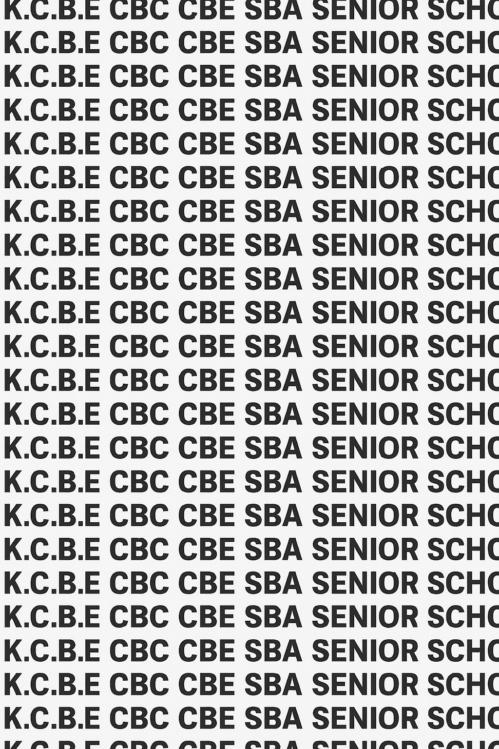


KENYA CERTIFICATE OF BASIC EDUCATION (K.C.B.E)


GRADE 10 I.C.T. (Theory) TERM 1 JANUARY 2026
Time: 1 Hour 50 Minutes
COMPETENCY BASED EDUCATION CKEAB 001

LEARNER’S DETAILS
Name: _______________________________________________________________________________________.
School: ______________________________________________________________________________________.
Assessment Number: ________________________________. Date: __________________________________.
School Code: _______________________________. Signature: ________________________________.

INSTRUCTIONS TO LEARNERS
- Write your name, School, assessment number, signature and date on all the answer sheets provided.


- The exam has two sections SECTION A and SECTION B
- SECTION A (40 marks): Answer all questions.
- SECTION B (60 marks): Answer any six questions.
- Read each question carefully before writing your answer.
- Ensure your answers are clear, neat, and well-organized.
- The marks for each question are indicated at the end of the question.
-INFORMATION AND COMMUNICATION TECHNOLOGY- -001- -Senior School-
- Do not write in the margin.
- Check your work before submitting the exam.
- Manage your time well to complete all questions.

PERFORMANCE LEVELS AND SCORE GRID
Q1 | Q2 |  | Q3 |  | Q4 |  |  | Q5 |  | Q6 |  | Q7 |  | Q8 | SECTION A TOTAL /40
4 | 4 |  | 4 |  | 4 |  |  | 4 |  | 4 |  | 4 |  | 4 | /40
Score
Q9 | Q10 |  |  | Q11 |  | Q12 |  |  | Q13 |  | Q14 |  |  | Q15 | Q16 | SECTION B TOTAL /60
10 | 10 |  |  | 10 |  | 10 |  |  | 10 |  | 10 |  |  | 10 | 10 | /60
Score
Section |  | Max Marks |  |  |  |  | 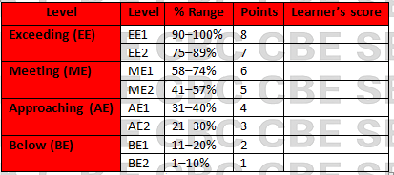  Learner Score
A |  | 40
B |  | 60
TOTAL |  | 100

This paper has 9 printed pages. Please check out to ensure all pages are printed
Turn over
SECTION A: (40 Marks)
Answer all questions in this section.

1. (a) At Sotik Senior School, the principal wants to improve communication between teachers, students, and parents. Define the following ICT terms that she encounters during the planning:
i. Information (1 mark)
_________________________________________________________________________________________________
_________________________________________________________________________________________________
ii. Process (1 mark)
_________________________________________________________________________________________________
_________________________________________________________________________________________________
iii. Communication (1 mark)
_________________________________________________________________________________________________
_________________________________________________________________________________________________
iv. Technology (1 mark)
_________________________________________________________________________________________________
_________________________________________________________________________________________________

2. During an ICT lesson, the teacher explains different application areas of ICT.
a. Keeping patients’ medical records.
b. Scanning barcodes on goods.
c. Recording students’ exam marks.
d. Producing sales receipts.
He then asked Grade 10 learners to name some of the places where ICT is used. The learners gave the following options.
- Hospital,
- School,
- Supermarket,
- Shops
Write the correct place from the options: (4 marks)
 | Application | Where used
i | Keeping patients’ medical records
ii | Scanning barcodes on goods
iii | Recording students’ exam marks
iv | Producing sales receipts

3. A company in Nairobi wants to improve its ICT infrastructure. State four components of ICT infrastructure that the company should install. (4 marks)
- ____________________________________________________________________________________________
- ____________________________________________________________________________________________
- ____________________________________________________________________________________________
- ____________________________________________________________________________________________

4. In the school computer laboratory, students are learning about types of operating systems. Identify the type of operating system used in each device:
a. iPhone: ______________________________________________ (1 mark)
b. Samsung phone: ______________________________________________ (1 mark)
c. Apple laptop: ______________________________________________ (1 mark)
d. Most desktop computers in school: ______________________________________________ (1 mark)

5. A student is changing the desktop appearance on a school computer. Write the steps for changing the desktop background in Windows OS. (4 marks)
- ____________________________________________________________________________________________
- ____________________________________________________________________________________________
- ____________________________________________________________________________________________
- ____________________________________________________________________________________________

6. A supermarket accountant wants to organize financial statements on the computer. State two uses of ICT in an Accounts Office. (4 marks)
- ____________________________________________________________________________________________
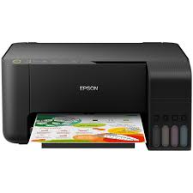
- ____________________________________________________________________________________________
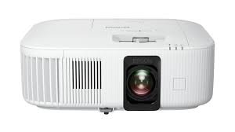
b) Janet visited a local ICT hub and observed that they used the following devices
X Y

Identify the name of the device marked X and Y
X: _________________________________________________________
Y: __________________________________________________________

7. Identify two technologies used in modern communication that a business in Kenya can use to reach customers. (2 marks)
- ____________________________________________________________________________________________
- ____________________________________________________________________________________________
(b) During an ICT lesson learners were taught on various parts of a computer.
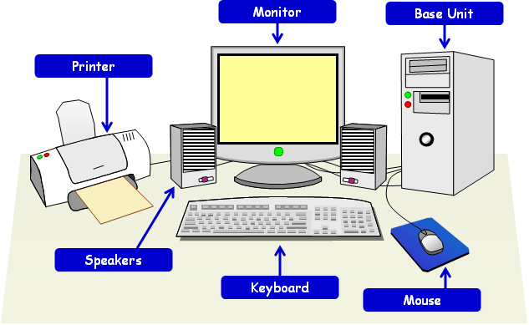
G

H
Identify the parts of a computer marked GH
G: ____________________________________________
H: ________________________________________________

8. (a) Name two precautions to undertake when using a computer. (2 marks)
- ____________________________________________________________________________________________
- ____________________________________________________________________________________________
(b) Write in full. (2 marks)
- O.S: _______________________________________________________________________________________.
- I.C.T: ______________________________________________________________________________________.

SECTION B (60 MARKS)
Answer ANY SIX questions from this section.

9. Kapkatet Hospital has decided to fully digitize its services.
a. Explain three ways ICT can improve patient care in the hospital. (3 marks)
- ____________________________________________________________________________________________
- ____________________________________________________________________________________________
- ____________________________________________________________________________________________
b. Describe two risks of using ICT systems in hospitals. (2 marks)
- ____________________________________________________________________________________________
- ____________________________________________________________________________________________
c. List three output devices that may be used in the hospital. (3 marks)
- ____________________________________________________________________________________________
- ____________________________________________________________________________________________
- ____________________________________________________________________________________________
d. Explain two reasons why backing up hospital data is important. (2 marks)
- ____________________________________________________________________________________________
- ____________________________________________________________________________________________

10. At Nakuru Ridge Senior School, teachers are encouraged to use ICT in teaching.
a. Explain four benefits of using ICT in the classroom. (4 marks)
- ____________________________________________________________________________________________
- ____________________________________________________________________________________________
- ____________________________________________________________________________________________
- ____________________________________________________________________________________________
b. Describe three challenges that teachers may face when integrating ICT. (3 marks)
- ____________________________________________________________________________________________
- ____________________________________________________________________________________________
- ____________________________________________________________________________________________
c. State three examples of ICT tools that can be used during a Geography lesson. (3 marks)
- ____________________________________________________________________________________________
- ____________________________________________________________________________________________
- ____________________________________________________________________________________________

11. You are appointed as the ICT prefect in your school.
a. Explain four functions of an operating system that help users manage files and programs. (4 marks)
- ____________________________________________________________________________________________
- ____________________________________________________________________________________________
- ____________________________________________________________________________________________
- ____________________________________________________________________________________________
b. Compare Command Line Interface (CLI) and Graphical User Interface (GUI) by giving three differences. (6 marks)
 | Command Line Interface (CLI) | Graphical User Interface (GUI)
i
ii
iii

12. A new retail shop in Eldoret wants to improve efficiency using ICT.
a. Explain three uses of ICT in a retail shop. (3 marks)
- ____________________________________________________________________________________________
- ____________________________________________________________________________________________
- ____________________________________________________________________________________________
b. Describe the steps of creating a new folder in Windows. (3 marks)
- ____________________________________________________________________________________________
- ____________________________________________________________________________________________
- ____________________________________________________________________________________________
- ____________________________________________________________________________________________
c. State four advantages of using ICT to manage stock in a retail shop. (4 marks)
- ____________________________________________________________________________________________
- ____________________________________________________________________________________________
- ____________________________________________________________________________________________
- ____________________________________________________________________________________________

13. a. Explain four applications of ICT in offices. (4 marks)
- ____________________________________________________________________________________________
- ____________________________________________________________________________________________
- ____________________________________________________________________________________________
- ____________________________________________________________________________________________

b. Describe three ways ICT is used in transportation systems. (3 marks)
- ____________________________________________________________________________________________
- ____________________________________________________________________________________________
- ____________________________________________________________________________________________

c. State three advantages of using ICT in communication. (3 marks)
- ____________________________________________________________________________________________
- ____________________________________________________________________________________________
- ____________________________________________________________________________________________

14. A Kenyan company wants to set up efficient ICT infrastructure.
a. Explain the meaning of ICT infrastructure. (2 marks)
____________________________________________________________________________________________
____________________________________________________________________________________________
b. Describe four components of ICT infrastructure in an organization. (4 marks)
- ____________________________________________________________________________________________
- ____________________________________________________________________________________________
- ____________________________________________________________________________________________
- ____________________________________________________________________________________________
c. Explain four factors the company should consider when choosing ICT infrastructure. (4 marks)
- ____________________________________________________________________________________________
- ____________________________________________________________________________________________
- ____________________________________________________________________________________________
- ____________________________________________________________________________________________

15. A Grade 10 learner is asked to define key ICT concepts.
a. Give the procedure for switching off a computer. (2 marks)
____________________________________________________________________________________________
____________________________________________________________________________________________
b. Give two uses of ICT in schools (2 marks)
- ____________________________________________________________________________________________
- ____________________________________________________________________________________________
c. Explain three differences between IT and ICT. (3 marks)
 | IT | ICT
i
ii
iii
d. State three reasons why ICT is important in modern organizations. (3 marks)
- ____________________________________________________________________________________________
- ____________________________________________________________________________________________
- ____________________________________________________________________________________________

16. A business is choosing between Windows, Linux, and macOS.
a. Give two advantages of using Windows OS. (2 marks)
- ____________________________________________________________________________________________
- ____________________________________________________________________________________________

b. Give two advantages of using Linux OS. (2 marks)
- ____________________________________________________________________________________________
- ____________________________________________________________________________________________
c. Give two advantages of using macOS. (2 marks)
- ____________________________________________________________________________________________
- ____________________________________________________________________________________________
d. Explain four factors the business should consider when selecting an operating system. (4 marks)
- ____________________________________________________________________________________________
- ____________________________________________________________________________________________
- ____________________________________________________________________________________________
- ____________________________________________________________________________________________

©2026
All rights reserved
©COMPETENCE KENYA EXAMINATION AND ASSESSMENT BOARD
THIS IS THE LAST PRINTED PAGE

