
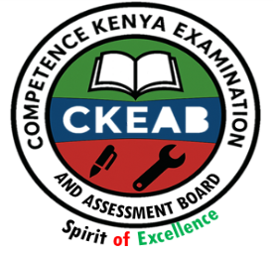
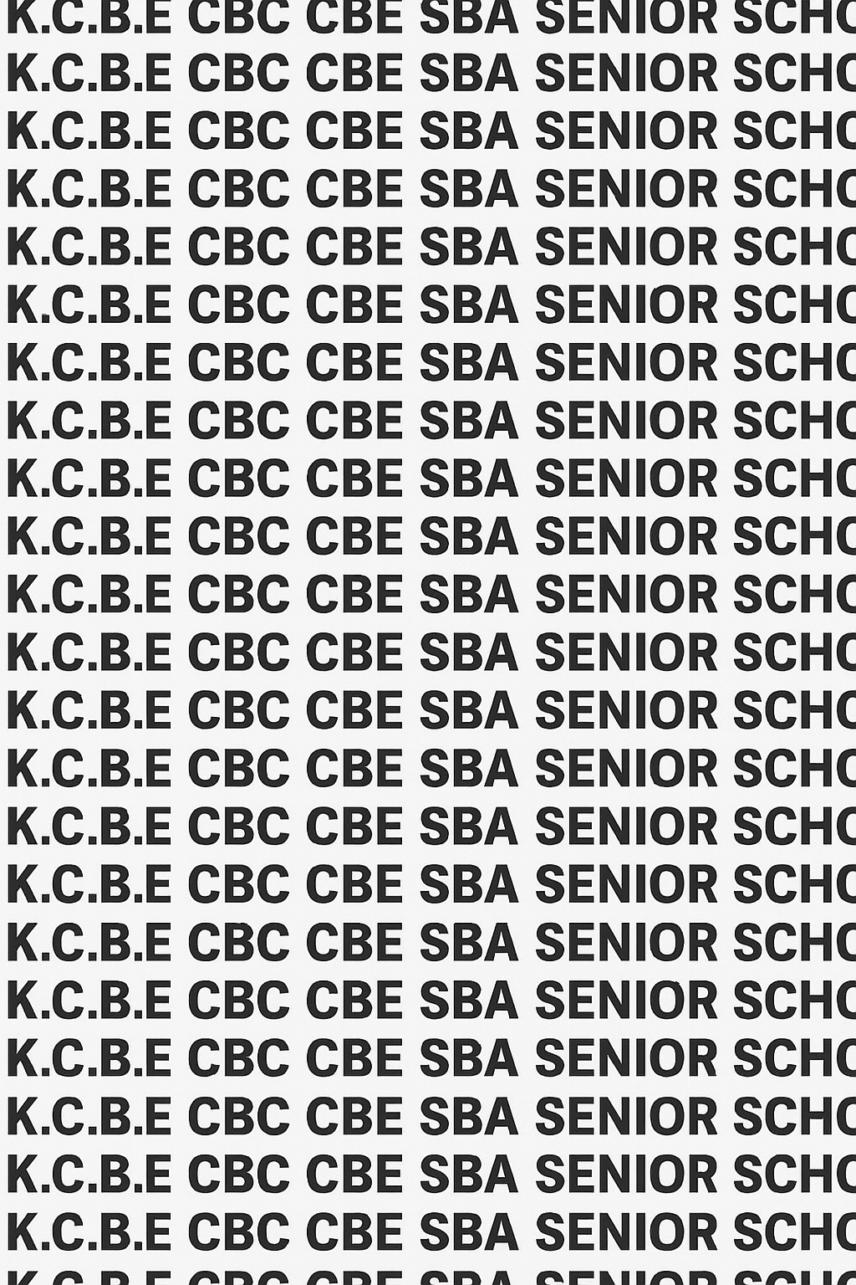
KENYA CERTIFICATE OF BASIC EDUCATION (K.C.B.E)


GRADE 10 I.R.E (Theory) TERM 1 JANUARY 2026
Time: 1 Hour 30 Minutes
COMPETENCY-BASED EDUCATION CKEAB 001

LEARNER’S DETAILS
Name: _______________________________________________________________________________________.
School: ______________________________________________________________________________________.
Assessment Number: ________________________________. Date: __________________________________.
School Code: _______________________________. Signature: ________________________________.

INSTRUCTIONS TO LEARNERS

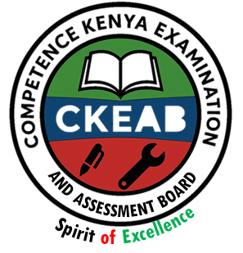
- Write your name, School, assessment number, signature and date on all the answer sheets provided.
- Answer all the questions in the spaces provided.
- Read each question carefully before writing your answer.
- PERFORMANCE LEVELS GRID
-ISLAMIC RELIGIOUS EDUCATION- -001- -Senior School-
Section | Q No. | Max Marks | Learner Score | Q No. | Max Marks | Learner Score | Q No. | Max Marks | Learner Score | Section Total
A | 1a | 4 |  | 1b | 2 |  | 2a | 4
 | 2b | 2 |  | 3a | 3 |  | 3b | 3
 | 4a | 4 |  | 4b | 2 |  | 5a | 4
 | 5b | 4 |  | 6a | 4 |  | 6b | 4
Total Section A |  | 40
B | 7a | 10 |  | 7b | 10 |  | 7c | 10
 | 8a | 10 |  | 8b | 10 |  | 8c | 10
 | 9a | 10 |  | 9b | 10 |  | 9c | 10
 | 10a | 10 |  | 10b | 10 |  | 10c | 10
Total Section B |  | 60
Grand Total |  | 100
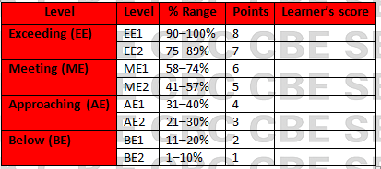
Section | Max Marks | Learner Score
A | 40
B | 60
TOTAL | 100

This paper has 6 printed pages. Please check out to ensure all pages are printed
Turn over
SECTION A: (40 Marks)
Answer all questions in this section.

1. During a battle at Yamamah, many Huffaadh (memorizers of the Qur’an) were killed.
a) Explain two circumstances that led Caliph Abu Bakr (R.A.) to initiate the compilation of the Qur’an after this battle. (4 marks)

____________________________________________________________________________________________

____________________________________________________________________________________________
b) State two qualities that made Zayd ibn Thabit (R.A.) suitable for leading the compilation team. (2 marks)

____________________________________________________________________________________________

____________________________________________________________________________________________

2. Muslims from different regions such as Sham, Iraq, and Hijaz began reciting the Qur’an differently.
a) Describe two circumstances that led to the standardization of the Qur’an during the reign of *Caliph Uthman (R.A.)**. (4 marks)

____________________________________________________________________________________________

____________________________________________________________________________________________
b) State two significance of the standardization of the Qur’an for the Ummah. (2 marks)

____________________________________________________________________________________________

____________________________________________________________________________________________

3. The early Muslims used parchments, bones, and leaves to record revelations.
a) Outline three steps followed in compiling the Qur’an during the reign of Caliph Abu Bakr (R.A.). (3 marks)

____________________________________________________________________________________________

____________________________________________________________________________________________

___________________________________________________________________________________________

____________________________________________________________________________________________
b) State three steps followed during the standardization under Caliph Uthman (R.A.). (3 marks)

____________________________________________________________________________________________

____________________________________________________________________________________________

___________________________________________________________________________________________

4. Non-Arab Muslims struggled to read Qur’anic words correctly due to lack of vowel marks.
a) Explain two circumstances that led to the diacriticalization of the Qur’an during the time of al-Hajjaj ibn Yusuf. (4 marks)

____________________________________________________________________________________________

____________________________________________________________________________________________
b) Identify two significance of diacritical marks in reading the Qur’an. (2 marks)

____________________________________________________________________________________________

____________________________________________________________________________________________

5. Students at a madrasa were analyzing Qur’anic verses to classify them.
a) Differentiate between Muhkamat and Mutashabihat verses. (4 marks)

____________________________________________________________________________________________

____________________________________________________________________________________________

___________________________________________________________________________________________

____________________________________________________________________________________________

____________________________________________________________________________________________

____________________________________________________________________________________________
b) With examples, distinguish between al-‘Aam and al-Khaas verses. (4 marks)

____________________________________________________________________________________________

____________________________________________________________________________________________

___________________________________________________________________________________________

____________________________________________________________________________________________

6. A teacher presents a verse and asks learners to explain why it was revealed.
a) Explain two kinds of Asbaab al-Nuzuul. (4 marks)

____________________________________________________________________________________________

____________________________________________________________________________________________
b) State four benefits of studying Asbaab al-Nuzuul. (4 marks)

____________________________________________________________________________________________

____________________________________________________________________________________________

___________________________________________________________________________________________

____________________________________________________________________________________________

SECTION B (60 MARKS)
Answer ANY TWO questions from this section.

7. A research group in your school is evaluating the importance of preserving Islamic manuscripts and how early Muslims preserved the Qur’an.
a) Discuss five significance of the compilation of the Qur’an under Caliph Abu Bakr (R.A.). (10 marks)

____________________________________________________________________________________________

____________________________________________________________________________________________

___________________________________________________________________________________________

___________________________________________________________________________________________

____________________________________________________________________________________________
b) Describe five characteristics of the Companions who participated in the compilation of the Qur’an. (10 marks)

____________________________________________________________________________________________

____________________________________________________________________________________________

___________________________________________________________________________________________

___________________________________________________________________________________________

____________________________________________________________________________________________
c) Explain five ways modern Muslims can preserve the Qur’an today. (10 marks)

____________________________________________________________________________________________

____________________________________________________________________________________________

___________________________________________________________________________________________

___________________________________________________________________________________________

____________________________________________________________________________________________

8. Your IRE class is preparing a documentary on the history of the Qur’an from revelation to standardization.
a) Explain five reasons why Caliph Uthman (R.A.) ordered the production of a standard copy of the Qur’an. (10 marks)

____________________________________________________________________________________________

____________________________________________________________________________________________

___________________________________________________________________________________________

___________________________________________________________________________________________

____________________________________________________________________________________________
b) Describe five steps taken by the committee led by Zayd ibn Thabit (R.A.) to standardize the Qur’an. (10 marks)

____________________________________________________________________________________________

____________________________________________________________________________________________

___________________________________________________________________________________________

___________________________________________________________________________________________

____________________________________________________________________________________________
c) Discuss five impacts of having a standard Qur’an on the unity of the Muslim Ummah. (10 marks)

____________________________________________________________________________________________

____________________________________________________________________________________________

___________________________________________________________________________________________

___________________________________________________________________________________________

____________________________________________________________________________________________

9. Your teacher assigns you the task of presenting Qur’anic verse categories at the school symposium.
a) Explain five characteristics of Muhkamat verses. (10 marks)

____________________________________________________________________________________________

____________________________________________________________________________________________

___________________________________________________________________________________________

___________________________________________________________________________________________

____________________________________________________________________________________________
b) Explain five characteristics of Mutashabihat verses. (10 marks)

____________________________________________________________________________________________

____________________________________________________________________________________________

___________________________________________________________________________________________

___________________________________________________________________________________________

____________________________________________________________________________________________

c) Discuss five significance of understanding al-‘Aam and al-Khaas verses in Qur’anic interpretation. (10 marks)

____________________________________________________________________________________________

____________________________________________________________________________________________

___________________________________________________________________________________________

___________________________________________________________________________________________

____________________________________________________________________________________________

10. During a class debate, students argued about the relevance of Asbaab al-Nuzuul in modern tafsir.
a) Explain five roles of Asbaab al-Nuzuul in understanding Qur’anic verses. (10 marks)

____________________________________________________________________________________________

____________________________________________________________________________________________

___________________________________________________________________________________________

___________________________________________________________________________________________

____________________________________________________________________________________________
b) Describe five challenges that may arise when interpreting verses without knowing their Asbaab al-Nuzuul. (10 marks)

____________________________________________________________________________________________

____________________________________________________________________________________________

___________________________________________________________________________________________

___________________________________________________________________________________________

____________________________________________________________________________________________
c) Discuss five benefits of applying lessons from Asbaab al-Nuzuul in contemporary Muslim life. (10 marks)

____________________________________________________________________________________________

____________________________________________________________________________________________

___________________________________________________________________________________________

___________________________________________________________________________________________

____________________________________________________________________________________________

©2026
All rights reserved
©COMPETENCE KENYA EXAMINATION AND ASSESSMENT BOARD
THIS IS THE LAST PRINTED PAGE

