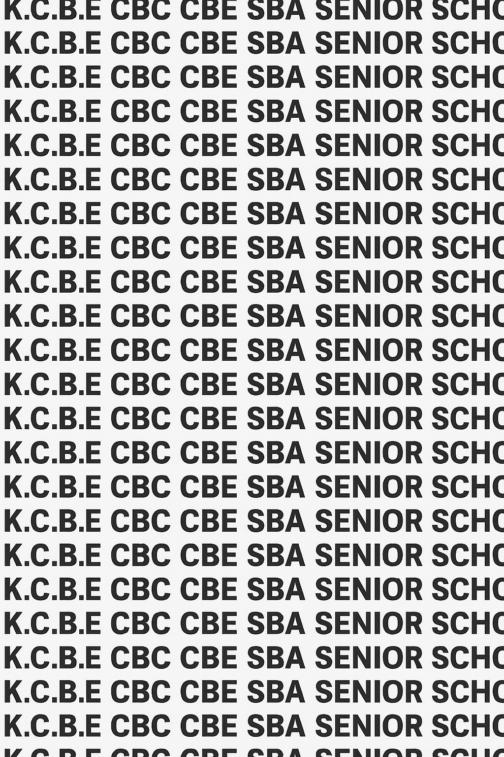
KENYA CERTIFICATE OF BASIC EDUCATION (K.C.B.E)


GREDI 10 KISWAHILI MUHULA 1 JANUARI 2026
Time: Saa 2
ELIMU YA MSINGI WA UMAHIRI CKEAB 001

LEARNER’S DETAILS
Jina: _______________________________________________________________________________________.
Shule: ______________________________________________________________________________________.
Namba ya Tathmini: ________________________________. Tarehe: ________________________________.
Namba ya Shule: ____________________________. Saini: ________________________________.

MAELEKEZO KWA MTAHINIWA
- Andika jina yako,jina ya shule,namba ya mtihani,tarehe na kisha weka saini.
- Soma maswali yote kwa makini kabla ya kuyajibu.
- Mtihani una sehemu mbili:
  - SEHEMU A: KISWAHILI – Alama 60
  - SEHEMU B: FASIHI – Alama 40
- Jibu maswali yote katika sehemu zote mbili.
-KISWAHILI NA FASIHI- -001- -Sekondari ya juu-

VIWANGO VYA KUTATHMINI
Sehemu |  | 1 | 2 | 3 | 4 | 5 | 6 | 7 |  | 8 | 9 | 10 | 11 | 12 | 13 | 14 | 15 | 16 | 17 | 18 | 19 | 20 | Jumla Sehemu | Alama Mwanafunzi
Sehemu A |  | 2 | 2 | 2 | 2 | 2 | 1 | 1 |  | 1 | 1 | 1 | 2 | 2 | 2 | 2 | 5 | 5 | 2 | 2 | 4 | 4 | 60
ALAMA YA MTAHINIWA
Sehemu B |  | 2 | 3 | 2 | 3 | 3 | 2 | 2 |  | 4 | 2 | 3 | 3 | 3 | 2 | 2 | 3 | 3 | 3 | 2 |  |  | 40
ALAMA YA MTAHINIWA
SEHEMU | ALAMA | ALAMA YA MTAHINIWA
A | 60
B | 40
JUMLA | 100
KIWANGO

Kiwango | Alama ya Kiwango | Uwiano wa % | Pointi | Alama ya Mwanafunzi
KUZIZISHA MATARAJIO | KUZ1 | 90–100% | 8
 | KUZ2 | 75–89% | 7
KUKIDHI MATARAJIO | KUF1 | 58–74% | 6
 | KUF2 | 41–57% | 5
KUKARIBIA MATARAJIO | KUK1 | 31–40% | 4
 | KUK2 | 21–30% | 3
CHINI YA MATARAJIO | CHI1 | 11–20% | 2
 | CHI2 | 1–10% | 1
Karatasi hii ina kurasa 5 zilizopigwa chapa.Mwanafunzi ahakikishe kwamba kurasa zote zipo
GEUZA KURASA

SEHEMU A: KISWAHILI (ALAMA 60)
Jibu maswali yote
- Soma kifungu kifuatacho kisha ujibu maswali:
Katika shule ya Mlimani, kulikuwa na utaratibu wa kila mwanafunzi kupanda mti mmoja kama njia ya kuendeleza mazingira. Wanafunzi walihimizwa kutunza miti hiyo kila wiki wawapo shuleni. Hata hivyo, baadhi yao hawakutilia maanani umuhimu wa shughuli hiyo.
Mwalimu mkuu aliwaita wanafunzi wote na kueleza kuwa kupanda miti sio tu kuimarisha mandhari ya shule, bali pia ni kuwekeza katika kesho yenye hewa safi. Wanafunzi walioshiriki kwa bidii walipewa vyeti vya kutambua mchango wao. Baada ya muda, shule ilianza kuonekana kijani na kupendeza. Wanakijiji walifuata mfano huo na kuanza kampeni ya kijiji kizima kupanda miti. Hatua hii ilibadilisha mazingira kwa kiasi kikubwa.
Maswali:
a) Eleza mada kuu ya kifungu. (Alama 2)
________________________________________________________________________________________________
________________________________________________________________________________________________
b) Taja sababu mbili zilizomfanya mwalimu mkuu kutoa hotuba. (Alama 2)
________________________________________________________________________________________________
________________________________________________________________________________________________
c) Eleza manufaa mawili ya kupanda miti kulingana na kifungu. (Alama 2)
________________________________________________________________________________________________
________________________________________________________________________________________________
d) Kwa nini baadhi ya wanafunzi walipatiwa vyeti? (Alama 2)
________________________________________________________________________________________________
________________________________________________________________________________________________
e) Eleza ujumbe mmoja katika kifungu hiki. (Alama 2)
________________________________________________________________________________________________
________________________________________________________________________________________________
f) Eleza maana ya maneno yafuatayo kama yalivyotumika katika kifungu:
i. Kuwekeza (Alama 1)
________________________________________________________________________________________________
________________________________________________________________________________________________
ii. Kampeni (1)
________________________________________________________________________________________________
________________________________________________________________________________________________
iii. Kuwatambua (Alama 1)
________________________________________________________________________________________________
________________________________________________________________________________________________

a)
Chagua aina za maneno zilizo katika sentensi ifuatayo:
“Wakulima wachapakazi walipanda mimea mizuri shambani.”
i. “Wachapakazi” ni aina gani ya nomino? (Alama 1)
________________________________________________________________________________________________
________________________________________________________________________________________________
ii. “Walipanda” ni aina gani ya kitenzi? (Alama 1)
________________________________________________________________________________________________
________________________________________________________________________________________________
iii. “Mzuri” katika sentensi ni aina gani ya neno? (Alama 1)
________________________________________________________________________________________________
________________________________________________________________________________________________

b)
Badili majina yaliyoandikwa kwa herufi kubwa kwa kutumia viwakilishi vinavyofaa:
i. MWALIMU JUMA alifika mapema. (Alama 2)
________________________________________________________________________________________________
________________________________________________________________________________________________
ii. Wanafunzi walimsikiliza MWALIMU MKUU. (Alama 2)
________________________________________________________________________________________________
________________________________________________________________________________________________

c)
Weka alama sahihi za uakifishaji katika sentensi zifuatazo:
i. mwalimu aliuliza nani hajafanya kazi hii (Alama 2)
________________________________________________________________________________________________
________________________________________________________________________________________________
ii. leo tutasoma shairi la ushairi wa kisasa alisema mwalimu (Alama 2)
________________________________________________________________________________________________
________________________________________________________________________________________________

d)
Tunga sentensi sahihi kwa kutumia kiunganishi ingawa. (Alama 2)
________________________________________________________________________________________________
________________________________________________________________________________________________
- Soma kifungu kifupi kifuatacho:
Katika juhudi za kuboresha afya ya jamii, hospitali ya Kijiji Kipya imeanzisha kampeni ya usafi iliyolenga kuelimisha wananchi juu ya umuhimu wa kudumisha mazingira safi na afya bora. Wanakijiji wanahimizwa kuosha mikono kila wakati kabla ya kula, kuhakikisha chakula ni safi na salama, na pia kutupa taka zao katika sehemu maalumu zilizotengwa kwa ajili ya taka. Aidha, wanashauriwa kuzingatia usafi wa nyumba zao, kusafisha vyumba vya kuishi na sehemu za jikoni, na kuhakikisha maji ya kunywa ni safi na salama. Hospitali hiyo pia imeanzisha warsha na mikutano ya jamii ili kutoa elimu kuhusu magonjwa yanayosababishwa na ukosefu wa usafi na kuonyesha njia za kuzuia maambukizi. Juhudi hizi zimekuwa na matokeo chanya kwa jamii, zikipunguza maambukizi ya maradhi, kuimarisha afya ya wakazi, na kuongeza ufahamu wa umma kuhusu umuhimu wa usafi wa mazingira na afya ya binadamu. Hatimaye, jamii imeanza kushirikiana katika miradi ya kudumisha mazingira safi, ikionyesha kuwa elimu na ushirikiano vinaweza kuleta mabadiliko chanya kwa afya ya wote.
a) Andika kwa ufupi (kwa maneno yasiyozidi 30) muhtasari wa kifungu. (Alama 5)
NAKALA CHAFU
________________________________________________________________________________________________
________________________________________________________________________________________________
________________________________________________________________________________________________
________________________________________________________________________________________________
NAKALA SAFI
________________________________________________________________________________________________
________________________________________________________________________________________________
________________________________________________________________________________________________
________________________________________________________________________________________________

b) Soma kifungu kilichofupishwa kisha ujibu:

“Hospitali ya Kijiji Kipya imeanzisha kampeni ya usafi ili kuelimisha wanakijiji kuhusu kuosha mikono kabla ya kula, kutupa taka kwenye sehemu maalumu, na kudumisha usafi wa nyumba zao. Juhudi hizi zimepunguza maradhi na kuimarisha afya ya jamii.”
Maswali:
a) Eleza muhtasari wa kifungu kwa maneno machache (2)
________________________________________________________________________________________________
________________________________________________________________________________________________
________________________________________________________________________________________________

b) Taja faida mbili za kampeni hii kwa jamii (Alama 2)
________________________________________________________________________________________________
________________________________________________________________________________________________

c) Taja hatua moja inayochukuliwa na wanakijiji kuhakikisha usafi (Alama 1)
________________________________________________________________________________________________
________________________________________________________________________________________________

- Soma kifungu cha simulizi kifuatacho:
Asubuhi moja, Asha aliamka akiwa amejaa matumaini. Alikuwa amejipanga kushiriki mashindano ya uchoraji yaliyofanyika katika ukumbi wa shule. Katika safari yake, alikutana na rafiki yake, Zuri, ambaye alimpa moyo wa kutokata tamaa.
Akiwa ukumbini, Asha alizidiwa na uoga alipoona michoro mizuri ya wenzake. Hata hivyo, aliweka bidii na kuchora mandhari ya kijiji chao – miti, watu, na nyumba za kienyeji. Mwishoni mwa siku, Asha alishinda nafasi ya kwanza. Ushindi wake ulikuwa somo kwa wengine kuwa bidii hulipa.
Maswali:
a) Eleza aina ya msimulizi katika kifungu. (Alama 2)
________________________________________________________________________________________________
________________________________________________________________________________________________
b) Ainisha mhusika mkuu na mhusika msaidizi. (Alama 2)
________________________________________________________________________________________________
________________________________________________________________________________________________
c) Eleza mandhari ya simulizi na umuhimu wake. (Alama 4)
________________________________________________________________________________________________
________________________________________________________________________________________________
________________________________________________________________________________________________
________________________________________________________________________________________________
d) Taja kipengele kimoja cha msuko (ploti) kinachoonekana. (Alama 2)
________________________________________________________________________________________________
________________________________________________________________________________________________
e) Taja mbinu mbili za lugha zilizotumika. (Alama 4)
________________________________________________________________________________________________
________________________________________________________________________________________________
________________________________________________________________________________________________
________________________________________________________________________________________________
f) Eleza ujumbe mmoja unaojitokeza. (Alama 2)
________________________________________________________________________________________________
________________________________________________________________________________________________
g) Andika kwa ufupi sababu zilizomfanya Asha kushinda. (Alama 4)
________________________________________________________________________________________________
________________________________________________________________________________________________
________________________________________________________________________________________________
________________________________________________________________________________________________

SEHEMU B: FASIHI (ALAMA 40)

Fasihi Simulizi (Alama 10)
a) Eleza maana ya fasihi simulizi. (Alama 2)
________________________________________________________________________________________________
________________________________________________________________________________________________
b) Taja sifa tatu za fasihi simulizi. (Alama 3)
________________________________________________________________________________________________
________________________________________________________________________________________________
________________________________________________________________________________________________
________________________________________________________________________________________________
c) Eleza umuhimu wowote miwili wa fasihi simulizi katika jamii ya leo. (Alama 2)
________________________________________________________________________________________________
________________________________________________________________________________________________
________________________________________________________________________________________________
________________________________________________________________________________________________
d) Taja aina mbili za fasihi simulizi. (Alama 3)
________________________________________________________________________________________________
________________________________________________________________________________________________
- Soma shairi lifuatalo kisha ujibu maswali.
Pepo watiririka, wakilia majira,
Vumbi latanda juu, lafunika mandhari;
Mito yatiririka, yamejaa takataka,
Mwanadamu kashindwa, kutunza mazingira.
Mimea yanyauka, kutokana na ukame,
Wanyama wahamahama, porini wakitafuta;
Mabaki ya viwanda, yanarushwa hovyo hovyo,
Hewa yawaka moto, dunia inalia.
Tuamke ndugu zangu, tushike jukumu letu,
Tuitunze nchi yetu, kwa sasa na kwa baadaye;
Mazingira yakipendeza, nasi tutapendeza,
Maisha yatastawi, ulimwengu utatabasamu.
Maswali:
a) Eleza maana ya ujumbe mkuu wa shairi. (Alama 3)
________________________________________________________________________________________________
________________________________________________________________________________________________
b) Taja sifa mbili za ushairi unaoziona. (Alama 2)
________________________________________________________________________________________________
________________________________________________________________________________________________
c) Bainisha aina ya shairi hili na ueleze kwa nini. (Alama 3)
________________________________________________________________________________________________
________________________________________________________________________________________________
d) Taja taswira mbili zilizotumika. (Alama 2)
________________________________________________________________________________________________
________________________________________________________________________________________________
e) Eleza hisia zinazojitokeza katika ubeti wa kwanza. (Alama 2)
________________________________________________________________________________________________
________________________________________________________________________________________________
f) Taja mishororo miwili inayoonyesha mwito kwa jamii. (Alama 3)
________________________________________________________________________________________________
________________________________________________________________________________________________
- Soma kifungu cha bunilizi:
Wakati jua lilipokuwa likizama, Mzee Gwala alitembea taratibu kuelekea shamba lake dogo lililopo nyuma ya nyumba. Alipoingia, aligundua kuwa mimea yake ilikuwa imeliwa na wanyama wa porini waliokuwa wakitoroka ukame mkali. Alisikitika mno, lakini akajipa moyo kuwa kesho ni siku mpya.
Aliamua kuzungumza na wanakijiji ili kutafuta njia ya pamoja ya kulinda mashamba yao. Baada ya mkutano, walikubaliana kujenga uzio wa pamoja. Hatua hii ilileta umoja na mafanikio katika kijiji chote.
Maswali:
a) Eleza maana ya bunilizi. (Alama 2)
________________________________________________________________________________________________
________________________________________________________________________________________________
b) Taja aina mbili za bunilizi. (Alama 2)
________________________________________________________________________________________________
________________________________________________________________________________________________
c) Taja mandhari ya kifungu na umuhimu wake. (Alama 3)
________________________________________________________________________________________________
________________________________________________________________________________________________
________________________________________________________________________________________________
________________________________________________________________________________________________
d) Taja kipengele chochote cha fani kinachoonekana katika kifungu. (Alama 3)
________________________________________________________________________________________________
________________________________________________________________________________________________
________________________________________________________________________________________________
________________________________________________________________________________________________
e) Eleza dhima mbili za wahusika katika hadithi. (Alama 3)
________________________________________________________________________________________________
________________________________________________________________________________________________
________________________________________________________________________________________________
________________________________________________________________________________________________
f) Eleza ujumbe mmoja unaojitokeza katika bunilizi hili. (Alama 2)
________________________________________________________________________________________________
________________________________________________________________________________________________

©2026
Haki zote zimelindwa
©COMPETENCE KENYA EXAMINATION AND ASSESSMENT BOARD
THIS IS THE LAST PRINTED PAGE

