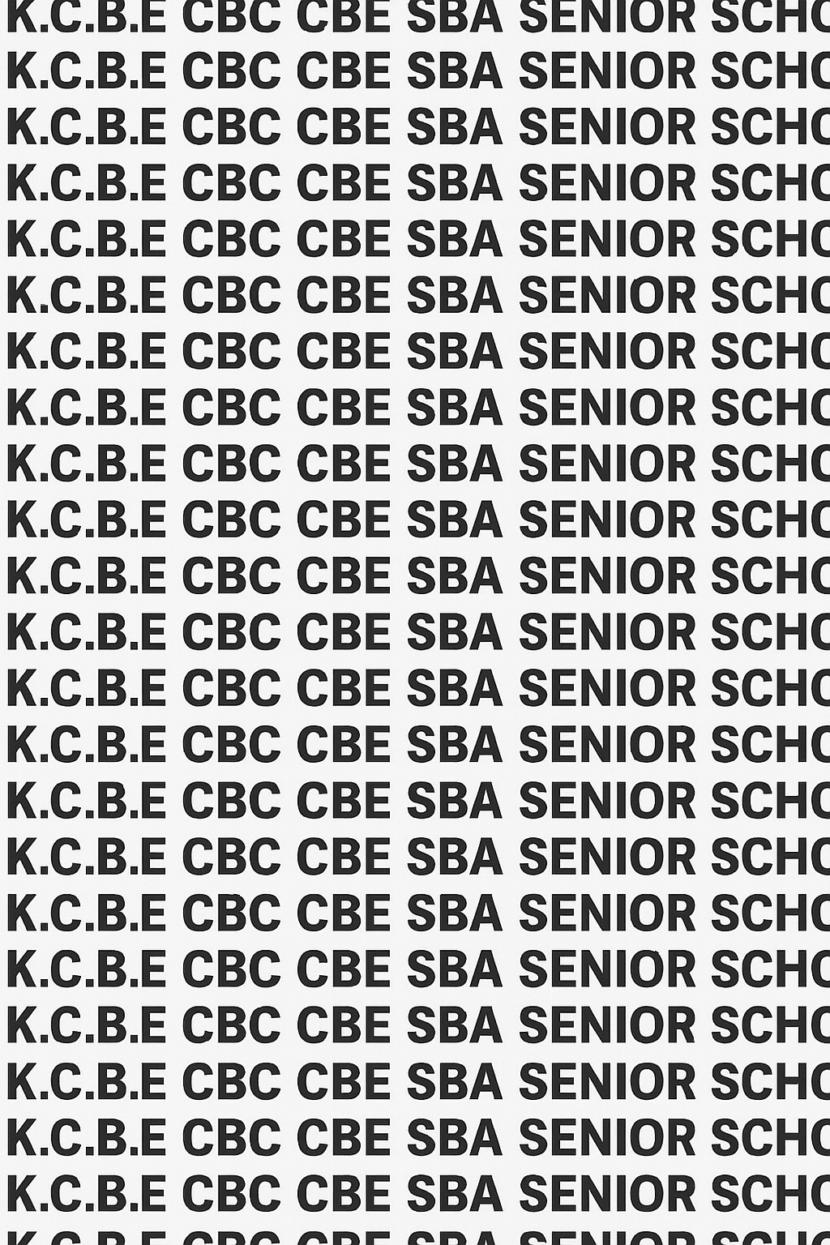
KENYA CERTIFICATE OF BASIC EDUCATION (K.C.B.E)
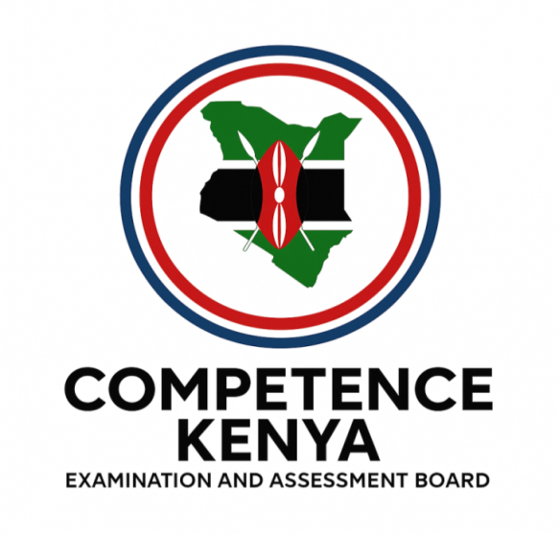
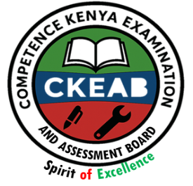


GRADE 10 METAL TECHNOLOGY (Theory) TERM 1 JANUARY 2026
Time: 1 Hour 30 Minutes
COMPETENCE ASSESSMENT EXAMINATION CKEAB 001

LEARNER’S DETAILS
Name: _______________________________________________________________________________________.
School: ______________________________________________________________________________________.
Assessment Number: ________________________________. Date: __________________________________.
School Code: _______________________________. Signature: ________________________________.

INSTRUCTIONS TO LEARNERS
- Write your name, School, assessment number, signature and date on all the answer sheets provided.
- Answer all the questions in the spaces provided.
- Read each question carefully before writing your answer.
- Ensure your answers are clear, neat, and well-organized.
- Check your work before submitting the exam.
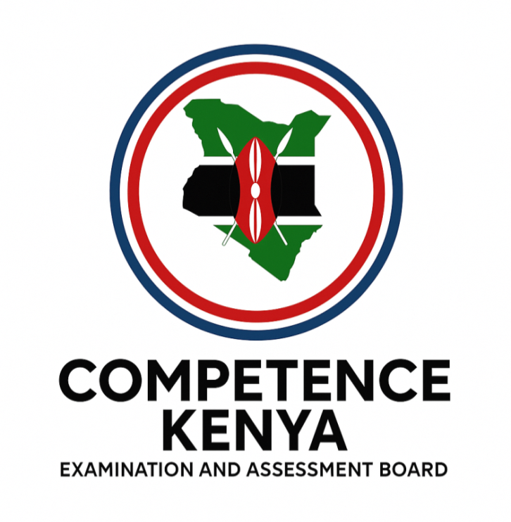
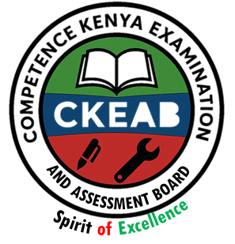
- Manage your time well to complete all questions.
-METAL TECHNOLOGY- -001- -Senior School-

Performance Levels Grid

Section |  | 1a |  | 1b |  | 1c |  | 2 |  | 3 | 4 |  | 5 |  | 6 | 7 |  | 8 |  | Section Total
Marks |  | 1 |  | 1 |  | 1 |  | 3 |  | 2 | 3 |  | 3 |  | 3 | 3 |  | 3 |  | 35
Score
Section | 9a |  | 9b |  | 9c |  | 9d |  | 10a |  |  | 10b |  | 10c |  |  | 10d |  | 11a(i) |  | 11a(ii) | 11b |  | 11c | 11d | 11e | 12a | 12b | 12c | 12d | 12e | Section Total
Marks | 8 |  | 8 |  | 6 |  | 3 |  | 8 |  |  | 8 |  | 6 |  |  | 3 |  | 2 |  | 2 | 8 |  | 6 | 3 | 2 | 3 | 8 | 6 | 6 | 2 | 75
Score
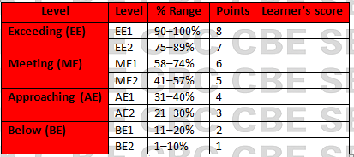
Section | Max Marks | Learner Score
A | 35
B | 75
TOTAL | 100

This paper has 7 printed pages. Please check out to ensure all pages are printed
Turn over
SECTION A: (35 Marks)
Answer all questions in this section.

1. The Metal Technology teacher at Bahati Senior School asks learners to define common terms used in the workshop before beginning practical lessons.
Define the following terms:
a) Material (1 mark)
____________________________________________________________________________________________________________________________________________________________________________________________________
b) Metal Technology (1 mark)
____________________________________________________________________________________________________________________________________________________________________________________________________
c) Machine (1 mark)

______________________________________________________________________________________________________________________________________________________________________________

2. During an orientation session at the school metal workshop, students are shown various personal protective equipment (PPE).
Give three examples of PPE used in a metal workshop. (3 marks)

_________________________________________________________________________________

_________________________________________________________________________________

_________________________________________________________________________________

3. While working at the vise bench, a student accidentally cuts himself with a hacksaw blade.
State two first aid procedures that should be applied immediately. (2 marks)

_________________________________________________________________________________

_________________________________________________________________________________

4. The principal encourages learners to consider skills that can support self-employment.
List three businesses related to Metal Technology. (3 marks)

_________________________________________________________________________________

_________________________________________________________________________________

_________________________________________________________________________________

5. A new workshop technician wants to label different zones of the workshop.
Identify three components of a metal workshop layout. (3 marks)

_________________________________________________________________________________

_________________________________________________________________________________

_________________________________________________________________________________

6. During a safety inspection, the teacher reminds the class of general workshop rules.
State three general workshop rules as outlined under the Occupational Safety and Health Act (OSHA). (3 marks)

_________________________________________________________________________________

_________________________________________________________________________________

_________________________________________________________________________________

7. A metal rod is being drilled using a drilling machine.
State three causes of accidents that may occur when using machines in a metal workshop. (3 marks)

_________________________________________________________________________________

_________________________________________________________________________________

_________________________________________________________________________________

8. A village elder asks students to explain the relevance of metalwork skills in society.
State three uses of metals in the community. (3 marks)

_________________________________________________________________________________

_________________________________________________________________________________

_________________________________________________________________________________

SECTION B (75 MARKS)
Answer Question 9 and ANY OTHER TWO questions.

9. Metal Workshop Safety and Accident Response
You have been appointed the Safety Prefect for the metal workshop at Tulip Senior School. After a series of minor accidents, the administration requires a safety audit report.

a) Explain four causes of accidents in a metal workshop. (8 marks)

_________________________________________________________________________________

_________________________________________________________________________________

_________________________________________________________________________________

_________________________________________________________________________________

b) Describe four first aid procedures you would apply to a student who suffers a deep cut from a sharp metal edge. (8 marks)

_________________________________________________________________________________

_________________________________________________________________________________

_________________________________________________________________________________

_________________________________________________________________________________

c) Explain three reasons why safety is important in a metal workshop. (6 marks)

_________________________________________________________________________________

_________________________________________________________________________________

_________________________________________________________________________________

d) Briefly explain one (1) responsibility of a workshop technician in ensuring safety. (3 marks)

_________________________________________________________________________________

_________________________________________________________________________________

_________________________________________________________________________________

10. Importance and Application of Metal Technology
A community vocational centre in your county has started a Metal Technology outreach program targeting youths.

a) Explain four reasons why studying Metal Technology is important to learners. (4 marks)

_________________________________________________________________________________

_________________________________________________________________________________

_________________________________________________________________________________

_________________________________________________________________________________

b) Name any four magnetic metals

_________________________________________________________________________________

_________________________________________________________________________________

_________________________________________________________________________________

_________________________________________________________________________________

b) Outline four career opportunities available in the field of Metal Technology. (8 marks)

_________________________________________________________________________________

_________________________________________________________________________________

_________________________________________________________________________________

_________________________________________________________________________________

c) Describe three ways in which metal products support daily activities in the community. (6 marks)

_________________________________________________________________________________

_________________________________________________________________________________

_________________________________________________________________________________

d) State three reasons why metals are preferred materials in construction and manufacturing. (3 marks)

_________________________________________________________________________________

_________________________________________________________________________________

_________________________________________________________________________________

11. The management of Kilele Technical School plans to renovate the metal workshop and has requested input from learners.

a) Differentiate between the following:
i) Tools and Machines (2 marks)

_________________________________________________________________________________

_________________________________________________________________________________
ii) Workshop and Store (2 marks)

_________________________________________________________________________________

_________________________________________________________________________________

b) Explain four factors that should be considered when designing a metal workshop layout. (8 marks)

_________________________________________________________________________________

_________________________________________________________________________________

_________________________________________________________________________________

_________________________________________________________________________________

c) During a certain metal practical lesson, Grade 10 learners observed the following tools.
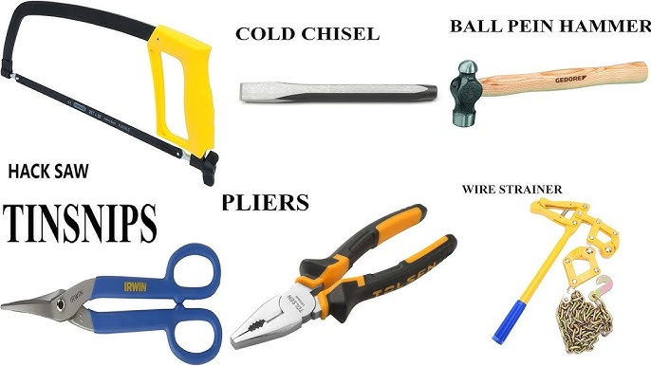





A B C


D E F

Name them. (6 marks)

A: _________________________ B: _________________________ C: __________________________

D: __________________________ E: ___________________________ F: ___________________________

d) The school plans to buy PPE. State three reasons why PPE is essential in a metal workshop. (3 marks)

_________________________________________________________________________________

_________________________________________________________________________________

_________________________________________________________________________________

e) Give two examples of measuring tools used in Metal Technology. (2 marks)

_________________________________________________________________________________

_________________________________________________________________________________

12. A local fabrication company invites Metal Technology students for an educational tour.

a) Define the term blacksmith and give two examples of metallic materials. (3 marks)

__________________________________________________________________________________________________________________________________________________________________

Metallic materials

_________________________________________________________________________________

_________________________________________________________________________________

b) Explain four properties that make metals suitable for use in fabrication. (8 marks)

_________________________________________________________________________________

_________________________________________________________________________________

_________________________________________________________________________________

_________________________________________________________________________________

c) Describe three differences between ferrous and non–ferrous metals. (6 marks)

_________________________________________________________________________________

_________________________________________________________________________________

_________________________________________________________________________________

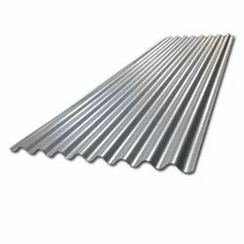


d) Soina observed the following items made of certain metals

M N O

Name the metal each is made of

M: _____________________________ N: ____________________________ O: __________________________

d) Explain three ways in which proper handling and storage of materials improves workshop safety. (3 marks)

_________________________________________________________________________________

_________________________________________________________________________________

_________________________________________________________________________________

e) State two economic benefits of metalworking businesses to the community. (2 marks)

_________________________________________________________________________________

_________________________________________________________________________________

©2026
All rights reserved
©COMPETENCE KENYA EXAMINATION AND ASSESSMENT BOARD
THIS IS THE LAST PRINTED PAGE

