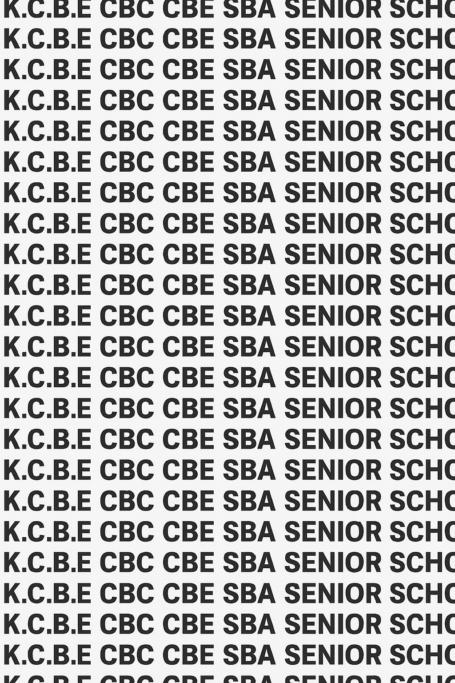
KENYA CERTIFICATE OF BASIC EDUCATION (K.C.B.E)
GRADE 10 PHYSICAL EDUCATION (Theory) TERM 1 JANUARY 2026
Time: 1 Hour 30 Minutes
COMPETENCE ASSESSMENT EXAMINATION CKEAB 001

LEARNER’S DETAILS
Name: _______________________________________________________________________________________.
School: ______________________________________________________________________________________.
Assessment Number: ________________________________. Date: __________________________________.
School Code: _______________________________. Signature: ________________________________.

INSTRUCTIONS TO LEARNERS
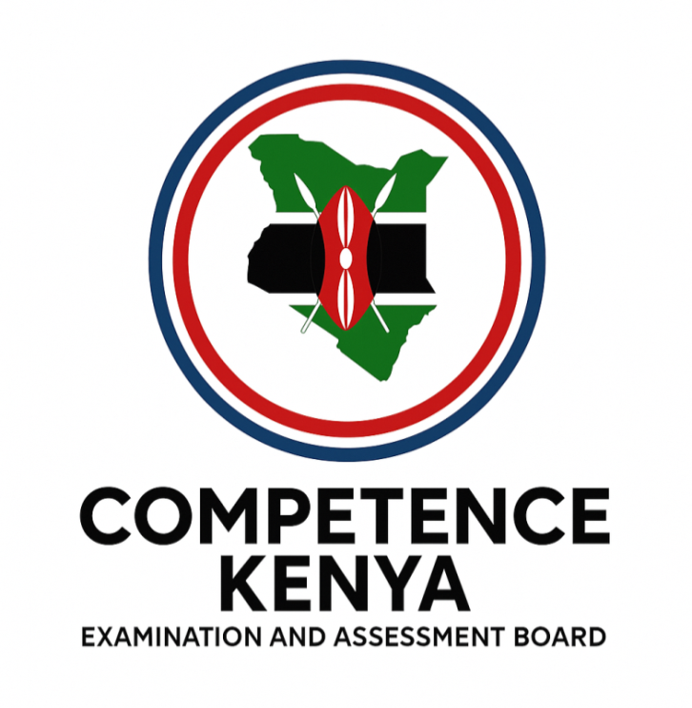
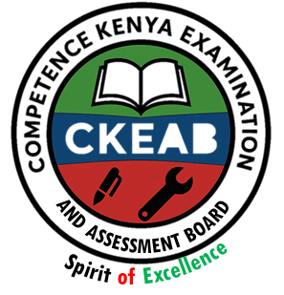
- Write your name, School, assessment number, signature and date on all the answer sheets provided.
- Answer all the questions in the spaces provided.
- Read each question carefully before writing your answer.

Performance Levels Grid
-PHYSICAL EDUCATION- -001- -Senior School-
Qn No. | 1 | 2 | 3 | 4 | 5 | 6 | 7 | 8 | 9 | 10 | TOTAL (40)
Marks | 4 | 4 | 4 | 4 | 4 | 4 | 4 | 4 | 4 | 4 | 40
Learner Score

Qn No. | 11 | 12 | 13 | 14 | 15 | 16 | 17 | TOTAL (60)
Marks | 12 | 12 | 12 | 12 | 12 | 12 | 12 | 60
Learner Score

Section | Max Marks | 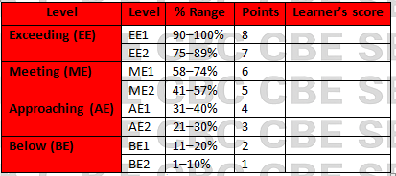  Learner Score
A | 40
B | 60
TOTAL | 100

This paper has 10 printed pages. Please check out to ensure all pages are printed
Turn over
SECTION A: (40 Marks)
Answer all questions in this section.

1. During a weekend inter-class tournament at Mwangaza Senior School, the football pitch was found to be uneven, with long grass covering some areas.

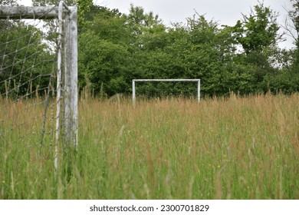

a) Identify two problems players may face when using such a facility. (2 marks)

i. __________________________________________________________________________________.

ii. __________________________________________________________________________________

b) State one way the sports committee can improve the pitch before the next match. (1 mark)

__________________________________________________________________________________.

__________________________________________________________________________________

2. In a football practice session, Coach Amani instructs players to perform a lofted pass.
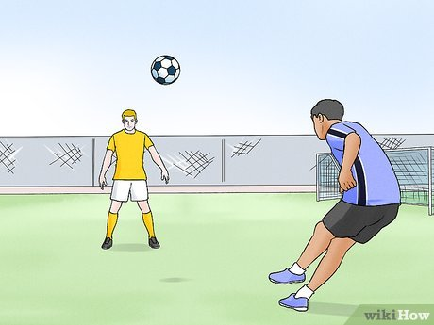

a) Define a lofted pass. (1 mark)

__________________________________________________________________________________.

__________________________________________________________________________________

b) Give two situations in a match where a lofted pass is appropriate. (2 marks)

i. __________________________________________________________________________________.

ii. __________________________________________________________________________________

3. During training, a student is correcting their stance, contact, and follow-through when kicking the ball.
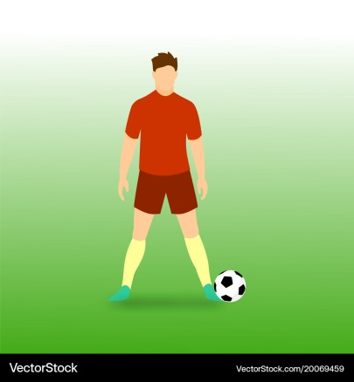

a) identify the football position activity. (1 mark)

i. __________________________________________________________________________________.

ii. __________________________________________________________________________________

b) Describe the correct contact point on the ball for a lofted pass. (1 mark)
__________________________________________________________________________________.

. __________________________________________________________________________________

c) Explain the importance of follow-through. (2 marks)

i. __________________________________________________________________________________.

ii. __________________________________________________________________________________

4. In a football match, a defender struggles to prevent an attacker from dribbling past him.
a) State two principles of effective marking. (2 marks)

i. __________________________________________________________________________________.

ii. __________________________________________________________________________________

b) Identify one dodging move commonly used by attackers. (1 mark)

__________________________________________________________________________________.

__________________________________________________________________________________

5. A goalkeeper at Sunrise High School is being trained to improve performance.
a) State one correct stance for a goalkeeper ready to receive a shot. (1 mark)

__________________________________________________________________________________.

b) Mention two skills a goalkeeper must master. (2 marks)

i. __________________________________________________________________________________.

ii. __________________________________________________________________________________

6. The netball court at Umoja School recently had new lines painted.
a) State two features of a standard netball court. (2 marks)

i. __________________________________________________________________________________.

ii. __________________________________________________________________________________

b) Name the position that is not allowed inside the goal circle. (1 mark)

i. __________________________________________________________________________________.

ii. __________________________________________________________________________________

7. During training, the coach demonstrates the flip pass used in netball.

a) Define the flip pass. (1 mark)

__________________________________________________________________________________.

__________________________________________________________________________________

b) State the correct stance for performing a flip pass. (1 mark)

__________________________________________________________________________________.

__________________________________________________________________________________

c) State two situations where the flip pass is effective. (2 marks)

i. __________________________________________________________________________________.

ii. __________________________________________________________________________________

8. A player attempts a side pass but keeps releasing the ball too early, making it inaccurate.
a) State the correct contact and release technique. (2 marks)

__________________________________________________________________________________.

__________________________________________________________________________________

b) State one factor that determines accuracy in a side pass. (1 mark). __________________________________________________________________________________.

__________________________________________________________________________________

9. During a netball match, a player steps while holding the ball.
a) Identify the rule broken. (1 mark)

__________________________________________________________________________________.

b) State the penalty awarded for this offence. (1 mark)

__________________________________________________________________________________.

__________________________________________________________________________________

c) Which team gets possession? (1 mark)

__________________________________________________________________________________.

__________________________________________________________________________________

10. Give three safety precautions that should be taken when using sports equipment and facilities. (3 marks)

SECTION B (60 MARKS)
Answer ANY FIVE questions.

11. During a friendly match, the midfielders at Akili Secondary School struggled to bypass a compact defence. The coach instructed them to use lofted passes.
a) Explain four key teaching points for executing an accurate lofted pass. (4 marks)

i. __________________________________________________________________________________.

ii. __________________________________________________________________________________

iii. __________________________________________________________________________________.

iv. __________________________________________________________________________________
b) Describe three game situations where a lofted pass is the best option. (3 marks)

i. __________________________________________________________________________________.

ii. __________________________________________________________________________________

iii. __________________________________________________________________________________.
c) Explain three common errors players make when attempting a lofted pass. (3 marks)
i. __________________________________________________________________________________.

ii. __________________________________________________________________________________

iii. __________________________________________________________________________________.
d) State two dangers of overusing lofted passes in a match. (2 marks)

i. __________________________________________________________________________________.

ii. __________________________________________________________________________________

12. During a county tournament, Lanet High School defenders were constantly beaten by fast attackers.
a) Describe three types of marking used in football. (3 marks)

i. __________________________________________________________________________________.

ii. __________________________________________________________________________________

iii. __________________________________________________________________________________.
b) Explain three defensive principles that help prevent attackers from dodging. (3 marks)

i. __________________________________________________________________________________.

ii. __________________________________________________________________________________

iii. __________________________________________________________________________________.
c) Describe three dodging techniques attackers use to beat defenders. (3 marks)

i. __________________________________________________________________________________.

ii. __________________________________________________________________________________

iii. __________________________________________________________________________________.
d) Suggest three training drills that would help improve a defender’s marking ability. (3 marks)

i. __________________________________________________________________________________.

ii. __________________________________________________________________________________

iii. __________________________________________________________________________________.

13. In a school-level semi-final, the goalkeeper made several mistakes leading to goals.

a) Describe four key responsibilities of a goalkeeper during a match. (4 marks)
i. __________________________________________________________________________________.

ii. __________________________________________________________________________________

iii. __________________________________________________________________________________.

iv. __________________________________________________________________________________.

b) Outline four fundamentals of proper goalkeeping technique (stance, footwork, handling, and communication). (4 marks)
i. __________________________________________________________________________________.

ii. __________________________________________________________________________________

iii. __________________________________________________________________________________.

iv. __________________________________________________________________________________.
c) Explain four common causes of goalkeeping errors in school-level matches. (4 marks)

i. __________________________________________________________________________________.

ii. __________________________________________________________________________________

iii. __________________________________________________________________________________.

iv. __________________________________________________________________________________.

14. During training, a coach at Tabasamu Girls demonstrates the flip pass and side pass.
a) Compare the flip pass and the side pass under:
 | Flip pass | Side pass
i. stance (2 marks)
ii. grip (2 marks)
iii. release (2 marks)
b) Explain three factors that ensure accuracy in both passes. (3 marks)

i. __________________________________________________________________________________.

ii. __________________________________________________________________________________

iii. __________________________________________________________________________________.

iv. __________________________________________________________________________________.
c) Give three common mistakes players make when performing these passes. (3 marks)

i. __________________________________________________________________________________.

ii. __________________________________________________________________________________

iii. __________________________________________________________________________________.

15. During an inter-school match, several fouls were committed.
a) Explain four footwork rule violations in netball. (4 marks)

i. __________________________________________________________________________________.

ii. __________________________________________________________________________________

iii. __________________________________________________________________________________.

iv. __________________________________________________________________________________.
b) Describe four contact fouls and their penalties. (4 marks)

i. __________________________________________________________________________________.

ii. __________________________________________________________________________________

iii. __________________________________________________________________________________.

iv. __________________________________________________________________________________.
c) Give four scenarios where the umpire awards a free pass or penalty pass. (4 marks)

i. __________________________________________________________________________________.

ii. __________________________________________________________________________________

iii. __________________________________________________________________________________.

iv. __________________________________________________________________________________.

16. Your school plans to upgrade its sports facilities.
a) Describe three essential features of a standard football pitch. (3 marks)

i. __________________________________________________________________________________.

ii. __________________________________________________________________________________

iii. __________________________________________________________________________________.

b) Describe three essential features of a standard netball court. (3 marks)

i. __________________________________________________________________________________.

ii. __________________________________________________________________________________

iii. __________________________________________________________________________________.

c) Explain three characteristics of safe sports equipment for school use. (3 marks)

i. __________________________________________________________________________________.

ii. __________________________________________________________________________________

iii. __________________________________________________________________________________.
d) Suggest three maintenance practices for sports facilities. (3 marks)

i. __________________________________________________________________________________.

ii. __________________________________________________________________________________

iii. __________________________________________________________________________________.

17. Your school is hosting a combined football and netball tournament.
a) Explain three ways proper warm-up prevents injuries in both sports. (3 marks)

i. __________________________________________________________________________________.

ii. __________________________________________________________________________________

iii. __________________________________________________________________________________.
b) Explain three reasons correct stance is important in football and netball skills execution. (3 marks)

i. __________________________________________________________________________________.

ii. __________________________________________________________________________________

iii. __________________________________________________________________________________.
c) Describe three similarities in follow-through technique in football kicking and netball passing. (3 marks)

i. __________________________________________________________________________________.

ii. __________________________________________________________________________________

iii. __________________________________________________________________________________.
d) Suggest three ways poor facilities negatively affect performance in both sports. (3 marks)

i. __________________________________________________________________________________.

ii. __________________________________________________________________________________

iii. __________________________________________________________________________________.
Bottom of Form

©2026
All rights reserved
©COMPETENCE KENYA EXAMINATION AND ASSESSMENT BOARD
THIS IS THE LAST PRINTED PAGE

