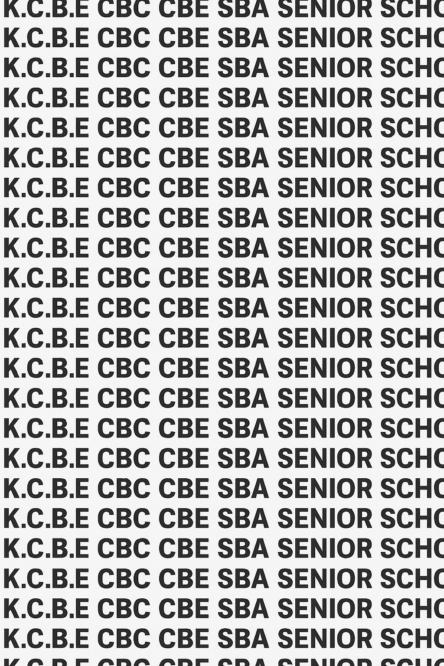


KENYA CERTIFICATE OF BASIC EDUCATION (K.C.B.E)
GRADE 10 PHYSICS (Theory) TERM 1 JANUARY 2026
Time: 2 Hours
COMPETENCY BASED EDUCATION CKEAB 001

LEARNER’S DETAILS
Name: _______________________________________________________________________________________.
School: ______________________________________________________________________________________.
Assessment Number: ________________________________. Date: __________________________________.
School Code: _______________________________. Signature: ________________________________.

INSTRUCTIONS TO LEARNERS
- Write your name, School, assessment number, signature and date on all the answer sheets provided.
- Answer all the questions in the spaces provided.
- Read each question carefully before writing your answer.
- Ensure your answers are clear, neat, and well-organized.
- Check your work before submitting the exam.
- Manage your time well to complete all questions.
-PHYSICS- -001- -Senior School-

Performance Levels Grid
Section | 1a | 1b(i) | 1b(ii) | 2i | 2ii | 2iii | 2iv | 3a | 3b | 3c | 3d | 4i | 4ii | 4iii | 5a | 5b | 5c | 6a(i) | 6a(ii) | 6b | 6b | 7a | 7b | 7c | 7d | 8a | 8b | 8c | Section Total
Marks | 1 | 1 | 1 | 4 | 4 | 4 | 4 | 1 | 1 | 1 | 1 | 1 | 1 | 1 | 1 | 2 | 1 | 1 | 1 | 2 | 2 | 1 | 2 | 2 | 2 | 3 | 3 | 3 | 40
Score

Section | 9a |  | 9b | 9ci | 9cii |  | 9di | 9dii | 9diii |  | 10a | 10b | 10ci | 10cii | 10c | 10di | 10dii | 10e1 | 10e2 | 10f | 10g | Section Total
Marks | 2 |  | 6 | 3 | 3 |  | 2 | 2 | 2 |  | 2 | 2 | 2 | 2 | 2 | 2 | 2 | 2 | 2 | 2 | 2 | 60
Score
Section |  | Max Marks |  |  |  | 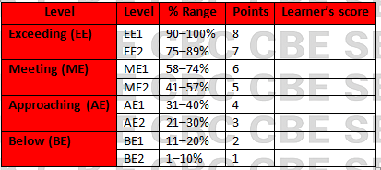  Learner Score
A |  | 40
B |  | 60
TOTAL |  | 100

This paper has 9 printed pages. Please check out to ensure all pages are printed
Turn over
SECTION A: (40 Marks)
Answer all questions in this section.

1. While demonstrating a science experiment during a school open day, a visitor asks “What exactly is Physics and why do you study it?”
a) Define Physics. (1 mark)

__________________________________________________________________________________________________

__________________________________________________________________________________________________

b) State two reasons why Physics is important in society. (2 marks)

____________________________________________________________________________________________

____________________________________________________________________________________________

2. A student found the following table in an old physics textbook but the branches were mixed up. Match the branches in List A with the correct description in List B. Write the correct letter in the space provided. (4 marks)
List A: Branch of Physics | List B: Description
i. Mechanics | A. Study of heat and temperature
ii. Thermodynamics | B. Study of motion of bodies
iii. Optics | C. Study of sound and its properties
iv. Acoustics | D. Study of light
3. A team of experts is designing a new hospital theatre.
Explain how Physics relates to each of the following fields:
a) Biology (1 mark)
__________________________________________________________________________________________________
_________________________________________________________________________________________________
b) Medicine (1 mark)
__________________________________________________________________________________________________
_________________________________________________________________________________________________
c) Engineering (1 mark)
__________________________________________________________________________________________________
_________________________________________________________________________________________________
d) Agriculture (1 mark)
__________________________________________________________________________________________________
_________________________________________________________________________________________________

4. A Career Day is organised in your school. Mention three career opportunities directly related to Physics that a visiting speaker may talk about. (3 marks)
- ____________________________________________________________________________________________
- ____________________________________________________________________________________________
- ____________________________________________________________________________________________

5. A cook presses a sharp knife and a blunt knife on a tomato. The sharp one cuts easily while the blunt one does not.
a) Define pressure (1 mark)
__________________________________________________________________________________________________
_________________________________________________________________________________________________

b) Explain why the sharp knife cuts more easily. (2 marks)
__________________________________________________________________________________________________
_________________________________________________________________________________________________

c) State the SI unit of pressure. (1 mark)
__________________________________________________________________________________________________
_________________________________________________________________________________________________

6. A diver descends deeper into the ocean and notices his ears feel more pressure.
a) State two factors that affect pressure in liquids. (2 marks)
- ____________________________________________________________________________________________
- ____________________________________________________________________________________________

b) Explain why the diver feels more pressure as he goes deeper. (2 marks)
__________________________________________________________________________________________________
_________________________________________________________________________________________________

7. A soft plastic bottle is sealed tightly at the top of Mount Kenya and later opened at sea level. The bottle collapses inward immediately.
a) Define atmospheric pressure. (1 mark)
__________________________________________________________________________________________________
_________________________________________________________________________________________________

b) Explain why the bottle collapses at sea level. (2 marks)
__________________________________________________________________________________________________
_________________________________________________________________________________________________

c) The bicycle pump shown in Figure 7 below is one of the applications of pressure in gases.
﻿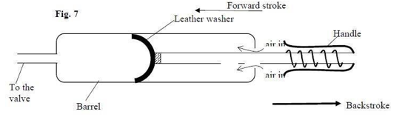
Explain how the pump operates during backstroke. (2mks)
__________________________________________________________________________________________________
_________________________________________________________________________________________________
__________________________________________________________________________________________________
_________________________________________________________________________________________________

d) The sketch graph below shows the relationship between pressure and temperature of a gas in a fixed volume container.

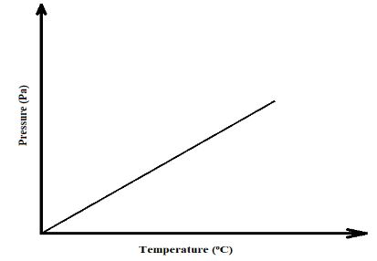

State the relationship between pressure and temperature that can be deduced from the graph (1 Mark)
__________________________________________________________________________________________________
_________________________________________________________________________________________________

8. a) A rectangular block of mass 8 kg rests on a table. Its base area is 0.02 m².
Calculate the pressure it exerts on the table. (3 marks)

b) A liquid of density 1000 kg/m³ is filled in a tank to a depth of 5 m.
Calculate the pressure at the bottom of the tank using P = ρgh.
(Take g = 9.8 m/s²). (3 marks)

c) Given that density of water = 1000Kgm⁻³, density of kerosene = 800Kgm-3 and atmospheric pressure = 1.03x10⁵ pascals, determine the pressure acting on the base of the container

SECTION B (60 MARKS)
Answer all questions from this section.

9. A new borehole water supply system is being installed in a village dispensary. The technician uses devices that rely on transmission of pressure in fluids.
a) State Pascal's Principle. (2 marks)
__________________________________________________________________________________________________
_________________________________________________________________________________________________
b) Using a labelled diagram, explain how a hydraulic lift works in raising a car in a garage. (6 marks)
__________________________________________________________________________________________________
_________________________________________________________________________________________________
__________________________________________________________________________________________________
_________________________________________________________________________________________________
c) A hydraulic lift has a small piston of area 0.01 m² and a large piston of area 0.5 m².
If a force of 40 N is applied on the small piston:
i) Calculate the pressure transmitted through the fluid. (3 marks)

ii) Calculate the force exerted on the large piston. (3 marks)

d) Explain how each of the following devices uses pressure differences in fluids:
i) A drinking straw (2 marks)
__________________________________________________________________________________________________
_________________________________________________________________________________________________
ii) A bicycle pump (2 marks)
__________________________________________________________________________________________________
_________________________________________________________________________________________________
iii) A syringe (2 marks)
__________________________________________________________________________________________________
_________________________________________________________________________________________________

10. A science club is testing the use of a syphon to transfer water from an upper tank to a lower tank without using electricity.
a) A syphon tube is used to drain water from a dam. If the height difference between the dam water level and the outlet is 2.5 m, calculate the pressure difference using P = ρgh.
(Take ρ = 1000 kg/m³, g = 9.8 m/s²). (2 marks)

b) A tractor tyre has an internal surface area of 0.8 m². The pressure inside is 2.5 × 10⁵ Pa.
Calculate the force the air exerts on the tyre walls. (2 marks)

c) Explain the working principle of each:
i) Hydraulic brake system in a car (2 marks)
__________________________________________________________________________________________________
_________________________________________________________________________________________________
__________________________________________________________________________________________________
_________________________________________________________________________________________________
c) A fish tank at a pet shop is 0.6 m deep. The shop owner places sensors to detect pressure at different levels.
Explain why pressure in liquids increases with depth. (2 marks)
__________________________________________________________________________________________________
_________________________________________________________________________________________________
__________________________________________________________________________________________________
_________________________________________________________________________________________________
d) Water of density 1000 kg/m³ fills the tank.
i) Calculate the pressure at a depth of 0.2 m. (2 marks)

ii) Calculate the pressure at the bottom of the tank. (2 marks)

e) Explain the effect of increasing each of the following on the pressure at the bottom of the tank:
i) Density of the liquid (2 marks)
__________________________________________________________________________________________________
_________________________________________________________________________________________________
__________________________________________________________________________________________________
ii) Depth of the liquid (2 marks)
__________________________________________________________________________________________________
_________________________________________________________________________________________________
__________________________________________________________________________________________________
f) The tank has a base area of 0.3 m².
Calculate the total force exerted on the base by the water at full capacity. (2 marks)

g) Explain why deep-sea animals require stronger body structures compared to surface animals. (2 marks)

©2026
All rights reserved
©COMPETENCE KENYA EXAMINATION AND ASSESSMENT BOARD
THIS IS THE LAST PRINTED PAGE

