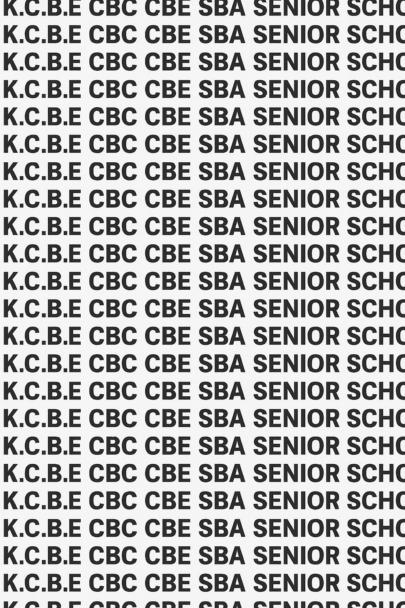
KENYA CERTIFICATE OF BASIC EDUCATION (K.C.B.E)

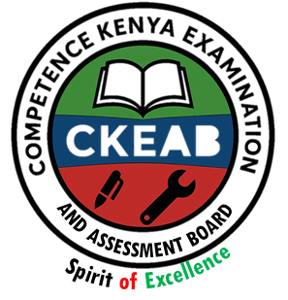
GRADE 10 POWER MECHANICS (Theory) TERM 1 JANUARY 2026
Time: 1 Hour 30 Minutes
COMPETENCY BASED EDUCATION CKEAB 001

LEARNER’S DETAILS
Name: _______________________________________________________________________________________.
School: ______________________________________________________________________________________.
Assessment Number: ________________________________. Date: __________________________________.
School Code: _______________________________. Signature: ________________________________.

INSTRUCTIONS TO LEARNERS
- Answer all questions in both Section A and Section B.
- Write your answers clearly in the spaces provided.
- Use diagrams where necessary.
- Ensure you observe safety and cleanliness during practical-related discussions.

SECTION A: (30 Marks)
-POWER MECHANICS- -001- -Senior School-
Question | Q1 | Q2 | Q3 | Q4 | Q5 | Q6 | Q7 | Q8 | Q9 | Q10 | TOTAL (30)
Maximum score | 4 | 4 | 3 | 4 | 3 | 3 | 2 | 3 |  |  | 30
Learners score

SECTION B: (40 Marks)
Question | Q11 | Q12 | Q13 | Q14 | TOTAL (40) | GRAND TOTAL
Maximum score | 10 | 8 | 12 | 10 | 40 | 70
Learners score

Performance Levels Grid
Level | Level | % Range | Points | Learner’s score | Remarks
Exceeding (EE) | EE1 | 90–100% | 8 |  | Exceptional mastery; exceeds expectations
 | EE2 | 75–89% | 7 |  | Very strong performance
Meeting (ME) | ME1 | 58–74% | 6 |  | Solid understanding
 | ME2 | 41–57% | 5 |  | Partial achievement
Approaching (AE) | AE1 | 31–40% | 4 |  | Limited achievement
 | AE2 | 21–30% | 3 |  | Very limited
Below (BE) | BE1 | 11–20% | 2 |  | Poor performance
 | BE2 | 1–10% | 1 |  | Extremely weak
This paper has 6 printed pages. Please check out to ensure all pages are printed
Turn over
SECTION A: (30 Marks)
Answer all questions in this section.

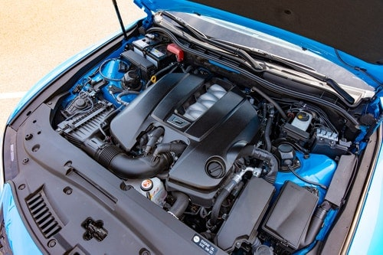
1. During a lesson on machines that produce power, the teacher displayed the picture below showing a vehicle engine.

He then asked the learners to:-
(a) Define Power Mechanics. (2 marks) ______________________________________________________________________________________________________________________________________________________________________________________________________
(b) Identify two main systems studied under power mechanics. (2 marks)
- _____________________________________________________________________________________________
- _____________________________________________________________________________________________

c) Agnes was asked to identify the first persons credited as founders of automobile. (1 mark)
_____________________________________________________________________________________________
- Mention two Power Sources for automobiles: (3 marks)
- _____________________________________________________________________________________________
- _____________________________________________________________________________________________
- _____________________________________________________________________________________________

2. In a discussion about daily life applications, a learner mentioned that generators and motorcycles are both products of power mechanics.
Explain two ways in which power mechanics is important in everyday life. 2 marks)
- _____________________________________________________________________________________________
- _____________________________________________________________________________________________

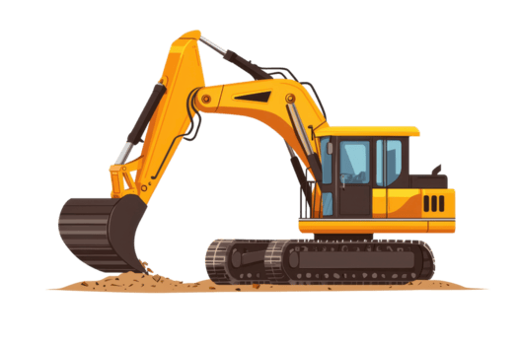
3. The image below shows a hydraulic excavator used in road construction.

(a) Name the type of system used to control the movement of the arm. (1 mark)
__________________________________________________________________________________________________
(b) Explain how this system operates. (2 marks)
_____________________________________________________________________________________________
_____________________________________________________________________________________________

4. A learner visited a local garage and observed different sections in the workshop.
(a) List three main areas found in a power mechanics workshop. (3 marks)
- _____________________________________________________________________________________________
- _____________________________________________________________________________________________
- _____________________________________________________________________________________________
(b) State one importance of organizing a workshop layout properly. (1 mark)

______________________________________________________________________________________________________________________________________________________________________________________________________

5. A guest mechanic visited the school and described his role in repairing tractors and harvesters.
(a) Identify two careers related to power mechanics. (2 marks)
- _____________________________________________________________________________________________
- _____________________________________________________________________________________________
(b) State one skill required for success in any of these careers. (1 mark)
_____________________________________________________________________________________________
_____________________________________________________________________________________________

6. During a safety training session, learners were shown the following workshop signs:
(a) Match each sign with its meaning: (3 marks)
Sign | Meaning
  (i) | (i) No Smoking Sign
  (ii) | ii) Wear Safety Goggles Sign
  (iii) | (iii) High Voltage Sign
(b) Name two types of Personal Protective Equipment (PPE) used in a workshop. (2 marks)
- _____________________________________________________________________________________________
- _____________________________________________________________________________________________

7. A learner said,

“Power mechanics helps in national development.”
Give two ways in which power mechanics contributes to a country’s economic growth. (2 marks)
- _____________________________________________________________________________________________
- _____________________________________________________________________________________________

8. During a field visit, learners observed a mechanic using a jack to lift a car.
(a) State one precaution that must be taken before working under a vehicle. (1 mark)
_____________________________________________________________________________________________
_____________________________________________________________________________________________
(b) Explain why this precaution is important. (2 marks)
- _____________________________________________________________________________________________
- _____________________________________________________________________________________________

SECTION B: (40 Marks)
Answer all questions in this section.

9. The teacher showed a series of images representing the development of the automobile over time.
(a) Explain four major stages in the evolution of the automobile. (8 marks)
- _____________________________________________________________________________________________
- _____________________________________________________________________________________________
- _____________________________________________________________________________________________
- ____________________________________________________________________________________________
(b) Describe two ways innovation has improved modern vehicles. (2 marks)
- _____________________________________________________________________________________________
- _____________________________________________________________________________________________

10. A learner was asked to design a Power Mechanics Workshop Layout for a small local garage.
(a) Explain three benefits of having an organized workshop layout. (3 marks)
- _____________________________________________________________________________________________
- _____________________________________________________________________________________________
- _____________________________________________________________________________________________

(b) Sketch and label a simple layout of a power mechanics workshop, showing at least five main sections. (5 marks)

(c) State two safety features that should be included in a workshop. (2 marks)
- _____________________________________________________________________________________________
- _____________________________________________________________________________________________

11. A team of learners visited two local workshops — one for vehicle repair and another for farm machinery.
(a) Compare three differences between an automotive workshop and an agricultural machinery workshop. (6 marks)
 | Automotive workshop | Agricultural machinery workshop
i
ii
iii
(b) Explain two ways that technology has changed the work of modern mechanics. (4 marks)
- _____________________________________________________________________________________________
- _____________________________________________________________________________________________

12. A mechanic ignored workshop safety rules and got injured while welding a metal frame.
(a) Explain four general safety rules that could have prevented this accident. (8 marks)
- _____________________________________________________________________________________________
- _____________________________________________________________________________________________
- _____________________________________________________________________________________________
- _____________________________________________________________________________________________
(b) Describe two types of PPE that should be used when welding. (2 marks)
- _____________________________________________________________________________________________
- _____________________________________________________________________________________________

©2026
ALL RIGHTS RESERVED
COMPETENCE KENYA EXAMINATIONS AND ASSESSMENT BOARD
This is the last printed page

