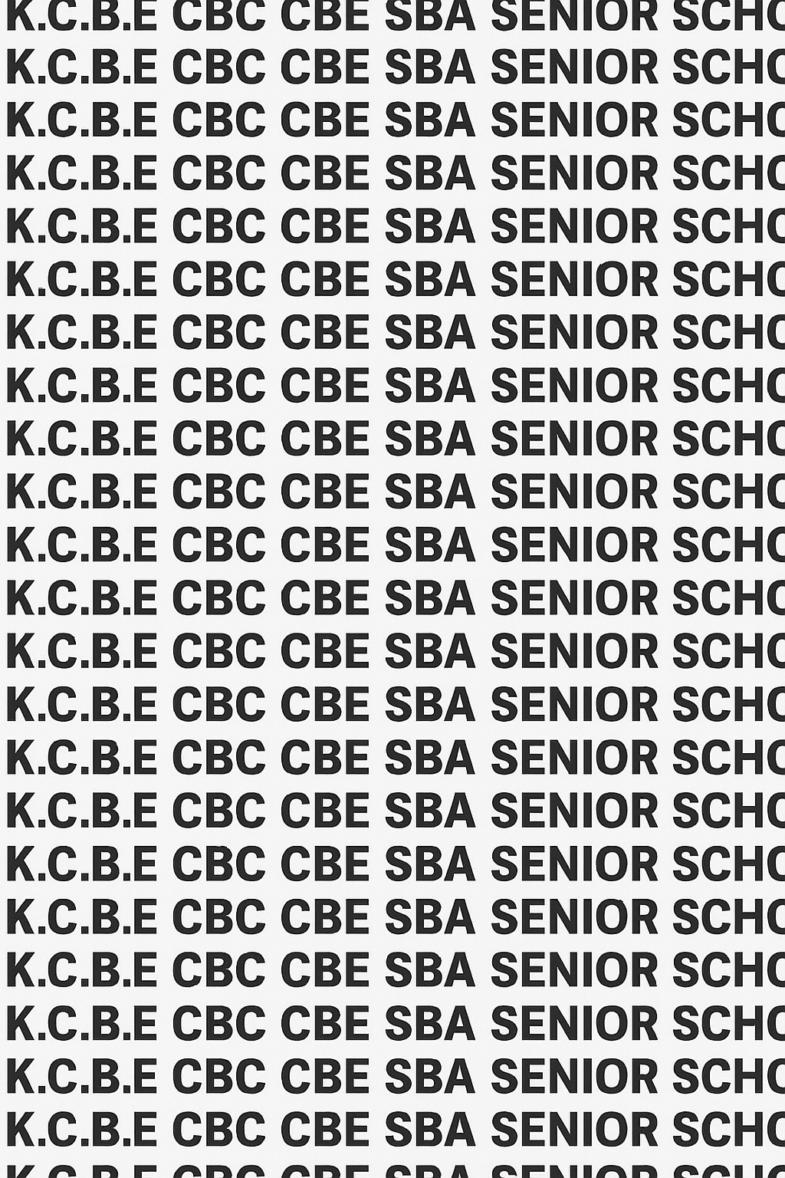
KENYA CERTIFICATE OF BASIC EDUCATION (K.C.B.E)


GRADE 10 SPORTS AND RECREATION (Theory) TERM 1 JANUARY 2026
Time: 1 Hour 30 Minutes
COMPETENCY BASED EDUCATION CKEAB 001

LEARNER’S DETAILS
Name: _______________________________________________________________________________________.
School: ______________________________________________________________________________________.
Assessment Number: ________________________________. Date: __________________________________.
School Code: _______________________________. Signature: ________________________________.

INSTRUCTIONS TO LEARNERS
- Write your name, School, assessment number, signature and date on all the answer sheets provided.
- Answer all the questions in the spaces provided.
- Read each question carefully before writing your answer.
- Check your work before submitting the exam.

Performance Levels Grid
-SPORTS AND RECREATION- -001- -Senior School-
Section | Q1a | Q1b | Q1c | Q1d | Q2a | Q2b | Q2c | Q3a | Q3b | Q4a | Q4b | Q5a | Q5b | Q6 | Q7a | Q7b | Q8 | TOTAL (40)
Marks Allocation | 1 | 1 | 1 | 2 | 2 | 2 | 2 | 2 | 2 | 2 | 2 | 1 | 2 | 3 | 1 | 2 | 3 | 40
Learner’s Score

Section | Q9 | Q10 |  | Q11 | Q12 | Q13 |  | TOTAL (60)
Marks Allocation | 14 | 13 |  | 9 | 10 | 14 |  | 60
Learner’s Score
Section | Max Marks |  | 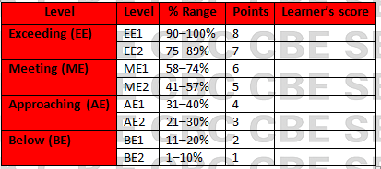  Learner Score
A | 40
B | 60
TOTAL | 100

This paper has 8 printed pages. Please check out to ensure all pages are printed
Turn over
SECTION A: (40 Marks)
Answer all questions in this section.

1. (a) A Sports Club in your school has introduced a morning stretching routine. Learners are shown an image of a student holding a deep stretch without movement.
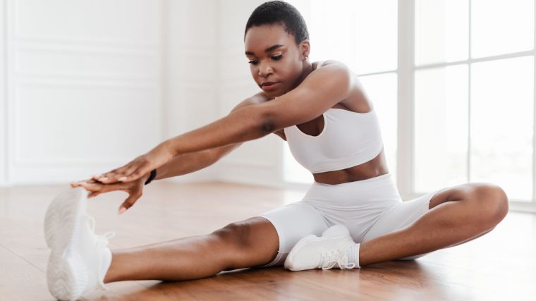
i. Identify the type of stretch being demonstrated. (1 mark)
_______________________________________________________________
ii. Give one characteristic of this type of stretch. (1 mark)

____________________________________________________________________________________________________________________________________________________________________________________________________

(b) The instructor later demonstrates a leg-swing warm-up where the leg moves forward and backward continuously.
i. Identify this type of stretch. (1 mark)
________________________________________________________________________________________
ii. State two advantages of this type of stretching before physical activity. (2 marks)

____________________________________________________________________________________________________________________________________________________________________________________________________

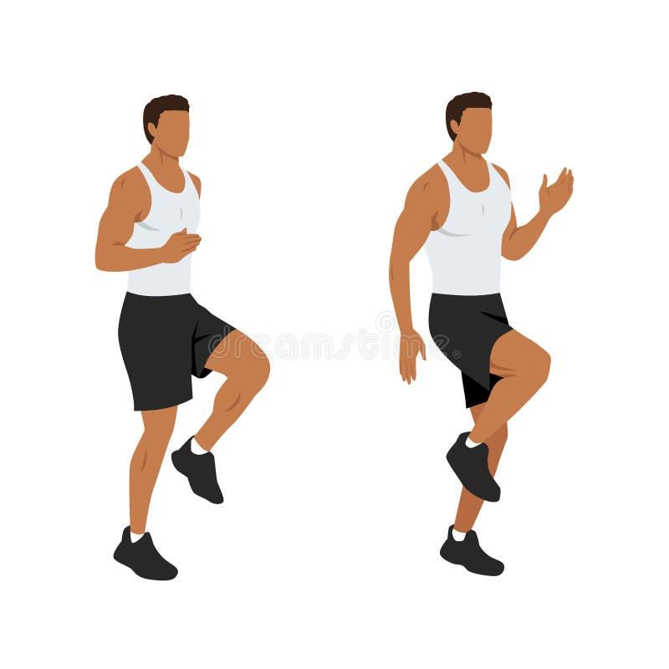
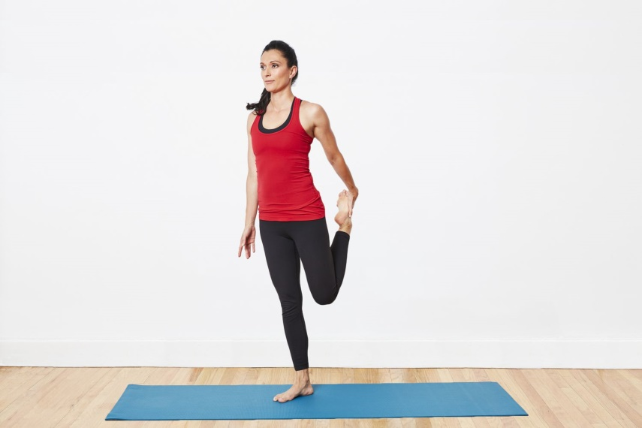
2. During a PE lesson, Grade 10 learners are shown two images:

A B

Using the images, compare static and dynamic stretches under the following: (6 marks)
 | Static stretch | Dynamic stretch
(a) Movement
(b) Purpose
(c) Best time to perform

3. Your school’s athletics trainer emphasizes the importance of form while stretching and exercising.
(a) Define form as used in physical fitness. (2 marks)
____________________________________________________________________________________________________________________________________________________________________________________________________
(b) Explain why good form is important when performing exercises. (2 marks)
____________________________________________________________________________________________________________________________________________________________________________________________________

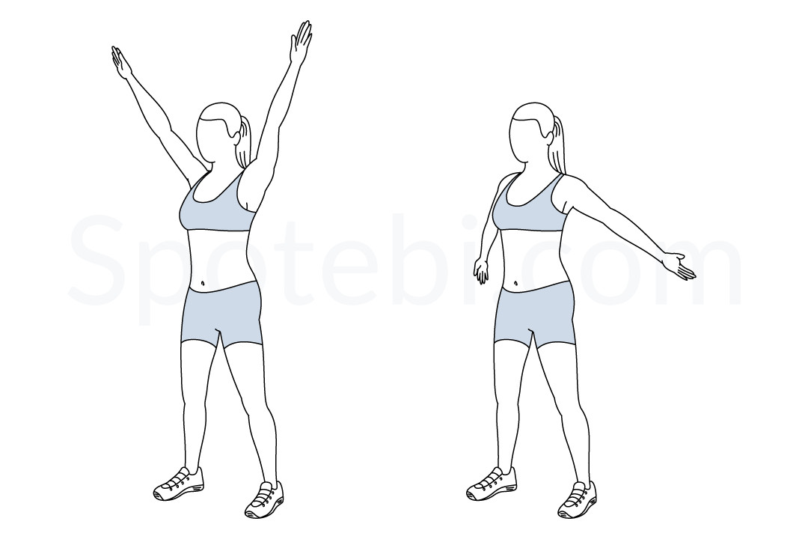
4. An image shows a learner performing a full-range arm circle.

(a) Define Range of Motion (ROM). (2 marks) ____________________________________________________________________________________________________________________________________________________________________________________________________
(b) State two factors that affect ROM in the human body. (2 marks)
- ____________________________________________________________________________________________
- ____________________________________________________________________________________________

5. A coach observes that one learner struggles to coordinate movements smoothly during warm-up drills.
(a) Identify the physical fitness component the learner is lacking. (1 mark) __________________________________________________________________________________________________
(b) Give two ways the learner can improve this component. (2 marks)
- ____________________________________________________________________________________________
- ____________________________________________________________________________________________

6. Explain fluid movement in the context of sports performance. (3 marks)
______________________________________________________________________________________________________________________________________________________________________________________________________________________________________________________________________________________________________

7. Define the following terms:
(a) Flexibility (2 marks) ____________________________________________________________________________________________________________________________________________________________________________________________________
(b) Muscular Strength (2 marks) ____________________________________________________________________________________________________________________________________________________________________________________________________
(c) Muscular Endurance (2 marks) ____________________________________________________________________________________________________________________________________________________________________________________________________

SECTION B (60 MARKS)
Answer ALL questions

8. During preparations for inter-class competitions, the games captain designs a workout plan for the athletics team. The plan includes stretching, strength training, and endurance running.
(a) Explain three reasons why flexibility is important in sports performance. (6 marks)
- ____________________________________________________________________________________________
- ____________________________________________________________________________________________
- ____________________________________________________________________________________________
(b) Describe how dynamic stretching contributes to injury prevention. (4 marks)
________________________________________________________________________________________________________________________________________________________________________________________________________________________________________________________________________________________________________________________________________________________________________________________________________

9. Learners in Grade 10 are divided into groups to analyze an image showing a person performing a plank exercise.
(a) Identify the type of muscular fitness demonstrated. (2 marks)
______________________________________________________________________________________________
(b) Explain three differences between muscular strength and muscular endurance. (6 marks)
 | Muscular strength | Muscular endurance
i
ii
iii
(c) State three benefits of developing muscular endurance for a student athlete. (6 marks)
- ____________________________________________________________________________________________
- ____________________________________________________________________________________________
- ____________________________________________________________________________________________

10. You are the team leader of a football training session. Some players perform stretches improperly, compromising form and balance.
(a) Explain the term balance in the context of physical fitness. (3 marks)
_____________________________________________________________________________________________________________________________________________________________________________________________________________________________________________________________________________________________________
(b) Discuss two reasons why balance is essential in sports movements. (4 marks)
- ____________________________________________________________________________________________
- ____________________________________________________________________________________________
(c) Describe three consequences of poor form during exercise. (6 marks)
- ____________________________________________________________________________________________
- ____________________________________________________________________________________________
- ____________________________________________________________________________________________

11. During a fitness evaluation, a learner completes the following tasks:
- Holds a wall sit for 90 seconds.
- Performs 25 push-ups in one minute.
- Holds a static calf stretch for 45 seconds.
Using the activities above:
(a) Identify two activities that measure muscular endurance. (2 marks)
- ____________________________________________________________________________________________
- ____________________________________________________________________________________________
(b) Identify one activity that measures flexibility. (1 mark)
- ____________________________________________________________________________________________
(c) Explain how each activity supports overall physical fitness. (6 marks)
- ____________________________________________________________________________________________
- ____________________________________________________________________________________________
- ____________________________________________________________________________________________

12. A class is shown two images:
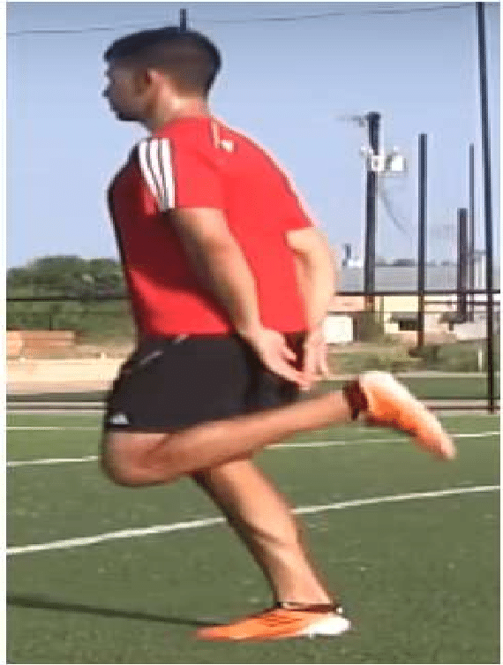
- Image 1: A gymnast performing a deep backbend. Image 2: A footballer doing butt-kicks before training.
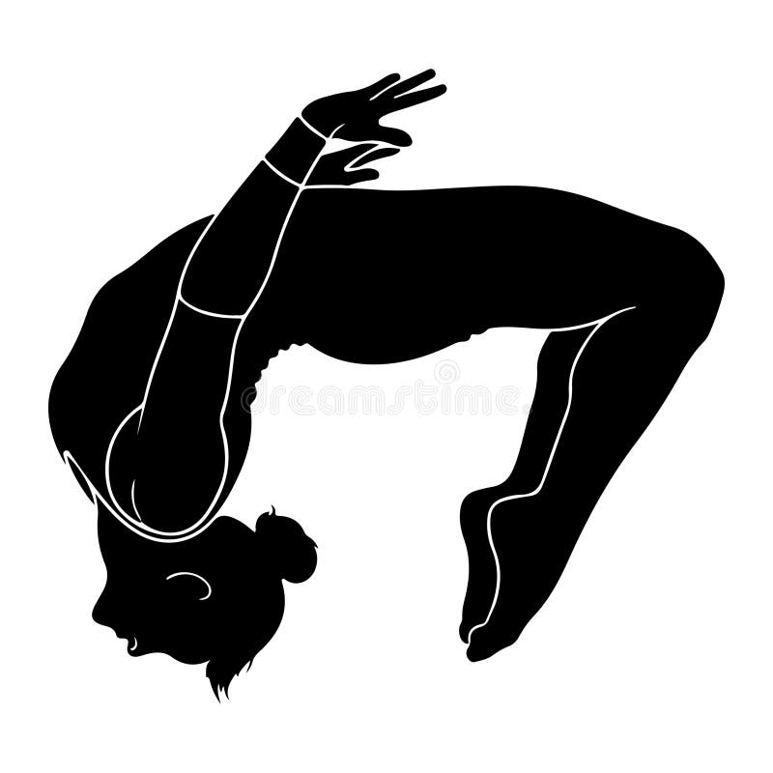

Using the images, analyze the contribution of flexibility, dynamic movement, and static stretching to performance in different sports. (10 marks)
- ____________________________________________________________________________________________
- ____________________________________________________________________________________________
- ____________________________________________________________________________________________
- ____________________________________________________________________________________________
- ____________________________________________________________________________________________

13. Discuss five components of muscular fitness applicable to health and physical performance. (10 marks)
- ____________________________________________________________________________________________
- ____________________________________________________________________________________________
- ____________________________________________________________________________________________
- ____________________________________________________________________________________________
- ____________________________________________________________________________________________

©2026
All rights reserved
©COMPETENCE KENYA EXAMINATION AND ASSESSMENT BOARD
THIS IS THE LAST PRINTED PAGE

