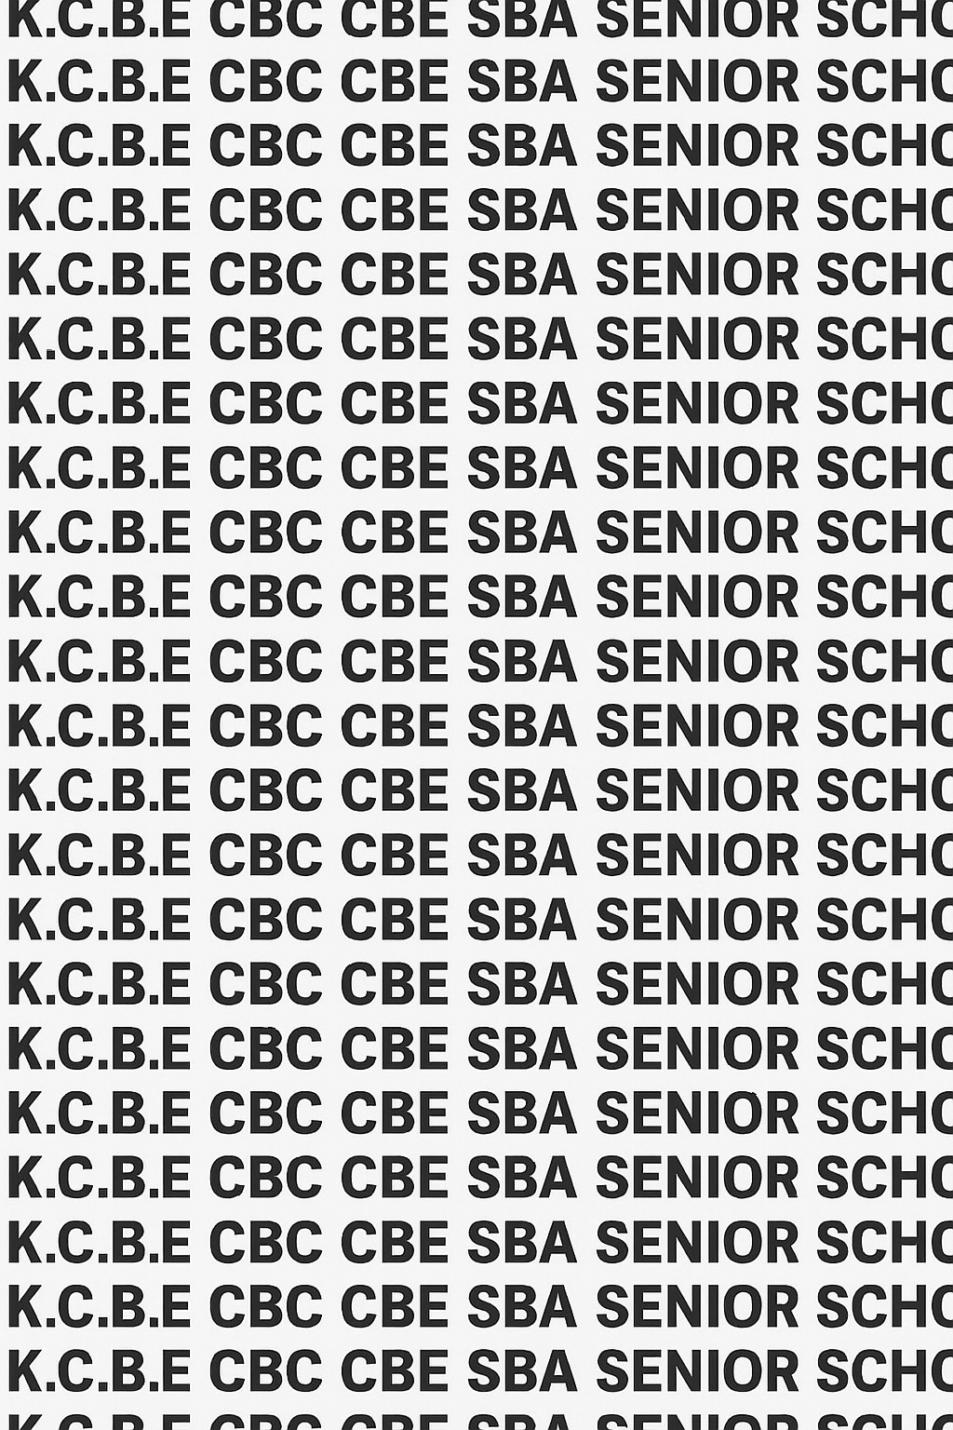
KENYA CERTIFICATE OF BASIC EDUCATION (K.C.B.E)


GRADE 10 THEATRE AND FILM (Theory) TERM 1 JANUARY 2026
Time: 1 Hour 40 Minutes
COMPETENCY BASED EDUCATION CKEAB 001

LEARNER’S DETAILS
Name: _______________________________________________________________________________________.
School: ______________________________________________________________________________________.
Assessment Number: ________________________________. Date: __________________________________.
School Code: _______________________________. Signature: ________________________________.

INSTRUCTIONS TO LEARNERS
- Write your name, School, assessment number, signature and date on all the answer sheets provided.
- Answer all the questions in the spaces provided.
- Read each question carefully before writing your answer.
- Manage your time well to complete all questions.
-THEATRE AND FILM- -001- -Senior School-

Performance Levels Grid
Learner Name | Q1(a) (4) | Q1(b) (2) | Q2 (6) | Q3 (3) | Q4(a) (2) | Q4(b) (2) | Q5 (2) | Q6 (6) | Q7 (3) | Q8 (3) | Q9 (4) | TOTAL SECTION A (35)
Marks
Leaner’s score

Learner Name | Q10 (14) | Q11 (20) | Q12 (14) | Q13 (20) | Q14 (20) | TOTAL Section B (60)
Marks
Learners score
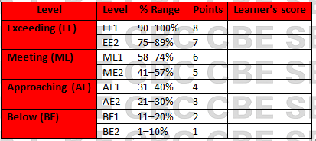
Section | Max Marks | Learner Score
A | 40
B | 60
TOTAL | 100

This paper has 10 printed pages. Please check out to ensure all pages are printed
Turn over
SECTION A: (35 Marks)
Answer all questions in this section.

1. (a) A Grade 10 drama club is preparing for the annual school arts festival. They want to create an original play but are unsure of where to begin.
Explain two reasons why exposition is important in the early stages of their play. (4 marks)
- ____________________________________________________________________________________________
- ____________________________________________________________________________________________

(b) Identify two ways the club can establish setting in the opening scene. (2 marks)
- ____________________________________________________________________________________________
- ____________________________________________________________________________________________

2. The Kibra Community Theatre is developing a play about urban youth entrepreneurship.
Explain three functions of dialogue in revealing character. (6 marks)
- ____________________________________________________________________________________________
- ____________________________________________________________________________________________
- ____________________________________________________________________________________________

3. Imagine a play where a young girl from Turkana discovers a buried ancient artifact that could transform her community.
Identify three elements of plot demonstrated in this scenario. (3 marks)
- ____________________________________________________________________________________________
- ____________________________________________________________________________________________
- ____________________________________________________________________________________________

4. A director is choosing a dramatic style for a performance about corruption in county governments.
(a) Define dramatic style. (2 marks)
_________________________________________________________________________________________________
________________________________________________________________________________________________

(b) Give two examples of dramatic styles the director could choose. (2 marks)
- ____________________________________________________________________________________________
- ____________________________________________________________________________________________

5. A play ends with a character reflecting on lessons learned after a major conflict is resolved.
State two characteristics of a good resolution in a play. (2 marks)
- ____________________________________________________________________________________________
- ____________________________________________________________________________________________

6. During rehearsal, an actor keeps forgetting movements during a key scene where tension is high.
Explain three ways in which dramatic action can heighten tension. (6 marks)
- ____________________________________________________________________________________________
- ____________________________________________________________________________________________
- ____________________________________________________________________________________________

7. Identify three characteristics of a well-developed character in a play. (3 marks)
- ____________________________________________________________________________________________
- ____________________________________________________________________________________________
- ____________________________________________________________________________________________

8. State three importance of plot structure in a school play production. (3 marks)
- ____________________________________________________________________________________________
- ____________________________________________________________________________________________
- ____________________________________________________________________________________________

9. The drama mentor tells students that “a story becomes a play when it is staged.”
Explain two differences between a story and a play. (4 marks)
- ____________________________________________________________________________________________
- ____________________________________________________________________________________________
- ____________________________________________________________________________________________
- ____________________________________________________________________________________________

SECTION B (60 MARKS)
Answer ANY THREE questions from this section.

10. The Extract Below is from a Short Play:
Title: The Broken Fence
(In a rural Kenyan village, two neighbouring families have been quarrelling over land boundaries for years. A heavy storm destroys the fence separating their farms, forcing them to confront each other truthfully.)
EXTRACT
(At dawn. A collapsed fence lies across the stage. Amina stands on one side, holding a broken post. Musa enters from the opposite side.)
Musa: Amina, your goats crossed again. Now they’ve eaten all my new seedlings.
Amina: (Angrily) How can you blame me? That fence has been weak for months. You refused to fix it!
Musa: Because you planted too close to the boundary!
(They stare at the broken fence in silence.)
Amina: Maybe… maybe the storm is telling us something.
Musa: (softening) Maybe it is time we talk—really talk.

(a) Identify the dramatic conflict in the extract. (2 marks)
- ____________________________________________________________________________________________
- ____________________________________________________________________________________________

(b) Explain how dialogue is used to reveal the strained relationship between the two characters. (4 marks)
- ____________________________________________________________________________________________
- ____________________________________________________________________________________________
- ____________________________________________________________________________________________
- ____________________________________________________________________________________________

(c) Suggest two ways the director could use stage movement to emphasize tension in this scene. (4 marks)
- ____________________________________________________________________________________________
- ____________________________________________________________________________________________

(d) State two possible themes emerging from the extract. (4 marks)
- ____________________________________________________________________________________________
- ____________________________________________________________________________________________

11. You have been invited by KIMENDE YOUTH THEATRE to help write a play that encourages peaceful coexistence during elections.
(a) Describe the exposition you would use to introduce the theme. (4 marks)
- ____________________________________________________________________________________________
- ____________________________________________________________________________________________
(b) Describe a rising action scene that increases political tension. (4 marks)
- ____________________________________________________________________________________________
- ____________________________________________________________________________________________
(c) Propose a climax that forces characters to make a crucial decision. (4 marks)
- ____________________________________________________________________________________________
- ____________________________________________________________________________________________
(d) Explain how the falling action would resolve misunderstandings. (4 marks)
- ____________________________________________________________________________________________
- ____________________________________________________________________________________________
(e) Suggest a meaningful resolution for the community. (4 marks)
- ____________________________________________________________________________________________
- ____________________________________________________________________________________________

12. Write a three-act structure outline for a play based on a pertinent Kenyan issue such as unemployment, drug abuse, drought, teenage pregnancy, or corruption.
Your outline should include:
(a) Act I – Exposition and introduction of characters (4 marks)
(b) Act II – Rising action and development of conflict (6 marks)
(d) Explanation of the moral lesson/message (4 marks)

______________________________________________________________________________________________________________________________________________________________________________________________________________________________________________________________________________________________________________________________________________________________________________________________________________________________________________________________________________________________________________________________________________________________________________________________________________________________________________________________________________________________________________________________________________________________________________________________________________________________________________________________________________________________________________________________________________________________________________________________________________________________________________________________________________________________________________________________________________________________________________________________________________________________________________________________________________________________________________________________________________________________________________________________________________________________________________________________________________________________________________________________________________________________________________________________________________________________________________________________________________________________________________________________________________________________________________________________________________________________________________________________________________________________________________________________________________________________________________________________________________________________________________________________________________________________________________________________________________________________________________________________________________________________________________________________________________________________________________________________________________________________________________________________________________________________________________________________________________________________________________________________________________________________________________________________________________________________________________________________________________________________________________________________________________________________________________________________________________________________________________________________________________________________________________________________________________________________________________________________________________________________________________________________________________________________________________________________________________________________________________________________________________________________________________________________________________________________________________________________________________________________________________________________________________________________________________________________________________________________________________________________________________________________________________________________________________________________________________________________________________________________________________________________________________________________________________________________________________________________________________________________________________________________________________________________________________________________________________________________________________________________________________________________________________________________________________________________________________________________________________________________________________________________________________________________________________________________________________________________________________________________________________________________________________________________________________________________________________________________________________________________________________________________________________________________________________________________________________________________________________________________________________________________________________________________________________________________________________________________________________________________________________________________________________________________________________________________________________________________________________________________________________________________________________________________________________________________________________________________________________________________________________________________________________________________________________________________________________________________________________________________________________________________________________________________________________________________________________________________________________________________________________________________________________________________________________________________________________________________________________________________________________________________________________________________________________________________________________________________________________________________________________________________________________________________________________________________________________________________________________________________________________________________________________________________________________________________________________________________________________________________________________________________________________________________________________________________________________________________________________________________________________________________________________________________________________________________________________________________________________________________________________________________________________________________________________________________________________________________________________________________________________________________________________________________________________________________________________________________________________________________________________________________________________________________________________________________________________________________________________________________________________________________________________________________________________________________________________________________________________________________________________________________________________

13. A Grade 10 class is analysing a play.
Title: “STAY SAFE, KENYA!”
PRODUCER: Kangala Misale
Characters:
- Narrator
- Mother
- Amina (daughter)
- Juma (son)
- Health Officer

SCENE 1: AT HOME
Narrator:In early 2020, news of Coronavirus reached Kenya. Families everywhere became worried.
Mother:Amina, Juma, before you eat, wash your hands with soap.
Juma:But Mama, we washed a few minutes ago!
Mother:This virus spreads fast. Clean hands protect us.

SCENE 2: OUTSIDE THE HOUSE
(Amina and Juma are playing. A Health Officer arrives.)
Health Officer:Hello children! Remember to wear your masks properly.
Amina:We heard Coronavirus is in Nairobi. Is it serious?
Health Officer:Yes, but you can stay safe by:
- Washing hands
- Keeping distance
- Avoiding crowds
- Wearing masks
Juma:Will school close?
Health Officer:Only for a while, to keep you safe.

SCENE 3: LESSON LEARNT
(Back at home, the children talk to their mother.)
Amina:Mama, we understand now. We must protect ourselves and others.
Juma:Yes! We will wear masks and wash our hands.
Mother:Good children. When we work together, we stay safe.
Narrator:And so, this family—and all of Kenya—learned that simple actions can save lives.
All:STAY SAFE, KENYA!
(a) Name the play and its playwright. (2 marks)
- ____________________________________________________________________________________________
- ____________________________________________________________________________________________
(b) Identify the main conflict. (4 marks)
- ____________________________________________________________________________________________
- ____________________________________________________________________________________________
(c) Describe the setting of the play. (4 marks)
- ____________________________________________________________________________________________
- ____________________________________________________________________________________________
(d) Explain how the playwright uses three elements of style (e.g., symbolism, satire, irony). (6 marks)
- ____________________________________________________________________________________________
- ____________________________________________________________________________________________
- ____________________________________________________________________________________________
(e) State two lessons the audience learns. (4 marks)
- ____________________________________________________________________________________________
- ____________________________________________________________________________________________

14. You are the scriptwriter in a media company preparing a short TV drama series.
(a) Explain three characteristics of effective dialogue in film. (6 marks)
- ____________________________________________________________________________________________
- ___________________________________________________________________________________________
- ____________________________________________________________________________________________
(b) Describe four ways in which setting influences the mood of a film. (8 marks)
- ____________________________________________________________________________________________
- ___________________________________________________________________________________________
- ____________________________________________________________________________________________
- ____________________________________________________________________________________________
(c) Explain three qualities of a strong protagonist. (6 marks)
- ____________________________________________________________________________________________
- ____________________________________________________________________________________________
- ____________________________________________________________________________________________

©2026
All rights reserved
©COMPETENCE KENYA EXAMINATION AND ASSESSMENT BOARD
THIS IS THE LAST PRINTED PAGE

