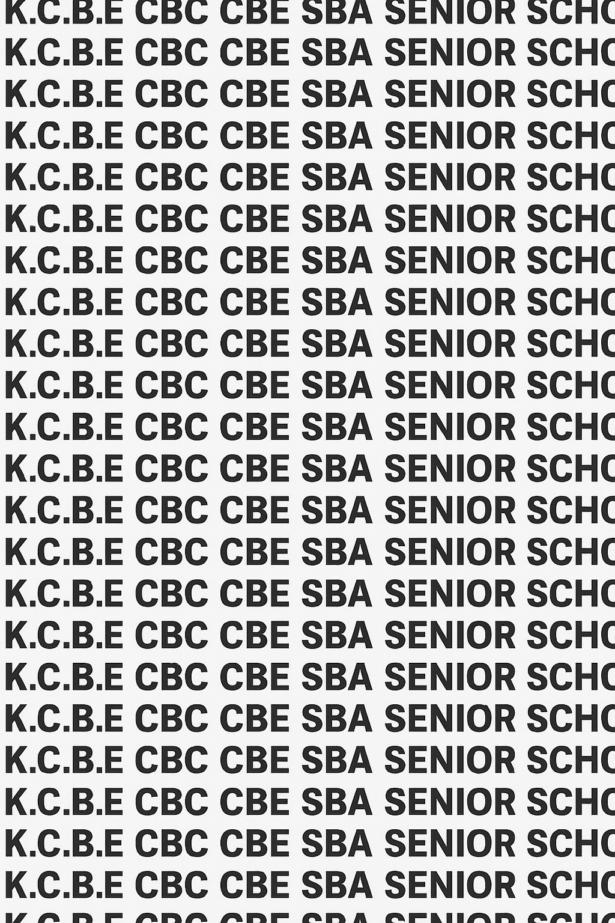
KENYA CERTIFICATE OF BASIC EDUCATION (K.C.B.E)
GRADE 10 WOOD TECHNOLOGY (Theory) TERM 1 JANUARY 2026
Time: 1 Hour 30 Minutes
COMPETENCE ASSESSMENT EXAMINATION CKEAB 001

LEARNER’S DETAILS
Name: _______________________________________________________________________________________.
School: ______________________________________________________________________________________.
Assessment Number: ________________________________. Date: __________________________________.
School Code: _______________________________. Signature: ________________________________.

INSTRUCTIONS TO LEARNERS
- Write your name, School, assessment number, signature and date on all the answer sheets provided.
- Answer all the questions in the spaces provided.
- Read each question carefully before writing your answer.
- Check your work before submitting the exam.


- Manage your time well to complete all questions.
-WOOD TECHNOLOGY- -001- -Senior School-

Performance Levels Grid
Qn No. | 1 | 2 | 3 |  | 4 | 5 |  |  | 6 | TOTAL SECTION A
Marks | 4 | 4 | 3 |  | 4 | 4 |  |  | 6 | 25
Learner Score
Qn No. | 7 |  |  | 8 |  |  |  | 9 |  | 10 | TOTAL (Best 3 Only) |  |  | SECTION B TOTAL
Marks | 25 |  |  | 25 |  |  |  | 25 |  | 25 | 75 |  |  | 75
Learner Score
Section | Max Marks |  |  |  |  |  | Learner Score
A | 25
B | 75
TOTAL | 100
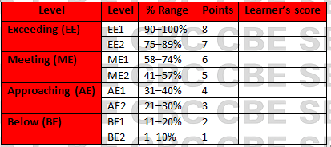

This paper has 8 printed pages. Please check out to ensure all pages are printed
Turn over

SECTION A: (25 Marks)
Answer all questions in this section.
- Your school has introduced a new Wood Technology learning area.
a) Define Wood Technology. (2 marks)
____________________________________________________________________________________________
____________________________________________________________________________________________
b) State two benefits of studying Wood Technology to a learner. (2 marks)
- ______________________________________________________________________________________
- ______________________________________________________________________________________
- A Grade 10 class visited a carpentry workshop in town.
a) State two features they observed in a standard wood workshop. (2 marks)
- ______________________________________________________________________________________
- ______________________________________________________________________________________
b) Give two reasons why good workshop layout is important. (2 marks)
- ______________________________________________________________________________________
- ______________________________________________________________________________________
- Chebet wants to pursue a Wood Technology–related career after Senior School.
State three career opportunities available in the wood industry. (3 marks)
- ______________________________________________________________________________________
- ______________________________________________________________________________________
- ______________________________________________________________________________________
- A new project requires the use of wood as a construction material.
a) Give two uses of wood in the community. (2 marks)
- ______________________________________________________________________________________
- ______________________________________________________________________________________

b) Explain one role of Wood Technology in national development. (2 marks)
______________________________________________________________________________________
______________________________________________________________________________________
- A student accidentally mishandled a saw in the workshop.
a) State two reasons for observing safety in a wood workshop. (2 marks)
- ______________________________________________________________________________________
- ______________________________________________________________________________________
b) Mention two general safety rules that should be followed in the workshop. (2 marks)
- ______________________________________________________________________________________
- ______________________________________________________________________________________
- Different tools are used in woodwork.
a) Classify the following tools into their correct categories: (4 marks)
- Try square
- Jack plane
- Brace
- Bench hook
TOOL | CATEGORY
Try square
Jack plane
Brace
Bench hook

SECTION B (75 MARKS)
Answer Question 7 and ANY OTHER TWO questions from this section.
- You are required to set up a new wood workshop for the Junior School. The head teacher has asked you to prepare a brief report.
a) Explain three factors to consider when selecting a suitable site for a wood workshop. (6 marks)
- ______________________________________________________________________________________
- ______________________________________________________________________________________
- ______________________________________________________________________________________
b) Describe four key features of a well-designed wood workshop. (8 marks)
- ______________________________________________________________________________________
- ______________________________________________________________________________________
- ______________________________________________________________________________________
- ______________________________________________________________________________________
c) With the aid of a labelled sketch, illustrate the layout of a simple wood workshop showing: (6 marks)
- Workbenches
- Storage area
- Tool rack
- Machine area
d) State five rules that learners must follow to maintain safety in the workshop. (5 marks)
- ______________________________________________________________________________________
- ______________________________________________________________________________________
- ______________________________________________________________________________________
- ______________________________________________________________________________________
- ______________________________________________________________________________________

- A school is designing a wooden locker project for all Grade 10 learners.
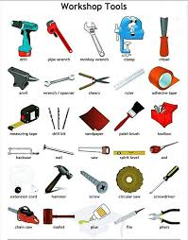
- Identify the following workshop tools
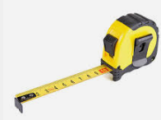



A B C D

A: _________________________________
B: _________________________________
C: _________________________________
D: _________________________________
b) Explain four uses of marking tools during preparation of wood for the locker project. (8 marks)
- ______________________________________________________________________________________
- ______________________________________________________________________________________
- ______________________________________________________________________________________
- ______________________________________________________________________________________
c) Describe four cutting tools used in woodwork and state one use of each. (8 marks)
 | Cutting tool | Use
i
ii
iii
iv

d) Explain three reasons for sharpening woodwork tools regularly. (6 marks)
- ______________________________________________________________________________________
- ______________________________________________________________________________________
- ______________________________________________________________________________________
e) Name three boring tools used to create holes in wooden components. (3 marks)
- ______________________________________________________________________________________
- ______________________________________________________________________________________
- ______________________________________________________________________________________
- Your community youth group wants to start a small furniture business using locally available wood.
a) Discuss four benefits of Wood Technology in economic development of a country. (8 marks)
- ______________________________________________________________________________________
- ______________________________________________________________________________________
- ______________________________________________________________________________________
- ______________________________________________________________________________________
b) Describe five careers related to Wood Technology that members of the youth group can pursue. (10 marks)
- ______________________________________________________________________________________
- ______________________________________________________________________________________
- ______________________________________________________________________________________
- ______________________________________________________________________________________
- ______________________________________________________________________________________
c) Explain three reasons why wood is preferred for making household furniture. (6 marks)
- ______________________________________________________________________________________
- ______________________________________________________________________________________
- ______________________________________________________________________________________
d) State one example each of the following: (3 marks)
 | Holding tool | Clamping tool | Impelling tool
i
ii
- A student is preparing a wooden stool for their practical assessment.
a) Describe four measuring tools and explain the function of each. (8 marks)
- ______________________________________________________________________________________
- ______________________________________________________________________________________
- ______________________________________________________________________________________
- ______________________________________________________________________________________
b) Explain four planing tools and the purpose they serve in wood finishing. (8 marks)
- ______________________________________________________________________________________
- ______________________________________________________________________________________
- ______________________________________________________________________________________
- ______________________________________________________________________________________
c) A portable stand and a bench hook are common equipment in the workshop.
Describe three uses of each. (6 marks)
Tool | Use
Portable stand
Bench hook

d) State three shaping tools used for smoothing or forming wood. (3 marks)
- ______________________________________________________________________________________
- ______________________________________________________________________________________
- ______________________________________________________________________________________

©2026
All rights reserved
©COMPETENCE KENYA EXAMINATION AND ASSESSMENT BOARD
THIS IS THE LAST PRINTED PAGE

