KENYA CERTIFICATE OF BASIC EDUCATION

SENIOR SCHOOL ASSESSMENT

TERM 2 END TERM ASSESSMENTS 2026
GRADE 10 – APPLIED AGRICULTURE 007 JULY
Time: 2 Hours
LEARNER’S DETAILS
Name: ________________________________________________. School: ________________________________________.
Assessment Number: _________________________________. Date: __________________________________________.
School Code: _______________________________________. Signature: ______________________________________.

INSTRUCTIONS TO CANDIDATES
- Write your name in the spaces provided above.
- Write the name of your school and your stream in the spaces provided.
- Write your admission number and the date of the assessment in the spaces provided.
- This paper consists of two sections: A and B.
- Answer all questions in section A and section B.
- Answer the questions in English.
- All answers MUST be written in the spaces provided in the paper.
- Do NOT remove any page from this question paper.

FOR OFFICIAL USE ONLY (EXAMINER’S USE)
SECTION | SECTION A | SECTION B | % SCORE | EE1 | EE2 | ME1 | ME2 | AE1 | AE2 | BE1 | BE2
SCORE RANGE | 30 MARKS | 50 MARKS |  | 90-100 | 75-89 | 58-74 | 41-57 | 31-40 | 21-30 | 11-20 | 1-10
POINTS |  |  |  | 8 POINTS | 7 POINTS | 6 POINTS | 5 POINTS | 4 POINTS | 3 POINTS | 2 POINTS | 1 POINT
LEARNER’S TOTAL SCORE

SECTION A (30 MARKS)
Answer ALL questions in this section.
- (a) Match the following ways of accessing land in Kenya with their correct descriptions. (4 Marks)
Method of Access | Description
i. Leasing | A. Receiving land from a parent or relative after they pass away.
ii. Inheritance | B. Paying a specific fee to use land for a set period.
iii. Buying | C. Being given land for free by the government or a well-wisher.
iv. Donation | D. Acquiring permanent ownership through a financial transaction.

(b) State two natural factors that determine the productivity of land in Mwea, Kirinyaga County. (2 Marks)
- __________________________________________________________________________________________
- __________________________________________________________________________________________
- Define the following terms as used in Agricultural Technologies: (3 Marks)
a) Value Addition: ________________________________________________________________________________________________________________________________________________________________________________________________
b) Fallow Land: ________________________________________________________________________________________________________________________________________________________________________________________________
c) Apiary: ________________________________________________________________________________________________________________________________________________________________________________________________
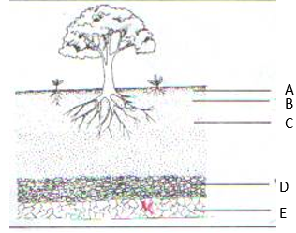
- Study the diagram below of a soil profile observed by learners at Alliance Senior School during a field trip and answer the questions that follow.

(a) Name the horizons labeled: A, B, C, D and E. (1 ½ mks)
A: _________________________________ D: _________________________________
B: _________________________________ E: _________________________________
C: _________________________________
(b) State two characteristics of topsoil. (2mks)
- __________________________________________________________________________________________
- __________________________________________________________________________________________
- Distinguish between the following soil properties: (2 Marks)

Soil Texture and Soil Structure:

____________________________________________________________________________________________________________________________________________________________________________________________________________________________________________________________________________________________________________________________________________________________________________________
- State whether the following statements regarding bee keeping are True or False. (4 Marks)
a) An apiary should be sited near a busy road to allow bees to travel easily. [________ ]
b) Smoking is a method used to calm bees during honey harvesting. [________ ]
c) Water should be provided near the hive for the bees. [________ ]
d) A catcher box is used to transport honey to the market. [________ ]
- Grade 10 learners used some tools to restrain the animals in the farm. Mention three tools used for livestock restraining and safety at Nakuru Senior School farm. (3 Marks)
i. _________________________________
ii. _________________________________
iii. _________________________________
- List three factors of production required by a Grade 10 learner to establish a poultry enterprise. (3 Marks)
i. _____________________________________________________________________________________________
ii. _____________________________________________________________________________________________
iii. _____________________________________________________________________________________________
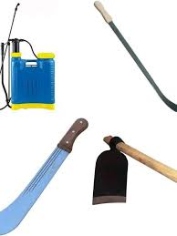
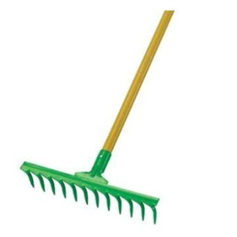
- Learners used the following tools while working in the school farm.



Q R S T

Identify the tools labelled Q,R,S and T(4 Marks)

Q: __________________________ R:___________________________

S:____________________________ T:____________________________
- Outline two maintenance practices carried out on a jembe or a panga. (2 Marks)
i. _____________________________________________________________________________________________
ii. _____________________________________________________________________________________________
SECTION B (50 MARKS)
(Answer all questions in this section)
- Learners at Limuru Girls' School were preparing a seedbed for kales. They started by clearing the bush, then performed primary cultivation, followed by secondary cultivation.
a) Explain the importance of secondary cultivation in seedbed preparation. (4 Marks)
i. _____________________________________________________________________________________________
ii. _____________________________________________________________________________________________
b) Identify two conservation tillage practices the learners could use to conserve soil moisture. (2 Marks)
i. _____________________________________________________________________________________________
ii. _____________________________________________________________________________________________
c) Compare zero tillage and minimum tillage as used in crop production. (4 Marks)
Zero tillage | Minimum tillage
- Study the images of the cattle below and answer the questions.
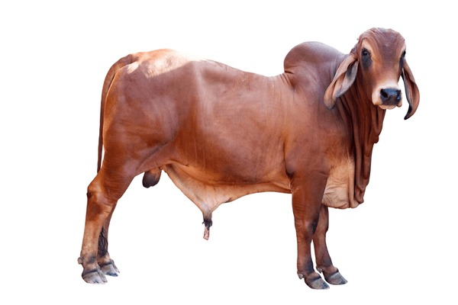
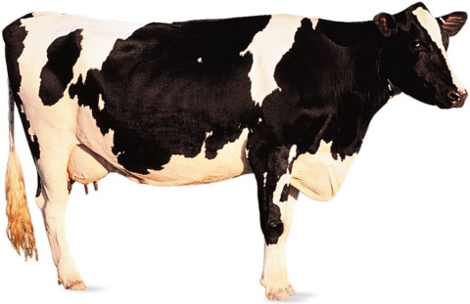
a) Identify the breeds above: (2 Marks)

M. _________________________________ N. _________________________________
b) Distinguish between the two breeds based on their primary use. (2 Marks)

M | N

c) A farmer in Kitale wants to start a commercial milk business. Which of the two breeds would you recommend? Give a reason. (2 Marks)
i. _____________________________________________________________________________________________
ii. _____________________________________________________________________________________________

- During an excursion to a farm in Narok, four learners (Kamau, Moraa, Fatuma, and Mutua) were describing a specific weed they found in a wheat field.
- Kamau: "This weed has a very short life cycle, completing it in one season."
- Moraa: "I noticed its leaves are very broad compared to the wheat."
- Fatuma: "It competes heavily with the wheat for nutrients and light."
- Mutua: "It can be controlled easily by uprooting it before it produces seeds."
a) Based on Kamau’s description, classify the weed by its life cycle. (1 Mark)
________________________________________________
b) Based on Moraa’s description, classify the weed by its morphology. (1 Mark)
________________________________________________________
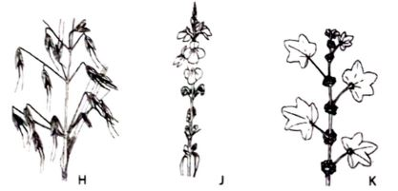

c) Timothy a Grade 10 learner came across the weeds shown below



Identify the weed labelled:

H__________________________ (1 mark)

J __________________________ (1 mark)

K__________________________ (1 mark)
d) Explain two economic importances of weeds to a farming household. (2 Marks)
i. _____________________________________________________________________________________________
ii. _____________________________________________________________________________________________

e) Describe three cultural methods of weed control. (3 Marks)
i. _____________________________________________________________________________________________
ii. _____________________________________________________________________________________________
iii. _____________________________________________________________________________________________
- A group of Grade 10 learners from Kenya Senior School visited a local resource person to discuss how to market their tomatoes. The resource person described several activities.
Activity 1: Sorting tomatoes into "Large", "Medium", and "Small".
Activity 2: Putting them into crates and labeling them with the school logo.
Activity 3: Calculating the cost of the pick-up truck and the market entrance fee.
a) Identify the specific marketing preparation process described in Activity 1. (1 Mark)
_____________________________________________________
b) Mention two benefits of branding as mentioned in Activity 2. (2 Marks)
i. _____________________________________________________________________________________________
ii. _____________________________________________________________________________________________
c) Evaluate the expenses mentioned in Activity 3. Name two types of marketing expenses. (2 Marks)
i. _____________________________________________________________________________________________
ii. _____________________________________________________________________________________________
d) The learners decided to turn some tomatoes into tomato paste. Suggest two benefits of this value addition. (2 Marks)
i. _____________________________________________________________________________________________
ii. _____________________________________________________________________________________________
e) State three digital platforms the learners can use to market their produce in Kenya. (3 Marks)
i. __________________________________.
ii. __________________________________.
iii. __________________________________.
- A farmer in Mombasa noticed that his cows were dull, had rough coats, and had a drop in milk production.
a) Identify three signs of ill health from the description above. (3 Marks)
i. _________________________________
ii. _________________________________
iii. _________________________________
b) Explain three general preventative measures the farmer should take to maintain animal health. (6 Marks)
i. _____________________________________________________________________________________________.
ii. ____________________________________________________________________________________________.
iii. ____________________________________________________________________________________________.
c) Why is it important to wear Personal Protective Equipment (PPE) when handling livestock? (1 Mark)
________________________________________________________________________________________________________________________________________________________________________________________________
- A learner wants to start a bee-keeping project but has no money.
a) Propose four ways the learner can acquire capital to establish the enterprise. (4 Marks)
i. _____________________________________________________________________________________________.
ii. ____________________________________________________________________________________________.
iii. ____________________________________________________________________________________________. iv. ____________________________________________________________________________________________.
b) State one factor to consider when selecting an agricultural enterprise. (2 Marks)
________________________________________________________________________________________________________________________________________________________________________________________________

THIS IS THE LAST PRINTED PAGE

