KENYA CERTIFICATE OF BASIC EDUCATION

SENIOR SCHOOL ASSESSMENT

TERM 2: ENDTERM ASSESSMENT 2026
GRADE 10 – AVIATION 007 JULY
Time: 2 Hours
LEARNER’S DETAILS
Name: ________________________________________________. School: ________________________________________.
Assessment Number: _________________________________. Date: __________________________________________.
School Code: _______________________________________. Signature: ______________________________________.

INSTRUCTIONS TO CANDIDATES
- Write your name in the spaces provided above.
- Write the name of your school and your stream in the spaces provided.
- Write your admission number and the date of the assessment in the spaces provided.
- This paper consists of two sections: A and B.
- Answer all questions in section A and section B.
- Answer the questions in English.
- All answers MUST be written in the spaces provided in the paper.
- Do NOT remove any page from this question paper.

FOR OFFICIAL USE ONLY (EXAMINER’S USE)
SECTION | SECTION A | SECTION B | % SCORE | EE1 | EE2 | ME1 | ME2 | AE1 | AE2 | BE1 | BE2
SCORE RANGE | 30 MARKS | 50 MARKS |  | 90-100 | 75-89 | 58-74 | 41-57 | 31-40 | 21-30 | 11-20 | 1-10
POINTS |  |  |  | 8 POINTS | 7 POINTS | 6 POINTS | 5 POINTS | 4 POINTS | 3 POINTS | 2 POINTS | 1 POINT
LEARNER’S TOTAL SCORE

SECTION A (30 MARKS)
Answer ALL questions in this section.
- (a)Learners from Mang’u Senior School visited a museum and saw various aircraft models. Match the aviation pioneer in Column A with their specific contribution in Column B. (4 Marks)
Column A: Pioneer | Column B: Contribution
i) Montgolfier Brothers | A. Developed the first practical helicopter (rotary wing)
ii) Wright Brothers | B. Known as the "Father of Aviation" for glider principles
iii) George Cayley | C. Launched the first successful hot air balloon
iv) Igor Sikorsky | D. Achieved the first powered, controlled fixed-wing flight

(b) Based on your knowledge, list two examples of lighter-than-air aircraft. (2 Marks)
i.__________________________________________________________________________________________
ii. _________________________________________________________________________________________
- While at Jomo Kenyatta International Airport (JKIA), a learner noticed several signs in the terminal area.
i) Identify the three categories of safety signs. (3 Marks)
i.__________________________________________________________________________________________
ii. _________________________________________________________________________________________
iii.__________________________________________________________________________________________
ii) Mention one area of the airport categorized as airside. (1 Mark)
______________________________________________________________________________________
- State whether the following statements regarding aviation weather are TRUE or FALSE. (4 Marks)
a) Cirrus clouds are found at very high altitudes and are made of ice crystals. [___________ ]
b) Humidity has no effect on the performance of an aircraft engine. [___________]
c) The troposphere is the lowest layer of the atmosphere where weather occurs. [___________ ]
d) A wind vane is used to measure the speed of the wind at an airstrip. [___________ ]
- Kamau, a Grade 10 student at Alliance High School, is using a drawing board to create an isometric view of a wing component.
i) Define an isometric drawing. (2 Marks) ______________________________________________________________________________________________________________________________________________________________________________________________
ii) Describe one characteristic of the axes used in the drawing. (2 Marks) ______________________________________________________________________________________________________________________________________________________________________________________________
- Distinguish between physical properties and mechanical properties of aircraft materials (2 Marks) ________________________________________________________________________________________________________________________________________________________________________________________________________________________________________________________________________________________________________________________________________________________________________________
- Three learners are discussing the properties of the atmosphere: Three learners gave their views as follows:- Zawadi: “I think pressure increases as you go higher.” Mutua: “No, the air gets thinner and the density decreases.” Achieng: “And don’t forget the temperature; it generally drops in the lower layer.”
i) Identify the learner who made a false statement. (1 Mark)
_______________________________________________________________________
ii) Outline the two main physical properties of the atmosphere being discussed. (2 Marks)
- _________________________________________________________________________________________
- _________________________________________________________________________________________
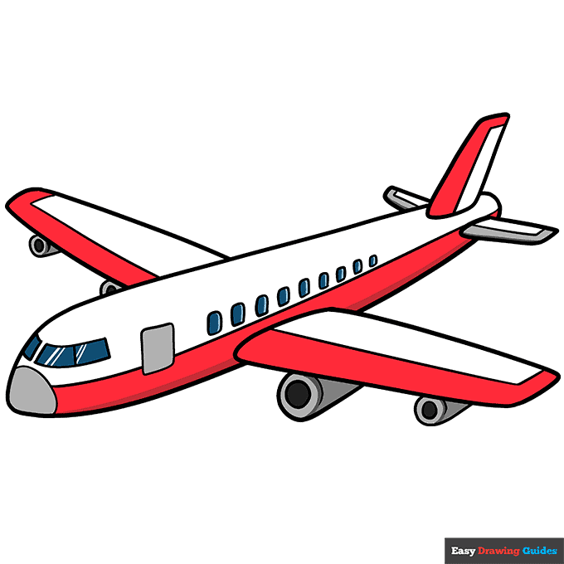
- Grade 10 learners boarded a plane bound to Kisumu.

List the four forces that act on an aircraft during steady flight in Kisumu airspace. (4 Marks)
- _________________________________________________________________________________________
- _________________________________________________________________________________________
- _________________________________________________________________________________________
- _________________________________________________________________________________________
- Mention three standard first aid items found in an aviation workshop kit. (3 Marks)
- _________________________________________________________________________________________
- _________________________________________________________________________________________
- _________________________________________________________________________________________

SECTION B (50 MARKS)
(Answer ALL questions in this section)
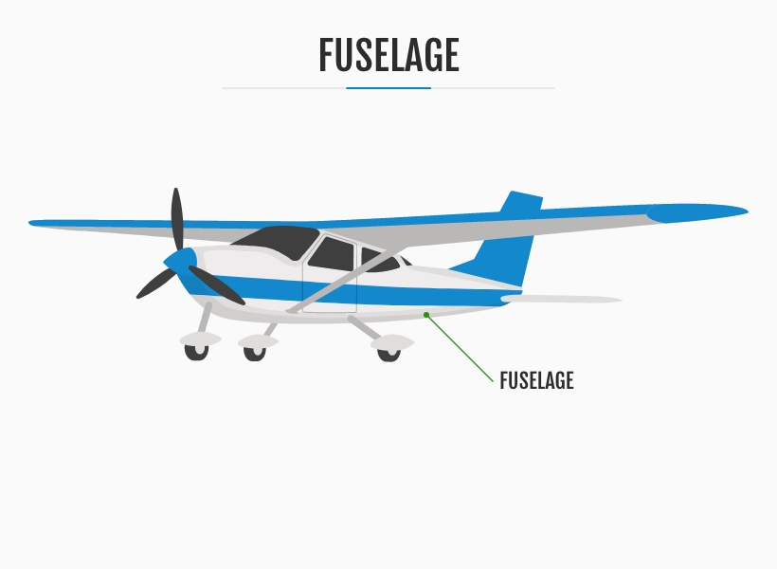
- (a)Below is a diagram of a fixed-wing aircraft used for training at Wilson Airport.
B C

D A
i) Name the parts labeled. (4 Marks)
A: __________________________ B: __________________________
C: __________________________ D: __________________________
ii) Explain the function of: (4 Marks)
B __________________________________________________________________________________________
C __________________________________________________________________________________________

(b) Amina, a Grade 10 learner, wants to construct a heavier-than-air model. Outline three locally available materials she can use. (3 Marks)
- _________________________________________________________________________________________
- _________________________________________________________________________________________
- _________________________________________________________________________________________
- Aviation Communication. Aircraft “5Y-KAA” is communicating with the tower at Eldoret International Airport.
i) Using ICAO phonetics, spell out the aircraft call sign 5Y-KAA. (5 Marks)
5: __________________
Y: __________________
K: __________________
A: __________________
A: __________________
ii) Identify the standard phrase used to mean: (2 Marks)
“I have received all of your last transmission”: __________________________.
“My transmission is ended and I expect a response from you”: __________________.
iii) Describe the marshalling signal for “Stop.” (2 Marks)
- _________________________________________________________________________________________
- _________________________________________________________________________________________

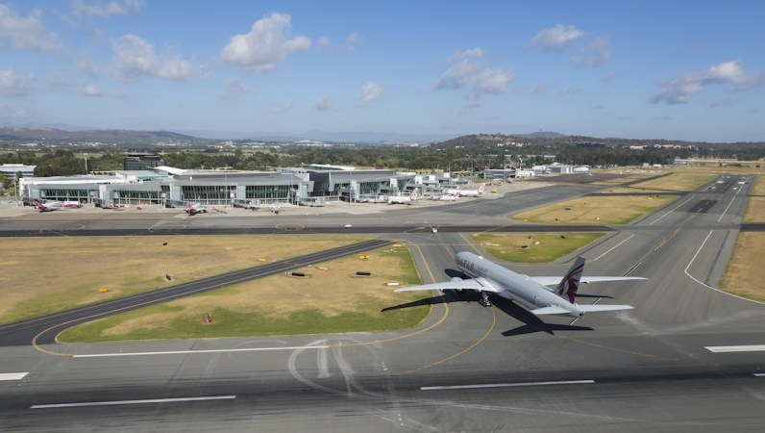
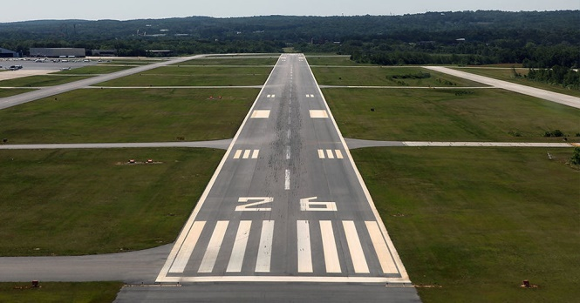
- Airport Operations and Business. Malindi Senior School learners are analyzing the layout of Malindi Airport.

M N

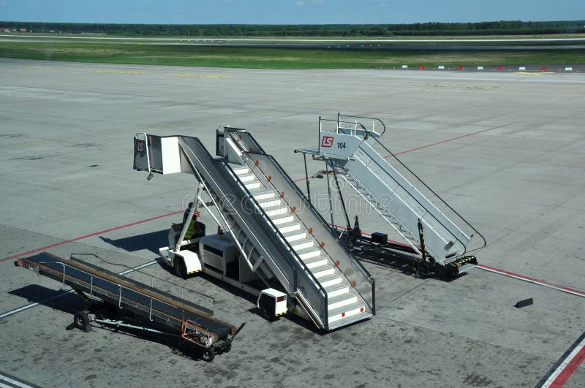
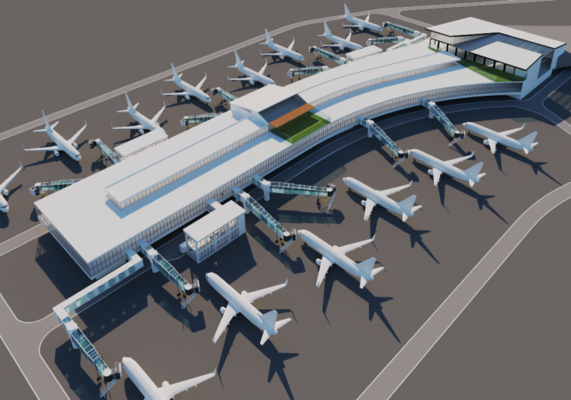

O P
a) Identify the physical components shown in the layout. (4 Marks)

M: ____________________________________.
N: ____________________________________.
O: ____________________________________.
P: ____________________________________.
b) Categorize the following services as Landside or Airside. (4 Marks)
- Duty-Free Shop: ____________________
- Aircraft Refueling: __________________
- Car Parking: ________________________
- Baggage Handling: __________________
c) Explain the role of the Kenya Civil Aviation Authority (KCAA) in consumer protection. (2 Marks)
- _________________________________________________________________________________________
- _________________________________________________________________________________________
- During a practical lesson at a flight training workshop, learners observed how an aircraft moves in different directions while in flight. They discussed how these movements occur along different axes and how forces act on the aircraft
a) Name the motion about the following axes. (3 Marks)
- Longitudinal Axis: ____________________
- Lateral Axis: _________________________
- Vertical Axis: ________________________
b) Describe how the weight of an aircraft is affected by gravity. (2 Marks)
- _________________________________________________________________________________________
- _________________________________________________________________________________________
- Safety and Hazards. In the aviation workshop at Starehe Boys’ Centre, a learner is using a powered cutting tool.
a) State two hazards visible in the scenario. (2 Marks)
- _________________________________________________________________________________________
- _________________________________________________________________________________________
b) Mention two safety precautions when using powered tools. (2 Marks)
- _________________________________________________________________________________________
- _________________________________________________________________________________________
c) Explain the first aid procedure for a minor electric shock injury. (4 Marks)
- _________________________________________________________________________________________
- _________________________________________________________________________________________
- _________________________________________________________________________________________
- _________________________________________________________________________________________
- Four learners are discussing the financial side of a flight school.
- Wanjiku: “The money we get from student fees is our revenue.”
- Otieno: “The fuel we buy and the salaries we pay are our expenses.”
- Ali: “If our revenue is higher than our expenses, we have made a profit.”
- Moraa: “We need to do budgeting to plan how much we will spend next term.”
a) Identify the learner describing a plan for future spending. (1 Mark)
_________________________________________________________
b) Define profit as used by Ali. (2 Marks)
______________________________________________________________________________________________________________________________________________________________________________________________
c) List two rights of a consumer at an airport as protected by ICAO. (2 Marks)
- _________________________________________________________________________________________
- _________________________________________________________________________________________

THIS IS THE LAST PRINTED PAGE

