KENYA CERTIFICATE OF BASIC EDUCATION

SENIOR SCHOOL ASSESSMENT

TERM 2: ENDTERM ASSESSMENT 2026
GRADE 10 – BIOLOGY 007 JULY
Time: 2 Hours
LEARNER’S DETAILS
Name: ________________________________________________. School: ________________________________________.
Assessment Number: _________________________________. Date: __________________________________________.
School Code: _______________________________________. Signature: ______________________________________.

INSTRUCTIONS TO CANDIDATES
- Write your name in the spaces provided above.
- Write the name of your school and your school code in the spaces provided.
- Write your assessment number and the date of the assessment and sign in the spaces provided.
- This paper consists of two sections: A and B.
- Answer all questions in section A and section B.
- Answer the questions in English.
- All answers MUST be written in the spaces provided in the paper.
- Do NOT remove any page from this question paper.

FOR OFFICIAL USE ONLY (EXAMINER’S USE)
SECTION | SECTION A | SECTION B | % SCORE | EE1 | EE2 | ME1 | ME2 | AE1 | AE2 | BE1 | BE2
SCORE RANGE | 30 MARKS | 50 MARKS |  | 90-100 | 75-89 | 58-74 | 41-57 | 31-40 | 21-30 | 11-20 | 1-10
POINTS |  |  |  | 8 POINTS | 7 POINTS | 6 POINTS | 5 POINTS | 4 POINTS | 3 POINTS | 2 POINTS | 1 POINT
LEARNER’S TOTAL SCORE

SECTION A (30 MARKS)
Answer ALL questions in this section.
- During a career talk at Alliance Senior School, a biologist explains different applications of Biology.
a) Define Biology. (1 mark)
______________________________________________________________________________________________________________________________________________________________________________________________
b) State two applications of Biology in everyday life. (2 marks)
- _________________________________________________________________________________________
- _________________________________________________________________________________________

- During a visit to a laboratory in Nairobi, learners observed different professionals.
Match the fields in Column A with careers in Column B.
Column A | Column B
i. Botany | A. Microbiologist
ii. Zoology | B. Plant Scientist
iii. Microbiology | C. Animal Scientist
iv. Genetics | D. Genetic Engineer
- Learners collected insects near Lake Nakuru.
a) Name two apparatus used in collecting insects. (2 marks)
- _________________________________________________________________________________________
- _________________________________________________________________________________________
b) State one importance of preserving specimens. (1 mark) ______________________________________________________________________________________________________________________________________________________________________________________________
- State whether the following statements are TRUE or FALSE:
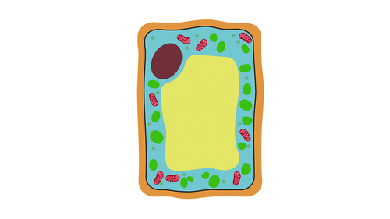
a) A microscope is used to observe cells. ___________________________
b) Ethanol is used for cooking food in Biology experiments. ___________________________
c) Labels are important in specimen preservation. ___________________________
- Gregory drew a plant cell as shown below

A C
B D

Identify parts A, B, C and D. (4 marks)
A: _____________________________
B: _____________________________
C: _____________________________

- Using the diagram above, distinguish between plant and animal cells (any TWO differences).

Plant Cell | Animal Cell

- Three learners from Mema Senior School observed different cells and gave various description:
- Brian: “This cell absorbs water efficiently.”
- Amina: “This cell contains chloroplasts.”
- Kevin: “This cell transmits impulses.”
a) Identify the specialized cells described. (3 marks)
Learner | Brian | Amina | Kevin

Specialized cell
- During a Biology lesson in Kisumu Girls Senior school, Grade 10 learners conducted an experiments on food test:
a) Name three food substances tested. (3 marks)
- _________________________________________________________________________________________
- _________________________________________________________________________________________
- _________________________________________________________________________________________
b) State one factor affecting enzyme activity. (1 mark) ______________________________________________________________________________________________________________________________________________________________________________________________
- Outline two stages of photosynthesis.
- _________________________________________________________________________________________
- _________________________________________________________________________________________
- State the functions of:
a) Xylem
_________________________________________________________________________________________
_________________________________________________________________________________________

b) Phloem
_________________________________________________________________________________________
_________________________________________________________________________________________

SECTION B (50 MARKS)
Answer ALL questions
- At Jomo Kenyatta Senior School, students displayed a “Career Wheel”.
a) State two factors influencing career choice. (2 marks)
- _________________________________________________________________________________________
- _________________________________________________________________________________________
b) Explain three importance of Biology in society. (3 marks)
- _________________________________________________________________________________________
- _________________________________________________________________________________________
- _________________________________________________________________________________________
c) Mention one career that relate the following fields of Biology: (3 marks)
- Ecology ________________________________
- Genetics ________________________________
- Microbiology ________________________________
- Learners carried out a project in Kericho Tea Senior School.
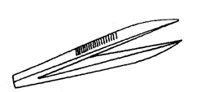
- Identify the apparatus represented by the diagram below and states its function,

i. Name ________________________________ (1 mark)

ii. Function __________________________________________________________________________(1mark)
b) Apart from the apparatus shown in 12 (a) above List two apparatus used in specimen collection. (2 marks)
- _________________________________________________________________________________________
- _________________________________________________________________________________________
c) Outline steps in preparing a herbarium. (4 marks)
- _________________________________________________________________________________________
- _________________________________________________________________________________________
- _________________________________________________________________________________________
- _________________________________________________________________________________________

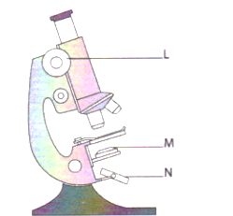
- A learner is using a light microscope to study the components of an animal cell.

K

a. Name the part labelled (2 marks)

K _____________________________________

N. ____________________________________

b. State the functions of the parts labelled L and M.

L -___________________________________________________________________________________ (1 mark)

M - __________________________________________________________________________________(1 mark)

c) Describe two differences between light and electron microscopes. (4 marks)

 | Light microscope | Electron microscope

i

ii

- Learners tested enzyme activity using liver.
a) Define enzyme. (1 mark)
______________________________________________________________________________________________________________________________________________________________________________________________
b) Describe the role of enzymes in cells. (2 marks)
- _________________________________________________________________________________________
- _________________________________________________________________________________________
c) Explain three factors affecting enzyme activity. (3 marks)
- _________________________________________________________________________________________
- _________________________________________________________________________________________
- _________________________________________________________________________________________
d) State two functions of water in cells. (2 marks)
- _________________________________________________________________________________________
- _________________________________________________________________________________________
- During a Biology practical lesson, learners observed a diagram of a chloroplast and discussed its parts and role in plant nutrition.
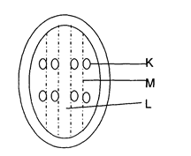

a. Name the parts labeled M and L.

M- _________________________________(1 mark)

L- _______________________________(1 mark)

b. Describe the process that takes place in the structure labeled K. (2 marks) ______________________________________________________________________________________________________________________________________________________________________________________________
c) Explain the importance of photosynthesis. (2 marks)
- _________________________________________________________________________________________
- _________________________________________________________________________________________

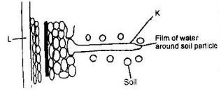
- Learners performed a dye experiment. They set up the experiment as shown below to represents the pathway of water from soil into the plant.

  - Name the structures labeled K and L (2mks)
K_______________
L_______________
  - Explain how water from the soil reaches the structure labeled L. (3mks)

____________________________________________________________________________________________________________________________________________________________________________________________________________________________________________________________________________________________________________________________________________________________________________________________
  - Name the process by which mineral salts enter into the plant. (1mk)

_____________________________________________________________________________
  - Explain two factors affecting transpiration. (2 marks)
- _________________________________________________________________________________________
- _________________________________________________________________________________________
- Learners at Moi Girls Senior School Eldoret studied leaves.
a) Name two gaseous exchange sites. (2 marks)
- _________________________________________________________________________________________
- _________________________________________________________________________________________
b) Describe how stomata open and close. (3 marks)
- _________________________________________________________________________________________
- _________________________________________________________________________________________
- _________________________________________________________________________________________
- _________________________________________________________________________________________

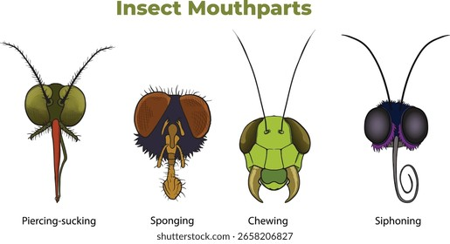

- During an Biology lesson, learners examined different insect mouthparts and discussed how their structures are adapted to specific feeding habits

X Y
a) Identify the types of mouthparts shown. (2 marks)
X: _______________________________________. Y: _______________________________________.
b) Explain how each is adapted to feeding. (4 marks)

X | Y

- Grade 10 learners visited a hospital in Nairobi County, to study about the blood.
a) Name two components of blood. (2 marks)
______________________________________________________________________________________________________________________________________________________________________________________________
b) Describe the pumping mechanism of the heart. (4 marks) ____________________________________________________________________________________________________________________________________________________________________________________________________________________________________________________________________________________________________________________________________________________________________________________________
- During a sports activity learners were involved in some training about respiration:
a) Distinguish between aerobic and anaerobic respiration. (2 marks)
______________________________________________________________________________________________________________________________________________________________________________________________
______________________________________________________________________________________________________________________________________________________________________________________________
b) Define respiratory quotient. (2 marks) ______________________________________________________________________________________________________________________________________________________________________________________________
c) State two factors affecting respiration rate. (2 marks)
- _________________________________________________________________________________________
- _________________________________________________________________________________________

THIS IS THE LAST PRINTED PAGE

