K.C.B.E

KENYA CERTIFICATE OF BASIC EDUCATION

SENIOR SCHOOL ASSESSMENT

TERM 2: ENDTERM ASSESSMENT 2026
GRADE 10 – CHEMISTRY 007 JULY
Time: 2 Hours
LEARNER’S DETAILS
Name: _____________________________________________________________. School: ____________________________________________.
Assessment Number: _______________________________________________. Date: ____________________________________________.
School Code: ______________________________________________________. Signature: _______________________________________.

INSTRUCTIONS TO CANDIDATES
- Write your name in the spaces provided above.
- Write the name of your school and your stream in the spaces provided.
- Write your admission number and the date of the assessment in the spaces provided.
- This paper consists of two sections: A and B.
- Answer all questions in section A and section B.
- Answer the questions in English.
- All answers MUST be written in the spaces provided in the paper.
- Do NOT remove any page from this question paper.

FOR OFFICIAL USE ONLY
SECTION | SECTION A | SECTION B | % SCORE | EE1 | EE2 | ME1 | ME2 | AE1 | AE2 | BE1 | BE2
SCORE RANGE | 30 MARKS | 50 MARKS |  | 90-100 | 75-89 | 58-74 | 41-57 | 31-40 | 21-30 | 11-20 | 1-10
POINTS |  |  |  | 8 POINTS | 7 POINTS | 6 POINTS | 5 POINTS | 4 POINTS | 3 POINTS | 2 POINTS | 1 POINT
LEARNER’S TOTAL SCORE

SECTION A (30 MARKS)
Answer ALL questions in this section.
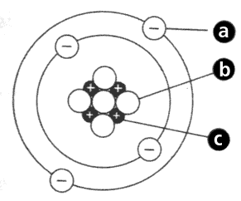
- In Oltanki Senior School laboratory, learners observed a certain atomic models. Three of the learners described it as follows
Peter: “The center contains protons. ”
Achieng: “Electrons move around it.”
Kamau: “It is Rutherford’s model.”
(a) Name the part labelled [+]. (1 mark)
___________________________________________________.
(b) Identify the particle labelled e⁻. (1 mark)
_____________________________________________________________.
(c) State ONE feature of Rutherford’s atomic model. (1 mark)
____________________________________________________________________________________________________________________________________________________________________________________________________
(d) Define the term isotope. (1 mark)
____________________________________________________________________________________________________________________________________________________________________________________________________
(e) State ONE use of isotopes. (1 mark)
____________________________________________________________________________________________________________________________________________________________________________________________________
- A Grade 10 learners from Chewoyet senior school tested the PH of five substances A, B, C, D and E using the universal indicator. He recorded the results in the table below.

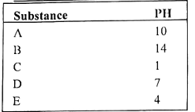

a)Which of the substances is likely to be: (4mks)

i) Sodium hydroxide: ____________________________.

ii) Pure water: ____________________________.

ii) Tomato juice: ____________________________.

iv) hydrochloric acid: ____________________________.
(b) State ONE product of acid + metal reaction. (1 mark)
____________________________________________________________________________________________________________________________________________________________________________________________________
(c) Distinguish strong and weak acids. (2 marks)
____________________________________________________________________________________________________________________________________________________________________________________________________
- The grid given below represents part of the periodic table. Study it and answer the questions that follow. The letters are not the actual symbols of the elements.

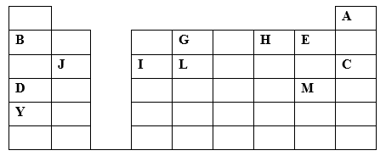

i. What name is given to the family of elements to which A and C belong? :___________________________ (1 mrk)

ii. Write the chemical formula of the sulphate of element D. :_________________________________ (1 mrk)

iii. Which letter represents the most reactive (2mrks)

a. Metal: :_______________________________________

b. Non-metal :_______________________________________

iv. Select one element that belongs to period 4. :_______________________________________ (1mrk)

v. Explain why the Ionic radius of element E is bigger than the atomic radius. (2mrks)

____________________________________________________________________________________________________________________________________________________________________________________________________

vi. The electron configuration of a divalent anion of element N is 2.8.8. Indicate the position of element N on the periodic table drawn above. (1mrk) _________________________________________________________________________________

vii. How do the atomic radii of I and C compare. Explain. (2mrks) ____________________________________________________________________________________________________________________________________________________________________________________________________

viii. Explain the trend in the 1st ionization energies of the elements J, I and L. (1mrk) ____________________________________________________________________________________________________________________________________________________________________________________________________

- At Malava Girls Senior School, learners modeled bonding types.
  - Draw a diagram to show bonding in an ammonium ion. (N = 7, H = 1) (2 marks)

  - Identify the bond in NaCl. _______________________________________ (1 mark)
  - Name ONE property of ionic compounds. (1 mark)
______________________________________________________________________________________________________________________________________________________________________________________________
  - Distinguish ionic and covalent bonds. (2 marks) ______________________________________________________________________________________________________________________________________________________________________________________________
  - State ONE use of metallic bonding materials. (1 mark)
____________________________________________________________________________________________________________________________________________________________________________________________________

SECTION B: (50 MARKS)
- A student in Starehe Boys’ Centre prepared a salt using acid and base.They conducted the following reaction

HCl + NaOH → ___________ + H₂O

(a) Name the salt formed. (1 mark)
_____________________________________________________
(b) State the type of reaction. (1 mark)
_____________________________________________________________________________________________
(c) Identify TWO types of salts. (2 marks)
- _________________________________________________________________________________________
- _________________________________________________________________________________________
(d) State ONE use of salts. (1 mark)
_________________________________________________________________________________________
_________________________________________________________________________________________

- At Kakamega Senior School, learners tested hydrochloric acid with metals.

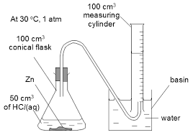

Zn + HCl → Gas bubbles observed
(a) Identify the gas produced. ___________________________(1 mark)
(b) Describe TWO properties of acids. (2 marks)
- ____________________________________________________________________________________________
- ____________________________________________________________________________________________
(c) Write TWO reactions of acids with:
    - metal oxides (2 marks)
____________________________________________________________________________________________________________________________________________________________________________________________________
    - carbonates (2 marks)
____________________________________________________________________________________________________________________________________________________________________________________________________
(d) State ONE use of acids in industry. (1 mark)
____________________________________________________________________________________________________________________________________________________________________________________________________

- (a) The table shows the results of adding three metals, P, Q, and R, to dilute hydrochloric acid and to water.

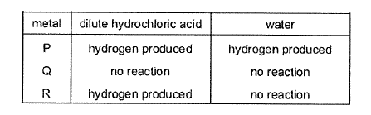

What is the order of reactivity of the metals? (1 mark)
____________________________________________________________________________________________

(b) Study the information provided:-
Element | Atomic radius (nm) | Ionic radius (nm) | Melting point of oxide (ºC )
W  Y  Z | 0.381  0.733  0.544 | 0.418  0.669  0.489 | -117  849  1399
Explain why the melting point of the oxide of W is lower than that of the oxide of Z (2 marks)
________________________________________________________________________________________________________________________________________________________________________________________
- A learner in Mary Hill Senior School prepared copper sulfate crystals.
(a) Describe THREE methods of preparing salts. (3 marks)
- _______________________________________________________________________________________________
- _______________________________________________________________________________________________
- _______________________________________________________________________________________________
(b) Explain behavior of salts in air. (2 marks)
- _______________________________________________________________________________________________
- _______________________________________________________________________________________________
(c) State TWO uses of salts. (2 marks)
- _______________________________________________________________________________________________
- _______________________________________________________________________________________________

- The table below gives information about ions of P and Y

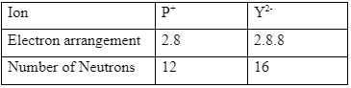

a. Write the electron configuration for the atom of Y (1mk)

___________________________________________________

b. How many protons are there in the nucleus of (2mks)

(i) P________________________________________________

(ii) Y________________________________________________

c. Write the formula of the compound formed when P and Y reacts (2mks)

________________________________________________________________________________________________
(d) State TWO uses of sodium. (2 marks)
- _______________________________________________________________________________________________
- _______________________________________________________________________________________________
(e) Identify ONE safety precaution when handling alkali metals. (2 marks)
____________________________________________________________________________________________________________________________________________________________________________________________________

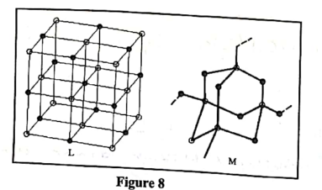
- Study the structures of substances L and M shown below

Complete the table given by giving the names that describe the type of structure and bonding in each substance. (2 marks)
Substances | L | M

Structure

Bonding

- The atomic numbers of nitrogen and fluorine are 7 and 9 respectively.

a. Draw electron dot (•) and cross (x) diagrams to illustrate bonding in the molecules of:

i. nitrogen; (1 mark) ii. fluorine (1 mark)

b. With reference to the diagrams in (a), state why fluorine is more reactive than nitrogen. (1 mark) ____________________________________________________________________________________________________________________________________________________________________________________________________
- At Maranda Senior School, learners studied chlorine isotopes.
Cl-35 = 75%
Cl-37 = 25%
(a) Define relative atomic mass. (2 marks)
____________________________________________________________________________________________________________________________________________________________________________________________________
(b) Calculate relative atomic mass of chlorine. (2 marks)

- A factory in Nairobi Industrial Area produces fertilizers and detergents.
(a) Explain THREE uses of chemistry in daily life. (3 marks)
- _______________________________________________________________________________________________
- _______________________________________________________________________________________________
- _______________________________________________________________________________________________
(b) State TWO environmental effects of chemical misuse. (2 marks)
- _______________________________________________________________________________________________
- _______________________________________________________________________________________________
(c) Suggest TWO safety measures in chemical handling. (2 marks)
- _______________________________________________________________________________________________
- _______________________________________________________________________________________________
- Ethanol is a liquid at room temperature but does not conduct electricity. Explain.(2 marks)

____________________________________________________________________________________________________________________________________________________________________________________________________

THIS IS THE LAST PRINTED PAGE

