KENYA CERTIFICATE OF BASIC EDUCATION

SENIOR SCHOOL ASSESSMENT

TERM 2: ENDTERM ASSESSMENT 2026
GRADE 10 – COMPUTER STUDIES 007 JULY
Time: 2 Hours
LEARNER’S DETAILS
Name: _____________________________________________________________. School: ____________________________________________.
Assessment Number: _______________________________________________. Date: ____________________________________________.
School Code: ______________________________________________________. Signature: _______________________________________.

INSTRUCTIONS TO CANDIDATES
- Write your name in the spaces provided above.
- Write the name of your school and your stream in the spaces provided.
- Write your admission number and the date of the assessment in the spaces provided.
- This paper consists of two sections: A and B.
- Answer all questions in section A and section B.
- Answer the questions in English.
- All answers MUST be written in the spaces provided in the paper.
- Do NOT remove any page from this question paper.

FOR OFFICIAL USE ONLY (EXAMINER’S USE)
SECTION | SECTION A | SECTION B | % SCORE | EE1 | EE2 | ME1 | ME2 | AE1 | AE2 | BE1 | BE2
SCORE RANGE | 30 MARKS | 50 MARKS |  | 90-100 | 75-89 | 58-74 | 41-57 | 31-40 | 21-30 | 11-20 | 1-10
POINTS |  |  |  | 8 POINTS | 7 POINTS | 6 POINTS | 5 POINTS | 4 POINTS | 3 POINTS | 2 POINTS | 1 POINT
LEARNER’S TOTAL SCORE

SECTION A (30 MARKS)
Answer ALL questions in this section.
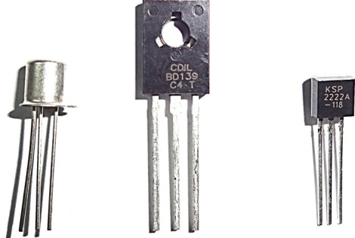
- Amani, a learner at Mumbi Girls senior School, is creating a chart to show the principle technologies that defined computer generations. He has collected the following components:

(a) Identify the technology labeled above that belongs to the Second Generation of computers. (1 Mark) ___________________________________________________
(b) Write the technology used in the respective generation: (3 Marks)
- Vacuum Tubes: ________________________
- Integrated Circuits (ICs): ________________________
- Very Large Scale Integration (VLSI): ________________________
  - At Santa Education Centre, three learners are describing the Fetch-Decode-Execute cycle:
Wekesa: "I am the component that fetches the instruction from the main memory."
Cherono: "I translate the instruction into signals the computer understands."
Njoroge: "I actually carry out the mathematical calculations."
(a) List the names of the CPU components described by Wekesa and Njoroge. (2 Marks)
- Wekesa: _________________________
- Njoroge: _________________________
(b) State whether the following is TRUE or FALSE:
The Von Neumann architecture uses separate storage for instructions and data. [__________] (1 Mark)
  - Morara was standing at a police roadblock in Narok and observed an officer using a Walkie-Talkie.
(a) Identify the mode of data flow used by the Walkie-Talkie. (1 Mark)
______________________________________________________________
(b) Distinguish between the mode identified in (a) and the Full-Duplex mode used by a mobile phone. (2 Marks)
_____________________________________________________________________________________________________________________________________________________________________________________________________________________________________________________________________________________________
  - (a) Define the term Operating System. (2 Marks)
______________________________________________________________________________________________________________________________________________________________________________________________
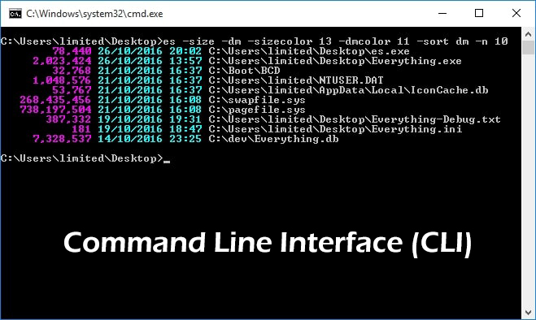
(b) Name the type of User Interface (UI) shown in the image below. (1 Mark)

______________________________________________
  - Kendi is writing a Python program at Kenya High School. She wrote the following line:

total_score = (math_mark + eng_mark) * 0.5
(a) Identify one identifier and one arithmetic operator from the code above. (2 Marks)
Identifier: _________________________
Operator: _________________________
(b) Outline the order of precedence used to evaluate the expression in the brackets first. (2 Marks)
- _____________________________________________________________________________________
- ______________________________________________________________________________________
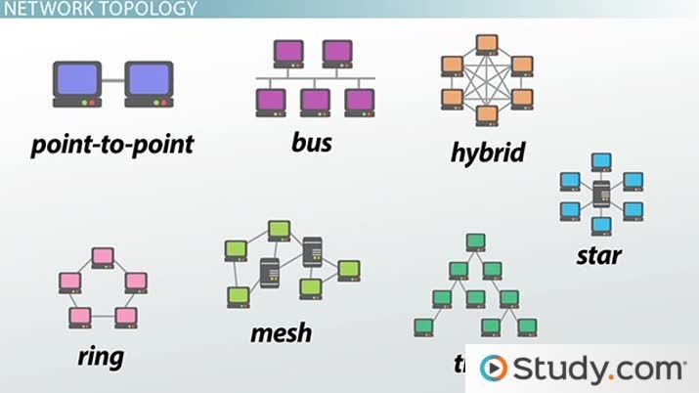
  - Look at the network layouts below found in a computer lab in Machakos.
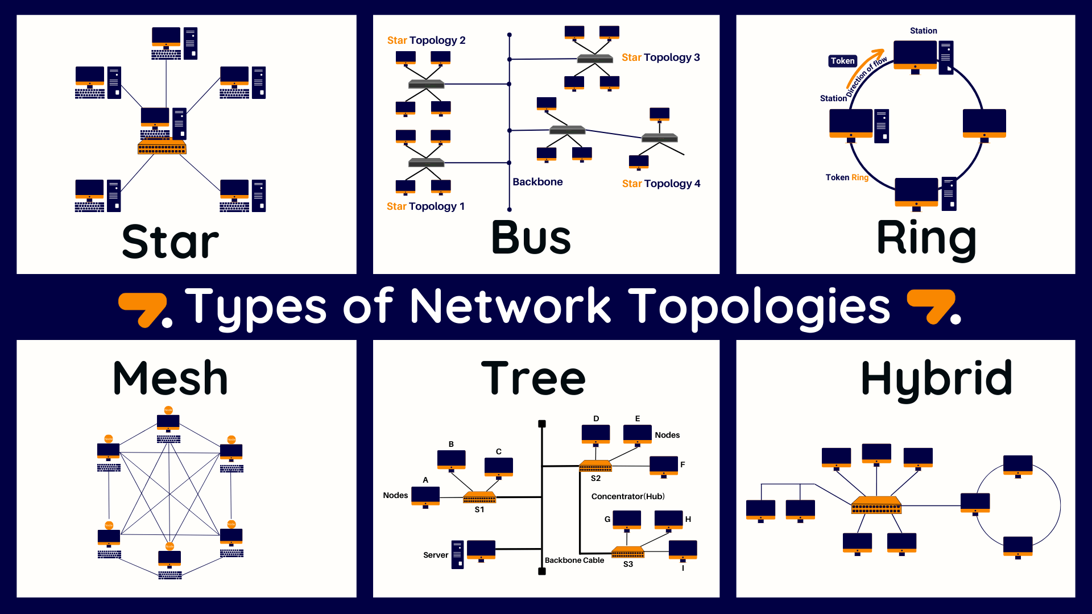

Q R S
(a) Identify the topology Q. _____________________________________ (1 Mark)
(b) Mention one disadvantage of the topology R. (1 Mark)
______________________________________________________________________________________________________________________________________________________________________________________________
  - (a) List three types of containers used in Python programming. (3 Marks)
- _____________________________________________________________________________________
- ______________________________________________________________________________________
- _____________________________________________________________________________________
(b) Compare a List and a Tuple in terms of mutability. (2 Marks)
List | Tuple

  - Bakari is designing an algorithm to check if a student has passed an exam.
(a) Name the flowchart symbol used for "Decision" making. (1 Mark)
____________________________________________________________
(b) Draw the symbol used to indicate the "Start" or "Stop" of a program. (2 Marks)

SECTION B (50 MARKS)
(Answer ALL questions in this section)
  - Tambach Senior School wants to connect two buildings that are 5 kilometers apart to share the internet. (a) Select the most appropriate type of network for this scenario. (1 Mark)

LAN MAN WAN


(b) Below is a transmission media best for high-speed transmission over long distances. (1 Mark)

Identify the transmission media shown: ____________________________________.

(c) Explain three factors that can lead to transmission impairment in a network. (6 Marks)
- _____________________________________________________________________________________
- ______________________________________________________________________________________
- _____________________________________________________________________________________
(d) Describe the function of a Router in this network setup. (1 Mark)
______________________________________________________________________________________________________________________________________________________________________________________________
(e) Identify three online problems that can be caused by using pubic Wi-Fi. (3 Marks)

- _____________________________________________________________________________________
- ______________________________________________________________________________________
- _____________________________________________________________________________________
  - A graphic designer in Nairobi is choosing between two computers. One has an SSD and the other an HDD.
(a) Write in full. (2 Marks)
- SSD: _____________________________________________________________________________________.
- HDD: ____________________________________________________________________________________.
(b) Distinguish between primary and secondary storage. (2 Marks)
____________________________________________________________________________________________________________________________________________________________________________________________________________________________________________________________________________________________________________________________________________________________________________________________
(c) Explain two advantages of using an SSD over an HDD for a designer. (2 Marks)
- ______________________________________________________________________________________
- ______________________________________________________________________________________
(d) Identify the component of the CPU shown in the block diagram below. (1 Mark)

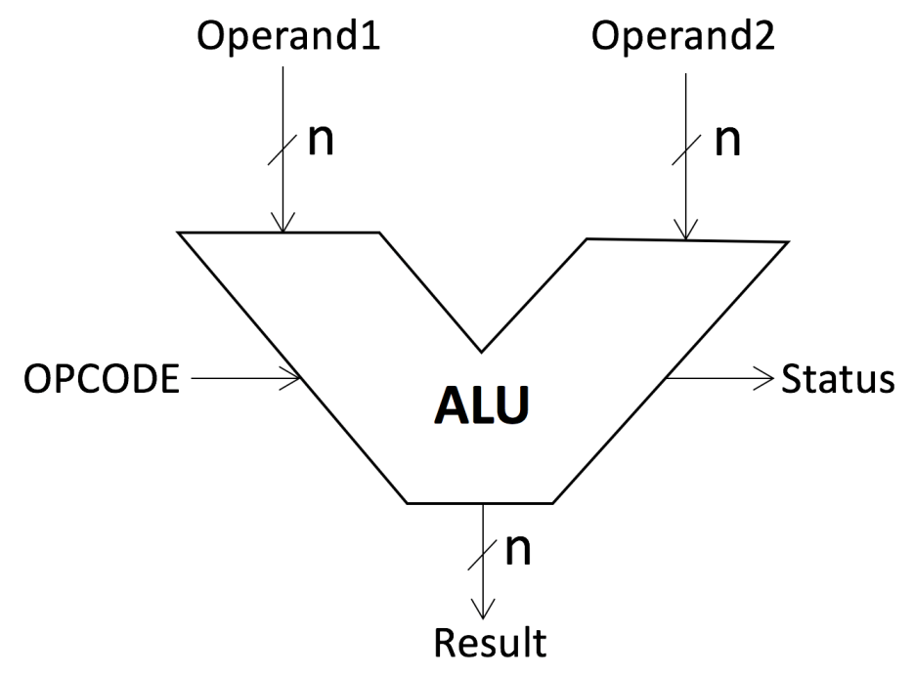

___________________________________

(e) Outline the difference between RISC and CISC processor architectures. (4 Marks)
____________________________________________________________________________________________________________________________________________________________________________________________________________________________________________________________________________________________________________________________________________________________________________________________
(f) Name one type of ROM technology. (2 Marks)
____________________________________________________________
  - A group of learners in Thika Senior School are developing a program to calculate the average age of 10 students. (a) Arrange the following stages of the Program Development Cycle in the correct order: (5 Marks) Coding,
Implementation,
Problem Definition
Program Design
Testing

___________________________________________________________________________________________________________________________________________________________________________________________________________________________________________________________________________________________________________________________________________________________________________________________________________________________________________________________________________________________
(b) Write a pseudocode that accepts the ages of two students and displays the average. (4 Marks)
____________________________________________________________________________________________________________________________________________________________________________________________________________________________________________________________________________________________________________________________________________________________________________________________
(c) Identify the error in the following Python snippet:
print("Your age is" + age) (where age is an integer). (2 Marks)
______________________________________________________________________________________________________________________________________________________________________________________________
(d) Define what an Integrated Development Environment (IDE) is. (2 Marks)
______________________________________________________________________________________________________________________________________________________________________________________________
  - Zahara, a student in Mombasa, has a list of marks:
[45, 82, 33, 60].

She needs to sort them in ascending order.
(a) Describe how the Bubble Sort technique works to sort this list. (4 Marks)
____________________________________________________________________________________________________________________________________________________________________________________________________________________________________________________________________________________________________________________________________________________________________________________________

(b) Explain the difference between Sequential Search and Binary Search. (4 Marks)
____________________________________________________________________________________________________________________________________________________________________________________________________________________________________________________________________________________________________________________________________________________________________________________________
(c) Identify the data structure shown in the image below. (1 Mark)
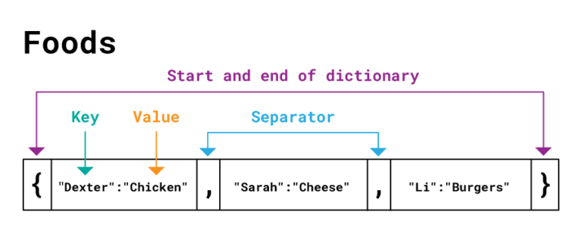
_______________________________________________________________________________________________
(d) Mention three characteristics of an effective algorithm. (3 Marks)
- ______________________________________________________________________________________
- ______________________________________________________________________________________
- ______________________________________________________________________________________

THIS IS THE LAST PRINTED PAGE

