KENYA CERTIFICATE OF BASIC EDUCATION

SENIOR SCHOOL ASSESSMENT

TERM 2: ENDTERM ASSESSMENT 2026
GRADE 10 – CORE MATHEMATICS 007 JULY
Time: 2 Hours
LEARNER’S DETAILS
Name: _____________________________________________________________. School: ____________________________________________.
Assessment Number: _______________________________________________. Date: ____________________________________________.
School Code: ______________________________________________________. Signature: _______________________________________.

INSTRUCTIONS TO CANDIDATES
- Write your name in the spaces provided above.
- Write the name of your school and your stream.
- Write your admission number and date.
- This paper consists of two sections: A and B.
- Answer all questions.
- Show your working clearly.
- All answers must be written in the spaces provided.
- Do NOT remove any page.

FOR OFFICIAL USE ONLY
SECTION | SECTION A | SECTION B | % SCORE | EE1 | EE2 | ME1 | ME2 | AE1 | AE2 | BE1 | BE2
SCORE RANGE | 30 MARKS | 50 MARKS |  | 90-100 | 75-89 | 58-74 | 41-57 | 31-40 | 21-30 | 11-20 | 1-10
POINTS |  |  |  | 8 POINTS | 7 POINTS | 6 POINTS | 5 POINTS | 4 POINTS | 3 POINTS | 2 POINTS | 1 POINT
LEARNER’S TOTAL SCORE

SECTION A (30 MARKS)
Answer ALL questions in this section.


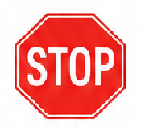
The diagrams below represent common road signs:
(a) (b)

State the number of lines of symmetry for the
Triangle: _________________ Octagon: _______________________

- Given that A’ (3, -3) is the image of A (-1, -5) under a reflection. Find the equation of the mirror line in the form of ax+by+c= 0. (5 marks)

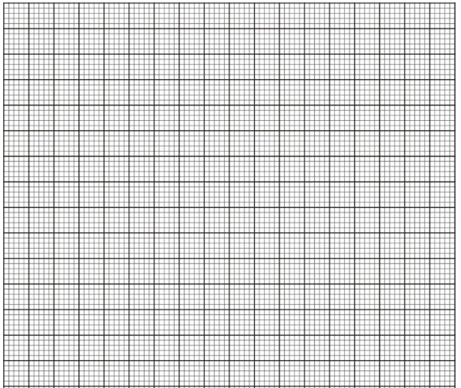

- A straight line L₁ whose equation is y = 2 – ¹/₃ x meets the y – axis at Q. Another straight line L₂ is perpendicular to L₁ at Q. Find the equation of L₂ in the form y = mx + c where m and c are constants. (3 marks)

- Solve for x in the equation 25^{x}=125 ^{2/3} ÷5⁻¹(3 marks)

- A carpenter had two big pieces of wood of equal length. The carpenter cut the first piece into smaller pieces of length 15 cm each without remainder. The carpenter cut the second piece into smaller pieces of length 24 cm each without remainder. Determine the minimum length of each of the big pieces of wood. (2 marks)

- A cylindrical container of internal radius 10.5 cm has a hemispherical base. The container has water up to a height of 30.5 cm. Calculate the surface area of the container that is in contact with water. (Take π =²²/₇) (4 marks)

- In the following figure, points A and D are vertices of a trapezium ABCD. Line DC is parallel to line AQ. Line DC = 4 cm. Point B lies on the line AQ such that angle DCB = 90°.

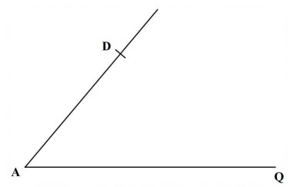

Using a rule and a pair of compasses only, complete the trapezium. Hence, measure the length of line AB. (4 marks)
- The length of a minor arc AB of a circle centre O is 10 cm. The arc AB subtends an angle of 1.25 radians at O. Calculate the area of the minor sector AOB. (3 marks)

- The following figure represents part of a pattern. A line of symmetry, L₁, of the pattern is also shown.

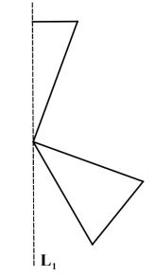

Complete the pattern and hence state the order of rotational symmetry of the patterns. (3 marks)
- The following figure (not drawn to scale) represents a communication mast. The mast has been divided into 4 equal parts. A point P is 30 m from the foot of the mast on the same ground level.

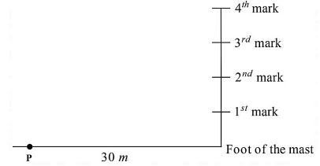

The angle of elevation of the 3rd mark from P is 50°. Calculate the height of the mast. (3 marks)

- The following marks were scored by Grade 10 learners in a Mathematics quiz:
12, 15, 18, 12, 20, 15, 14, 12, 16
(a) Calculate the mean mark. (1 mark)

(b) Determine the median mark. (1 mark)

(c) State the mode of the data. (1 mark)

- Use the cartesian plane provided to solve graphically the simultaneous equations 2x + 3y = 1.2 and 5x + 4y = 1

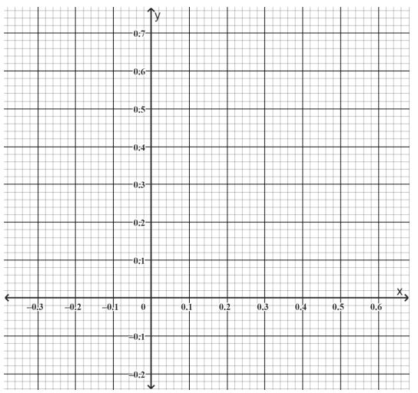
- On the cartesian plane below, triangle ABC has vertices A (–4, –4), B (–2.5, 7) and C (–2, –5.5) while triangle A"B"C" has vertices A" (1, 2), B" (4, 8) and C" (5, 5). The line joining A" (2, –1), B" (8, –4) is part of another triangle A" B" C".

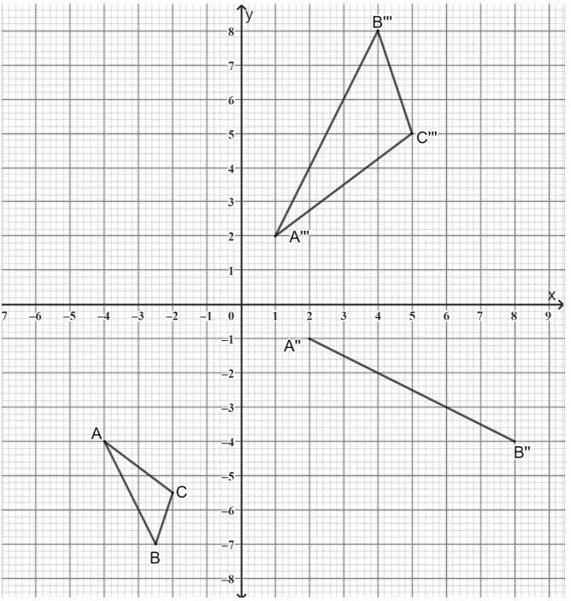

(a) Triangle A' B' C' is the image of triangle ABC under an enlargement centre (−3, −2) and scale factor (S.F.) = −2.

On the same grid, draw ΔA' B' C'. (3 marks)

(b) Triangle A'' B'' C'' is the image of triangle A' B' C' under rotation centre O (0, 0)

(i) State the angle of rotation. (1 mark)

(ii) Complete triangle A'' B'' C'' (2 marks)

(c) Triangle A'' B'' C'' is the image of triangle A' B' C' under a reflection.

(i) Draw the mirror line. (1 mark)

(ii) Determine the equation of the mirror line in the form y = mx + c (2 marks)

(d) Describe fully a single transformation that maps triangle

A' B' C' onto triangle A'' B'' C'' (1 mark)

- John cycles from shopping centre A on a bearing of 120º for 5 km to shopping centre B. He then cycles on a bearing of 200º for 7 km to the shopping centre C. Calculate to 1 decimal place.
  - The direct distance from A to C.

  - The bearing of A from C.
  - Bearing of B from C.

- Given that tan x = ⁵/₁₂, find the value of the following without using mathematical tables or calculator:
  - Cos x

  - Sin²(90-x)

- In a triangle ABC, angle B is 90º. Find the value of x and hence the area of the triangle
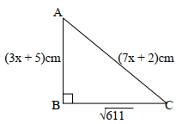

- Solve the following inequalities and represent the solution on a number line hence state the integral values 7x – 4 ≤9x + 2 <3x + 14

- The figure below represents a triangular plot ABC. The lengths of AB = 50m, AC = 80m and angle BAC =30º

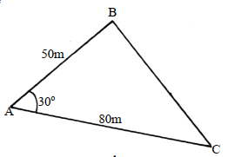
  - Find the length of BC to 2 s.f

  - Find the area of the plot in hectares

  - The plot is fenced using 4 strands of barbed wire. The length of one roll of barbed wire is 600m and it costs shs.4000. Calculate;
    - The length of fencing wire required

    - The number of complete rolls to be bought

    - The cost of the rolls

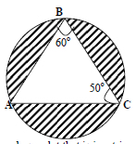
- The figure below is a circle of radius 5cm. Points A, B and C are the vertices of the triangle ABC in which <ABC = 60º and <ACB=50º which is in the circle. Calculate the area of triangle ABC )

THIS IS THE LAST PRINTED PAGE

