KENYA CERTIFICATE OF BASIC EDUCATION

SENIOR SCHOOL ASSESSMENT

TERM 2: ENDTERM ASSESSMENT 2026
GRADE 10 – CHRISTIAN RELIGIOUS EDUCATION 006 JUNE
Time: 2 Hours
LEARNER’S DETAILS
Name: _____________________________________________________________. School: ____________________________________________.
Assessment Number: _______________________________________________. Date: ____________________________________________.
School Code: ______________________________________________________. Signature: _______________________________________.

INSTRUCTIONS TO CANDIDATES
- Write your name in the spaces provided above.
- Write the name of your school and your stream.
- Write your admission number and the date.
- This paper consists of TWO sections: A and B.
- Answer ALL questions in both sections.
- Answer all questions in English.
- All answers MUST be written in the spaces provided.
- Do NOT remove any page from this paper.

FOR OFFICIAL USE ONLY
SECTION | SECTION A | SECTION B | % SCORE | EE1 | EE2 | ME1 | ME2 | AE1 | AE2 | BE1 | BE2
SCORE RANGE | 30 MARKS | 50 MARKS |  | 90-100 | 75-89 | 58-74 | 41-57 | 31-40 | 21-30 | 11-20 | 1-10
POINTS |  |  |  | 8 POINTS | 7 POINTS | 6 POINTS | 5 POINTS | 4 POINTS | 3 POINTS | 2 POINTS | 1 POINT
LEARNER’S TOTAL SCORE

SECTION A (30 MARKS)
Answer ALL questions in this section.
- Wamaitha, a student at Starehe Girls School, is leading a Bible study session. He shows his peers the following image of a scroll to explain how the Bible was written.
(a) Define the term 'Inspired' as used in the context of the Holy Bible. (2 Marks)
________________________________________________________________________________________________________________________________________________________________________________________________________________
(b) Identify two human authors of the Bible who were inspired by the Holy Spirit. (2 Marks)
- ____________________________________________________________________________________________________
- ____________________________________________________________________________________________________
(c) Explain why the Bible is referred to as a "Library" of books. (2 Marks)
________________________________________________________________________________________________________________________________________________________________________________________________________________
- At Kamasara Senior School, four learners are categorizing books of the Old Testament:
Wanjiku: "I think Genesis and Exodus belong to the Law books."
Achieng: "Isaiah and Jeremiah are definitely Major Prophets."
Kiplagat: "Psalms and Proverbs are books of Poetry."
Mutua: "Ruth and Esther are classified as Historical books."
(a) List the four categories of Old Testament books mentioned by the learners. (4 Marks)
Learner | Category described

Wanjiku

Achieng

Kiplagat

Mutua
(b) Identify which learner correctly identified the category for the book of Proverbs. (1 Mark)
___________________________________________________________
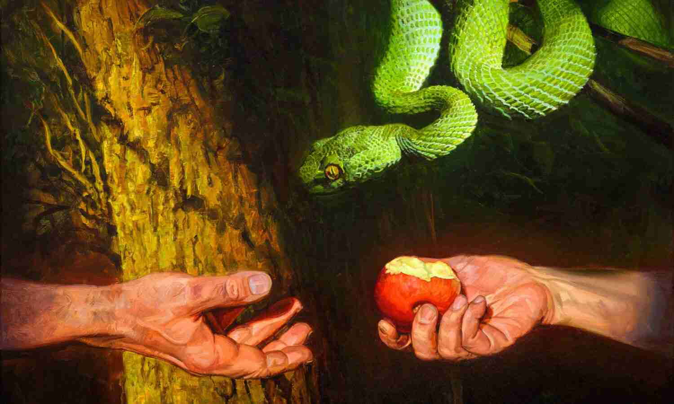
- Look at the illustration below representing a significant event in the Garden of Eden.

(a) Identify the event depicted in the image. (1 Mark)
______________________________________________________________________________

(b) Outline two consequences of sin based on the story of the fall of man in Genesis 3. (2 Marks)
- ____________________________________________________________________________________________________
- ____________________________________________________________________________________________________
(c) Define the term 'Redemption'. (2 Marks)
________________________________________________________________________________________________________________________________________________________________________________________________________________
- Juma, a learner from Mandera Senior School, is participating in a tree-planting exercise in Haller Park.
(a) Select the principle of stewardship Juma is practicing in the image above. (1 Mark)
_______________________________________________________________________________________________
(b) State whether the following is TRUE or FALSE:
According to Genesis 1:26-28, God gave man dominion over creation to exploit it selfishly. [__________] (1 Mark)
(c) Mention two qualities of a good steward. (2 Marks)
- ____________________________________________________________________________________________________
- ____________________________________________________________________________________________________
- Study the diagram below showing the miraculous crossing of the Israelites.
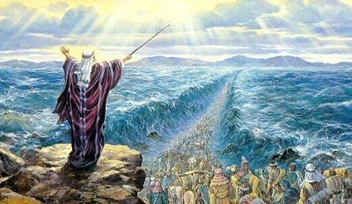
(a) Name the leader of the Israelites shown leading the people across the sea. (1 Mark)
_________________________________________________________________________

(b) Identify the attribute of God revealed through the tenth plague. (1 Mark)
_____________________________________________________________________________
(c) Distinguish between the Passover Lamb and Jesus Christ as the 'Lamb of God'. (2 Marks)
________________________________________________________________________________________________________________________________________________________________________________________________________________________________________________________________________________________________________________________
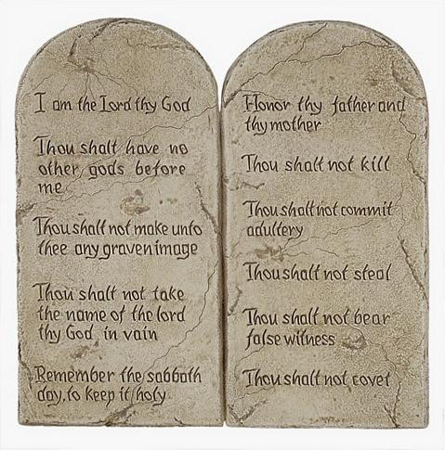
- (a) Identify the object shown in the image below where the Ten Commandments were written. (1 Mark)

(b) Explain one way the Israelites broke the Sinai Covenant while Moses was on the mountain. (2 Marks)
________________________________________________________________________________________________________________________________________________________________________________________________________________
(c) Describe how the Sinai Covenant was renewed. (3 Marks)
________________________________________________________________________________________________________________________________________________________________________________________________________________________________________________________________________________________________________________________________________________________________________________________________________________________________________________________________________________________________________________________________________________________________________________________________________________________________________________

SECTION B (50 MARKS)
(Answer ALL questions in this section)
- A group of learners at Maseno School are watching a video about the contest at Mount Carmel.
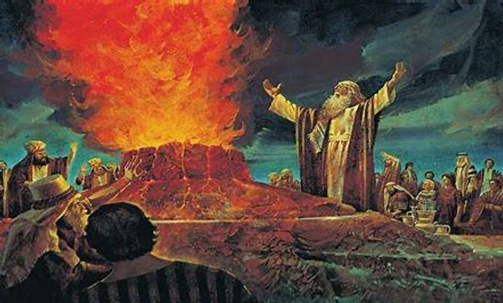
(a) Identify the location where the event in the image took place. (1 Mark)
____________________________________________________________________________________
(b) Explain the reasons why Elijah contested against the prophets of Baal. (4 Marks)
- ____________________________________________________________________________________________________
- ____________________________________________________________________________________________________
- ____________________________________________________________________________________________________
- ____________________________________________________________________________________________________
(c) Describe the circumstances that led to Elijah’s flight to Mount Horeb. (4 Marks)
- ____________________________________________________________________________________________________
- ____________________________________________________________________________________________________
- ____________________________________________________________________________________________________
- ____________________________________________________________________________________________________
(d) Outline three forms of idol worship or religious extremism in Kenya today. (3 Marks)
- ____________________________________________________________________________________________________
- ____________________________________________________________________________________________________
- ____________________________________________________________________________________________________
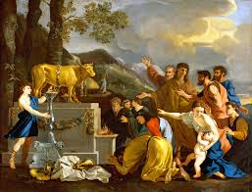
- During a CRE symposium at Kilgoris Girls Senior School, a CRE teacher asks the students to relate the teachings of Prophet Amos to modern social evils.

(a) Identify the social evil depicted in the illustration above. (1 Mark)
_____________________________________________________________________________
(b) Describe the religious background of the people of Israel during the time of Prophet Amos. (4 Marks)
- ____________________________________________________________________________________________________
- ____________________________________________________________________________________________________
- ____________________________________________________________________________________________________
- ____________________________________________________________________________________________________
(c) Explain the meaning of "The Day of the Lord" according to Prophet Amos. (4 Marks)
________________________________________________________________________________________________________________________________________________________________________________________________________________________________________________________________________________________________________________________
(d) Compare the theme of 'Remnant' and 'Restoration' in the book of Amos. (4 Marks)
________________________________________________________________________________________________________________________________________________________________________________________________________________________________________________________________________________________________________________________________________________________________________________________________________________________________
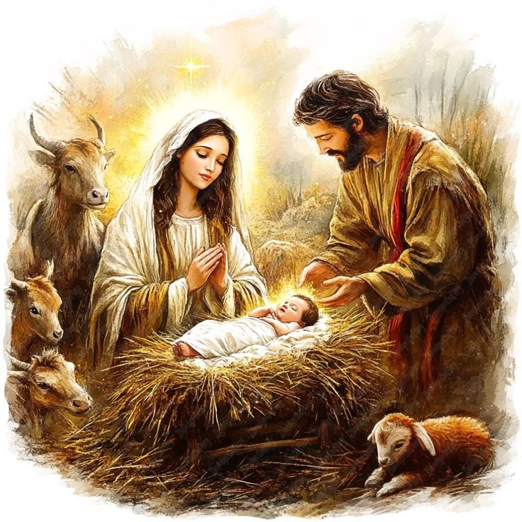
- In Limuru Girls' Senior School, learners are preparing a skit about the visit of the Shepherds.

(a) Name the town where Jesus was born as shown in the image. (1 Mark)
____________________________________________________________
(b) Describe the role of John the Baptist as a link between the Old and the New Testament. (4 Marks)
- ____________________________________________________________________________________________________
- ____________________________________________________________________________________________________
- ____________________________________________________________________________________________________
- ____________________________________________________________________________________________________
(c) Discuss the relevance of Jesus' baptism to Christians today. (4 Marks)
- ____________________________________________________________________________________________________
- ____________________________________________________________________________________________________
- ____________________________________________________________________________________________________
- ____________________________________________________________________________________________________
(d) State three temptations Jesus faced in the wilderness. (3 Marks)
- ____________________________________________________________________________________________________
- ____________________________________________________________________________________________________
- ____________________________________________________________________________________________________
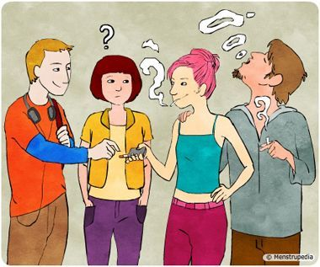
- A counselor is addressing Grade 10 learners at Kapsabet Boys Senior School on responsible living.

(a) Identify the ethical issue facing the youth being addressed in the image. (1 Mark)
______________________________________________________________________________________

(b) Distinguish between 'Dating' and 'Courtship' from a Christian perspective. (4 Marks)
____________________________________________________________________________________________________
____________________________________________________________________________________________________
____________________________________________________________________________________________________
____________________________________________________________________________________________________
(c) Explain the Christian teaching on male-female relationships based on Genesis 1:26-28. (4 Marks)
- ____________________________________________________________________________________________________
- ____________________________________________________________________________________________________
- ____________________________________________________________________________________________________
- ____________________________________________________________________________________________________
(d) Propose solutions to the challenge of irresponsible sexual behavior among teenagers in Kenya. (4 Marks)
- ____________________________________________________________________________________________________
- ____________________________________________________________________________________________________
- ____________________________________________________________________________________________________
- ____________________________________________________________________________________________________

THIS IS THE LAST PRINTED PAGE

