KENYA CERTIFICATE OF BASIC EDUCATION

SENIOR SCHOOL ASSESSMENT

TERM 2: ENDTERM ASSESSMENT 2026
GRADE 10 – COMMUNITY SERVICE LEARNING 007 JULY
Time: 2 Hours
LEARNER’S DETAILS
Name: _____________________________________________________________. School: ____________________________________________.
Assessment Number: _______________________________________________. Date: ____________________________________________.
School Code: ______________________________________________________. Signature: _______________________________________.

INSTRUCTIONS TO CANDIDATES
- Write your name in the spaces provided above.
- Write the name of your school and your stream.
- Write your admission number and the date.
- This paper consists of TWO sections: A and B.
- Answer ALL questions in both sections.
- Answer all questions in English.
- All answers MUST be written in the spaces provided.
- Do NOT remove any page from this paper.

FOR OFFICIAL USE ONLY (EXAMINER’S USE)
SECTION | SECTION A | SECTION B | % SCORE | EE1 | EE2 | ME1 | ME2 | AE1 | AE2 | BE1 | BE2
SCORE RANGE | 30 MARKS | 50 MARKS |  | 90-100 | 75-89 | 58-74 | 41-57 | 31-40 | 21-30 | 11-20 | 1-10
POINTS |  |  |  | 8 POINTS | 7 POINTS | 6 POINTS | 5 POINTS | 4 POINTS | 3 POINTS | 2 POINTS | 1 POINT
LEARNER’S TOTAL SCORE

SECTION A (30 MARKS)
Answer ALL questions in this section.
- At Kibera Senior School, Nairobi, learners are developing a social enterprise project to recycle plastic waste into school chairs.
Plastic Waste → Collection → Sorting → Recycling → Chairs Production
↑ ↑ ↑ ↑
Community Students Machines Market Sales
a) Identify TWO resources shown in the illustration above. (2 marks)
- _________________________________________________.
- _________________________________________________.
b) List THREE ways learners can mobilise resources for the project. (3 marks)
- __________________________________________________________________________________.
- __________________________________________________________________________________.
- __________________________________________________________________________________.
c) State ONE importance of resource mobilisation in social entrepreneurship. (1 mark)
_________________________________________________________________________________________________________
- Learners from Nairobi School conducted a survey in Mathare slums and found the following:
- Lack of clean water
- Poor waste disposal
- Unemployment among youth
- Poor health services

TASK:
a) List FOUR community needs identified. (4 marks)
- __________________________________________________________________________________.
- __________________________________________________________________________________.
- __________________________________________________________________________________.
- __________________________________________________________________________________.
b) Identify ONE category of needs from the list above. (1 mark) ________________________________________________________________________________________________________________________________________________________________________________________________
- Learners at Moi Girls Eldoret are investigating poor hygiene in dormitories.
PLAN → ACT → OBSERVE → REFLECT → (repeat)
a) Name the cycle shown in Figure above. ____________________________________(1 mark)
b) Outline FOUR stages of action research. (4 marks)
- __________________________________________________________________________________.
- __________________________________________________________________________________.
- __________________________________________________________________________________.
- __________________________________________________________________________________.

- At Kanga Senior School, learners from different counties participated in cultural day held at the school ground.
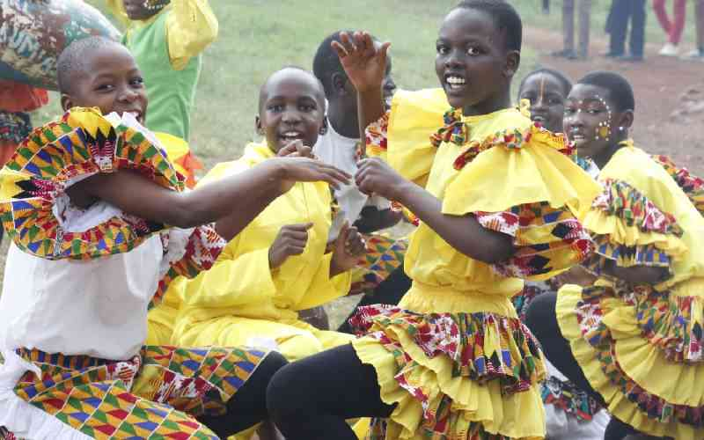
a) Identify the concept illustrated in Figure 3. ___________________________________(1 mark)
b) List FOUR benefits of intercultural interaction. (4 marks)
- __________________________________________________________________________________.
- __________________________________________________________________________________.
- __________________________________________________________________________________.
- __________________________________________________________________________________.
c) State ONE attitude needed for peaceful coexistence. (1 mark)
________________________________________________________________________________________________________________________________________________________________________________________________
- Two learners at Starehe Boys Centre disagree over leadership roles in a CSL project.
a) List TWO conflict resolution strategies they can use. (2 marks)
- __________________________________________________________________________________.
- __________________________________________________________________________________.
- __________________________________________________________________________________.

b) State TWO causes of conflict among learners. (2 marks)
- __________________________________________________________________________________.
- __________________________________________________________________________________.
- Learners at Nakuru High School are planning a school garden enterprise.
a) Name TWO components of a social enterprise plan. (2 marks)
- __________________________________________________________________________________.
- __________________________________________________________________________________.
b) State TWO reasons why planning is important in social enterprise. (2 marks)
- __________________________________________________________________________________.
- __________________________________________________________________________________.

SECTION B: (50 MARKS)

(Answer ALL questions)
- At Kisumu Girls High School, learners want to start a fish farming project to support school feeding programs.
a) Explain FIVE steps of resource mobilisation for this project. (5 marks)
- __________________________________________________________________________________.
- __________________________________________________________________________________.
- __________________________________________________________________________________.
- __________________________________________________________________________________.
- __________________________________________________________________________________.
b) Distinguish between locally available and externally sourced resources. (2 marks)
________________________________________________________________________________________________________________________________________________________________________________________________________________________________________________________________________________________________
c) Suggest THREE ways learners can manage resources effectively. (3 marks)
- __________________________________________________________________________________.
- __________________________________________________________________________________.
- __________________________________________________________________________________.
- Learners at Lenana School identified littering as a major problem in school.

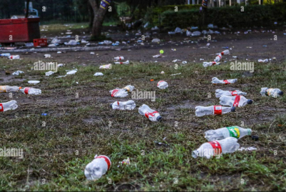
a) Identify the problem shown in the image above: ___________________________________ (1 mark)
b) Describe FOUR steps learners would take to implement an action plan. (4 marks)
- __________________________________________________________________________________.
- __________________________________________________________________________________.
- __________________________________________________________________________________.
- __________________________________________________________________________________.
c) Explain THREE benefits of action research in solving school problems. (3 marks)
- __________________________________________________________________________________.
- __________________________________________________________________________________.
- __________________________________________________________________________________.
d) State TWO data collection tools used in action research. (2 marks)
- __________________________________________________________________________________.
- __________________________________________________________________________________.
- Learners from Bahati High School, Nakuru County, visited a nearby village and observed:
- Drug abuse among youth
- Early school dropout
- Teenage pregnancies
a) Identify THREE problems from the scenario. (3 marks)
- __________________________________________________________________________________.
- __________________________________________________________________________________.
- __________________________________________________________________________________.
b) Explain FOUR ways learners can collect data on these problems. (4 marks)
- __________________________________________________________________________________.
- __________________________________________________________________________________.
- __________________________________________________________________________________.
- __________________________________________________________________________________.
c) Suggest THREE ways of documenting community data. (3 marks)
- __________________________________________________________________________________.
- __________________________________________________________________________________.
- __________________________________________________________________________________.
Item Quantity Cost (Ksh)
Fabric 10 metres _______
Threads 20 rolls _______
Machines 2 units _______
a) Complete TWO missing budget values logically. (2 marks)
- __________________________________________________________________________________.
- __________________________________________________________________________________.
b) Outline FOUR steps in developing a social enterprise budget. (4 marks)
- __________________________________________________________________________________.
- __________________________________________________________________________________.
- __________________________________________________________________________________.
- __________________________________________________________________________________.
c) Explain TWO roles of budgeting in social entrepreneurship. (4 marks)
- __________________________________________________________________________________.
- __________________________________________________________________________________.
- Learners at Garissa Senior School are preparing a CSL campaign on responsible decision-making.
a) Define responsible decision-making. (2 marks)
________________________________________________________________________________________________________________________________________________________________________________________________
b) Distinguish between responsible and irresponsible decisions. (4 marks)
________________________________________________________________________________________________________________________________________________________________________________________________________________________________________________________________________________________________________________________________________________________________________________________________________________________________________________________________________________________________
c) Suggest FOUR ways learners can promote responsible decision-making in school. (4 marks)
- __________________________________________________________________________________.
- __________________________________________________________________________________.
- __________________________________________________________________________________.
- __________________________________________________________________________________.
- At Loreto Senior School Limuru, learners are organizing a cultural exchange and electing CSL leaders.
a) Identify TWO leadership roles. (2 marks)
- __________________________________________________________________________________.
- __________________________________________________________________________________.
b) Explain FOUR qualities of an effective CSL leader. (4 marks)
- __________________________________________________________________________________.
- __________________________________________________________________________________.
- __________________________________________________________________________________.
- __________________________________________________________________________________.
c) State TWO ways intercultural activities promote unity. (2 marks)
- __________________________________________________________________________________.
- __________________________________________________________________________________.
d) Suggest TWO guidelines for fair elections in CSL groups. (2 marks)
- __________________________________________________________________________________.
- __________________________________________________________________________________.

THIS IS THE LAST PRINTED PAGE

