KENYA CERTIFICATE OF BASIC EDUCATION

SENIOR SCHOOL ASSESSMENT

TERM 2: ENDTERM ASSESSMENT 2026
GRADE 10 – ELECTRICITY TECHNOLOGY 006 JUNE
Time: 2 Hours
LEARNER’S DETAILS
Name: _____________________________________________________________. School: ____________________________________________.
Assessment Number: _______________________________________________. Date: ____________________________________________.
School Code: ______________________________________________________. Signature: _______________________________________.

INSTRUCTIONS TO CANDIDATES
- Write your full name in the space provided above.
- Indicate your school and stream clearly.
- Fill in your admission number and the date.
- The paper is divided into Section A and Section B.
- Attempt all questions in both sections.
- Respond to all questions in English.
- Write all answers in the spaces provided in the question paper.
- Do not tear or remove any page from this paper.

FOR OFFICIAL USE ONLY
SECTION | SECTION A | SECTION B | % SCORE | EE1 | EE2 | ME1 | ME2 | AE1 | AE2 | BE1 | BE2
SCORE RANGE | 30 MARKS | 50 MARKS |  | 90-100 | 75-89 | 58-74 | 41-57 | 31-40 | 21-30 | 11-20 | 1-10
POINTS |  |  |  | 8 POINTS | 7 POINTS | 6 POINTS | 5 POINTS | 4 POINTS | 3 POINTS | 2 POINTS | 1 POINT
LEARNER’S TOTAL SCORE

SECTION A (30 MARKS)
Answer ALL questions in this section.
- Below are four learners from Alliance Senior School in Kiambu discussing the importance of electricity in Kenya.
Amani: "Electricity is vital for lighting our homes at night."
Baraka: "It powers the machines in our tea processing factories in Kericho."
Chari: "It is essential for charging electric buses used for transport in Nairobi."
Dola: "It is used in hospitals to run life-saving equipment."
(a) From the descriptions above, list four sectors of the Kenyan economy where electricity is applied. (4 Marks)
- _______________________________________________________.
- _______________________________________________________.
- _______________________________________________________.
- _______________________________________________________.
(b) Identify the career opportunity shown in the image above. (1 Mark)

____________________________________________________________
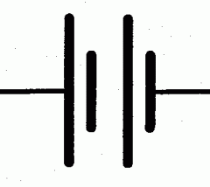
- Study the diagram below showing components of an electrical circuit.
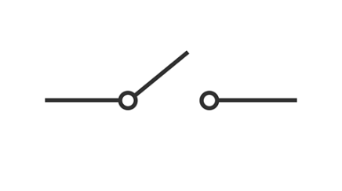
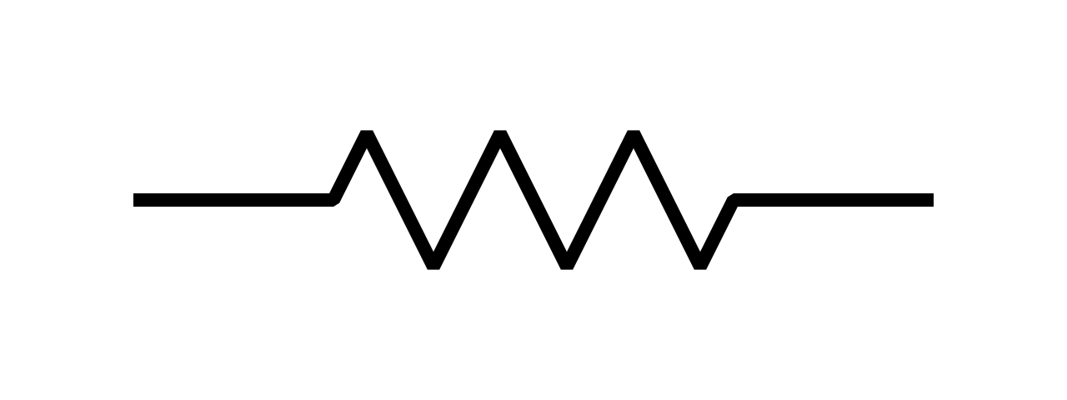

P Q R
(a) Name the components labeled: (3 Marks) P) ________________________________
Q) ________________________________
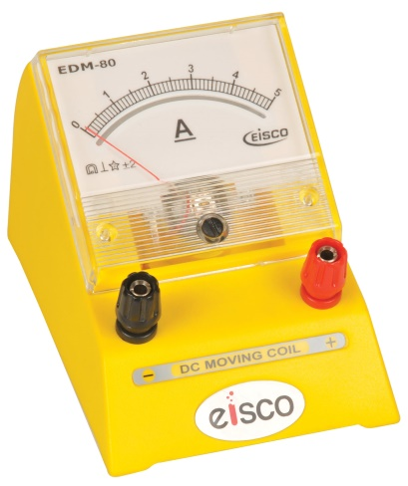
R) _______________________________
(b) Below is electrical equipment

State the function of the equipment shown above. (1 Mark)
______________________________________________________________________________________________________________________________________________________________________________________________
- (a) Identify the collective name of the items below worn by the technician . (1 Mark)

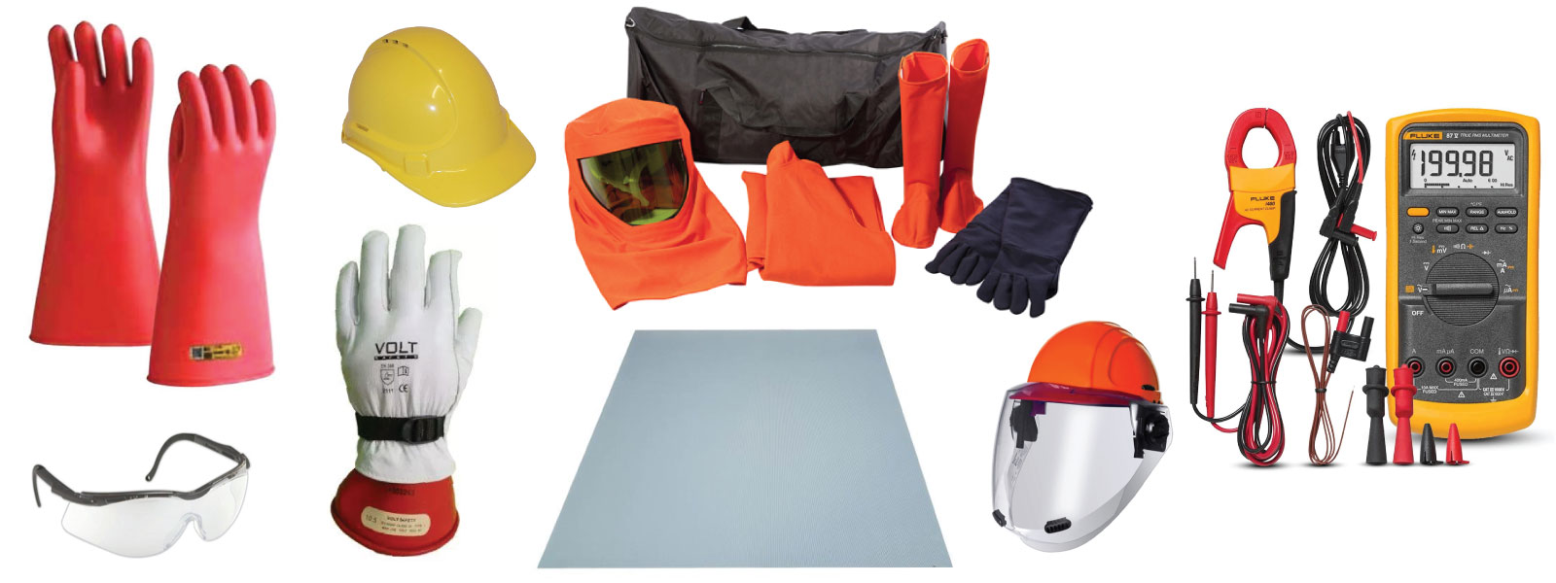

__________________________________________________

(b) Explain one safety regulation a learner must follow when working with live wires. (2 Marks)

________________________________________________________________________________________________________________________________________________________________________________________

- A learner at Ekerubo Senior School is comparing materials. Study the table and images below.

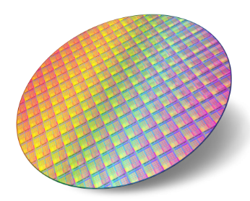
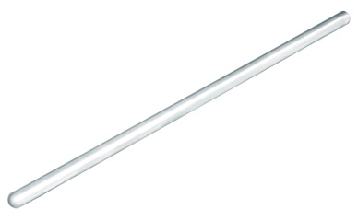
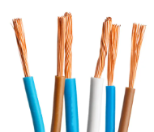

[Copper Wire] [Glass Rod] [Silicon Wafer]

(a) Match the image to the correct category: (3 Marks)
- Conductor: ___________
- Insulator: ___________
- Semiconductor: ___________
(b) Distinguish between a conductor and an insulator based on the flow of electrons. (2 Marks)
_____________________________________________________________________________________________________________________________________________________________________________________________________________________________________________________________________________________________
- (a) Identify the parts of the magnet where the magnetic force is strongest. (1 Mark)

_______________________________________________________________.

(b) Outline two ways of caring for magnets in a school laboratory. (2 Marks)

- ___________________________________________________________________________________.
- ___________________________________________________________________________________.

- Study the image of the electronic component below used in a radio at Kisumu.
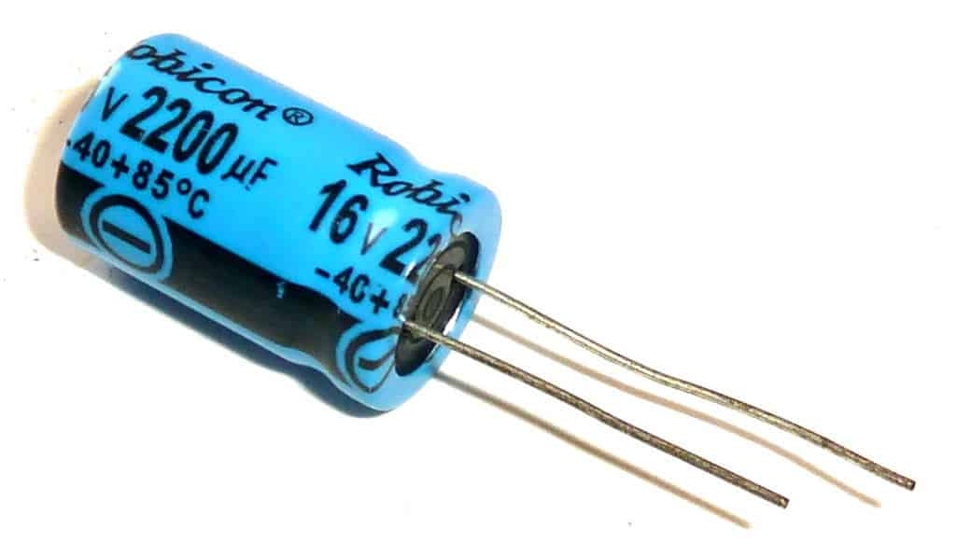

(a) Name the component shown. (1 Mark)
____________________________________________________________
(b) State whether the following statement is True or False:
The device shown above stores energy in a magnetic field.____________________________ (1 Mark)
- (a) Identify which one is a Primary Cell and which is a Secondary Cell. (2 Marks)

- ii)
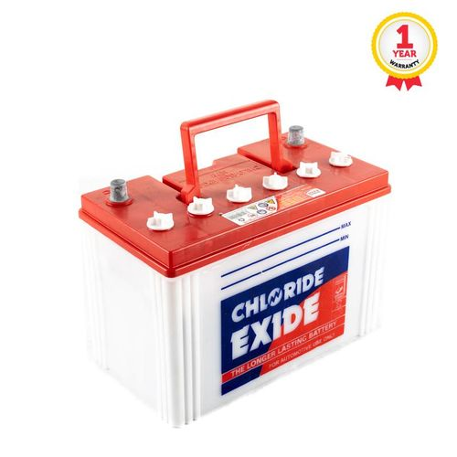
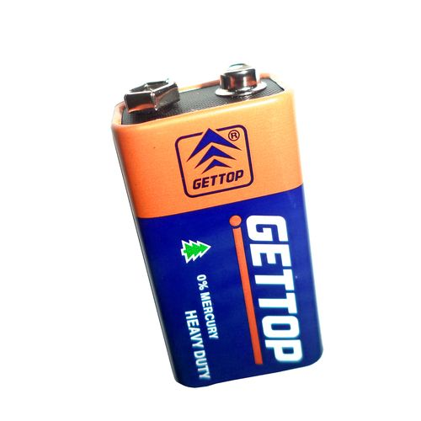

___________________________ _________________________

(b) Mention one safe method of disposing of used batteries in the environment. (1 Mark)
______________________________________________________________________________________________________________________________________________________________________________________________

- During a Physics lesson, a teacher demonstrates the interaction between a current-carrying conductor and a magnetic field as illustrated

(a) Identify the rule being demonstrated in the illustration. (1 Mark)
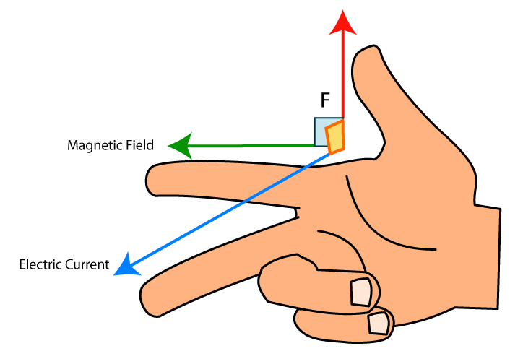

_________________________________________________

(b) Define the term "Electromagnetism." (2 Marks)
______________________________________________________________________________________________________________________________________________________________________________________________

SECTION B (50 MARKS)
Answer ALL questions in this section.
- A technician at a construction site in Mombasa needs to interpret a drawing to install a junction box.
(a) The figure below shows a block drawn in isometric projection.

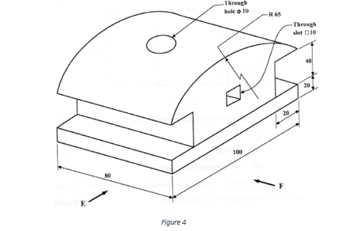

Using first angle projection, draw the following views full size: (6 marks)

Front elevation in the direction of arrow F;

End elevation in the direction of arrow E;

Plan.

(b) Describe two differences between Isometric and Oblique drawings. (2 Marks)
- ________________________________________________________________________________________
- ________________________________________________________________________________________
(c) Using the provided space, sketch the symbol for a fixed resistor and a variable resistor. (3 Marks)

(d) Compare a 2D sketch and a 3D pictorial drawing in terms of information provided. (2 Marks)
____________________________________________________________________________________________________________________________________________________________________________________________________________________________________________________________________________________________________________________________________________________________________________________________
- A learner at Sameta Senior School is conducting an experiment on Ohm's Law.
(a) Calculate the current flowing through the circuit. (Show your working). (2 Marks)

(b) Explain the relationship between Voltage and Current if the Resistance is kept constant. (2 Marks)
_____________________________________________________________________________________________________________________________________________________________________________________________________________________________________________________________________________________________

(c) i) Identify the type of network connection shown. (1 Mark)
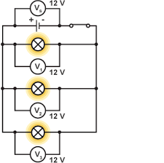
_____________________________________________
ii) List two properties of this type of connection. (2 Marks)
- ________________________________________________________________________________________
- ________________________________________________________________________________________
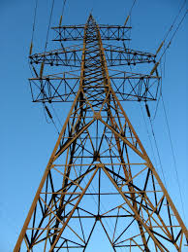
- Kenya is expanding its power grid from Olkaria to other regions.

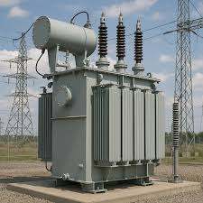
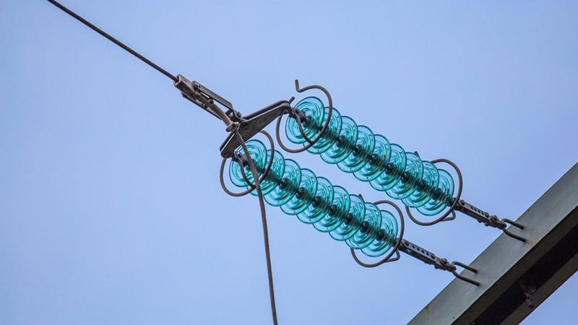
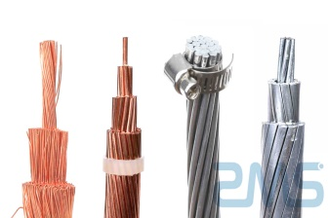

J K L M
(a) Name the components of the transmission network shown above. (4 Marks)
J: ____________________________________________________
K: ____________________________________________________
L: ____________________________________________________
M: ____________________________________________________

(b) Describe the function of a Step-up Transformer in the grid. (3 Marks)
- ________________________________________________________________________________________
- ________________________________________________________________________________________
(c) Explain why electricity is transmitted at very high voltages. (3 Marks)
- ________________________________________________________________________________________
- ________________________________________________________________________________________
- ________________________________________________________________________________________
- (a) Identify the electronic device formed by the junction below. (1 Mark)

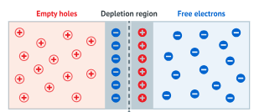

________________________________________________________

(b) Describe the "Doping" process in semiconductors. (3 Marks)

- ________________________________________________________________________________________
- ________________________________________________________________________________________
- ________________________________________________________________________________________
- ________________________________________________________________________________________

(c) i) Identify the biasing method shown. (1 Mark)
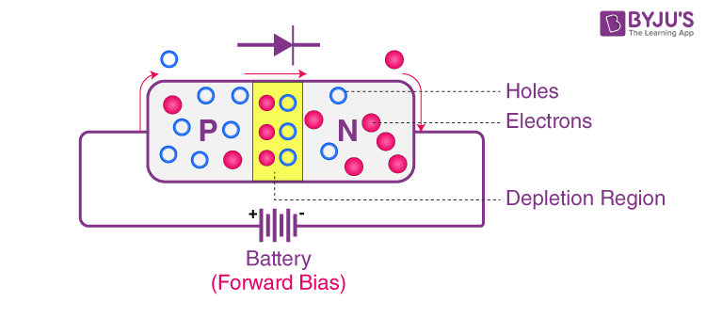

___________________________________________________________

ii) Explain what happens to the depletion layer in this state. (3 Marks)

____________________________________________________________________________________________________________________________________________________________________________________________________________________________________________________________________________________

(d) State two applications of diodes in day-to-day life. (2 Marks)
- ________________________________________________________________________________________
- ________________________________________________________________________________________
- (a) Identify three pieces of equipment found at the consumer intake point. (3 Marks)

- ________________________________________________________________________________________
- ________________________________________________________________________________________
- ________________________________________________________________________________________
(b) Explain the importance of the Earth Electrode in a domestic installation. (3 Marks)

- ________________________________________________________________________________________
- ________________________________________________________________________________________
- ________________________________________________________________________________________
(c) Three learners at Pema Senior School are describing a transistor:
- Moraa: "It has three terminals: Emitter, Base, and Collector."
- Achieng: "It can be used as a switch in a circuit."
- Wanjiku: "It can amplify weak signals."
List the three functions/features of a transistor mentioned by the learners. (3 Marks)
Learner | Function of the transistor he or she mentioned
- (a) Name the device shown in the illustration. (1 Mark)

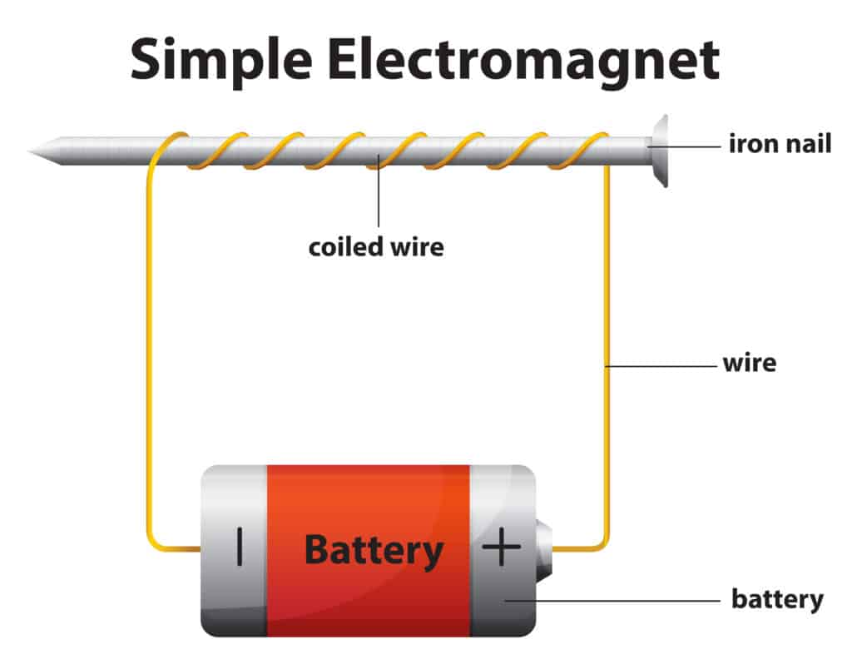
_______________________________________________

(b) Outline how the strength of the magnetic field in the coil can be increased. (2 Marks)
- ________________________________________________________________________________________
- ________________________________________________________________________________________
THIS IS THE LAST PRINTED PAGE

