KENYA CERTIFICATE OF BASIC EDUCATION

SENIOR SCHOOL ASSESSMENT

TERM 2: ENDTERM ASSESSMENT 2026
GRADE 10 – ESSENTIAL MATHEMATICS 007 JULY
Time: 2 Hours
LEARNER’S DETAILS
Name: _____________________________________________________________. School: ____________________________________________.
Assessment Number: _______________________________________________. Date: ____________________________________________.
School Code: ______________________________________________________. Signature: _______________________________________.

INSTRUCTIONS TO CANDIDATES
- Write your full name in the space provided above.
- Indicate your school, stream, admission number, and date clearly.
- This paper has TWO sections: A and B.
- Attempt ALL questions in both sections.
- Show all working clearly where necessary.
- Write all answers in the spaces provided.
- Do NOT remove any page from this paper.

FOR OFFICIAL USE ONLY (EXAMINER’S USE)
SECTION | SECTION A | SECTION B | % SCORE | EE1 | EE2 | ME1 | ME2 | AE1 | AE2 | BE1 | BE2
SCORE RANGE | 30 MARKS | 50 MARKS |  | 90-100 | 75-89 | 58-74 | 41-57 | 31-40 | 21-30 | 11-20 | 1-10
POINTS |  |  |  | 8 POINTS | 7 POINTS | 6 POINTS | 5 POINTS | 4 POINTS | 3 POINTS | 2 POINTS | 1 POINT
LEARNER’S TOTAL SCORE

SECTION A (30 MARKS)
- Classify the following numbers as either Rational or Irrational: (2 Marks)
- 25​: ____________________________
- π: ____________________________
- Evaluate the value of x in (2 Marks)
81^{(x+1)} + 3^{4x} = 246

- Factorize the quadratic expression below: x² + 6x + 9 (3mks)

- In a right angled triangle, the two sides enclosing the right angle measure (3x - 2)cm and (x+2) cm. If the area of the triangle is 17.5 cm², find the length of these two sides. (3 marks)

- The area of a sector of a circle is 11cm² and its radius is 3cm. Find the angle enclosed by the sector at the centre. Take(π= ²²/₇) (3 Marks)

- Solve for x in the equation. (3 marks)

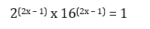

- Convert 500 US Dollars to local currency, given the exchange rate is 1 USD = 130 Units. (1 Mark)

- Identify the number of lines of symmetry in a Regular Hexagon. (1 Mark)

- M A bag contains 3 red balls and 5 blue balls. If one ball is picked at random, what is the probability it is Red? (2 Marks)

- ABCDE is a right pyramid on a horizontal square base of side 10 cm. The slant edges are all 8 cm long. Calculate;
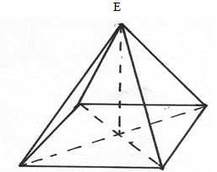
  - The height of the pyramid (3 marks)

  - The angle between;
    - A slant face and the base (2 marks)

    - A slant edge and the base (2 marks)

  - The angle between the planes ABE and DCE (3 marks)

SECTION B (50 MARKS)
- Two circles with centres O and Q and radii 8cm intersect at points A and B as shown below.
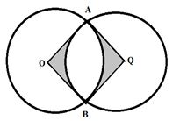
Given that the distance between O and Q is 12cm and that the line AB meets OQ at X, find:
  - the length of the chord AB. (3marks)

  - the reflex angle AOB. (3marks)

  - the area of the shaded region. ( 4marks)

- A bag contains 3 black balls and 6 white balls. If two balls are drawn from the bag one a time, find the:-
  - Probability of drawing two white balls
    - with replacement (2marks)

    - without replacement (2marks)

  - Probability of drawing a black ball and white ball.
    - with replacement (3marks)

    - without replacement (3marks)

- The figure below represents a model of a solid structure in the shape of frustrum of a cone with a hemisphere top. The diameter of the hemispherical part is 70cm and is equal to the diameter of the top of the frustrum. The frustrum has a base diameter of 28cm and slant height of 60cm.
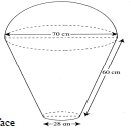
Calculate :
  - the area of the hemispherical surface (3 Marks)

  - the slant height of cone from which the frustrum was cut (3 Marks)

  - the surface area of frustrum (3 Marks)

  - the area of the base (2 Marks)

  - the total surface area of the model (2 Marks)

- In the figure below, ADE is a triangle and BC is parallel to DE, AB, BD and BC are 4cm, 3cm and 8cm respectively. Find the length of DE(3 Marks)
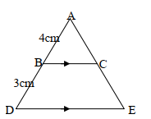

- The surface area of two similar bottles are 12cm² and 108cm² respectively. If the larger one has a volume of 810cm³. Find the volume of the smaller one (2 Marks)

a. Find the area of the figure below (2 marks)

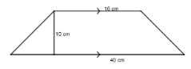

b. A piece of wire is in the shape of an arc of a circle, radius 10.5cm .The angle at the centre is 150°

(i). Calculate the length of the wire (2 marks)

(ii). If the wire is bent to form a complete circle find its radius (3 marks)

c. A flower garden measuring 10m by 15m is surrounded by a path 2m wide as shown below. Find the area of the path (Unshaded region). (3 marks)

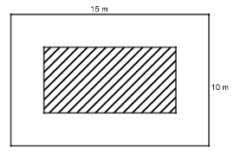
THIS IS THE LAST PRINTED PAGE

