KENYA CERTIFICATE OF BASIC EDUCATION

SENIOR SCHOOL ASSESSMENT

TERM 2: ENDTERM ASSESSMENT 2026
GRADE 10 – GENERAL SCIENCE
Time: 2 Hours
LEARNER’S DETAILS
Name: _____________________________________________________________. School: ____________________________________________.
Assessment Number: _______________________________________________. Date: ____________________________________________.
School Code: ______________________________________________________. Signature: _______________________________________.

INSTRUCTIONS TO CANDIDATES
- Write your name in the spaces provided above.
- Write the name of your school and your stream in the spaces provided.
- Write your admission number and the date of the assessment in the spaces provided.
- This paper consists of two sections: A and B.
- Answer all questions in section A and section B.
- Answer the questions in English.
- All answers MUST be written in the spaces provided in PAPER.
- Do NOT remove any page from this question paper.

FOR OFFICIAL USE ONLY (EXAMINER’S USE)
SECTION | SECTION A | SECTION B | % SCORE | EE1 | EE2 | ME1 | ME2 | AE1 | AE2 | BE1 | BE2
SCORE RANGE | 20 MARKS | 60 MARKS |  | 90-100 | 75-89 | 58-74 | 41-57 | 31-40 | 21-30 | 11-20 | 1-10
POINTS |  |  |  | 8 POINTS | 7 POINTS | 6 POINTS | 5 POINTS | 4 POINTS | 3 POINTS | 2 POINTS | 1 POINT
LEARNER’S TOTAL SCORE

SECTION A (20 MARKS)
Answer ALL questions in this section.
- Mutua, a student at Agoro Sare Senior School, is observing a sample of water from the Tana River. He notices the water is brown and concludes it contains soil particles from upstream erosion.
(a) Identify the scientific principle Mutua is using to reach his conclusion. (1 mark)
___________________________________________________________________________________________
(b) Mention two branches of General Science Mutua would apply to analyze the chemical and biological content of this water. (2 marks)
i) _____________________________________________________________________________________________
ii) ____________________________________________________________________________________________
- Akinyi is trying to open a heavy gate at Mama Ngina Girls’ Secondary School. She finds it easier to push the gate far from the hinges than close to them.

(a) Name the turning effect of force illustrated in this scenario. (1 mark)
_______________________________________________________________.
(b) Study the diagram below of a spanner.

X
- Identify the part labeled X (1 mark)
___________________________________________________________.
- Explain why a longer handle makes it easier to loosen a nut. (1 mark)
________________________________________________________________________________________________________________________________________________________________________________________________________________
- Three learners, Kamau, Fatuma, and Juma, are discussing the periodic table.
Kamau says: “Group 1 elements are called Alkali metals.”
Fatuma says: “Noble gases are very reactive.”
Juma says: “Magnesium belongs to the Alkaline Earth Metals family.”
(a) Which learner made an incorrect statement? _______________________________ (1 mark)
(b) Give the reason for the unreactive nature of the Noble gases mentioned by Fatuma. (2 marks) ______________________________________________________________________________________________________________________________________________________________________________________________

- Study the diagram of the human digestive system below.
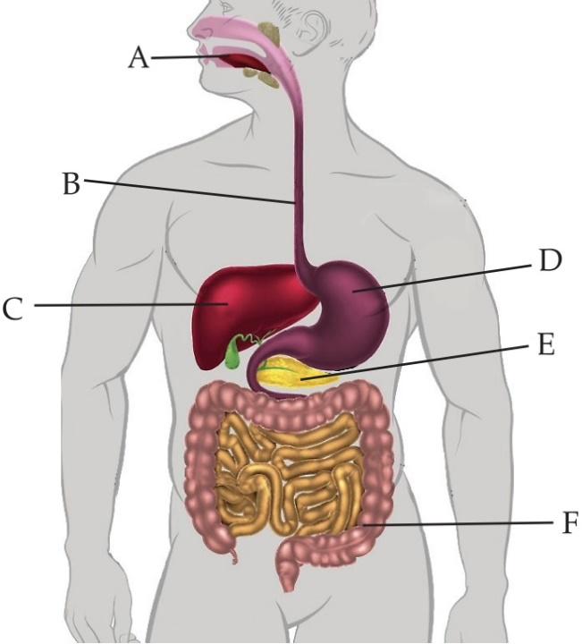

T

(a) Identify the parts labeled: (2 marks)
B: __________________________ F: __________________________
(b) State the adaptation of part T for the absorption of digested food. (1 mark) ______________________________________________________________________________________________________________________________________________________________________________________________
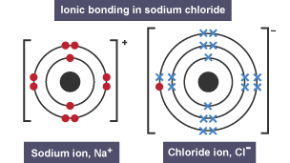
- Look at the illustration of a chemical bond formation between Sodium and Chlorine.

(a) Identify the type of bond being formed. (1 mark)
____________________________________________________________________
(b) Distinguish between an ionic bond and a covalent bond based on electron movement. (4 marks)
_______________________________________________________________________________________________________________________________________________________________________________________________________________________________________________________________________________________________________________________

- In a laboratory in Kisumu, a student added zinc granules to dilute hydrochloric acid. The reaction produced bubbles of gas.
(a) Outline how the student can increase the rate of this reaction by changing the surface area of the zinc. (1 mark)
______________________________________________________________________________________________________________________________________________________________________________________________
(b) True or False:
Increasing the temperature of the reaction mixture will decrease the rate of reaction. (1 mark)
_________________________________________________________

SECTION B (60 MARKS)
Answer ALL questions in this section.
- A bus traveling from Nairobi to Nakuru starts from rest and accelerates uniformly.
(a) Define the term acceleration. (1 mark) ______________________________________________________________________________________________________________________________________________________________________________________________

b) A body starts from rest and reaches 20m/s after travelling with uniform acceleration in a straight line for 4 seconds

i) Determine the acceleration of this body (2mks)

ii) A body initially moving at 20m/s comes to rest after 5 seconds (2mks)

c) Distinguish between distance and displacement. (2 marks)
______________________________________________________________________________________________________________________________________________________________________________________________
(d) Explain one real-life application of the concept of free fall in safety. (1 mark)
_______________________________________________________________________________________________________________________________________________________________________________________________________________
- A learner at Mangu High School set up the following experiment to investigate seed germination.
(a) Name the condition for germination being investigated. (1 mark)
__________________________________________________________
(b) Describe the difference between epigeal and hypogeal germination. (4 marks)
____________________________________________________________________________________________________________________________________________________________________________________________________________________________________________________________________________________________________________________________________________________________________________________________
- The diagram below represents a transverse section through a plant organ.

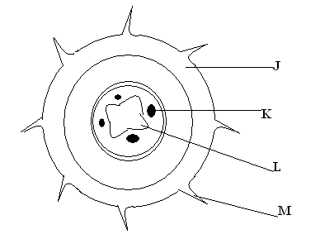
  - From which plant organ was the section obtained?_________________________ (1 mark)
  - Give two reasons for your answer in (a) above. (2 marks)
- ____________________________________________________________________________________________________
- ____________________________________________________________________________________________________
  - Name the labeled parts J, K , L and M. (4 marks)

J: __________________________________ K: _________________________________

L: _________________________________ M: _________________________________
  - Identify the tissue responsible for the translocation of food. (1 mark)

_________________________________________________________

  - List three environmental factors that affect the rate of transpiration in plants found in Turkana. (3 marks)
- ____________________________________________________________________________________________________
- ____________________________________________________________________________________________________
- ____________________________________________________________________________________________________
- During a field trip to Lake Magadi, learners collected salt samples. They noticed that some salts became wet when exposed to air.
(a) Match the term to the correct description: (3 marks)
Term | Description
Hygroscopic | A. Absorbs water to form a solution
Deliquescent | B. Loses water of crystallization to the air
Efflorescent | C. Absorbs moisture but does not dissolve
(b) Using the pH chart below, select which substance is a strong acid. (1 mark)
__________________________________________________________
(c) Explain the role of hydrochloric acid in the human stomach during digestion. (1 mark)
______________________________________________________________________________________________________________________________________________________________________________________________
(d) State one application of salts in the food industry. (1 mark)
_______________________________________________________________________________________________________

The grid below represents part of the periodic table. The letters do not represent actual symbols of the elements. Study it and answer the questions that follow:-
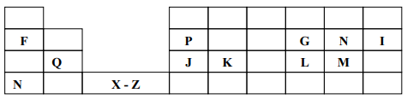
  - What type of bond would you expect in the compound formed between H and F. Explain(2 marks)
______________________________________________________________________________________________________________________________________________________________________________________________

    - Which of the elements J and M will have a greater atomic radius? Explain(2 marks)
______________________________________________________________________________________________________________________________________________________________________________________________
    - Elements F and N are in the same group of periodic table. How do their atomic radius compare? Explain(2 marks)
______________________________________________________________________________________________________________________________________________________________________________________________
  - An element W has atomic number 15. Indicate the position it would occupy in the table above(1 mark)
____________________________________________________________________
  - What is the name given to elements X – Z? (1 mark)
___________________________________________________________________________
  - Why is J used in electric cables where Q is not(2 marks)
________________________________________________________________________________________________________________________________________________________________________________________
  - P and J are termed as metalloids. What does the term metalloid mean? (2 marks)
________________________________________________________________________________________________________________________________________________________________________________________
  - How would you expect the reactivity of H and M to compare? Explain(2 marks)
________________________________________________________________________________________________________________________________________________________________________________________
- (a) Name two types of microscopes (2 marks)
- ______________________________________________________________________________________
- ______________________________________________________________________________________
(b) Describe the function of the mitochondria found in both plant and animal cells. (2 marks)
______________________________________________________________________________________________________________________________________________________________________________________________
(c) List two infections caused by fungi in human beings. (2 marks)
- __________________________________________________________________________________________
- __________________________________________________________________________________________
(d) Explain the economic importance of yeast (2 marks)
- ______________________________________________________________________________________
- ______________________________________________________________________________________
- A group of athletes training in Iten are discussing how their muscles feel after a sprint. One athlete says, “My legs feel heavy and painful.”
(a) Name the type of respiration that leads to the accumulation of lactic acid in muscles. (1 mark)
____________________________________________________________-
(b) Define the term oxygen debt. (2 marks) ______________________________________________________________________________________________________________________________________________________________________________________________
(c) Write a word equation for aerobic respiration. (3 marks)

(d) Mention three factors that affect the rate of respiration in living organisms. (3 marks)
- ______________________________________________________________________________________
- ______________________________________________________________________________________
- ______________________________________________________________________________________

THIS IS THE LAST PRINTED PAGE

