KENYA CERTIFICATE OF BASIC EDUCATION

SENIOR SCHOOL ASSESSMENT

TERM 2 ENDTERM ASSESSMENTS 2026
GRADE 10 – GEOGRAPHY
Time: 2 Hours 30 Minutes
LEARNER’S DETAILS
Name: _____________________________________________________________. School: ____________________________________________.
Assessment Number: _______________________________________________. Date: ____________________________________________.
School Code: ______________________________________________________. Signature: _______________________________________.

INSTRUCTIONS TO CANDIDATES
- Write your name in the spaces provided above.
- Write the name of your school and your stream in the spaces provided.
- Write your admission number and the date of the assessment in the spaces provided.
- This paper consists of two sections: A and B.
- Answer all questions in section A and section B.
- Answer the questions in English.
- All answers MUST be written in the spaces provided in PAPER.
- Do NOT remove any page from this question paper.

FOR OFFICIAL USE ONLY
SECTION | SECTION A | SECTION B | % SCORE | EE1 | EE2 | ME1 | ME2 | AE1 | AE2 | BE1 | BE2
SCORE RANGE | 40 MARKS | 50 MARKS |  | 90-100 | 75-89 | 58-74 | 41-57 | 31-40 | 21-30 | 11-20 | 1-10
POINTS |  |  |  | 8 POINTS | 7 POINTS | 6 POINTS | 5 POINTS | 4 POINTS | 3 POINTS | 2 POINTS | 1 POINT
LEARNER’S TOTAL SCORE

SECTION A (30 MARKS)
Answer ALL questions in this section.
- Study the map of Kipkabus 1:50,000 (Sheet 104/1) provided and answer the questions that follow.

(a)
(i) What type of map is Kipkabus?___________________________________ (1 mark)
(ii) Identify two physical features found in grid square 8336. (2 marks) ________________________________________________________________________________________________________________________________________________________________________________________________
(iii) What is the direction of Air Photo Principal Point 87 (grid reference 8338) from Trigonometrical Station Primary SKP 102? (1 mark)
________________________________________________________________________________________________________________________________________________________________________________________________
(iv) Calculate the area of Chof/Chop Forest. Give your answer in square kilometres. (1 mark)

(v) What is the six-figure grid reference of Air Photo Principal 92/KE/17/013? (1 mark)
________________________________________________________________________

(b)
(i) Draw a rectangle measuring 12 cm × 8 cm to represent the area between:
- Eastings 80 and 86
- Northings 30 and 37 (1 mark)

(ii) On the rectangle, mark and name the following features:
- Water hole (1 mark)
- Forest (1 mark)
- Dry weather road (1 mark)

(c)
(i) Describe the drainage of the area covered by the map. (2 marks)
________________________________________________________________________________________________________________________________________________________________________________________________________________________________________________________________________________________________

(ii) Citing evidence from the map, name two economic activities carried out in the area. (2 marks)
________________________________________________________________________________________________________________________________________________________________________________________________________________________________________________________________________________________________
- Four learners (Amina, Baraka, Chot, and Dan) collected data on rainfall in Nanyuki for four months.
Amina: January had 50mm.
Baraka: February had 40mm.
Chot: March had 120mm.
Dan: April had 200mm.

(a) Construct a simple bar graph to represent this data. [4 Marks]

(b) Define the term Discrete data as used in statistics. [2 Marks]
________________________________________________________________________________________________________________________________________________________________________________________________

- (a) Name the rock samples labeled A, B, and C based on the mode of formation. [3 Marks]
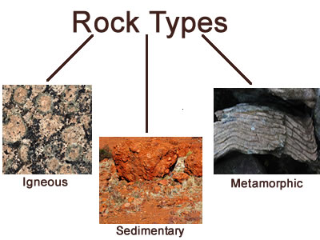



A B C

A: ______________________________
B: ______________________________
C: ______________________________

(b) Distinguish between volcanic and plutonic igneous rocks. [2 Marks]

__________________________________________________________________________________________________________________________________________________________________________________________

(c) Mention two uses of rocks in the Kenyan economy. [2 Marks]

- _____________________________________________________________________________________________
- _____________________________________________________________________________________________
- (a) Name the parts labeled 4, 5, and 6 in the diagram. [3 Marks]

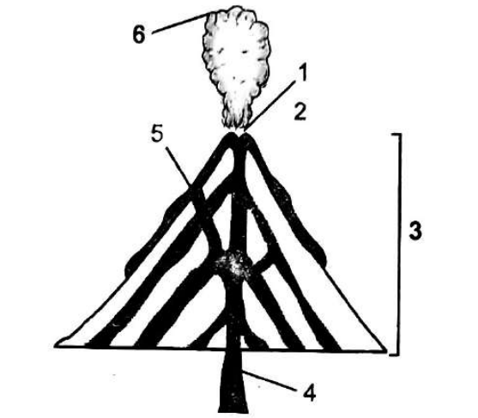
4 -__________________________________.
5 - _________________________________.
6 - _________________________________.
(b) State two negative effects of volcanic eruptions on the environment. [2 Marks]
- __________________________________________________________________________________________
- __________________________________________________________________________________________

- (a) Identify the types of folds represented by the diagrams marked X, Y and Z. (3 marks)
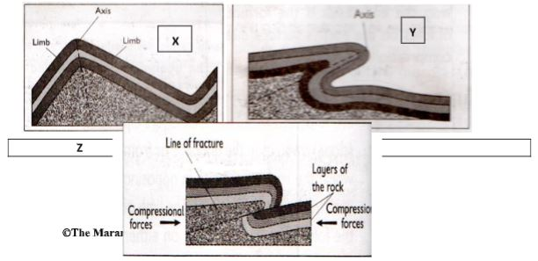




X: _______________________________
Y: _______________________________
Z: _______________________________

(b) With the aid of well labelled diagrams, describe how Fold Mountains were formed. [4 Marks]

(c) Name one Fold Mountain in Africa. [1 Mark]
______________________________________

SECTION B: [50 MARKS]
Answer all questions in this section.
- The Grade 10 class at Kanga Senior School visited the Olkaria Geothermal Power Plant.
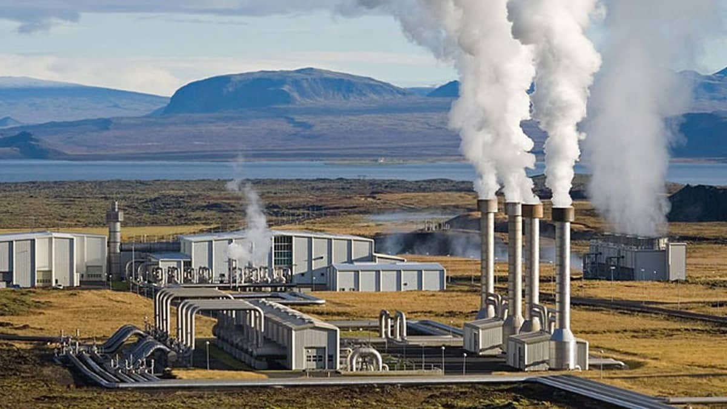

(a) Name the type of renewable energy source shown in the picture below. [1 Mark]
________________________________________________
(b) Explain three factors that influenced the location of this energy project in the Rift Valley. [3 Marks]
- __________________________________________________________________________________________
- __________________________________________________________________________________________
- __________________________________________________________________________________________
(c) Grade 10 Geography learners were Comparing Jua Kali industries in Kenya and Car Manufacturing in Japan:
(i) List two characteristics of Jua Kali industries. [2 Marks]
- __________________________________________________________________________________________
- __________________________________________________________________________________________
(ii) State one major difference in the level of technology used. [2 Marks]
________________________________________________________________________________________________________________________________________________________________________________________________
(d) Describe two ways in which industrialization leads to environmental pollution in cities like Nairobi. [4 Marks]
- __________________________________________________________________________________________
- __________________________________________________________________________________________
- __________________________________________________________________________________________
- (a) Identify the mining method shown in the illustration above. [1 Mark]
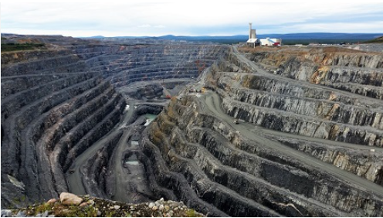

(b) Name the mineral mined at Bamburi in Mombasa using the method above. [1 Mark]

___________________________________________________

(c) Below are descriptions from three learners regarding mining:
Learner 1: This mineral occurs in deep horizontal layers.
Learner 2: This method involves using water under high pressure.
Learner 3: This is a precious stone mined in Botswana.
Identify the mining method described by Learner 2 and the mineral mentioned by Learner 3. [2 Marks]
__________________________________________________________________________________________
__________________________________________________________________________________________
__________________________________________________________________________________________

(d) Explain three problems facing the mining industry in Kenya. [6 Marks]
- __________________________________________________________________________________________
- __________________________________________________________________________________________
- __________________________________________________________________________________________
(e) State two ways of rehabilitating a derelict mining site. [2 Marks]
- __________________________________________________________________________________________
- __________________________________________________________________________________________
(f) True/False:
Mining is a non-renewable economic activity. (_______) [1 Mark]
(g) Define Adit mining. [2 Marks]
________________________________________________________________________________________________________________________________________________________________________________________________
- (a) Name the instrument used to record the intensity of earthquakes as shown in the image. [2 Marks]
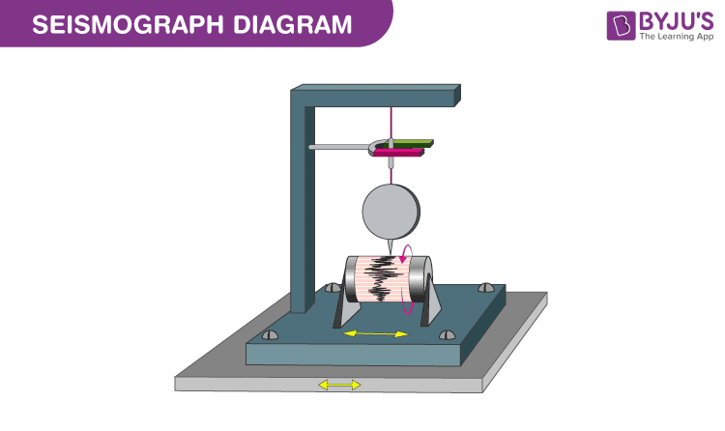

_______________________________________

(b) Identify the major earthquake zone shaded on the world map. [2 Marks]
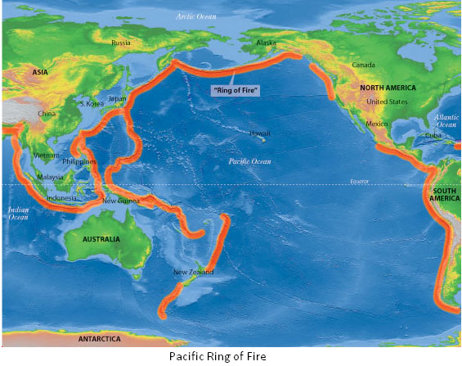

______________________________________________________________

(c) Explain how tectonic plate movements cause earthquakes. [4 Marks]

- __________________________________________________________________________________________
- __________________________________________________________________________________________
- __________________________________________________________________________________________
- __________________________________________________________________________________________

(d) List three disaster preparedness strategies for people living in earthquake-prone areas. [3 Marks]
- __________________________________________________________________________________________
- __________________________________________________________________________________________
- __________________________________________________________________________________________

(e) Grade 10 learners discussed about Geographic Information Systems (GIS):
(i) Name the four components of GIS they likely discussed. [4 Marks]
- __________________________________________________________________________________________
- __________________________________________________________________________________________
- __________________________________________________________________________________________
- __________________________________________________________________________________________
(ii) Describe how a farmer in Narok can use GPS (Global Positioning System) to improve productivity. [4 Marks]
- __________________________________________________________________________________________
- __________________________________________________________________________________________
- __________________________________________________________________________________________
- __________________________________________________________________________________________
(iii) Match the following geospatial terms to their correct definition: [4 Marks]
Term | Definition
1. Remote Sensing | A. Locating points using satellites.
2. GPS | B. Collecting data from a distance (e.g., satellites).
3. Hardware | C. The actual computer and scanner.
4. Data | D. The information collected for analysis.

THIS IS THE LAST PRINTED PAGE

