KENYA CERTIFICATE OF BASIC EDUCATION

SENIOR SCHOOL ASSESSMENT

TERM 2: ENDTERM ASSESSMENT 2026
GRADE 10 – HISTORY AND CITIZAENSHIP
Time: 2 Hours
LEARNER’S DETAILS
Name: _____________________________________________________________. School: ____________________________________________.
Assessment Number: _______________________________________________. Date: ____________________________________________.
School Code: ______________________________________________________. Signature: _______________________________________.

INSTRUCTIONS TO CANDIDATES
- Write the detail required above
- This paper consists of two sections: A and B. Answer all questions in section A and section B.
- Answer the questions in English.
- All answers MUST be written in the spaces provided in PAPER.
- Do NOT remove any page from this question paper.

FOR OFFICIAL USE ONLY (EXAMINER’S USE)
SECTION | SECTION A | SECTION B | % SCORE | EE1 | EE2 | ME1 | ME2 | AE1 | AE2 | BE1 | BE2
SCORE RANGE | 30 MARKS | 50 MARKS |  | 90-100 | 75-89 | 58-74 | 41-57 | 31-40 | 21-30 | 11-20 | 1-10
POINTS |  |  |  | 8 POINTS | 7 POINTS | 6 POINTS | 5 POINTS | 4 POINTS | 3 POINTS | 2 POINTS | 1 POINT
LEARNER’S TOTAL SCORE

SECTION A: (30 marks)
Answer ALL questions in this section.
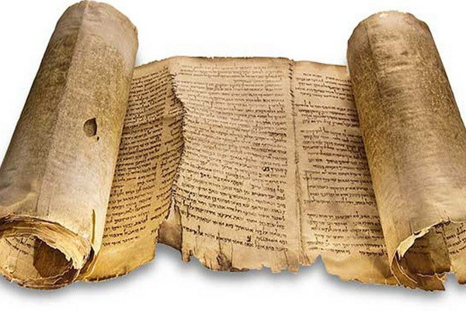
- Imagine you are a researcher visiting the National Archives in Nairobi to study the struggle for independence in Kenya.

(a) Identify the category of historical source shown in the documents above. (1 mk)
________________________________________________
(b) From the picture, select two primary sources of information a historian would use. (2 mks)
- _________________________________________________________________________________________
- _________________________________________________________________________________________
(c) Distinguish between a Primary Source and a Tertiary Source of historical information. (3 mks)
____________________________________________________________________________________________________________________________________________________________________________________________________________________________________________________________________________________________________________________________________________________________________________________________
- Use the map of Eastern Africa below to answer questions 2.

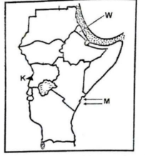
(a) Name the linguistic group represented by the migration route labeled Route X. (1 mk)
_________________________________________________________
(b) Identify three social effects of the settlement of these linguistic groups in Kenya. (3 mks)
- _________________________________________________________________________________________
- _________________________________________________________________________________________
- _________________________________________________________________________________________
(c) State two reasons why these groups moved from their original cradle land. (2 mks)
- _________________________________________________________________________________________
- _________________________________________________________________________________________

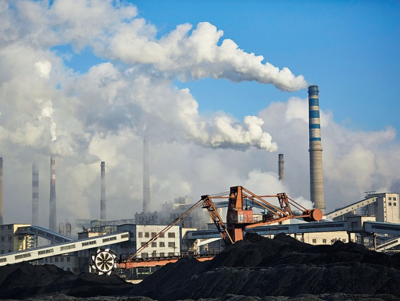
- The world has transitioned through various technological milestones. Look at the images of the 1st and 4th Industrial Revolutions.

(a) Name the primary source of energy used in the 1st Industrial Revolution as shown in the picture. (1 mk)
________________________________________________
(b) Identify three ways in which the 4th Industrial Revolution (Digital Age) has impacted the economy of Kenya. (3 mks)
- _________________________________________________________________________________________
- _________________________________________________________________________________________
- _________________________________________________________________________________________
(c) List two environmental challenges caused by the rapid industrialization depicted in the first image. (2 mks)
- _________________________________________________________________________________________
- _________________________________________________________________________________________
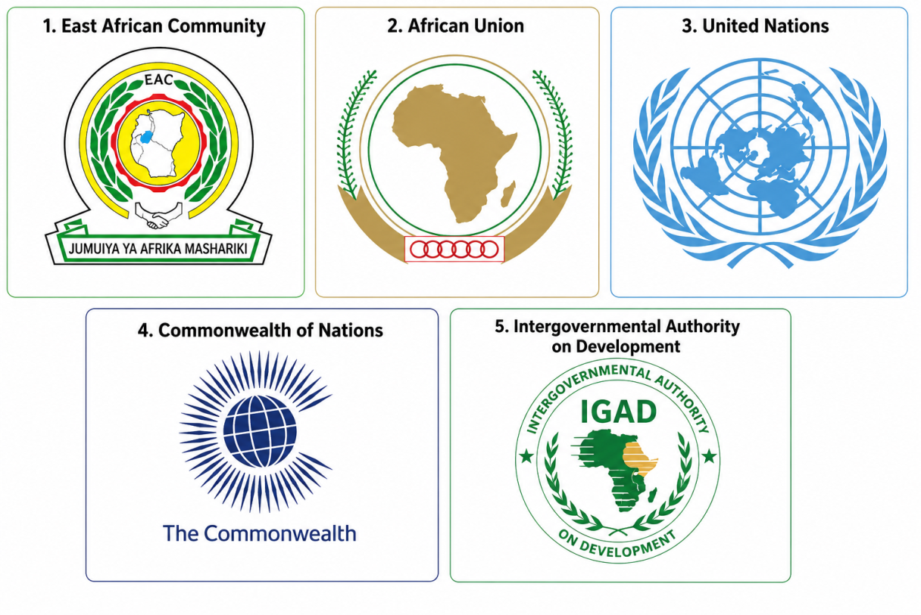
- The following emblems represent organizations that Kenya is a member of.

(a) Identify the organization that promotes cooperation among former British colonies. (1 mk)
______________________________________________________________
(b) Select two guiding principles of Global Governance that these organizations promote. (2 mks)
- _________________________________________________________________________________________
- _________________________________________________________________________________________
(c) Name three challenges facing the Commonwealth of Nations in the modern world. (3 mks)
- _________________________________________________________________________________________
- _________________________________________________________________________________________
- _________________________________________________________________________________________
- A local community is holding a "Baraza" to discuss the use of a new public library.
(a) Which pillar of citizenship is being demonstrated in the scenario above? (1 mk)
______________________________________________________________
(b) Categorize the following into Social or Economic public resources: (2 mks)
(i) Public Hospitals: ____________________.
(ii) Standard Gauge Railway (SGR): ____________________ .
(c) Identify three measures a citizen can take to advocate for the efficient use of public resources. (3 mks)
- _________________________________________________________________________________________
- _________________________________________________________________________________________
- _________________________________________________________________________________________

SECTION B: [50 MARKS]
Answer ALL questions in this section.
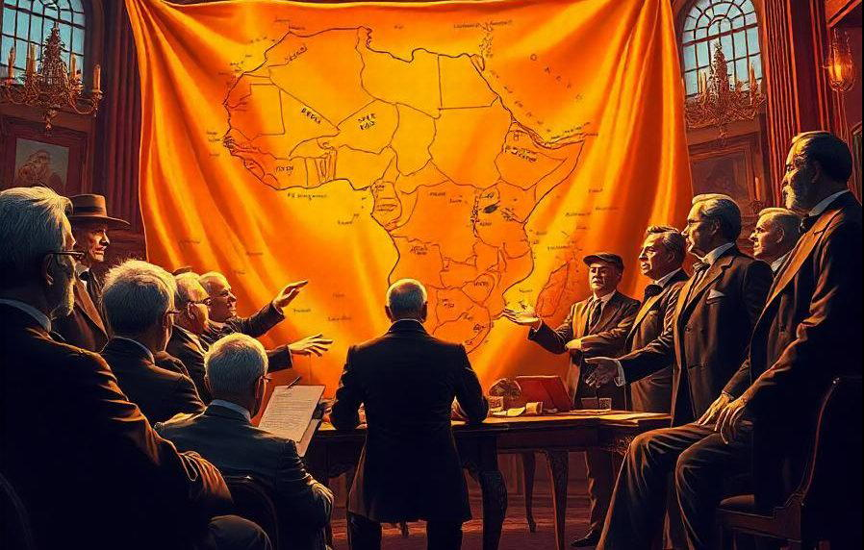
- In the late 19th century, European powers met in Germany to divide Africa. Look at the illustration below.

(a) Name the historical event taking place in the image above. (1 mk)
______________________________________________________________________________________
(b) Identify the three main methods used by the British to establish colonial rule in Kenya. (3 mks)
- _________________________________________________________________________________________
- _________________________________________________________________________________________
- _________________________________________________________________________________________
(c) Explain four economic reasons that led to the scramble for and partition of Africa. (4 mks)
- _________________________________________________________________________________________
- _________________________________________________________________________________________
- _________________________________________________________________________________________
- _________________________________________________________________________________________
(d) Name four key European players (nations) who participated in the event shown above. (4 mks)
- _________________________________________________________________________________________
- _________________________________________________________________________________________
- _________________________________________________________________________________________
- _________________________________________________________________________________________
- The journey to African independence was led by courageous individuals and influenced by global events.
(a) Identify the nationalist leader in Africa who promoted "Ujamaa" in Tanzania. (1 mk)
_______________________________________________________________
(b) Select three factors that influenced the rise of modern nationalism in Africa after 1945. (3 mks)
- _________________________________________________________________________________________
- _________________________________________________________________________________________
- _________________________________________________________________________________________
(c) Discuss four political effects of World War II on the African quest for independence. (4 mks)
- _________________________________________________________________________________________
- _________________________________________________________________________________________
- _________________________________________________________________________________________
- _________________________________________________________________________________________
(d) Name four lessons modern African states can learn from the leadership of Thomas Sankara. (4 mks)
- _________________________________________________________________________________________
- _________________________________________________________________________________________
- _________________________________________________________________________________________
- _________________________________________________________________________________________
- History records the transition from ancient slavery to modern servitude. Study the portraits of the abolitionists below.
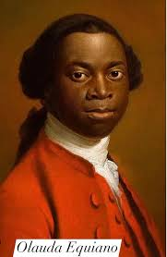
(a) Identify the abolitionist in the picture who was a former slave and wrote an influential autobiography. (1 mk)
___________________________________________________
(b) Distinguish between Slavery and Servitude as used in modern citizenship. (2 mks)
_____________________________________________________________________________________________________________________________________________________________________________________________________________________________________________________________________________________________
(c) Name three forms of modern slavery prevalent in the world today. (3 mks)
- _________________________________________________________________________________________
- _________________________________________________________________________________________
- _________________________________________________________________________________________
(d) List four roles played by Christian Missionaries in the abolition of the slave trade in East Africa. (4 mks)
- _________________________________________________________________________________________
- _________________________________________________________________________________________
- _________________________________________________________________________________________
- _________________________________________________________________________________________

- Since 1963 to date, Kenya has undergone significant constitutional changes, one such change is illustrated below.
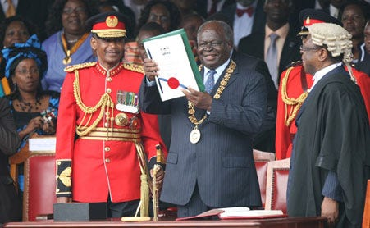
(a) Name the document being celebrated in the picture above. (1 mk)
__________________________________________________________________________________
(b) Identify three major political challenges Kenya has faced since independence. (3 mks)
- _________________________________________________________________________________________
- _________________________________________________________________________________________
- _________________________________________________________________________________________
(c) Explain four ways in which the 2010 Constitution strives to prevent conflicts and promote national integration. (4 mks)
- _________________________________________________________________________________________
- _________________________________________________________________________________________
- _________________________________________________________________________________________
- _________________________________________________________________________________________

- Technology has reshaped how citizens interact with the government.

(a) Identify the era of technology represented in the image above. (1 mk)
_________________________________________________________________________________
(b) Name three historical milestones in the evolution of communication technology. (3 mks)
- _________________________________________________________________________________________
- _________________________________________________________________________________________
- _________________________________________________________________________________________
(c) Discuss four ethical challenges posed by the Digital Age to modern citizenship. (4 mks)
- _________________________________________________________________________________________
- _________________________________________________________________________________________
- _________________________________________________________________________________________
- _________________________________________________________________________________________

THIS IS THE LAST PRINTED PAGE

