KENYA CERTIFICATE OF BASIC EDUCATION

SENIOR SCHOOL ASSESSMENT

TERM 2: ENDTERM ASSESSMENT 2026
GRADE 10 – HOMESCIENCE
Time: 2 Hours
LEARNER’S DETAILS
Name: _____________________________________________________________. School: ____________________________________________.
Assessment Number: _______________________________________________. Date: ____________________________________________.
School Code: ______________________________________________________. Signature: _______________________________________.

INSTRUCTIONS TO CANDIDATES
- Write your name in the spaces provided above.
- Write the name of your school and your stream in the spaces provided.
- Write your admission number and the date of the assessment in the spaces provided.
- This paper consists of two sections: A and B.
- Answer all questions in section A and section B.
- Answer the questions in English.
- All answers MUST be written in the spaces provided in PAPER.
- Do NOT remove any page from this question paper.

FOR OFFICIAL USE ONLY (EXAMINER’S USE)
SECTION | SECTION A | SECTION B | % SCORE | EE1 | EE2 | ME1 | ME2 | AE1 | AE2 | BE1 | BE2
SCORE RANGE | 45 MARKS | 35 MARKS |  | 90-100 | 75-89 | 58-74 | 41-57 | 31-40 | 21-30 | 11-20 | 1-10
POINTS |  |  |  | 8 POINTS | 7 POINTS | 6 POINTS | 5 POINTS | 4 POINTS | 3 POINTS | 2 POINTS | 1 POINT
LEARNER’S TOTAL SCORE

SECTION A (30 MARKS)
Answer ALL questions in this section.
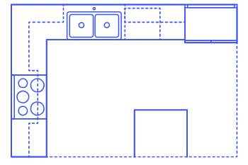
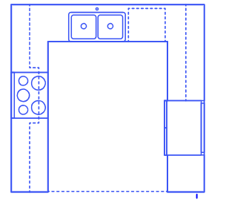
- Mutua and Atieno are planning to renovate their home kitchen in Machakos. They are comparing different layouts to improve efficiency.

X Y
(a) Identify the two kitchen layouts shown in Diagram X and Diagram Y above. (2 mks)
X: ________________________________________ Y: ______________________________________
(b) List two factors Mutua should consider when choosing a kitchen layout. (2 mks)
- _________________________________________________________________________________________
- _________________________________________________________________________________________
(c) State whether the following is True or False:
The "Work Triangle" connects the sink, the cooker, and the refrigerator. [__________] (1 mk)
(d) Define the term "Kitchen Hygiene." (1 mk)
____________________________________________________________________________________________________________________________________________________________________________________________________
- Three learners—Kamau, Cherono, and Fatuma—are classifying food samples brought from Mwea and Molo.
(a) Name the food nutrient group represented by the foods in the basket above. (1 mk)
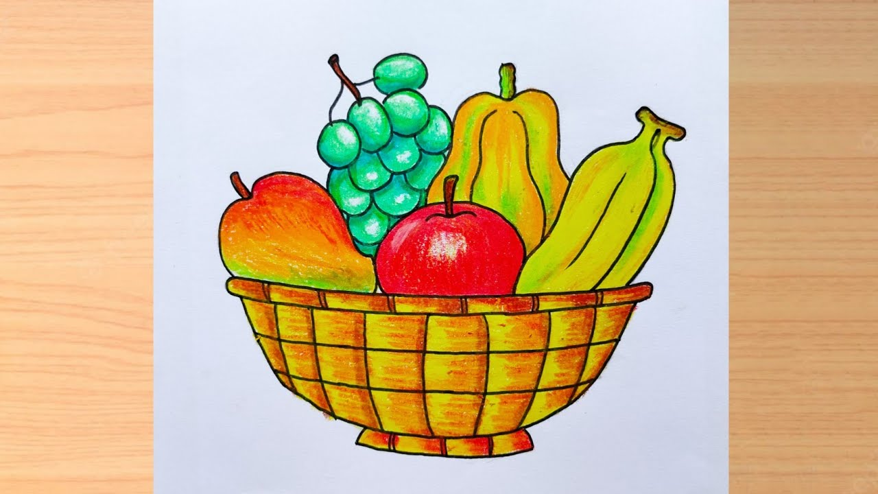
____________________________________________________
(b) Identify which learner is correct: (1 mk)
Kamau: "Maize is a body-building food."
Cherono: "Green leafy vegetables are protective foods."
Fatuma: "Fats are the primary source of dietary fibre."
____________________________________________________________________________________
(c) Distinguish between Fortification and Enrichment of foods. (2 mks)
____________________________________________________________________________________________________________________________________________________________________________________________________
(d) Mention two signs of Vitamin A deficiency in children. (2 mks)
- _________________________________________________________________________________________
- _________________________________________________________________________________________

- A school nurse at Alliance Girls is giving a talk on menstrual hygiene management.
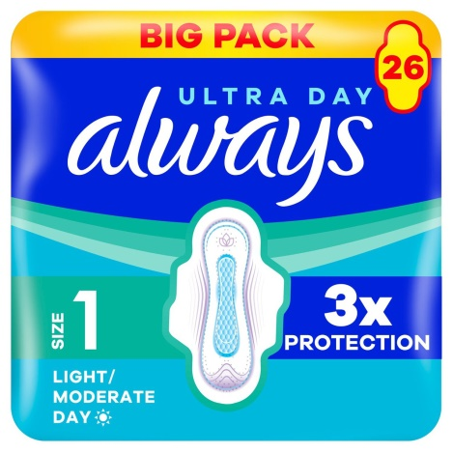
(a) Identify the item shown in the picture below. (1 mk)

_______________________________________________________________
(b) Outline three hygiene practices a girl should observe during menstruation. (3 mks)
- _________________________________________________________________________________________
- _________________________________________________________________________________________
- _________________________________________________________________________________________
(c) Explain why it is important to maintain high standards of personal hygiene during puberty. (2 mks)
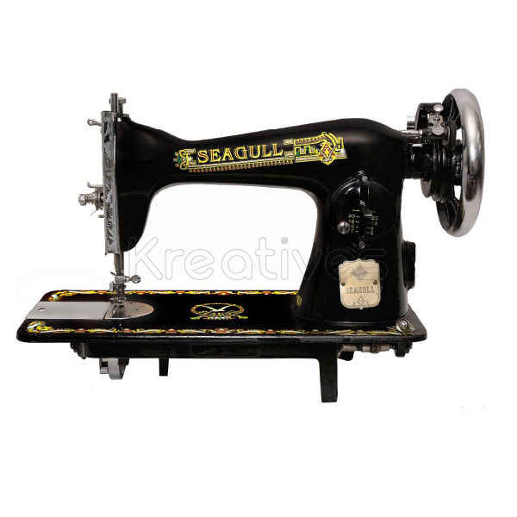
- _________________________________________________________________________________________
- _________________________________________________________________________________________
- During a Home Science practical at Nyeri High School, learners are preparing to make a simple garment.

Y

X

(a) Name the parts of the sewing machine labeled X and Y in the diagram. (2 mks)
X: __________________________________.
Y: __________________________________.

(b) Identify the type of stitch being worked in the illustration below. (1 mk)
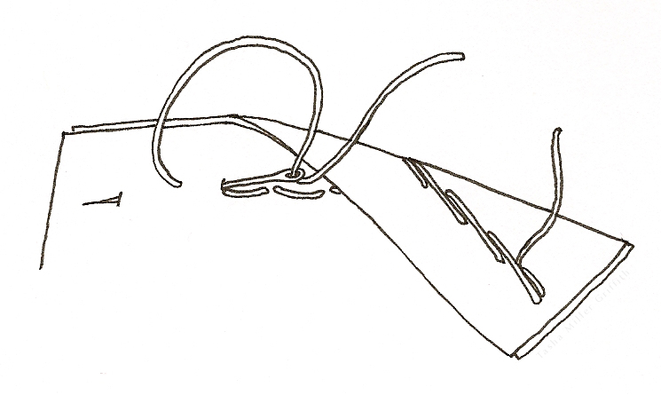

_____________________________________________________
(c) Classify the following stitches as either Temporary or Permanent: (2 mks)
(i) Even Tacking: ____________________
(ii) Running Stitch: ____________________
(d) State one rule for working stitches correctly. (1 mk)
____________________________________________________________________________________________________________________________________________________________________________________________________
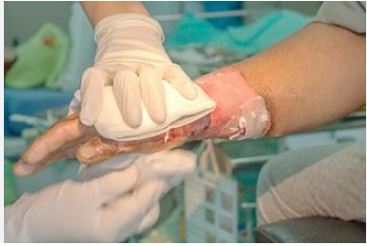
- While cooking in Eldoret, a learner accidentally splashes hot oil on their hand.

(a) Identify the type of injury shown in the picture. (1 mk) __________________________________________________________________
(b) Name two items found in the First Aid Kit used to treat the injury above. (2 mks)
- _________________________________________________________________________________________
- _________________________________________________________________________________________
(c) Describe the immediate First Aid action for a minor burn. (2 mks)
- _________________________________________________________________________________________
- _________________________________________________________________________________________
(d) Mention one safe way to dispose of used First Aid bandages. (1 mk)
____________________________________________________________________________________________________________________________________________________________________________________________________

SECTION B: [50 MARKS]
Answer ALL questions in this section.
- A Home Science club in Kisumu is investigating food spoilage in the local market.
(a) Identify two signs of food spoilage shown in bread. (2 mks)
- _________________________________________________________________________________________
- _________________________________________________________________________________________
(b) Compare the two methods of cooking below: (4 mks)
Boiling and Steaming.
________________________________________________________________________________________________________________________________________________________________________________________________________________________________________________________________________________________________________________________________________________________________________________________________________
(c) List three advantages of using moist heat methods of cooking. (3 mks)
- _________________________________________________________________________________________
- _________________________________________________________________________________________
- _________________________________________________________________________________________
(d) Explain the difference between Food Spoilage and Food Poisoning. (3 mks)
________________________________________________________________________________________________________________________________________________________________________________________________________________________________________________________________________________________________________________________________________________________________________________________________________
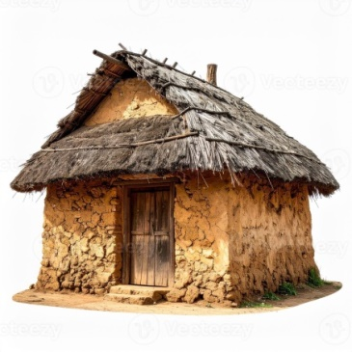
- A family in Nakuru is choosing between renting and buying a house.

(a) Identify the type of house shown in the picture __________________________ (1 mk)
(b) Match the cleaning equipment to its correct use: (4 mks)
I. Squeegee A. Removing loose dust from floors.
II. Soft Broom B. Clearing water from windows/floors.
III. Dustpan C. Scrubbing stained surfaces.
IV. Scrubbing Brush D. Collecting gathered dirt.
(c) Outline the procedure for daily cleaning of a living room. (4 mks)
- _________________________________________________________________________________________
- _________________________________________________________________________________________
- _________________________________________________________________________________________
- _________________________________________________________________________________________
(d) Suggest three ways to manage household waste water safely in a rural setting. (3 mks)
- _________________________________________________________________________________________
- _________________________________________________________________________________________
- _________________________________________________________________________________________
- Three learners are describing the burning test results of different fabric strands.
Learner 1: "It smells like burning hair and leaves a brittle black bead."
Learner 2: "It smells like burning paper and leaves fine grey ash."
Learner 3: "It melts and shrinks away from the flame, smelling like chemicals."
(a) Identify the fibres described by Learner 1 and Learner 2. (2 mks)
_____________________________________________________
(b) Name the laundry agent shown in the bottle labeled Z . (1 mk)
_______________________________________________________
(c) Describe the classification of detergents . (2 mks)
_____________________________________________________________________________
(d) Outline the steps for laundering a white cotton personal item. (5 mks)
- _________________________________________________________________________________________
- _________________________________________________________________________________________
- _________________________________________________________________________________________
- _________________________________________________________________________________________
- _________________________________________________________________________________________
(e) State three characteristics of synthetic fibres like polyester. (3 mks)
- _________________________________________________________________________________________
- _________________________________________________________________________________________
- _________________________________________________________________________________________
- Learners at Starehe Boys are constructing a pair of shorts as a project.
(a) Identify the type of seam shown in the diagram . (1 mk)

________________________________________________________
(b) Name two methods of managing fullness used in the waist of the shorts shown in the picture. (2 mks)
- _________________________________________________________________________________________
- _________________________________________________________________________________________
(c) Evaluate three qualities of a well-made seam. (3 mks)
- _________________________________________________________________________________________
- _________________________________________________________________________________________
- _________________________________________________________________________________________
(d) List four parts of a standard sewing machine that control the thread tension. (4 mks)
- _________________________________________________________________________________________
- _________________________________________________________________________________________
- _________________________________________________________________________________________
- _________________________________________________________________________________________
(e) Explain the importance of consumer education when buying sewing materials. (3 mks)
- _________________________________________________________________________________________
- _________________________________________________________________________________________
- _________________________________________________________________________________________
THIS IS THE LST PRINTED PAGE

