KENYA CERTIFICATE OF BASIC EDUCATION

SENIOR SCHOOL ASSESSMENT

TERM 2: ENDTERM ASSESSMENT 2026
GRADE 10 – HINDU RELIGIOUS EDUCATION
Time: 2 Hours
LEARNER’S DETAILS
Name: _____________________________________________________________. School: ____________________________________________.
Assessment Number: _______________________________________________. Date: ____________________________________________.
School Code: ______________________________________________________. Signature: _______________________________________.

INSTRUCTIONS TO CANDIDATES
- Write your name in the spaces provided above.
- Write the name of your school and your stream in the spaces provided.
- Write your admission number and the date of the assessment in the spaces provided.
- This paper consists of two sections: A and B.
- Answer all questions in section A and section B.
- Answer the questions in English.
- All answers MUST be written in the spaces provided in the paper.
- Do NOT remove any page from this question paper.

FOR OFFICIAL USE ONLY (EXAMINER’S USE)
SECTION | SECTION A | SECTION B | % SCORE | EE1 | EE2 | ME1 | ME2 | AE1 | AE2 | BE1 | BE2
SCORE RANGE | 30 MARKS | 50 MARKS |  | 90-100 | 75-89 | 58-74 | 41-57 | 31-40 | 21-30 | 11-20 | 1-10
POINTS |  |  |  | 8 POINTS | 7 POINTS | 6 POINTS | 5 POINTS | 4 POINTS | 3 POINTS | 2 POINTS | 1 POINT
LEARNER’S TOTAL SCORE

SECTION A (30 MARKS)
Answer ALL questions in this section.
- Learners at Alliance High School are studying the evolution of life through both scientific and spiritual lenses.
(a) Identify the first avatar shown in the diagram above which represents aquatic life. (1 mk)
_______________________________________________________________
(b) Compare the physical characteristics of the Matsya and Varah avatars in relation to their habitats. (4 mks)
_____________________________________________________________________________________________________________________________________________________________________________________________________________________________________________________________________________________________

(c) State whether the following is True or False:
The Dashavatars provide lessons on environmental conservation and the protection of all species. [__________] (1 mk)
(d) Explain how the concept of "Buddhahood" promotes social harmony in a diverse school setting like those found in Kilifi County. (4 mks)
- ________________________________________________________________________________________
- ________________________________________________________________________________________
- ________________________________________________________________________________________
- ________________________________________________________________________________________


- During the National Music Festivals in Nairobi, four learners are discussing the properties of materials used to make musical instruments.

X Y
(a) Identify and Name the instruments labeled X and Y in the illustration above. (2 mks)
X: ___________________________________________________.
Y: ___________________________________________________.
(b) Match the instrument to the primary material used in its construction: (4 mks)
I. Tabla A. Wood and Reeds
II. Sitar B. Wood and Animal Skin
III. Harmonium C. Gourd and Metal Strings
IV. Dhol D. Wood and stretched hide
(c) Describe the function of the Taanpura in a vocal music performance. (2 mks)
- ________________________________________________________________________________________
- ________________________________________________________________________________________

(d) Mention two Kenyan folk dances that utilize the Dhol or similar percussion instruments for rhythm. (2 mks)
- ________________________________________________________________________________________
- ________________________________________________________________________________________
- A Grade 10 student in Kisumu is keeping a journal to track their daily actions based on the Law of Karma.
(a) Define the term "Law of Karma" as understood in the Sanatan faith. (2 mks) ______________________________________________________________________________________________________________________________________________________________________________________________
(b) Distinguish between Sukrit Karma and Dukrit Karma in Sikhism. (4 mks)
Sukrit karma | Dukrit karma
(c) Outline the four types of Karma identified in Jainism regarding intensity and duration. (4 mks)
- ________________________________________________________________________________________
- ________________________________________________________________________________________
- ________________________________________________________________________________________
- ________________________________________________________________________________________

SECTION B: [50 MARKS]
- Learners at Kenya High School are researching the development of ancient texts using digital assistive technology.
(a) Identify the scripture in the picture that is considered the "Eternal Living Guru" in the Sikh faith. (1 mk)
________________________________________________________________
(b) List the three main divisions (baskets) of the Tripitaka in Buddhism. (3 mks)
- ________________________________________________________________________________________
- ________________________________________________________________________________________
- ________________________________________________________________________________________
(c) Describe the origin of the Vedas according to the Shruti tradition. (3 mks)
_____________________________________________________________________________________________________________________________________________________________________________________________________________________________________________________________________________________________
(d) Explain how studying the Mahabharata helps a learner resolve ethical dilemmas in modern society. (4 mks)
- ________________________________________________________________________________________
- ________________________________________________________________________________________
- ________________________________________________________________________________________
- ________________________________________________________________________________________
(e) Name the prominent personality who composed the Ramcharitmanas to propagate the teachings of Ram. (1 mk)
___________________________________________________________
(f) State three challenges encountered during the historical development of these scriptures. (3 mks)
- ________________________________________________________________________________________
- ________________________________________________________________________________________
- ________________________________________________________________________________________
- Three learners—Achieng, Mutua, and Hassan—are observing a cultural dance performance in Mombasa.
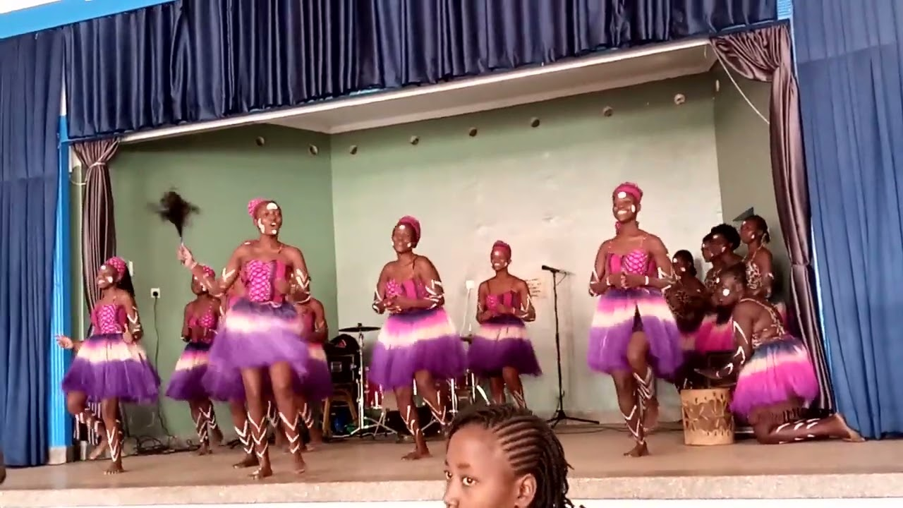
(a) Identify which dance in the picture originates from the Kenyan community. (1 mk)
__________________________________________________
(b) Examine the relationship between the frequency of the music and the pace of the Bhangra dance. (4 mks)
- ________________________________________________________________________________________
- ________________________________________________________________________________________
- ________________________________________________________________________________________

(c) Name the musical instrument typically paired with the Garba dance. (2 mks)
__________________________________________________________________

(d) Categorize the following vocal music forms: (4 mks)
I. National Anthem: ____________________
II. Bhajans: ____________________
III. Traditional Folk Song: ____________________
IV. Patriotic Song: ____________________
(e) Explain why correct pronunciation of Shabad (Hymns) is scientifically and spiritually important according to the Sikh faith. (4 mks)
- ________________________________________________________________________________________
- ________________________________________________________________________________________
- ________________________________________________________________________________________
- ________________________________________________________________________________________
- A resource person at Starehe Boys' Centre is giving a talk on the core beliefs of Dharma and environmental sustainability.
(a) Identify and Define the principle from the four faiths that forbids the harming of any living being. (3 mks)
_____________________________________________________________________________________________________________________________________________________________________________________________________________________________________________________________________________________________
(b) List the Five selected Tirthankaras in Jainism whose teachings emphasize agricultural and social reforms. (5 mks)
- ________________________________________________________________________________________
- ________________________________________________________________________________________
- ________________________________________________________________________________________
- ________________________________________________________________________________________
- ________________________________________________________________________________________
(c) Explain the contribution of Tirthankar Rishabhdev to agricultural development. (3 mks)
- ________________________________________________________________________________________
- ________________________________________________________________________________________
- ________________________________________________________________________________________
(d) Discuss how the principle of Aparigraha (Non-possessiveness) can be used to solve the emerging issue of resource depletion in Kenya. (5 mks)
- ________________________________________________________________________________________
- ________________________________________________________________________________________
- ________________________________________________________________________________________
- ________________________________________________________________________________________
- ________________________________________________________________________________________
(e) Identify the nine qualities of a Buddha that contribute to personal development and social integrity. (4 mks)
- ________________________________________________________________________________________
- ________________________________________________________________________________________
- ________________________________________________________________________________________
- ________________________________________________________________________________________
- ________________________________________________________________________________________
- ________________________________________________________________________________________
- ________________________________________________________________________________________
- ________________________________________________________________________________________
- ________________________________________________________________________________________

THIS IS THE LAST PRINTED PAGE

