KENYA CERTIFICATE OF BASIC EDUCATION

SENIOR SCHOOL ASSESSMENT

TERM 2: ENDTERM ASSESSMENT 2026
GRADE 10 – INFORMATION COMMUNICATION TECHNOLOGY
Time: 2 Hours
LEARNER’S DETAILS
Name: _____________________________________________________________. School: ____________________________________________.
Assessment Number: _______________________________________________. Date: ____________________________________________.
School Code: ______________________________________________________. Signature: _______________________________________.

INSTRUCTIONS TO CANDIDATES
- Write your details as required in the spaces provided above.
- This paper consists of two sections: A and B.
- Answer all questions in section A and section B.
- Answer the questions in English.
- All answers MUST be written in the spaces provided in the paper.
- Do NOT remove any page from this question paper.

FOR OFFICIAL USE ONLY (EXAMINER’S USE)
SECTION | SECTION A | SECTION B | % SCORE | EE1 | EE2 | ME1 | ME2 | AE1 | AE2 | BE1 | BE2
SCORE RANGE | 30 MARKS | 50 MARKS |  | 90-100 | 75-89 | 58-74 | 41-57 | 31-40 | 21-30 | 11-20 | 1-10
POINTS |  |  |  | 8 POINTS | 7 POINTS | 6 POINTS | 5 POINTS | 4 POINTS | 3 POINTS | 2 POINTS | 1 POINT
LEARNER’S TOTAL SCORE

SECTION A (30 MARKS)
Answer ALL questions in this section.



- Learners at Bahati Girls’ Senior School are setting up a small network in their computer lab to share resources.

P R S
(a) Identify the components of the IC T infrastructure labeled P, R, and S in the diagram above. (3 mks)
P: ____________________________________.
R: ____________________________________.
S: ____________________________________.
(b) Distinguish between 'Technology' and 'Information and Communication Technology (ICT)'. (2 mks) __________________________________________________________________________________________________________________________________________________________________________________________________
(c) State whether the following is True or False:
A printer is a part of the hardware component of ICT infrastructure. [__________] (1 mk)
(d) Mention two ways ICT has improved the lives of residents in Lodwar, a remote part of Kenya. (2 mks)
- ___________________________________________________________________________________________
- ___________________________________________________________________________________________
- Abdi, a learner at Kapsabet High, is organizing his school projects on a digital device.
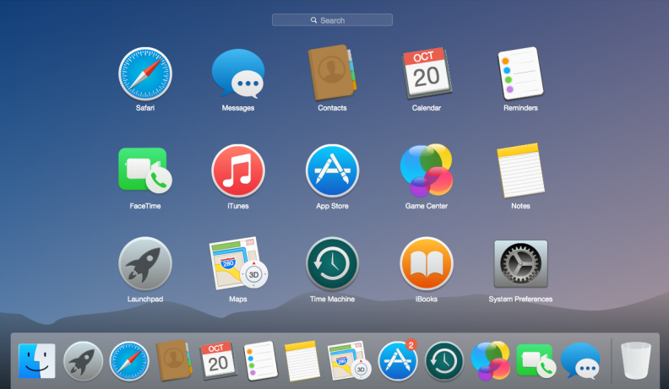
(a) Name the type of Operating System interface shown in the image above. (1 mk)

________________________________________________________
(b) Outline the steps Abdi should take to create a new folder named "History Project" and move it into the "Grade 10" directory. (3 mks)
- ___________________________________________________________________________________________
- ___________________________________________________________________________________________
- ___________________________________________________________________________________________
(c) Select the correct Operating System used primarily for mobile devices from the list below:

Windows Linux Android macOS (1 mk)

(d) Define the term 'Operating System' and Explain its importance in a computing device. (2 mks)
____________________________________________________________________________________________________________________________________________________________________________________________________________________________________________________________________________________________________________________________________________________________________________________________________
- Moraa, Otieno, and Chepngetich are discussing how to make their Grade 10 newsletter look professional.

X Y
(a) Identify the function of the icons labeled X and Y in the image. (2 mks)
X: _____________________________________________________________________________________________
Y: _____________________________________________________________________________________________
(b) Match the following Word Processing tasks with their correct tools: (3 mks)
I. Checking spelling errors A. Mail Merge
II. Generating mass letters B. Spell Checker
III. Changing paper size C. Page Setup
(c) Describe how Moraa can insert a Table of Contents automatically in her document. (2 mks)
- ___________________________________________________________________________________________
- ___________________________________________________________________________________________
- A guest speaker at Tala Senior School is talking about responsible use of the internet.

(a) Identify the concept represented by the illustration above. (1 mk)
__________________________________________________________
(b) List three "Netiquette" behaviors that a good digital citizen should observe in an online forum. (3 mks)
- ___________________________________________________________________________________________
- ___________________________________________________________________________________________
- ___________________________________________________________________________________________

(c) Explain the importance of adjusting Privacy Settings on social media platforms. (2 mks)
- ___________________________________________________________________________________________
- ___________________________________________________________________________________________
(d) Mention two healthy ergonomic practices to observe when using a computer for long hours. (2 mks)
- ___________________________________________________________________________________________
- ___________________________________________________________________________________________

SECTION B: [50 MARKS]
Answer ALL questions in this section.
- Learners from Limuru Girls visited a local supermarket in Nanyuki to observe ICT in use.
(a) Identify the specific application area of ICT shown in the picture. (1 mk)

_________________________________________________
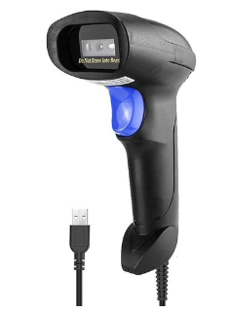
(b) Name the device shown below and Explain how it works. (3 mks)
_______________________________________

- ___________________________________________________________________________________________
- ___________________________________________________________________________________________

(c) Describe how ICT is used in the school administration office to solve community problems. (4 mks)
- ___________________________________________________________________________________________
- ___________________________________________________________________________________________
- ___________________________________________________________________________________________
- ___________________________________________________________________________________________
(d) Compare the use of ICT in Tele-medicine versus E-learning in the context of Kenya's development. (4 mks)
Tele- Medicine | E -Learning
- Wanjala wants to create a graduation brochure for his brother at Maseno School.
(a) Identify the tool Wanjala is using based on the layout in the picture. (1 mk)

______________________________________________
(b) Distinguish between a Word Processor and a Desktop Publisher in terms of their primary purpose. (3 mks)
Word processor | Desktop publisher
(c) List four common services offered through the internet that Wanjala might use to find images for his brochure. (4 mks)
- ___________________________________________________________________________________________
- ___________________________________________________________________________________________
- ___________________________________________________________________________________________
- ___________________________________________________________________________________________
(d) Describe how to add Slide Transitions and Animations in a presentation software to make it interactive. (5 mks)
- ___________________________________________________________________________________________
- ___________________________________________________________________________________________
- ___________________________________________________________________________________________
- ___________________________________________________________________________________________
- Four learners are describing different internet components.
Amina: "It is a global network of interconnected computers."
Brian: "It is a company that provides access to the internet."
Chalo: "It is a unique address used to locate a resource on the web."
Desta: "It is a software application used to access websites."
(a) Name the terms described by Amina, Brian, Chalo, and Desta. (4 mks)
Term described
Amina
Brian
Chalo
Desta
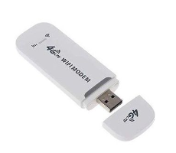
(b) Identify the hardware components in the diagram below required to set up an internet connection. (3 mks)
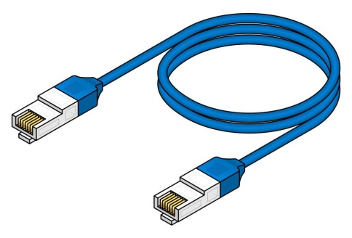
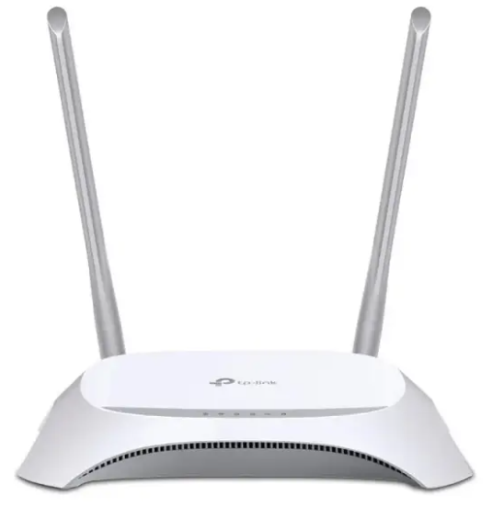
Q R S
Q: _____________________________________.
R: _____________________________________.
S: _____________________________________.
(c) Explain the role of a Search Engine in gathering information for a school project. (2 mks)
- ___________________________________________________________________________________________
- ___________________________________________________________________________________________

(d) Outline three positive impacts of the internet on the Kenyan society today. (3 mks)
- ___________________________________________________________________________________________
- ___________________________________________________________________________________________
- ___________________________________________________________________________________________
- During a project at Pangani Girls, learners are using collaboration tools to work on a joint report.

(a) Identify the digital collaboration platform represented in the image. (1 mk)

________________________________________________________
(b) Name two video conferencing tools commonly used for remote learning in Kenya. (2 mks)
- ___________________________________________________________________________________________
- ___________________________________________________________________________________________
(c) Discuss the impact of Artificial Intelligence (AI) in digital communication platforms. (4 mks)
- ___________________________________________________________________________________________
- ___________________________________________________________________________________________
- ___________________________________________________________________________________________
- ___________________________________________________________________________________________
(d) Explain how a learner can use an Online Forum to collaborate with peers on a topical issue. (3 mks)
- ___________________________________________________________________________________________
- ___________________________________________________________________________________________
- ___________________________________________________________________________________________
(e) State three practices for Environmental Conservation to mitigate electronic waste caused by digital technology. (3 mks)
- ___________________________________________________________________________________________
- ___________________________________________________________________________________________
- ___________________________________________________________________________________________
THIS IS THE LAST PRINTED PAGE

