KENYA CERTIFICATE OF BASIC EDUCATION

SENIOR SCHOOL ASSESSMENT

TERM 2: ENDTERM ASSESSMENT JUNE 2026
GRADE 10 – ISLAMIC RELIGIOUS EDUCATION
Time: 2 Hours
LEARNER’S DETAILS
Name: _____________________________________________________________. School: ____________________________________________.
Assessment Number: _______________________________________________. Date: ____________________________________________.
School Code: ______________________________________________________. Signature: _______________________________________.

INSTRUCTIONS TO CANDIDATES
- Write your details as required above
- This paper consists of two sections: A and B.
- Answer all questions in section A and section B.
- Answer the questions in English.
- All answers MUST be written in the spaces provided in the paper.
- Do NOT remove any page from this question paper.

FOR OFFICIAL USE ONLY (EXAMINER’S USE)
SECTION | SECTION A | SECTION B | % SCORE | EE1 | EE2 | ME1 | ME2 | AE1 | AE2 | BE1 | BE2
SCORE RANGE | 30 MARKS | 50 MARKS |  | 90-100 | 75-89 | 58-74 | 41-57 | 31-40 | 21-30 | 11-20 | 1-10
POINTS |  |  |  | 8 POINTS | 7 POINTS | 6 POINTS | 5 POINTS | 4 POINTS | 3 POINTS | 2 POINTS | 1 POINT
LEARNER’S TOTAL SCORE

SECTION A (30 MARKS)
Answer ALL questions in this section.


- Three learners—Zubair, Sumaiya, and Omar—at Sheikh Khalifa Senior School are discussing the history of the Quranic text.

X Y

(a) Identify the specific diacritical marks (tashkil) labeled X and Y in the scriptural image below. (2 mks)
X: _________________________ Y: _________________________
(b) List two reasons why Caliph Uthman (R.A.) ordered the standardisation of the Quran. (2 mks)
- ___________________________________________________________________________________________
- ___________________________________________________________________________________________
(c) Describe the role of Zaid bin Thabit during the compilation process under Caliph Abubakar (R.A.). (2 mks)
- _________________________________________________________________________________________
- _________________________________________________________________________________________
(d) Distinguish between Muhkamat (clear) and Mutashabihat (allegorical) verses using one example for each. (4 mks)
Muhkamat | mutashabihat
- Fatuma, a learner from Garissa High School, is examining a scroll containing a Prophetic tradition.
HADITH

B
A

(a) Identify the parts of the Hadith labeled A (Isnad) and B (Matn) in the diagram. (2 mks)
A: ________________________________________
B: ________________________________________
(b) State whether the following is True or False:
A Muhaddith must possess a strong memory and high integrity. [__________] (1 mk)
(c) Outline the criteria used to determine if a Hadith is Sahih (authentic). (3 mks)
- ___________________________________________________________________________________________
- ___________________________________________________________________________________________
- ___________________________________________________________________________________________

(d) Explain the teaching of the Hadith on Kinship regarding one’s provision and lifespan. (4 mks)
- ___________________________________________________________________________________________
- ___________________________________________________________________________________________
- ___________________________________________________________________________________________
- ___________________________________________________________________________________________
- It is the morning of Idd-ul-Fitr in Nyeri Town. The local mosque is preparing for the congregation.
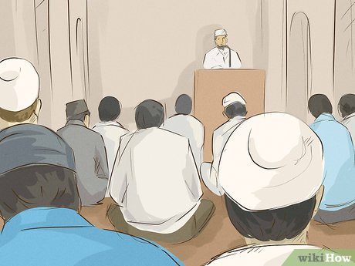
(a) Identify the ritual action being performed by the Imam in the picture above. (1 mk)
______________________________________________________________
(b) Compare two conditions for the validity of Swalatul Jum’a versus Swalatul Idd. (4 mks)
- ___________________________________________________________________________________________
- ___________________________________________________________________________________________
(c) Mention the number of extra Takbirat performed in the first and second rak'ah of Idd prayer. (2 mks)
- ___________________________________________________________________________________________
- ___________________________________________________________________________________________
(d) Define Fardh Kifayah in the context of funeral rites. (3 mks)
_____________________________________________________________________________________________________________________________________________________________________________________________________________________________________________________________________________________________

SECTION B: [50 MARKS]
Answer ALL questions in this section.
- Learners at Kamagambo Senior School are simulating the preparation of a deceased person for burial.
(a) Identify and Name the four stages of funeral rites. (4 mks)
- ___________________________________________________________________________________________
- ___________________________________________________________________________________________
- ___________________________________________________________________________________________
- ___________________________________________________________________________________________
(b) Describe the correct procedure for wrapping the Kafan for a male deceased. (3 mks)
- ___________________________________________________________________________________________
- ___________________________________________________________________________________________
- ___________________________________________________________________________________________
(c) Explain why it is important for the community to participate in Swalatul Janaza. (2 mks)
- ___________________________________________________________________________________________
- ___________________________________________________________________________________________
(d) Distinguish between the types of divorce: Li’an and Faskh Nikah. (3 mks)

Li’an | Faskh Nikah
- The Kenya Zakat Fund is assessing challenges in the distribution of funds to the needy in Isiolo County.
(a) Calculate the Zakat payable if a businessman in Eastleigh has 800,000 KES in savings for a full lunar year (Assume Nisab is 600,000 KES and rate is 2.5%). (3 mks)

(b) Identify two challenges facing the administration of Zakat in Kenya today. (2 mks)
- ___________________________________________________________________________________________
- ___________________________________________________________________________________________
(c) Explain the feature of Shura (consultation) in Islamic governance. (3 mks)
- ___________________________________________________________________________________________
- ___________________________________________________________________________________________
- ___________________________________________________________________________________________
(d) Describe the rights of an Employee regarding wages according to Islamic labor relations. (4 mks)
- ___________________________________________________________________________________________
- ___________________________________________________________________________________________
- ___________________________________________________________________________________________
- ___________________________________________________________________________________________
- A health inspector in Kisumu is explaining the Islamic rationale for dietary laws.
(a) Identify the prohibited food item shown in the diagram below. (1 mk)
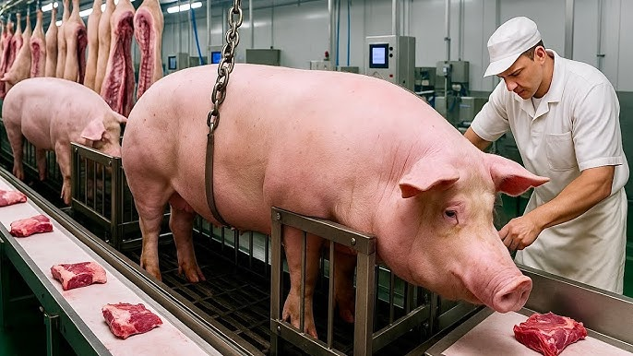
______________________________________________________________
(b) Examine the rationale for the prohibition of Carrion (Maytah) and Blood. (4 mks)
- ___________________________________________________________________________________________
- ___________________________________________________________________________________________
- ___________________________________________________________________________________________
- ___________________________________________________________________________________________
(c) List three manners of Walking as taught in the Quran (Surah Luqman/Surah Al-Furqan). (3 mks)
- ___________________________________________________________________________________________
- ___________________________________________________________________________________________
- ___________________________________________________________________________________________
(d) Distinguish between Hasad and Kibr and their effects on social harmony. (4 mks)
Hasad | Kibr
(e) State two rules governing Islamic Clothing for males. (2 mks)
- ___________________________________________________________________________________________
- ___________________________________________________________________________________________
- Musa, a student at Nairobi School, is researching the Umayyad Dynasty and East African scholars.
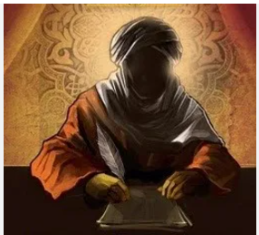
(a) Identify the caliph who is famously known as the "Fifth Rightly Guided Caliph" shown in the portrait. (1 mk)

__________________________________________________
(b) Assess the contributions of Abdulmalik ibn Marwan to the development of Islamic administration. (3 mks)
- ___________________________________________________________________________________________
- ___________________________________________________________________________________________
- ___________________________________________________________________________________________
(c) Describe three factors that led to the decline of the Umayyad Dynasty. (3 mks)
- ___________________________________________________________________________________________
- ___________________________________________________________________________________________
- ___________________________________________________________________________________________

(d) Explain the role played by Sheikh Abdallah Saleh Al-Farsy in the spread of Islamic knowledge in East Africa. (3 mks)
- ___________________________________________________________________________________________
- ___________________________________________________________________________________________
- ___________________________________________________________________________________________
(e) Name one contribution of Aisha Lemu to Islamic education. (2 mks)
- ___________________________________________________________________________________________
- ___________________________________________________________________________________________

THIS IS THE LAST PRINTED PAGE

