KENYA CERTIFICATE OF BASIC EDUCATION

SENIOR SCHOOL ASSESSMENT

TERM 2: ENDTERM ASSESSMENT 2026
GRADE 10 – MARINE TECHNOLOGY
Time: 2 Hours
LEARNER’S DETAILS
Name: _____________________________________________________________. School: ____________________________________________.
Assessment Number: _______________________________________________. Date: ____________________________________________.
School Code: ______________________________________________________. Signature: _______________________________________.

INSTRUCTIONS TO CANDIDATES
- Write your details as required above
- This paper consists of two sections: A and B.
- Answer all questions in section A and section B.
- Answer the questions in English.
- All answers MUST be written in the spaces provided in the paper.
- Do NOT remove any page from this question paper.

FOR OFFICIAL USE ONLY (EXAMINER’S USE)
SECTION | SECTION A | SECTION B | % SCORE | EE1 | EE2 | ME1 | ME2 | AE1 | AE2 | BE1 | BE2
SCORE RANGE | 30 MARKS | 50 MARKS |  | 90-100 | 75-89 | 58-74 | 41-57 | 31-40 | 21-30 | 11-20 | 1-10
POINTS |  |  |  | 8 POINTS | 7 POINTS | 6 POINTS | 5 POINTS | 4 POINTS | 3 POINTS | 2 POINTS | 1 POINT
LEARNER’S TOTAL SCORE

SECTION A (30 MARKS)
Answer ALL questions in this section.
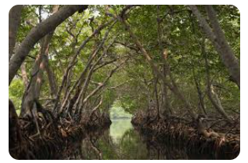
  - A group of Grade 10 learners from Lamu Senior School visited various coastal and inland sites. Below are the images of the aquatic ecosystems they observed. Name the ecosystem and state one physical characteristic.

(a) (i) Name of Ecosystem: _____________________________
(ii) Physical Characteristic: _______________________________________________________________

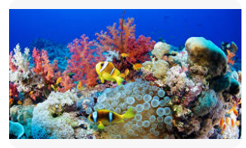
(b) (i) Name of Ecosystem: _________________
(ii) Physical Characteristic: __________________________________________________________________
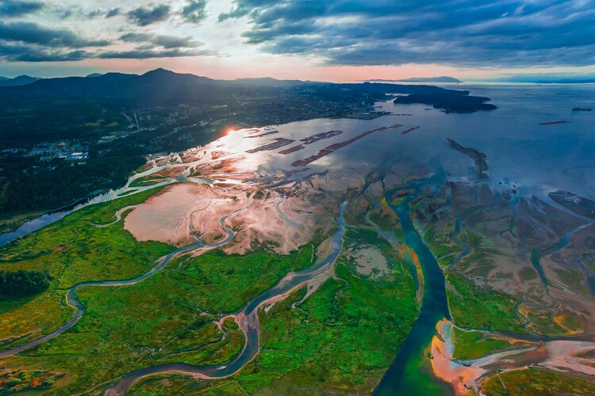
(c) (i) Name of Ecosystem: ___________________
(ii) Physical Characteristic: __________________________________________________________________
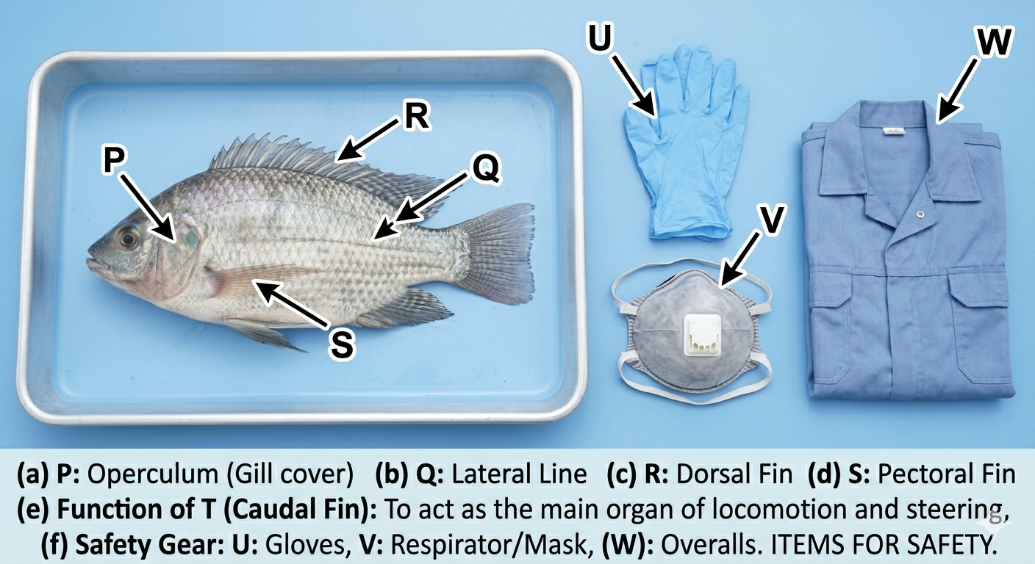
  - During a practical session at the Kisumu Fisheries Department, learners were provided with a Tilapia. Use the diagram below to answer the questions.

Name the parts labelled
P: _____________________________ (1mk) Q: _______________________________ (1mk)
R: _____________________________ (1mk) S: ________________________________ (1mk)
(e) State the function of part T: ______________________________________________________________________________________________________________________________________________________________________________________________
  - Match the professional in Column A with their primary work environment or role in Column B based on the provided images of their work tools.
Column A (Career) | Column B (Work Environment/Role)
(a) Aquaculturist | (i) Studies the chemical composition of seawater.
(b) Marine Biologist | (ii) Manages fish processing factories in Homa Bay.
(c) Quality Assurance Officer | (iii) Designs and manages fish cage systems in Lake Victoria.
(d) Oceanographer | (iv) Researches coral reef conservation in Malindi.
(e) Fisheries Extension Officer | (v) Educates farmers on pond management in Sagana.
  - State whether the following statements are TRUE or FALSE.
(a) High salinity is a biological characteristic of marine water. [__________]
(b) Lake Turkana is an example of a purely fresh water environment. [__________]
(c) Cartilaginous fish, like sharks, possess a swim bladder for buoyancy. [__________]
(d) Mangroves act as breeding grounds for many marine fish species. [__________]
(e) The Nile Perch is an indigenous species of Lake Victoria. [__________]
  - (a) Define Aquaculture. (2 marks) ________________________________________________________________________________________________________________________________________________________________________________________
(b) Outline three factors to consider when selecting a site for an earthen fish pond. (3 marks)
- ____________________________________________________________________________________________
- ____________________________________________________________________________________________
- ____________________________________________________________________________________________
(c) Name two internal parts of a fish responsible for breathing and buoyancy. (2 marks)
- ____________________________________________________________________________________________
- ____________________________________________________________________________________________
(d) Distinguish between Extensive and Intensive aquaculture systems. (3 marks) _____________________________________________________________________________________________________________________________________________________________________________________________________________________________________________________________________________________________

SECTION B (50 MARKS)
  - Chief Mwalimu of Kwale County wants to start a community fish farm. He has invited Mr. Okoth, a Marine Technology expert, to assess a piece of land.
(a) Explain why topography and soil type are critical for this construction. (4 marks)
______________________________________________________________________________________________________________________________________________________________________________________________
(b) Mr. Okoth recommends an Earthen Lined Pond. Describe the steps involved in constructing this type of pond. (6 marks)
- ____________________________________________________________________________________________
- ____________________________________________________________________________________________
- ____________________________________________________________________________________________
- ____________________________________________________________________________________________
- ____________________________________________________________________________________________
- ____________________________________________________________________________________________
(c) Calculate the area of a rectangular pond if the Chief decides to make it 25m long and 10m wide. (2 marks)

(d) Suggest three security measures the Chief should put in place for the farm. (3 marks)
- ____________________________________________________________________________________________
- ____________________________________________________________________________________________
- ____________________________________________________________________________________________
- Four learners from Mombasa Senior School are describing different management practices.
Ali: "I am adding lime to the pond bottom before putting in water."
Zavai: "I am placing the plastic bags of fingerlings in the pond water for 20 minutes before releasing them."
Musa: "I am adding cow manure to the water to make it green."
Fatuma: "I am recording the weight of the fish every two weeks."
(a) Identify the specific process Zavai is describing. (1 mark)
________________________________________________________________
(b) Explain why Zavai’s process is necessary for the survival of the fish. (3 marks)
_____________________________________________________________________________________________________________________________________________________________________________________________________________________________________________________________________________________________
(c) Name the practice Musa is carrying out and state its purpose. (3 marks)
_____________________________________________________________________________________________________________________________________________________________________________________________________________________________________________________________________________________________
(d) Outline three reasons why Fatuma’s record-keeping is important for the farm's economy. (3 marks)
- ____________________________________________________________________________________________
- ____________________________________________________________________________________________
- ____________________________________________________________________________________________
(e) State two reasons why Ali is "liming" the pond. (2 marks)
- ____________________________________________________________________________________________
- ____________________________________________________________________________________________

(f) Identify the safety equipment in the picture below that a worker must wear when applying chemicals. (3 marks)

(U) ________________________________.
(W) _______________________________.
(V) _______________________________.

- During a field trip to the Watamu Marine National Park, learners observed the following condition in the coral reefs.
(a) Explain two biological or chemical factors that could lead to the "bleached" condition. (4 marks)
- ____________________________________________________________________________________________
- ____________________________________________________________________________________________
(b) Describe three ways in which the local community benefits economically from a healthy reef. (3 marks)
- ____________________________________________________________________________________________
- ____________________________________________________________________________________________
- ____________________________________________________________________________________________
(c) Suggest three conservation efforts to protect Kenyan seagrass and mangroves. (3 marks)
- ____________________________________________________________________________________________
- ____________________________________________________________________________________________
- ____________________________________________________________________________________________

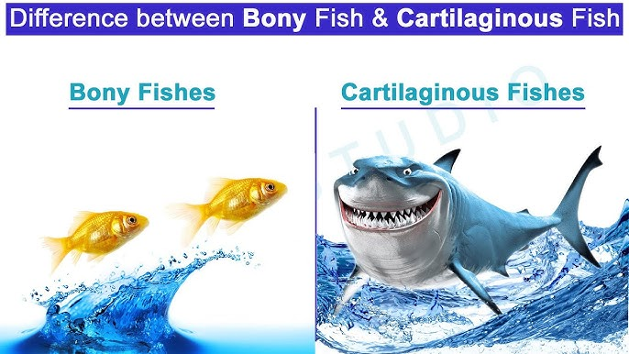
- Achieng works at a fish processing factory in Kisumu. She is comparing two types of fish for export.

F G
(a) Identify the major difference in the skeletal material of the two fish shown. (2 marks)
F | G

(b) Compare the gill structures of the two fish in the diagram. (4 marks)

F | G

(c) Identify the internal organ that helps the Nile Perch stay afloat without swimming. (2 marks)
______________________________________________________________________
(d) Mention two safety hazards Achieng might face in a fish processing factory. (2 marks)
- ____________________________________________________________________________________________
- ____________________________________________________________________________________________

THIS IS THE LAST PRINTED PAGE

