KENYA CERTIFICATE OF BASIC EDUCATION

SENIOR SCHOOL ASSESSMENT

TERM 2 ENDTERM ASSESSMENTS 2026
GRADE 10 – MEDIA TECHNOLOGY
Time: 2 Hours
LEARNER’S DETAILS
Name: _____________________________________________________________. School: ____________________________________________.
Assessment Number: _______________________________________________. Date: ____________________________________________.
School Code: ______________________________________________________. Signature: _______________________________________.

INSTRUCTIONS TO CANDIDATES
- Write your details as required in the spaces above.
- This paper consists of two sections: A and B.
- Answer all questions in section A and section B.
- Answer the questions in English.
- All answers MUST be written in the spaces provided in the paper.
- Do NOT remove any page from this question paper.

FOR OFFICIAL USE ONLY
SECTION | SECTION A | SECTION B | % SCORE | EE1 | EE2 | ME1 | ME2 | AE1 | AE2 | BE1 | BE2
SCORE RANGE | 30 MARKS | 50 MARKS |  | 90-100 | 75-89 | 58-74 | 41-57 | 31-40 | 21-30 | 11-20 | 1-10
POINTS |  |  |  | 8 POINTS | 7 POINTS | 6 POINTS | 5 POINTS | 4 POINTS | 3 POINTS | 2 POINTS | 1 POINT
LEARNER’S TOTAL SCORE

SECTION A (30 MARKS)
Answer ALL questions in this section.
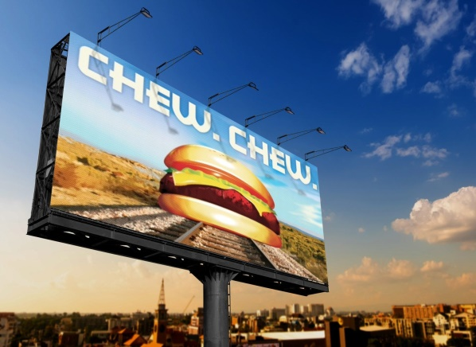

  - A group of Grade 10 learners at NEP Girls Senior School were discussing the evolution of media. Study the images below of traditional media formats.

L R
(a) Identify the print media format labelled L. ___________________________ (1 mark)
(b) Name the modern outdoor print media format labelled R. ___________________________ (1 mark)

(c) Distinguish between Traditional Media and New Media based on the images above. (3 marks)
Traditional Media | New Media
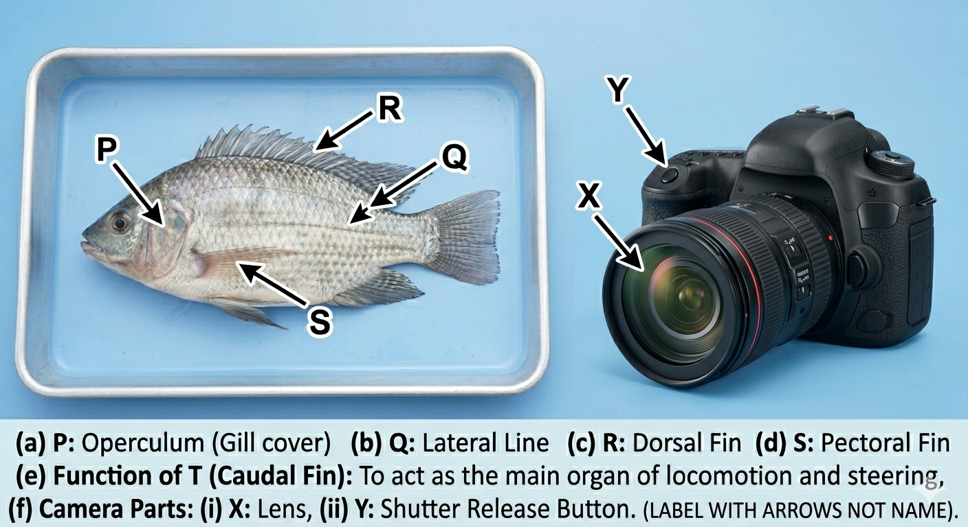
  - Stacy, a learner at Mama Ngina Girls High School, is learning about camera parts. Use the diagram of the DSLR camera below to answer the questions.

(a) Name the parts labeled:
(i) X: ________________________ (ii) Y: ________________________
(b) Explain the function of the Viewfinder in photography. (2 marks)
- ____________________________________________________________________________________________
- ____________________________________________________________________________________________
(c) State whether the following is TRUE or FALSE:
A Prime Lens has a fixed focal length and cannot zoom. [__________] (1 mark)
  - Match the professional role in Column A with their primary responsibility in Column B by drawing a line.
Gaffer (i) In charge of the creative vision and "calling the shots" on set.
Director (ii) Head of the electrical department/lighting setup.
Foley Artist (iii) Operates the camera during production.
Cinematographer (iv) Creates sound effects in post-production.
Editor (v) Assembles recorded footage into a final program.

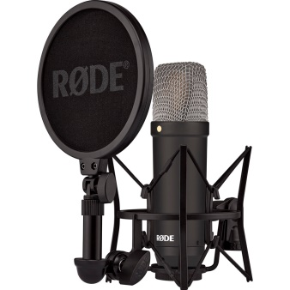
  - Below are images of equipment found in the media lab at Kagumo High School.

(a) Identify the specific type of microphone shown above.______________________________________ (1 mark)
(b) Name two accessories required to hold a microphone steady during a field recording in Marsabit. (2 marks)
(i) __________________________________________________
(ii) __________________________________________________
(c) Define "Ambience" as a type of sound in audio production. (2 marks)
______________________________________________________________________________________________________________________________________________________________________________________________
  - (a) Kenya has different types of media ownership. List three types. (3 marks)
(i) ________________________________________________________
(ii) _______________________________________________________
(iii) _______________________________________________________
(b) Outline two advantages of Community-owned media in rural areas like Narok. (2 marks)
- ____________________________________________________________________________________________
- ____________________________________________________________________________________________
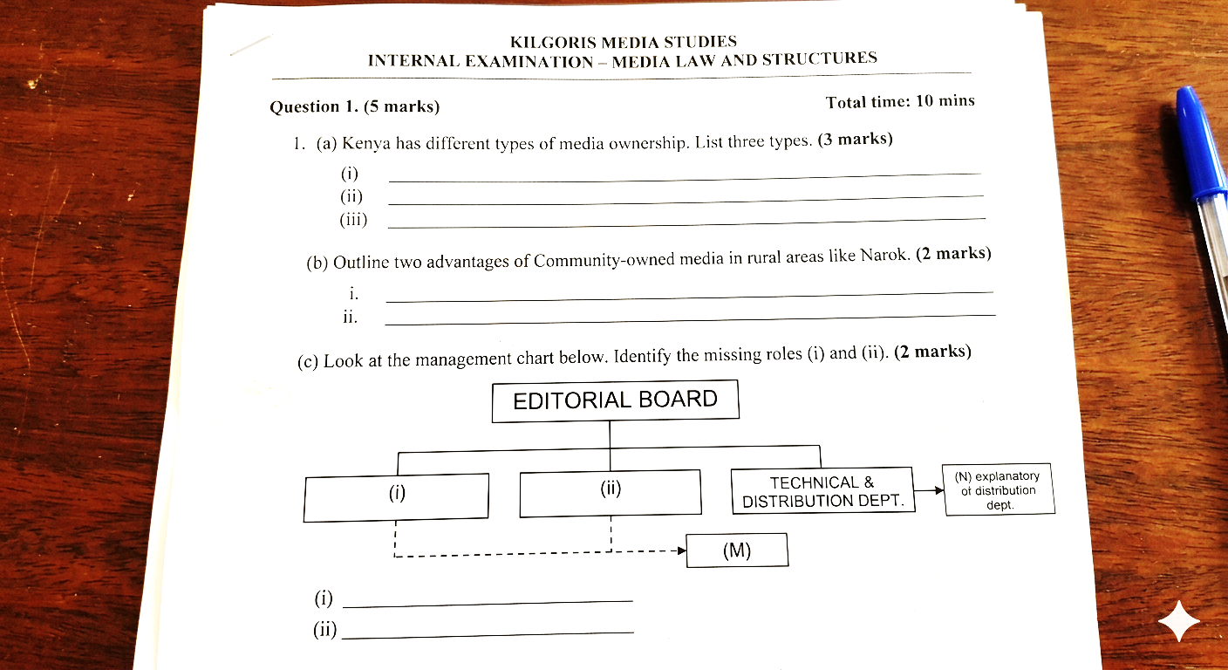
(c) Look at the management chart below. Identify the missing roles (i) and (ii). (2 marks)

(d) Explain the role of a Legal Advisor in a media company. (3 marks)
- ____________________________________________________________________________________________
- ____________________________________________________________________________________________
- ____________________________________________________________________________________________

SECTION B (50 MARKS)
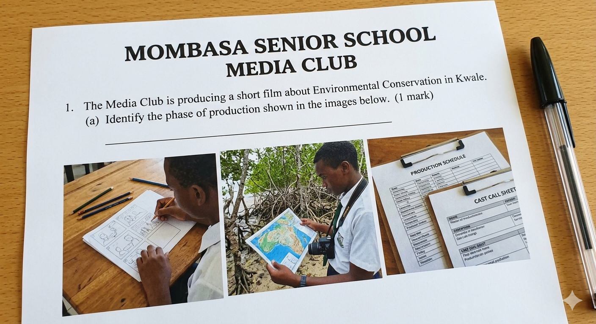
  - At Mombasa Senior School, the Media Club is producing a short film about "Environmental Conservation in Kwale."



(a) Identify the phase of production shown in the images above. (1 mark)
______________________________________________________________
(b) Outline four steps that must be completed during this phase before filming begins. (4 marks)
- ____________________________________________________________________________________________
- ____________________________________________________________________________________________
- ____________________________________________________________________________________________
- ____________________________________________________________________________________________
(c) Explain why Research is critical during the ideation stage of this film. (4 marks)
______________________________________________________________________________________________________________________________________________________________________________________________

(d) Draw a simple flow chart showing the three main phases of media production in their correct order. (6 marks)

- Achieng and her team are setting up a basic studio for a live news broadcast in Nairobi.
(a) Identify three potential OSHA hazards visible in the image. (3 marks)
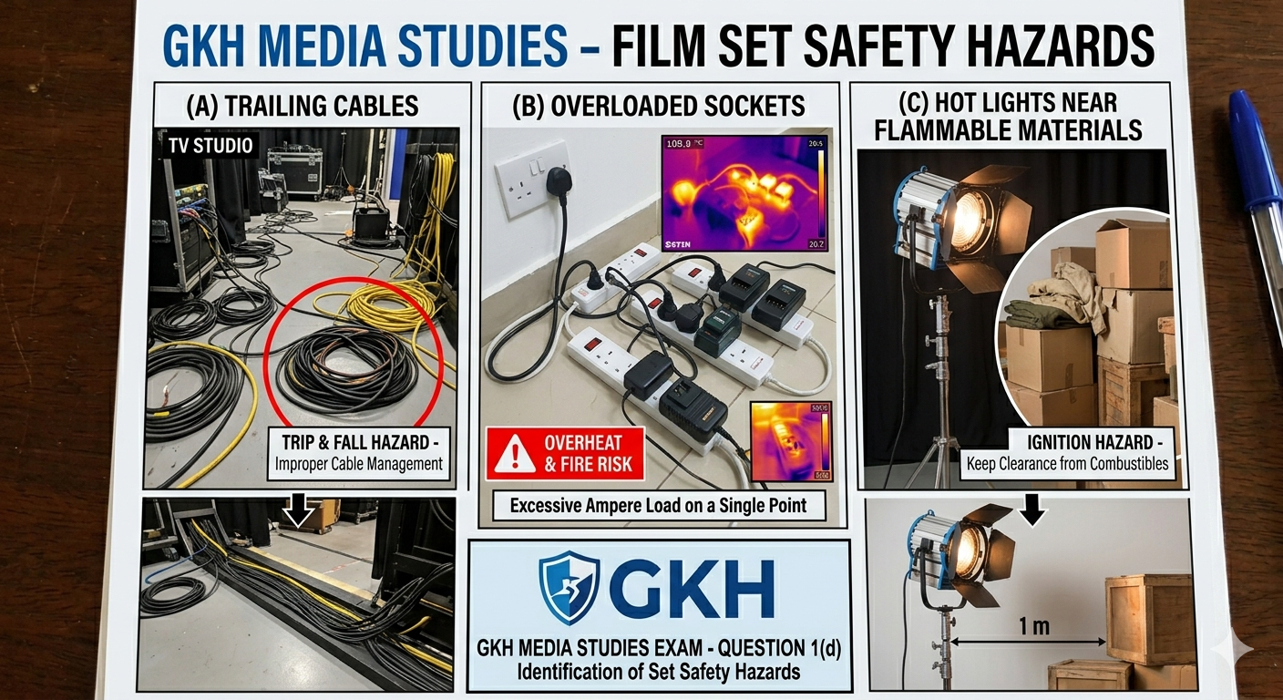
G I J
G) ________________________
I) ________________________
J) ________________________
(b) Describe how the team can mitigate (fix) the electrical hazards identified. (3 marks)
- ____________________________________________________________________________________________
- ____________________________________________________________________________________________
- ____________________________________________________________________________________________
(c) Compare a Tripod and a Gimbal as camera stabilizing accessories. (4 marks) _____________________________________________________________________________________________________________________________________________________________________________________________________________________________________________________________________________________________
(d) In the production phase, what is the role of the Sound Operator? (2 marks)
______________________________________________________________________________________________________________________________________________________________________________________________
(e) List three items found in a camera cleaning kit. (3 marks)
- ____________________________________________________________________________________________
- ____________________________________________________________________________________________
- ____________________________________________________________________________________________

- Three learners are discussing video editing software:
Ali: "I use Capcut on my phone to edit quick reels."
Zavai: "I prefer Adobe Premiere Pro for professional color grading."
Musa: "I use Filmora because it has many pre-set templates."
(a) Name the software Musa is describing. (1 mark)
___________________________________________________________________
(b) Explain the steps of Importing and Exporting in post-production. (4 marks)
- ____________________________________________________________________________________________
- ____________________________________________________________________________________________
- ____________________________________________________________________________________________
- ____________________________________________________________________________________________
(c) Describe the role of an Editor during the post-production phase. (3 marks)
- ____________________________________________________________________________________________
- ____________________________________________________________________________________________
- ____________________________________________________________________________________________
(d) Identify one disadvantage of using mobile-based editing software like Ali’s for a feature film. (2 marks)
______________________________________________________________________________________________________________________________________________________________________________________________
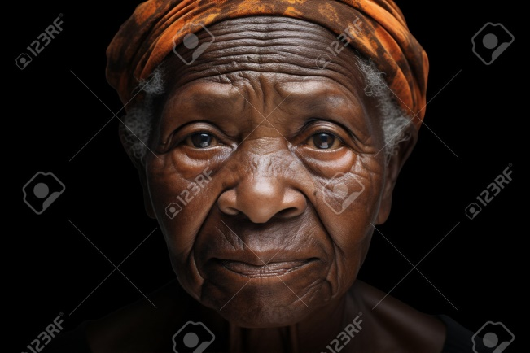
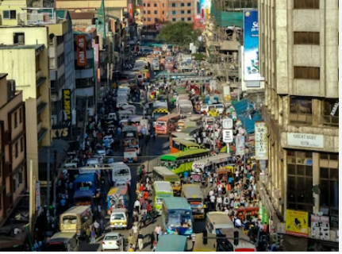
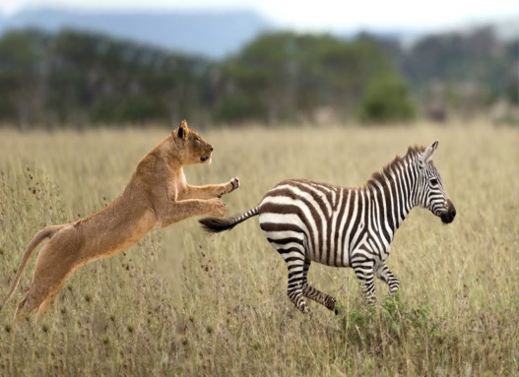
- Study the images below representing different genres of photography captured during a field trip to Maasai Mara and Nakuru.

A B C
(a) Identify the genres shown: (3 marks)
Image A: ________________________
Image B: ________________________
Image C: ________________________
(b) Explain the importance of Photojournalism in Kenyan society. (3 marks)
- ____________________________________________________________________________________________
- ____________________________________________________________________________________________
- ____________________________________________________________________________________________
(c) State two camera accessories a photographer would need for Wildlife Photography (Image A). (2 marks)
- ____________________________________________________________________________________________
- ____________________________________________________________________________________________
(d) Mention one ethical consideration a photographer should have when taking a Portrait (Image C). (2 marks)
______________________________________________________________________________________________________________________________________________________________________________________________

THIS IS THE LST PRINTED PAGE

