KENYA CERTIFICATE OF BASIC EDUCATION

SENIOR SCHOOL ASSESSMENT

TERM 2 ENDTERM ASSESSMENT 2026
GRADE 10 – METAL TECHNOLOGY
Time: 2 Hours
LEARNER’S DETAILS
Name: _____________________________________________________________. School: ____________________________________________.
Assessment Number: _______________________________________________. Date: ____________________________________________.
School Code: ______________________________________________________. Signature: _______________________________________.

INSTRUCTIONS TO CANDIDATES
- Write your name in the spaces provided above.
- Write the name of your school and your stream in the spaces provided.
- Write your admission number and the date of the assessment in the spaces provided.
- This paper consists of two sections: A and B.
- Answer all questions in section A and section B.
- Answer the questions in English.
- All answers MUST be written in the spaces provided in the paper.
- Do NOT remove any page from this question paper.

FOR OFFICIAL USE ONLY (EXAMINER’S USE)
SECTION | SECTION A | SECTION B | % SCORE | EE1 | EE2 | ME1 | ME2 | AE1 | AE2 | BE1 | BE2
SCORE RANGE | 30 MARKS | 50 MARKS |  | 90-100 | 75-89 | 58-74 | 41-57 | 31-40 | 21-30 | 11-20 | 1-10
POINTS |  |  |  | 8 POINTS | 7 POINTS | 6 POINTS | 5 POINTS | 4 POINTS | 3 POINTS | 2 POINTS | 1 POINT
LEARNER’S TOTAL SCORE

SECTION A (30 MARKS)
Answer ALL questions in this section.
  - A student at Ulanda Girls Senior School is categorizing terms used in the workshop.
(a) Define the term "Personal Protective Equipment. (2 marks) ______________________________________________________________________________________________________________________________________________________________________________________________
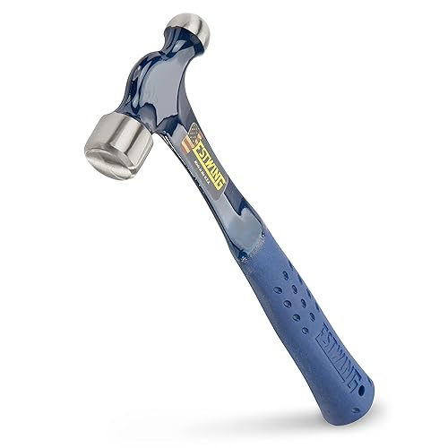
(b) Identify the tool shown in the image below and state its category. (2 marks)

Name: _________________________________.

Category: ______________________________.

(c) State one business opportunity related to metal technology found in Kenyan towns. (1 mark) ______________________________________________________________________________________________________________________________________________________________________________________________


  - During a lesson at Kiriaini Girl Senior School, learners discussed OSHA regulations. Use the diagram below to answer.

X Y
(a) Identify the two safety instructions given in the signs above. (2 marks)
X: ____________________________. Y: ____________________________. (b) Outline the first aid procedure for a minor burn sustained in the workshop. (2 marks)
- _________________________________________________________________________________________
- _________________________________________________________________________________________
(c) State whether the following is TRUE or FALSE:
Running in the workshop is allowed if you are in a hurry to pick up a tool. [__________] (1 mark)
  - Metal Classification (5 Marks) Three learners from Mang'u High School are sorting materials.
- Ali: "This metal is attracted to a magnet; it must be iron-based."
- Kamau: "This shiny sheet is lightweight and does not rust; I think it is Aluminum."
- Chebet: "This bar is very hard and used to make cutting tools; it is High Carbon Steel."
(a) Identify which learner is describing a Non-ferrous metal. ______________________________ (1 mark)
(b) Distinguish between Ferrous and Non-ferrous metals. (2 marks)
______________________________________________________________________________________________________________________________________________________________________________________________
(c) Name the furnace used in the process of producing iron from its ore. (2 marks)
_______________________________________________________________________________________
  - Match the tool shown in Column A with its correct name in Column B.
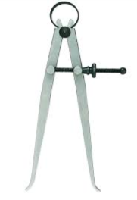
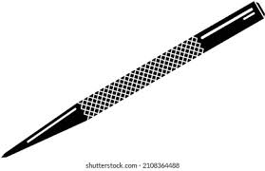
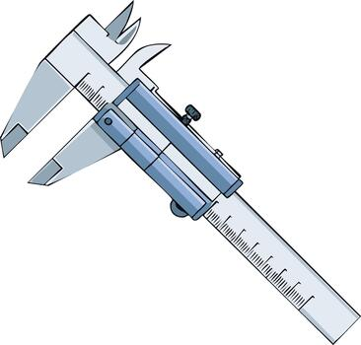
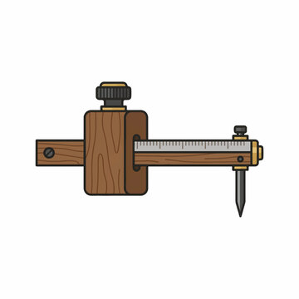
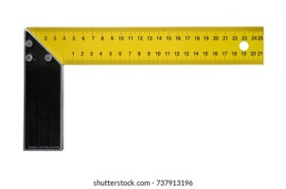

Q R S T U
Q: ___________________________________. R: ___________________________________.
S: ___________________________________. T: ___________________________________.
U: ___________________________________.
  - (a) Identify the forms of material supply shown below. (3 marks)
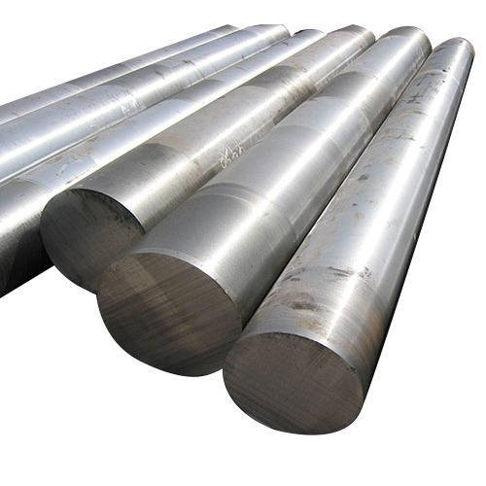

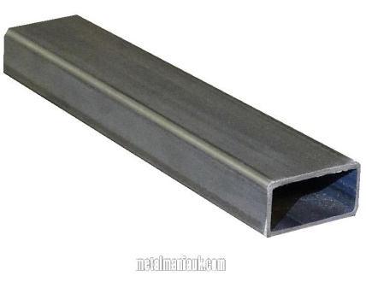

(i) (ii) (iii)

(i) ___________________________
(ii) __________________________
(iii) __________________________

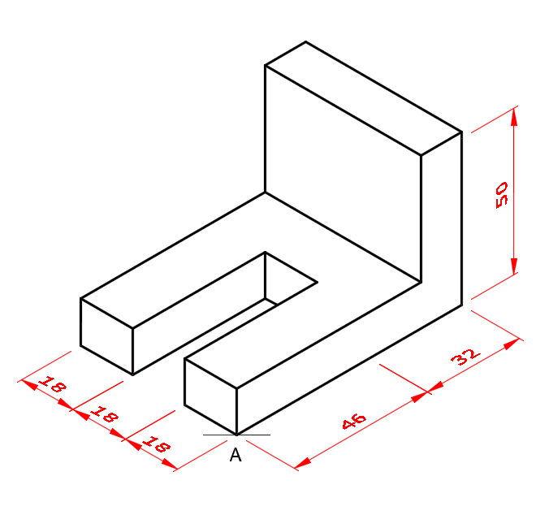
(b) Name the type of pictorial drawing shown in the diagram below. (2 marks)

_________________________________________________

(c) Explain the difference between Isometric and Oblique projections. (3 marks)
Isometric projection | Oblique projection
(d) State the importance of dimensioning a drawing before fabrication. (2 marks)
- _________________________________________________________________________________________
- _________________________________________________________________________________________

SECTION B (50 MARKS)
  - Chief Wanyama in Bungoma wants to set up a small metal fabrication workshop for the youth. He has provided the following layout plan.
(a) Identify two critical components of a workshop layout shown in the plan. (2 marks)
- _________________________________________________________________________________________
- _________________________________________________________________________________________
(b) Describe two safety rules regarding the "Welding Bay" area to protect other workers. (4 marks)
- _________________________________________________________________________________________
- _________________________________________________________________________________________

(c) Explain the "Three Es" of safety in the context of this workshop. (6 marks)
- _________________________________________________________________________________________
- _________________________________________________________________________________________
- _________________________________________________________________________________________
(d) Suggest three ways to maintain hand tools to ensure they last long in the Chief's workshop. (3 marks)
- _________________________________________________________________________________________
- _________________________________________________________________________________________
- _________________________________________________________________________________________
  - A learner at Kisumu Boys High School is tasked to mark out a 100mm×100mm square on a mild steel plate.
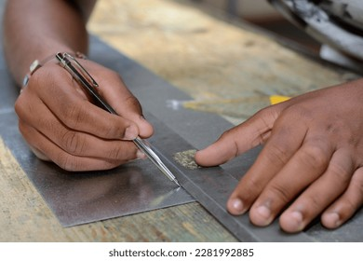
(a) Identify the tool being used to make the visible line in the image. (1 mark)
___________________________________________________________
(b) Describe the steps the learner should follow to ensure the corners of the square are exactly 90∘. (4 marks)
- _________________________________________________________________________________________
- _________________________________________________________________________________________
- _________________________________________________________________________________________
- _________________________________________________________________________________________
(c) Identify the tool used to make a permanent indentation at the center of a hole before drilling. (2 marks)
________________________________________________________

(d) The learner needs to join two pieces of sheet metal. Sketch a Lap Joint. (5 marks)

(e) List three tools required for a Riveting process. (3 marks)
- _________________________________________________________________________________________
- _________________________________________________________________________________________
- _________________________________________________________________________________________
- Grade 10 learners were constructing a Blast Furnace
(a) Identify the three raw materials fed into the top of the furnace. (3 marks)
- _________________________________________________________________________________________
- _________________________________________________________________________________________
- _________________________________________________________________________________________
(b) Explain the function of the "Hot Air Blast" in this process. (3 marks)
- _________________________________________________________________________________________
- _________________________________________________________________________________________
- _________________________________________________________________________________________
- _________________________________________________________________________________________
(c) Compare the physical properties of Mild Steel and Cast Iron. (4 marks)

Mild steel | Cast iron

- Learners at Lenana School noticed that the local market in Dagoretti lacks proper waste bins. They decide to fabricate a heavy-duty metal bin.
(a) Suggest the most suitable form of material supply for the body of the bin. (2 marks)
_________________________________________________________
(b) Outline the process of "Edge Treatment" and explain why it is important for a waste bin. (4 marks)
_________________________________________________________________________________________
_________________________________________________________________________________________
_________________________________________________________________________________________
_________________________________________________________________________________________
_________________________________________________________________________________________
_________________________________________________________________________________________
(c) Identify the most appropriate method of joining the heavy metal plates for this project and give a reason. (4 marks)
_________________________________________________________________________________________
_________________________________________________________________________________________
__________________________________________________________________________________________________________________________________________________________________________________
_________________________________________________________________________________________
_________________________________________________________________________________________

THIS IS THE LAST PRINTED PAGE

