KENYA CERTIFICATE OF BASIC EDUCATION

SENIOR SCHOOL ASSESSMENT

TERM 2 ENDTERM ASSESSMENTS 2026
GRADE 10 – MUSIC AND DANCE
Time: 2 Hours
LEARNER’S DETAILS
Name: _____________________________________________________________. School: ____________________________________________.
Assessment Number: _______________________________________________. Date: ____________________________________________.
School Code: ______________________________________________________. Signature: _______________________________________.

INSTRUCTIONS TO CANDIDATES
- Write your details as required above.
- This paper consists of two sections: A and B.
- Answer all questions in section A and section B.
- Answer the questions in English.
- All answers MUST be written in the spaces provided in the paper.
- Do NOT remove any page from this question paper.

EXAMINER’S USE
SECTION | SECTION A | SECTION B | % SCORE | EE1 | EE2 | ME1 | ME2 | AE1 | AE2 | BE1 | BE2
SCORE RANGE | 30 MARKS | 50 MARKS |  | 90-100 | 75-89 | 58-74 | 41-57 | 31-40 | 21-30 | 11-20 | 1-10
POINTS |  |  |  | 8 POINTS | 7 POINTS | 6 POINTS | 5 POINTS | 4 POINTS | 3 POINTS | 2 POINTS | 1 POINT
LEARNER’S TOTAL SCORE

SECTION A (30 MARKS)
Answer ALL questions in this section.
- Learners at Machakos Senior School are using Muse Score to transcribe a rhythmic pattern. Study the image below:
X Y
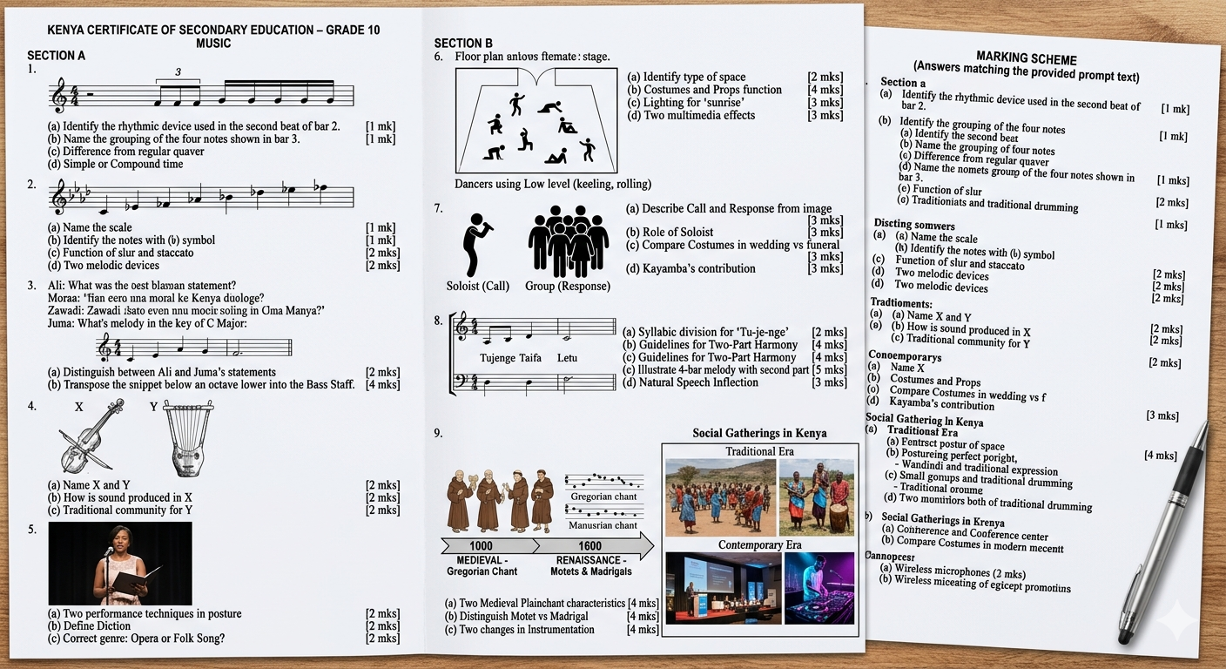
(a) Identify the rhythmic device used in the second beat X. ___________________________(1 mark)
(b) Name the grouping of the four notes shown in bar Y. (1 mark)
________________________________________________________.

(c) Describe how a triplet differs from a regular quaver beat in simple time. (2 marks)
______________________________________________________________________________________________________________________________________________________________________________________________
(d) State whether the time signature provided is Simple or Compound. (2 marks)
______________________________________________________________________________________________________________________________________________________________________________________________
- Kamau, a Grade 10 learner at Nyeri High School, is constructing a scale on a treble staff. Look at the illustration:
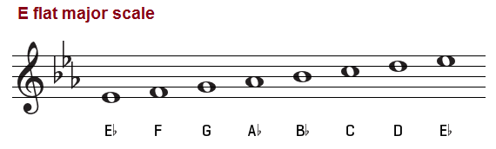
(a) Name the major scale illustrated above. (1 mark)
__________________________________________________
(b) Identify the notes marked with a (b) symbol. (1 mark)
______________________________________________________________________
(c) Explain the function of the Slur and Staccato marks used in the melody below the scale. (2 marks)
- _________________________________________________________________________________________
- _________________________________________________________________________________________
(d) List two melodic devices Kamau could use to make his melody more interesting. (2 marks)
- _________________________________________________________________________________________
- _________________________________________________________________________________________
- Four learners from Lamu Senior School are discussing intervals.
- Ali: "A Perfect 5th has 7 semitones."
- Moraa: "To transpose an octave up, we shift every note 8 steps higher."
- Zawadi: "Moving music from the Treble staff to the Bass staff changes the register."
- Juma: "A Major 3rd is smaller than a Minor 3rd."
(a) Distinguish between Ali and Juma’s statements by stating which one is TRUE and which is FALSE. (2 marks)
_________________________________________________________________________________________
_________________________________________________________________________________________
_________________________________________________________________________________________
_________________________________________________________________________________________
(b) Look at the snippet below. Transpose it an octave lower into the Bass Staff. (4 marks)
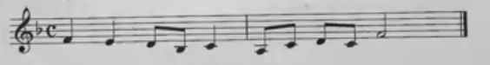
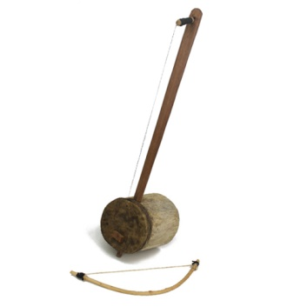
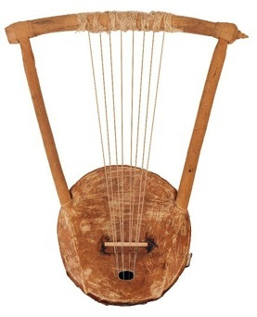
- Study the diagrams of the instruments found in a cultural center in Narok:

X Y
(a) Identify and Name the instruments labeled X and Y. (2 marks)
X: ____________________________________________________.
Y:_____________________________________________________.
(b) Explain how sound is produced in instrument X. (2 marks)
______________________________________________________________________________________________________________________________________________________________________________________________
(c) Mention the traditional community associated with instrument Y. (2 marks)
_________________________________________________________________________________________
_________________________________________________________________________________________
- Below is a picture of a soloist performing at the Kenya Music Festival.

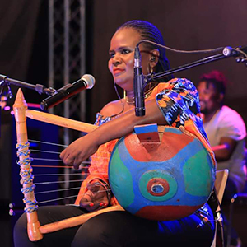
(a) Identify two performance techniques being demonstrated by the singer's posture. (2 marks)
- _________________________________________________________________________________________
- _________________________________________________________________________________________
(b) Define the term Diction in the context of vocal performance. (2 marks)
______________________________________________________________________________________________________________________________________________________________________________________________
(c) Select the correct genre if this is an "Aria": Is it from an Opera or a Folk Song? (2 marks)
__________________________________________________________________________________________

SECTION B: [50 MARKS]
Answer ALL questions in the spaces provided.
- The Grade 10 Dance troupe at Mombasa Academy is preparing a performance titled "The Harvest." They are utilizing the elements of Body, Action, Space, Time, and Energy (BASTE).
(a) Look at the floor plan below. Identify the type of Space the dancers are using. (2 marks)
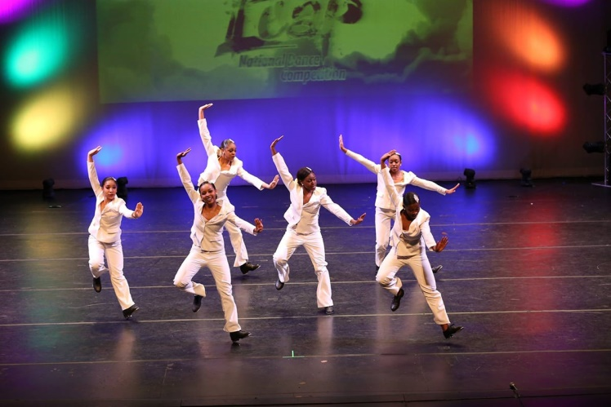
________________________________________________________
(b) Outline the importance of Costumes and Props in telling the story of "The Harvest." (4 marks)
___________________________________________________________________________________
(c) Describe how Lighting can be used to create a "sunrise" effect during the performance. (3 marks)
- _________________________________________________________________________________________
- _________________________________________________________________________________________
- _________________________________________________________________________________________
(d) Suggest two multimedia effects that would enhance this dance production. (3 marks)
- _________________________________________________________________________________________
- _________________________________________________________________________________________
- _________________________________________________________________________________________
- A group of learners at Eldoret Day Senior School is analyzing a video of a Call and Response folk song.
(a) Describe the characteristic of "Call and Response" as seen in the image. (3 marks)
- _________________________________________________________________________________________
- _________________________________________________________________________________________
- _________________________________________________________________________________________
(b) Explain the role of the Soloist in a Kenyan folk song performance. (3 marks)
- _________________________________________________________________________________________
- _________________________________________________________________________________________
- _________________________________________________________________________________________
(c) Compare the use of Costumes in a traditional wedding folk song versus a funeral dirge. (3 marks)
- _________________________________________________________________________________________
- _________________________________________________________________________________________
- _________________________________________________________________________________________
(d) Evaluate how the Kayamba contributes to the texture of the music. (3 marks)
- _________________________________________________________________________________________
- _________________________________________________________________________________________
- _________________________________________________________________________________________
- Zainab, a learner at Turkana Girls, is setting the Kiswahili text "Tujenge Taifa Letu" to music.
(a) Examine the rhythmic setting below. Identify the syllabic division used for the word "Tu-je-nge." (2 marks)
- _________________________________________________________________________________________
- _________________________________________________________________________________________
(b) State the guidelines for starting and ending a Two-Part Harmony. (4 marks)
- _________________________________________________________________________________________
- _________________________________________________________________________________________
- _________________________________________________________________________________________
- _________________________________________________________________________________________
(c) Illustrate a 4-bar melody and add a second part using Consonant Intervals (3rds or 6ths). (5 marks)

(d) Explain how Natural Speech Inflection guides the pitch choice in Kiswahili compositions. (3 marks)
- _________________________________________________________________________________________
- _________________________________________________________________________________________
- _________________________________________________________________________________________
- Students were studying the timeline of Western Classical Music and the images of social gatherings in Kenya.
(a) Identify two characteristics of Medieval Plainchant. (4 marks)
- _________________________________________________________________________________________
- _________________________________________________________________________________________
- _________________________________________________________________________________________
- _________________________________________________________________________________________
(b) Distinguish between a Motet and a Madrigal from the Renaissance period. (4 marks)
Motet | Madrigal
(c) Explain two ways in which Instrumentation has changed in Kenyan musical practices from the traditional era to the contemporary era. (4 marks)
- _________________________________________________________________________________________
- _________________________________________________________________________________________

THIS IS THE LAST PRINTED PAGE

