KENYA CERTIFICATE OF BASIC EDUCATION

SENIOR SCHOOL ASSESSMENT

TERM 2 ENDTERM ASSESSMENTS 2026
GRADE 10 – PHYSICAL EDUCATION
Time: 2 Hours
LEARNER’S DETAILS
Name: _____________________________________________________________. School: ____________________________________________.
Assessment Number: _______________________________________________. Date: ____________________________________________.
School Code: ______________________________________________________. Signature: _______________________________________.

INSTRUCTIONS TO CANDIDATES
- Write your name in the spaces provided above.
- Write the name of your school and your stream in the spaces provided.
- Write your admission number and the date of the assessment in the spaces provided.
- This paper consists of two sections: A and B.
- Answer all questions in section A and section B.
- Answer the questions in English.
- All answers MUST be written in the spaces provided in the paper.
- Do NOT remove any page from this question paper.

FOR OFFICIAL USE ONLY (EXAMINER’S USE)
SECTION | SECTION A | SECTION B | % SCORE | EE1 | EE2 | ME1 | ME2 | AE1 | AE2 | BE1 | BE2
SCORE RANGE | 30 MARKS | 50 MARKS |  | 90-100 | 75-89 | 58-74 | 41-57 | 31-40 | 21-30 | 11-20 | 1-10
POINTS |  |  |  | 8 POINTS | 7 POINTS | 6 POINTS | 5 POINTS | 4 POINTS | 3 POINTS | 2 POINTS | 1 POINT
LEARNER’S TOTAL SCORE

SECTION A (30 MARKS)
Answer ALL questions in this section.
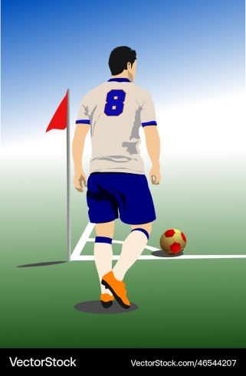
- Grade 10 learners at Kapsabet Boys are officiating a friendly match. Look at the images below of different game scenarios.

(a) Identify the restart method shown in the first image. (1 mark)
____________________________________________________________
(b) Name the specific skill used to restart the game from the center of the pitch after a goal is scored. (1 mark)
______________________________________________________________
(c) Describe two technical requirements for a valid "Throw-in" as per the laws of the game. (2 marks)
- _________________________________________________________________________________________
- _________________________________________________________________________________________
(d) State whether the following is TRUE or FALSE:
A goal can be scored directly from a goal kick into the opponent's goal. [__________] (2 marks)
- Four learners from Kisumu Girls are practicing passes.
Auma: "I am flicking the ball quickly using only my wrist."
Mutua: "I am passing the ball while sprinting towards the goal post."
Cherono: "I am holding the ball at waist level and releasing it to the side."
Wafula: "I am jumping to catch and release the ball in mid-air."
(a) Identify the pass being described by Auma. (1 mark)
________________________________________________
(b) Select the correct name for the pass described by Mutua. (1 mark)
_______________________________________________________________
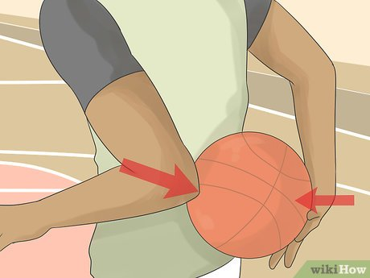
(c) Name the parts of the body labeled X and Y in the "Side Pass" diagram below. (2 marks)

X
Y

X-__________________________________
Y-__________________________________
(d) Outline one importance of the Running Shot in a fast-paced game. (2 marks)
______________________________________________________________________________________________________________________________________________________________________________________________
- Study the illustration of a basketball player performing a move at Maranda High School.
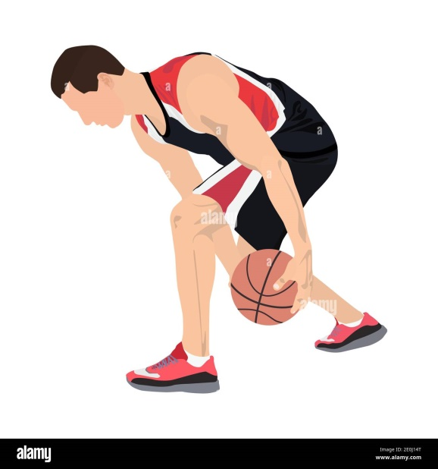
(a) Identify the type of dribble shown in the diagram. (1 mark)
___________________________________________________________________
(b) Distinguish between a Lay-up shot and a Jump shot based on the player's proximity to the rim. (2 marks)
_____________________________________________________________________________________________________________________________________________________________________________________________________________________________________________________________________________________________
c) Define the terms Faking and Feinting as used in offensive play. (2 marks)
i.Faking
______________________________________________________________________________________________________________________________________________________________________________________________
ii. Feinting
______________________________________________________________________________________________________________________________________________________________________________________________
(d) Mention one key factor in maintaining ball control during a crossover. (1 mark)
______________________________________________________________________________________________________________________________________________________________________________________________
- A learner at Iten High School is practicing for the 110m Hurdles.
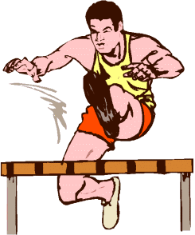

S

T
(a) Name the parts of the hurdling technique labeled S and T (2 marks)
S: _____________________________________________.
T: _____________________________________________.
(b) List two middle-distance races commonly held in Kenyan athletic meets. (2 marks)
- ____________________________________________________________________________________________
- ____________________________________________________________________________________________
(c) State the importance of Pacing during an 800m race. (2 marks)
- ____________________________________________________________________________________________
- ____________________________________________________________________________________________
- Learners prepared a campsite layout for Nakuru High School scouts.
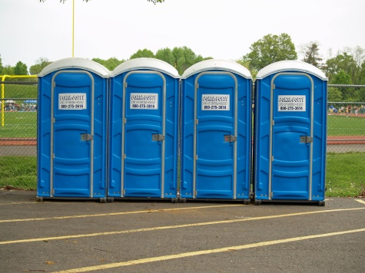
(a) Identify the feature below located downwind from the sleeping area. (1 mark)

________________________________________________

(b) Mention two factors to consider when Selecting a Campsite. (2 marks)
- ____________________________________________________________________________________________
- ____________________________________________________________________________________________
(c) Explain why the "Fire Pit" should be kept clear of overhanging branches. (3 marks)
- ____________________________________________________________________________________________
- ____________________________________________________________________________________________
- ____________________________________________________________________________________________

SECTION B: [50 MARKS]
Answer ALL questions in the spaces provided.
- During a match in Kakamega, a defender is tasked with Marking an opponent while the goalkeeper prepares for a Lofted Pass.
(a) Describe the correct body positioning for effective Marking to prevent an opponent from receiving the ball. (3 marks)
- ____________________________________________________________________________________________
- ____________________________________________________________________________________________
- ____________________________________________________________________________________________
(b) Identify the three phases of a Lofted Pass shown in the sequence below. (3 marks)
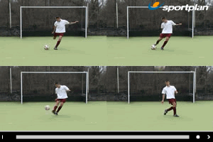



M N O
M: ___________________________________
N: ___________________________________
O: __________________________________
(c) Explain the role of Communication between the goalkeeper and the defenders during a corner kick. (3 marks)
- ____________________________________________________________________________________________
- ____________________________________________________________________________________________
- ____________________________________________________________________________________________

(d) Outline the safety measures a goalkeeper should take when diving to save a ground ball. (3 marks)
- ____________________________________________________________________________________________
- ____________________________________________________________________________________________
- ____________________________________________________________________________________________
- Learners at Nyeri Baptist are conducting a drill on Crossover Dribbling and Set Shots.
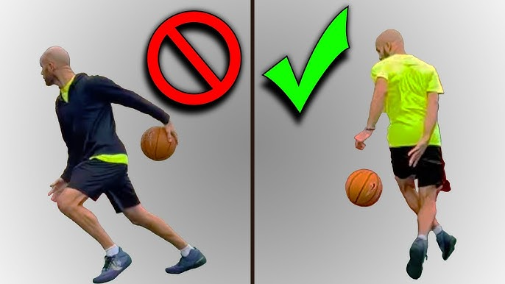
(a) Identify the errors in the "Set Shot" stance illustrated below. (3 marks)
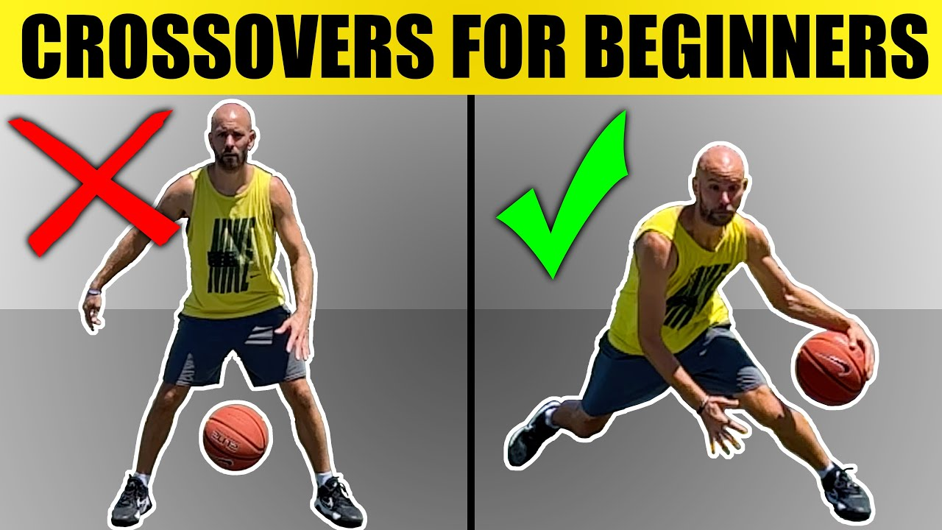

C D
C: _______________________________________________________________________________________
D: ______________________________________________________________________________________
(b) Explain how "Deception" is achieved during a Faking move to beat a defender. (3 marks)
- ____________________________________________________________________________________________
- ____________________________________________________________________________________________
- ____________________________________________________________________________________________
(c) Describe the follow-through action of the wrist during a Jump Shot. (3 marks)
- ____________________________________________________________________________________________
- ____________________________________________________________________________________________
- ____________________________________________________________________________________________
(d) Compare the hand positioning in a Crossover Dribble versus a high speed dribble. (3 marks)
- ____________________________________________________________________________________________
- ____________________________________________________________________________________________
- ____________________________________________________________________________________________

- An athlete in Eldoret is participating in a Cross Country race involving uphill and downhill terrains.
(a) Describe the correct body posture for running Uphill to maximize efficiency. (3 marks)
- ____________________________________________________________________________________________
- ____________________________________________________________________________________________
- ____________________________________________________________________________________________
(b) Identify the type of start used in Cross Country as shown in the diagram below. (2 marks)
- ____________________________________________________________________________________________
- ____________________________________________________________________________________________
- ____________________________________________________________________________________________
(c) Explain the "Landing" and "Recovery" phases in Hurdle Clearance. (4 marks)
- ____________________________________________________________________________________________
- ____________________________________________________________________________________________
- ____________________________________________________________________________________________
- ____________________________________________________________________________________________
(d) Distinguish between Stride Length and Stride Frequency in middle-distance running. (4 marks)
____________________________________________________________________________________________________________________________________________________________________________________________________________________________________________________________________________________________________________________________________________________________________________________________
- A group of Grade 10 learners from Kilifi is planning a three-day camping trip to Hell's Gate National Park.
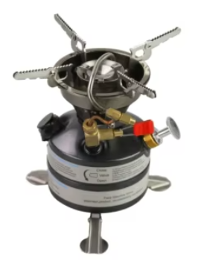
(a) Identify the camping gear shown in the images below. (3 marks)
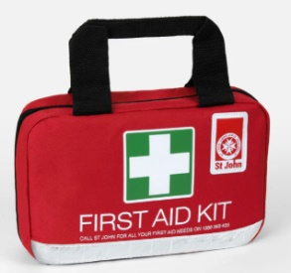
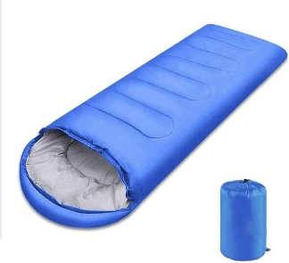
Q R S

_____________________________ _________________________ __________________________

(b) Describe the process of Tent Pitching in a team of four learners. (4 marks)
- ____________________________________________________________________________________________
- ____________________________________________________________________________________________
- ____________________________________________________________________________________________
- ____________________________________________________________________________________________
(c) Explain how camping activities like "Tree Identification" and "Eco-talks" promote Environmental Awareness. (3 marks)
- ____________________________________________________________________________________________
- ____________________________________________________________________________________________
- ____________________________________________________________________________________________
(d) Discuss how Teamwork and Problem-solving are tested when a tent pole breaks during a storm. (3 marks)
- ____________________________________________________________________________________________
- ____________________________________________________________________________________________
- ____________________________________________________________________________________________

THIS IS THE LAST PRINTED PAGE

