KENYA CERTIFICATE OF BASIC EDUCATION

SENIOR SCHOOL ASSESSMENT

TERM 2: ENDTERM ASSESSMENT 2026
GRADE 10 – PHYSICS
Time: 2 Hours
LEARNER’S DETAILS
Name: _____________________________________________________________. School: ____________________________________________.
Assessment Number: _______________________________________________. Date: ____________________________________________.
School Code: ______________________________________________________. Signature: _______________________________________.

INSTRUCTIONS TO CANDIDATES
- Write the details as required in the spaces above.
- This paper consists of two sections: A and B.
- Answer all questions in section A and section B.
- Answer the questions in English.
- All answers MUST be written in the spaces provided in the paper.
- Do NOT remove any page from this question paper
- Silent non programmable calculators may be used.
- Assume:
  - Acceleration due to gravity, g = 10 m/s²
  - Density of water = 1000 kg/m³

FOR OFFICIAL USE ONLY (EXAMINER’S USE)
SECTION | SECTION A | SECTION B | % SCORE | EE1 | EE2 | ME1 | ME2 | AE1 | AE2 | BE1 | BE2
SCORE RANGE | 30 MARKS | 60 MARKS |  | 90-100 | 75-89 | 58-74 | 41-57 | 31-40 | 21-30 | 11-20 | 1-10
POINTS |  |  |  | 8 POINTS | 7 POINTS | 6 POINTS | 5 POINTS | 4 POINTS | 3 POINTS | 2 POINTS | 1 POINT
LEARNER’S TOTAL SCORE

SECTION A (30 MARKS)
Answer ALL questions in this section.
  - Three learners at Mang'u High School are discussing the relevance of Physics.
- Abdi: "I want to study how stars and planets move."
- Bakari: "I am interested in how heat energy moves in car engines."
- Chantal: "I want to design circuits for the next Kenyan-made smartphone."
(a) Identify the branch of Physics each learner is interested in: (3 marks)
- Abdi: ____________________________.
- Bakari: ___________________________.
- Chantal: __________________________.
(b) Outline TWO importance of Physics in the field of Medicine. (2 marks)
- ____________________________________________________________________________________________
- ____________________________________________________________________________________________
  - Two immiscible liquids are poured in a container to the levels shown in the diagram below.
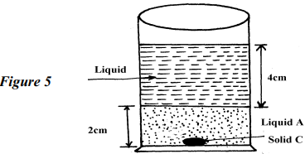
If the densities of the liquids A and B are 1g/cm³ and 0.8g/cm³ respectively, find the pressure acting upon solid C at the bottom of the container due to the liquids

(b) Name the two factors that affect pressure at a point in a liquid. (2 marks)
- ____________________________________________________________________________________________
- ____________________________________________________________________________________________
  - In the diagram below, the U-tube contains two liquids; X and Y which do not mix. If the density of liquid Y is 900Kgm⁻³ and that of X is 1200Kgm⁻³, calculate the height of liquid Y
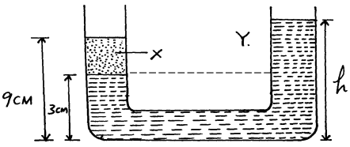

  - Grade 10 learners at Kisumu Boys are testing a copper wire and a glass rod.
(a) Identify the property of the material represented by the curve that snaps suddenly without stretching. (1 mark) ______________________________________________________________________________________________________________________________________________________________________________________________
(b) Define Hooke’s Law. (2 marks) ______________________________________________________________________________________________________________________________________________________________________________________________
(c) Distinguish between Ductility and Malleability. (2 marks) ____________________________________________________________________________________________________________________________________________________________________________________________________________________________________________________________________________________________________________________________________________________________________________________________

    - State coulombs law of electrostatic force
______________________________________________________________________________________________________________________________________________________________________________________________
    - Define capacitance
______________________________________________________________________________________________________________________________________________________________________________________________
  - Describe how the type of charge on a charged metal rod can be determined
______________________________________________________________________________________________________________________________________________________________________________________________
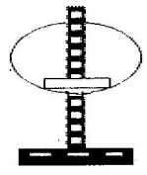
  - The fig. Shows hollow negatively charged sphere with a metal disk attached to an insulator placed inside. State what would happen to the leaf of an uncharged electroscope if the metal disk were brought near the cap of the electroscope. Give a reason for your answer.
____________________________________________________________________________________________________________________________________________________________________________________________________________________________________________________________________________________________________________________

  - State two ways of charging the magnitude of the deflection of the leaf of an electroscope.
- _________________________________________________________________________________________
- _________________________________________________________________________________________
  - The fig below shows an arrangement of capacitors connected to a 10V d.c supply.
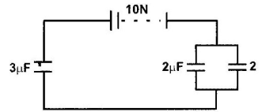
Determine:
    - The charge stored in the 2μF capacitor.

    - The total capacitance of the arrangement.

    - Explain the process of Earthing. (2 marks) ______________________________________________________________________________________________________________________________________________________________________
  - The figure below shows a bimetallic strip made of brass and iron. A marble is placed at end A of the bimetallic strip as shown below:-
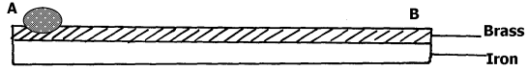
(a) State and explain what will be observed when the bimetallic strip is strongly cooled
______________________________________________________________________________________________________________________________________________________________________________________________
(b) Identify which metal expands more between Brass and Iron based on the curve. (1 mark)
________________________________________________
(c) Mention two applications of bimetallic strips in home appliances. (2 marks)
- _________________________________________________________________________________________
- _________________________________________________________________________________________
(d) State the SI unit of Temperature.________________________________ (1 mark)
(e) True or False:
Water contracts when cooled from 4∘C to 0∘C. [__________] (1 mark)
  - (a) Identify the material type (Insulator, Conductor, or Semiconductor) if the forbidden gap is very large. (1 mark)
(b) Name the process of adding impurities to an intrinsic semiconductor. (1 mark)
_____________________________________________________
(c) Distinguish between an n-type and a p-type semiconductor. (3 marks)
N-type | p-type

SECTION B: [50 MARKS]
Answer ALL questions in the spaces provided.
  - A bus company in Eldoret is designing a new double-decker bus. The engineers must ensure it does not topple on sharp corners.
(a) Define Centre of Gravity (C.O.G). (2 marks)
______________________________________________________________________________________________________________________________________________________________________________________________
(b) Explain why the bus with luggage on the roof is less stable than the empty one. (3 marks)
- _________________________________________________________________________________________
- _________________________________________________________________________________________
- _________________________________________________________________________________________
(c) State the two conditions for a body to be in static equilibrium. (4 marks)
- _________________________________________________________________________________________
- _________________________________________________________________________________________
(d) A uniform meter rule is pivoted at the 50cm mark. A 2N weight is placed at the 10cm mark. Calculate where a 5N weight should be placed to balance the rule. (3 marks)

- Construction workers in Kilifi are using a pulley system to lift bags of cement to the third floor.

a. Define the term mechanical advantage of a machine. (1mk) ______________________________________________________________________________________________________________________________________________________________________________________________

b The figure shows a pulley system being used to raise a load.

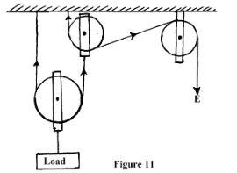

This pulley system has an efficiency of 75%.

i. Determine the velocity ratio of the system. (1mk)

ii. Calculate the mechanical advantage of the pulley system. (2mks)

iii What effort is required to raise a load of 240 kg? (2mks)

iv. Calculate the work done by a person using this machine in raising a load of 120 kg through a vertical distance of 2.5 m (3mks)

c. Give two reasons to explain why the efficiency of a machine cannot be 100%. (2mks)
- _________________________________________________________________________________________
- _________________________________________________________________________________________
d. Define Efficiency of a machine. (2 marks)
______________________________________________________________________________________________________________________________________________________________________________________________
e. Explain why the efficiency of this pulley system can never be 100%. (3 marks)
- _________________________________________________________________________________________
- _________________________________________________________________________________________
f. A worker lifts a 50kg bag through a height of 10m in 20 seconds. Calculate:
- Work done (2 marks)

- Power developed (2 marks)

g. Name three other types of simple machines used in construction. (3 marks)
- _________________________________________________________________________________________
- _________________________________________________________________________________________
- _________________________________________________________________________________________

- An ambulance is moving towards a hospital in Machakos with its siren on.
(a) Name the effect described where the frequency of sound changes due to relative motion. (2 marks)
______________________________________________________________________________________________________________________________________________________________________________________________
(b) Describe how the pitch heard by the observer changes as the ambulance approaches. (3 marks) ______________________________________________________________________________________________________________________________________________________________________________________________ (c) Identify the wave property shown in the diagram below where waves bend around a corner. (2 marks) ______________________________________________________________________________________________________________________________________________________________________________________________ (d) Distinguish between Refraction and Reflection of waves. (5 marks)
Refraction | Reflection
- Doctors at Kenyatta National Hospital use radioactive isotopes for cancer treatment, while environmentalists discuss the Greenhouse Effect.
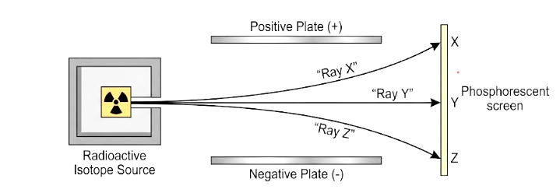
(a) Identify the three types of radiations emitted during radioactive decay from the diagram. (3 marks)
Ray X: _________________
Ray Y: _________________
Ray Z: _________________
(b) State two safety precautions when handling radioactive materials. (2 marks)
- _________________________________________________________________________________________
- _________________________________________________________________________________________
(c) Explain how the Greenhouse Effect leads to Global Warming. (4 marks)
- _________________________________________________________________________________________
- _________________________________________________________________________________________
- _________________________________________________________________________________________
- _________________________________________________________________________________________
(d) Mention two human activities that contribute to the depletion of the Ozone Layer. (2 marks)
- _________________________________________________________________________________________
- _________________________________________________________________________________________
(e) Define Half-life. (2 marks)
________________________________________________________________________________________________________________________________________________________________________________________________________________

THIS IS THE LAST PRINTED PAGE

