KENYA CERTIFICATE OF BASIC EDUCATION

SENIOR SCHOOL ASSESSMENT

TERM 2 ENDTERM ASSESSMENTS 2026
GRADE 10 – POWER MECHANICS
Time: 2 Hours 30 Minutes
LEARNER’S DETAILS
Name: _____________________________________________________________. School: ____________________________________________.
Assessment Number: _______________________________________________. Date: ____________________________________________.
School Code: ______________________________________________________. Signature: _______________________________________.

INSTRUCTIONS TO CANDIDATES
- Write your name in the spaces provided above.
- Write the name of your school and your stream in the spaces provided.
- Write your admission number and the date of the assessment in the spaces provided.
- This paper consists of two sections: A and B.
- Answer all questions in section A and section B.
- Answer the questions in English.
- All answers MUST be written in the spaces provided in the paper.
- Do NOT remove any page from this question paper.
- For technical drawing questions, ensure all construction steps are clearly shown

FOR OFFICIAL USE ONLY (EXAMINER’S USE)
SECTION | SECTION A | SECTION B | % SCORE | EE1 | EE2 | ME1 | ME2 | AE1 | AE2 | BE1 | BE2
SCORE RANGE | 30 MARKS | 50 MARKS |  | 90-100 | 75-89 | 58-74 | 41-57 | 31-40 | 21-30 | 11-20 | 1-10
POINTS |  |  |  | 8 POINTS | 7 POINTS | 6 POINTS | 5 POINTS | 4 POINTS | 3 POINTS | 2 POINTS | 1 POINT
LEARNER’S TOTAL SCORE

SECTION A (30 MARKS)
Answer ALL questions in this section.
- Three learners at Mombasa Senior School are discussing the future of Power Mechanics.
- Abdi: "I want to design high-speed electric trains in Nairobi."
- Bakari: "I am interested in repairing heavy-duty tractor engines in Narok."
- Chantal: "I want to work for a car manufacturing plant in Thika."
(a) List three career opportunities Abdi, Bakari, and Chantal are aiming for. (3 marks)
- ____________________________________________________________________________________________
- ____________________________________________________________________________________________
- ____________________________________________________________________________________________
(b) Outline the importance of Power Mechanics in the agricultural sector of Kenya. (2 marks)
- ____________________________________________________________________________________________
- ____________________________________________________________________________________________
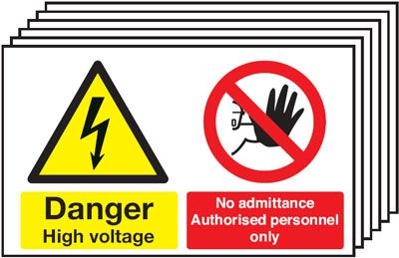

- In the Nanyuki Senior School workshop, the following safety signs are displayed.

Q R
(a) Identify and Name the type of safety signs shown above. (2 marks)
Q: ________________________________________
R:________________________________________
(b) State the specific Personal Protective Equipment (PPE) required when working under a vehicle chassis. (2 marks)
- ____________________________________________________________________________________________
- ____________________________________________________________________________________________
(c) True or False:
It is safe to use a screwdriver as a chisel in the workshop. [__________] (1 mark)
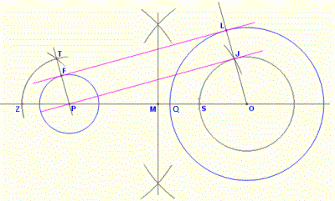
- Study the geometric illustration below showing a link mechanism used in a pump in Kisumu.

(a) Define the term Locus as used in technical drawing. (2 marks) ______________________________________________________________________________________________________________________________________________________________________________________________
(b) Identify the method used to construct the tangent labeled FL and PJ (1 mark) ______________________________________________________________________________________________________________________________________________________________________________________________
(c) Name the locus shape generated by a point on a circle rolling along a straight line. (1 mark)
_____________________________________________________________
(d) Mention one application of link mechanisms in an automobile engine. (2 marks) ______________________________________________________________________________________________________________________________________________________________________________________________
- A mechanic in Eldoret is inspecting a tire with the following specification: 205/55 R 16.
(a) Interpret the tire specification "R" and "16". (2 marks) ______________________________________________________________________________________________________________________________________________________________________________________________
(b) Identify the ply orientation shown in the cross-section diagram below. (1 mark)
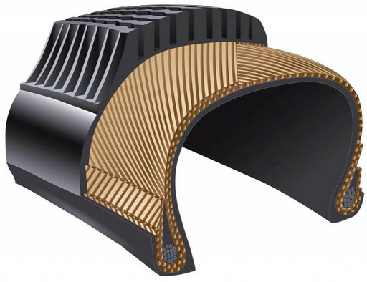
________________________________________________
(c) List two functions of the road wheels in a moving vehicle. (2 marks)
- ____________________________________________________________________________________________
- ____________________________________________________________________________________________

(d) Distinguish between a tube tire and a tubeless tire. (1 mark)
_____________________________________________________________________________________________________________________________________________________________________________________________________________________________________________________________________________________________
- Study the diagram of the Internal Combustion Engine (ICE) components used at Kabarak High School.
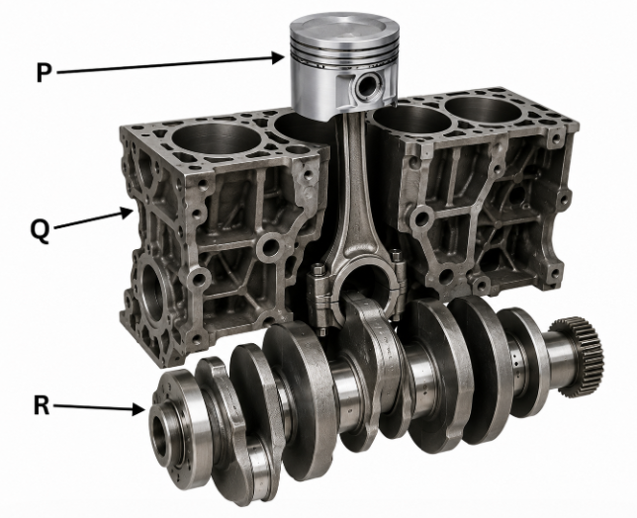
(a) Identify and Name the parts labeled P, Q, and R. (3 marks)
P: _______________________________________
Q: _______________________________________
R: _______________________________________
(b) Define the term Bore as used in engine measurements. (1 mark)
______________________________________________________________________________________________________________________________________________________________________________________________
(c) A single-cylinder engine has a bore of 80mm and a stroke of 90mm. Calculate the engine capacity. (Take π = 3.142). (3 marks)

(d) Select the correct engine cycle: Is the piston at TDC or BDC during the start of the power stroke? (1 mark)
_____________________________________________________________________________________________________

SECTION B: [50 MARKS]
Answer ALL questions in the spaces provided.
- The Board of Management at Butere Girls School wants to set up a new Power Mechanics workshop. You are provided with a list of areas: Storage, Office, Workbenches, and Passage Ways.
(a) Sketch a simple layout of a standard Power Mechanics workshop showing the four areas mentioned. (4 marks)

(b) Explain why the "Storage Area" should be separated from the "Working Area." (3 marks)
______________________________________________________________________________________________________________________________________________________________________________________________
(c) Describe the importance of clear "Passage Ways" in a workshop environment. (3 marks)
- _________________________________________________________________________________________
- _________________________________________________________________________________________
- _________________________________________________________________________________________
- During a practical lesson at Machakos Boys, learners are stripping a four-stroke petrol engine. They encounter the following components:
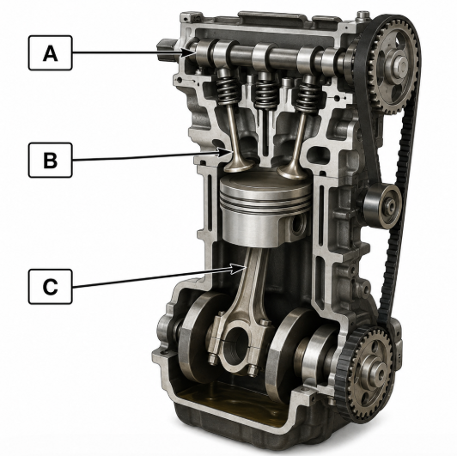
(a) Name the components labeled A, B, and C. (3 marks)
A:________________________________
B:________________________________
C: ________________________________
(b) Describe the function of the Camshaft in relation to the Valves. (3 marks)
- _________________________________________________________________________________________
- _________________________________________________________________________________________
- _________________________________________________________________________________________
(c) Match the component to its function: (4 marks)
Component | Function
Piston Rings | (i) Converts reciprocating motion to rotary motion
Crankshaft | (ii) Connects the piston to the crankshaft
Connecting Rod | (iii) Houses the cooling water jackets
Cylinder Block | (iv) Prevents compression leakage
(d) Outline the importance of the Sump in a vehicle's lubrication system. (4 marks)
- _________________________________________________________________________________________
- _________________________________________________________________________________________
- _________________________________________________________________________________________

- A vehicle body specialist in Juja is repairing a station wagon body. He needs to choose between threaded fasteners, rivets, and adhesives.
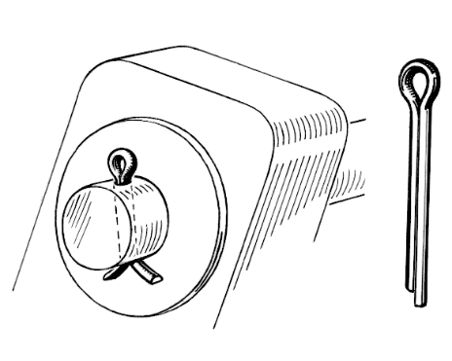
(a) Identify the locking device shown in the picture above. (1 mark)
X
________________________________

(b) Explain the process of Riveting as applied to joining thin sheet metals of a vehicle body. (4 marks)
- _________________________________________________________________________________________
- _________________________________________________________________________________________
- _________________________________________________________________________________________
- _________________________________________________________________________________________
(c) Compare the use of Adhesives versus Bolts and Nuts in terms of permanent versus temporary joining. (4 marks)
Adhesives | Bolts and Nuts
(d) Mention three interior body parts of a modern Kenyan bus. (3 marks)
- _________________________________________________________________________________________
- _________________________________________________________________________________________
- _________________________________________________________________________________________
- Technicians at Ganjoni Garage in Mombasa are performing an engine overhaul. They are using specialized tools to measure wear.
(a) Identify the tool being used to measure the Crankshaft Journal. (1 mark)
_________________________________________________
(b) Explain how to measure the Piston Ring Gap using a feeler gauge. (4 marks)
- _________________________________________________________________________________________
- _________________________________________________________________________________________
- _________________________________________________________________________________________
- _________________________________________________________________________________________
(c) Distinguish between a Cylinder Bore and Cylinder Clearance. (4 marks)
Cylinder bore | Cylinder clearance
(d) Discuss why measuring the Journal diameter is critical before installing new bearings. (5 marks)
- _________________________________________________________________________________________
- _________________________________________________________________________________________
- _________________________________________________________________________________________
- _________________________________________________________________________________________
- _________________________________________________________________________________________

THIS IS THE LAST PRINTED PAGE

