KENYA CERTIFICATE OF BASIC EDUCATION

SENIOR SCHOOL ASSESSMENT

TERM 2: ENDTERM ASSESSMENT 2026
GRADE 10 – THEATRE AND FILM
Time: 2 Hours
LEARNER’S DETAILS
Name: _____________________________________________________________. School: ____________________________________________.
Assessment Number: _______________________________________________. Date: ____________________________________________.
School Code: ______________________________________________________. Signature: _______________________________________.

INSTRUCTIONS TO CANDIDATES
- Write all the details as required above.
- This paper consists of two sections: A and B.
- Answer all questions in section A and section B.
- Answer the questions in English.
- All answers MUST be written in the spaces provided in the paper.
- Do NOT remove any page from this question paper.

FOR OFFICIAL USE ONLY (EXAMINER’S USE)
SECTION | SECTION A | SECTION B | % SCORE | EE1 | EE2 | ME1 | ME2 | AE1 | AE2 | BE1 | BE2
SCORE RANGE | 30 MARKS | 50 MARKS |  | 90-100 | 75-89 | 58-74 | 41-57 | 31-40 | 21-30 | 11-20 | 1-10
POINTS |  |  |  | 8 POINTS | 7 POINTS | 6 POINTS | 5 POINTS | 4 POINTS | 3 POINTS | 2 POINTS | 1 POINT
LEARNER’S TOTAL SCORE

SECTION A (30 MARKS)
Answer ALL questions in this section.
  - Three learners at Mombasa Senior School are discussing the structure of their play about "Environmental Conservation."
- Amani: "I am writing the beginning where we meet the characters in the forest."
- Baraka: "My part is the most intense; it’s where the forest guard finally catches the loggers!"
- Chaki: "I am writing the part where the forest is replanted and peace returns."
(a) Identify the element of plot Baraka is describing. (1 mark)
_________________________________________________________
(b) Name the plot element Amani is working on. (1 mark)
__________________________________________________________

(c) Explain the difference between Dialogue and Monologue. (2 marks)
____________________________________________________________________________________________________________________________________________________________________________________________________________________________________________________________________________________________________________________________________________________________________________________________
(d) State two Pertinent and Contemporary Issues (PCIs) that can be addressed through a play in Kenya today. (2 marks)
- _________________________________________________________________________________________
- _________________________________________________________________________________________
  - Study the image below of a spoken word artist performing at the Kenya Schools and Colleges Drama Festival.
(a) Identify the tool used by the poet to convey emotion through movement. (1 mark) _____________________________________________________________
(b) Define a Character Bible as used in poetry writing. (2 marks) ______________________________________________________________________________________________________________________________________________________________________________________________
(c) Outline two characteristics of a Spoken Word poem. (2 marks)
- _________________________________________________________________________________________
- _________________________________________________________________________________________
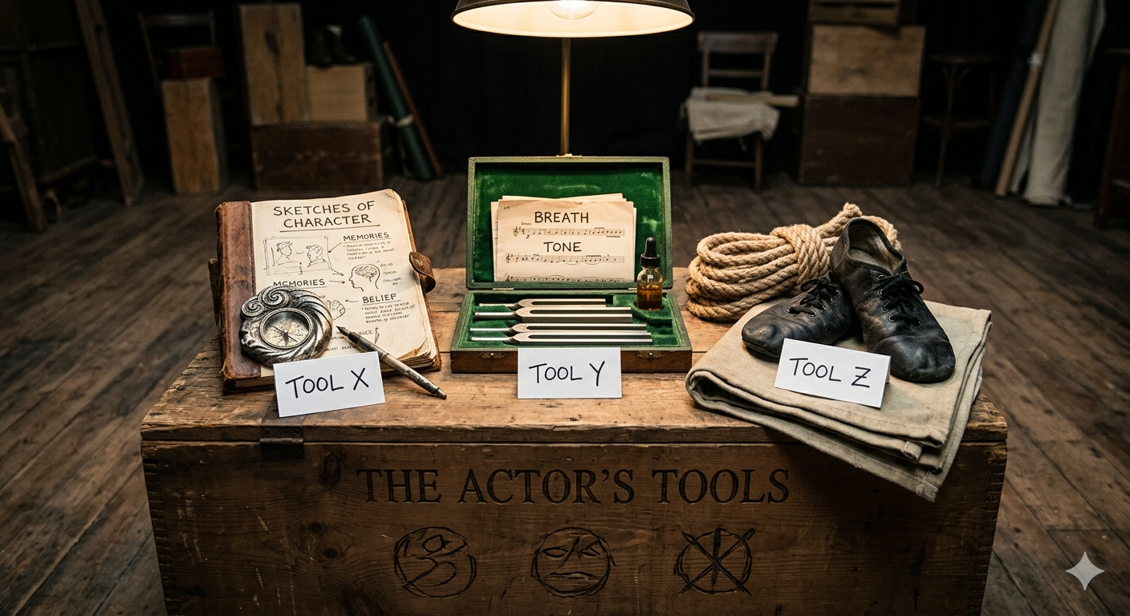
  - The diagram below shows the primary "tools" a Grade 10 learner at Nyeri High uses during a rehearsal.

(a) Identify the parts of the actor's tools labeled X, Y, and Z in the illustration. (3 marks)
X: ______________________________
Y: ______________________________
Z: _______________________________
(b) Mention one vocal exercise an actor should perform during a warm-up. (1 mark)
______________________________________________________________________________________________________________________________________________________________________________________________
(c) Explain why "Imagination" is a critical tool for an actor. (2 marks)
______________________________________________________________________________________________________________________________________________________________________________________________
  - Study the floor plan of a stage commonly used at the Kenya National Theatre.
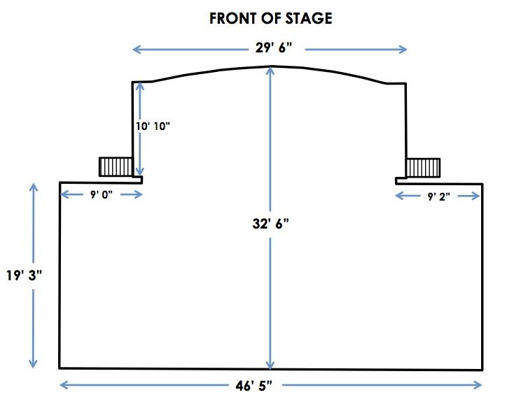
(a) Identify the type of stage shown in the diagram. (1 mark)
__________________________________________________________.

(b) Name the specific stage positions in full: (3 marks)
- USL: _________________________________________________________________________________
- CS: __________________________________________________________________________________
- DSR: _________________________________________________________________________________
(c) Define the "Apron" of a stage. (2 marks) ______________________________________________________________________________________________________________________________________________________________________________________________
(d) Distinguish between an Arena Stage and a Thrust Stage. (2 marks)
Arena Stage | Thrust Stage
  - Look at the adjudication sheet used by an official in Nakuru.
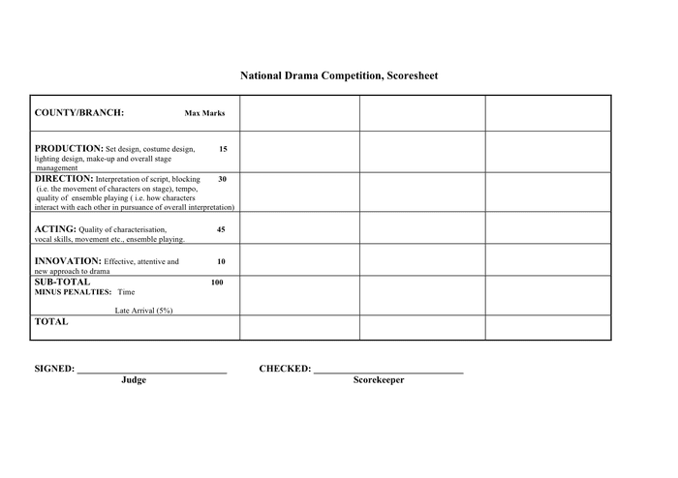
(a) List three criteria used to adjudicate a stage play. (3 marks)
- _________________________________________________________________________________________
- _________________________________________________________________________________________
- _________________________________________________________________________________________

(b) True or False:
Adjudication is only about pointing out mistakes in a performance. [__________] (1 mark)
(c) Identify the document an adjudicator writes after a festival to give feedback to teams. (1 mark)
______________________________________________________________________________________________________________________________________________________________________________________________

SECTION B: [50 MARKS]
Answer ALL questions in the spaces provided.
  - The Theatre and Film Club at Kakamega High School is preparing a production. They need to set up the lighting as shown in the diagram below.

(a) Identify the lighting technique labeled A that focuses on a single performer. (1 mark)
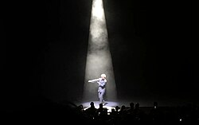
____________________________________
(b) Describe the function of Sound Special Effects in a play. (3 marks)
- _________________________________________________________________________________________
- _________________________________________________________________________________________
- _________________________________________________________________________________________
(c) Name three pieces of sound equipment found in a theatre control booth. (3 marks)
- _________________________________________________________________________________________
- _________________________________________________________________________________________
- _________________________________________________________________________________________

(d) Explain how "Make-up" enhances a character’s identity on stage. (5 marks)
- _________________________________________________________________________________________
- _________________________________________________________________________________________
- _________________________________________________________________________________________
- _________________________________________________________________________________________
- _________________________________________________________________________________________
- A director at Starehe Boys' Centre is creating a Prompt Book for a play set in a village in Turkana.
(a) What is a Directorial Concept? (2 marks)
______________________________________________________________________________________________________________________________________________________________________________________________
(b) List four components that must be included in a Director’s Prompt Book. (4 marks)
- _________________________________________________________________________________________
- _________________________________________________________________________________________
- _________________________________________________________________________________________
- _________________________________________________________________________________________
(c) Outline the responsibility of a director during the "Blocking" phase of rehearsal. (3 marks)
- _________________________________________________________________________________________
- _________________________________________________________________________________________
- _________________________________________________________________________________________
(d) Compare the roles of a Stage Manager and a Theatre Director. (3 marks)
Stage manager | Theatre director

- Grade 10 learners from Garissa Senior School are performing a community theatre piece at a local market.
(a) Identify the role of theatre in society described in the following scenarios: (3 marks)
- A play teaching people about handwashing: _________________
- A play making people laugh after a long day: _________________
- A play advocating for the rights of the girl child: _________________
(b) Explain the term "Found Space" as used in community theatre. (2 marks)
______________________________________________________________________________________________________________________________________________________________________________________________
(c) Describe two principles guiding the management of a Theatre and Film Club in school. (4 marks)
- _________________________________________________________________________________________
- _________________________________________________________________________________________
(d) Discuss how a "Reflective Logbook" helps a learner in their creative journey. (4 marks)
- _________________________________________________________________________________________
- _________________________________________________________________________________________
- _________________________________________________________________________________________
- _________________________________________________________________________________________
- Below is a character bible sketch for a persona in a spoken word piece titled "The Silent City," performed in Nairobi.

Character Bible Sketch

Title: The Silent City

Genre: Spoken Word / Social Awareness Poetry

Setting: Nairobi — a busy city filled with dreams, struggles, silence, and hidden pain.

Main Persona (Character)

Name: Amani

Age: 22 years old

Gender: Female

Background:
Amani is a university student living in Nairobi. She comes from a humble family and struggles to balance education, survival, and hope in a city that moves too fast to notice pain. She witnesses corruption, poverty, unemployment, broken families, and silent suffering among young people.

Personality Traits:
- Observant
- Emotional
- Courageous
- Thoughtful
- Hopeful despite challenges

Greatest Fear:
Being ignored and forgotten by society.

Greatest Dream:
To use her voice to awaken people and bring change to the community.

Symbolism:
Amani represents the silent youth in society whose struggles are rarely heard.

Costume Suggestion:
- Dark hoodie or simple black clothing
- Sneakers
- Notebook or microphone as a symbol of expression

Tone of Voice:
- Calm and reflective at the beginning
- Emotional and powerful in the middle
- Hopeful and inspiring at the end

Key Themes in the Performance:
- Social injustice
- Poverty
- Silence in society
- Youth struggles
- Hope and change

Spoken Word Performance

The Silent City

In the silent city,
Streetlights blink like tired eyes,
Watching dreams collapse on pavements
Where children sleep beside promises
Politicians forgot.
This city breathes smoke,
Not hope.
Its heartbeat is traffic,
Its anthem is survival.
I walk through downtown Nairobi
And every face carries a hidden funeral.
A mother selling oranges
With hands rough like unfinished prayers.
A graduate carrying certificates
Like expired passports to success.
A street child smiling wider
Than the men driving tinted dreams.
The city is loud,
Yet nobody listens.
We scroll through pain
Like entertainment.
Double tap tragedy.
Share hashtags.
Forget tomorrow.
The silent city.
Where depression wears school uniforms.
Where hunger hides behind makeup.
Where fathers disappear
And mothers become mountains.
Listen…
Can you hear the silence
Inside crowded matatus?
Can you hear the fear
Behind fake laughter?
This city taught us
To survive before living.
And still—
We rise.
Because somewhere in Kibera,
A child studies under candlelight
Believing education can outrun poverty.
Somewhere in Eastlands,
A poet writes revolution
On borrowed paper.
Somewhere in the silence,
A voice is growing.
Mine.
I am Amani.
Daughter of struggle.
Child of unfinished stories.
I speak for the invisible.
For the youth drowning quietly.
For the dreamers surviving loudly.
And maybe…
Maybe this city is not truly silent.
Maybe
We were simply afraid to speak.
But today,
I choose voice over fear.
Truth over comfort.
Hope over surrender.
So hear me, Nairobi—
Your children are awake.
And silence
Will no longer be our language.

(a) Name the four poetic elements used to convey a message in spoken word. (4 marks)
- _________________________________________________________________________________________
- _________________________________________________________________________________________
- _________________________________________________________________________________________
(b) Describe how Word Play adds value to a spoken word performance. (3 marks)
- _________________________________________________________________________________________
- _________________________________________________________________________________________
- _________________________________________________________________________________________
(c) Explain the importance of "Persona" in a poem. (3 marks)
- _________________________________________________________________________________________
- _________________________________________________________________________________________
- _________________________________________________________________________________________
(d) List three steps in the process of composing a spoken word poem. (3 marks)
- _________________________________________________________________________________________
- _________________________________________________________________________________________
- _________________________________________________________________________________________

THIS IS THE LAST PRINTED PAGE

