KENYA CERTIFICATE OF BASIC EDUCATION

SENIOR SCHOOL ASSESSMENT

TERM 2: ENDTERM ASSESSMENT 2026
GRADE 10 – WOOD TECHNOLOGY
Time: 2 Hours
LEARNER’S DETAILS
Name: _____________________________________________________________. School: ____________________________________________.
Assessment Number: _______________________________________________. Date: ____________________________________________.
School Code: ______________________________________________________. Signature: _______________________________________.

INSTRUCTIONS TO CANDIDATES
- Write your name in the spaces provided above.
- Write the name of your school and your stream in the spaces provided.
- Write your admission number and the date of the assessment in the spaces provided.
- This paper consists of two sections: A and B.
- Answer all questions in section A and section B.
- Answer the questions in English.
- All answers MUST be written in the spaces provided in the paper.
- Do NOT remove any page from this question paper.

FOR OFFICIAL USE ONLY
SECTION | SECTION A | SECTION B | % SCORE | EE1 | EE2 | ME1 | ME2 | AE1 | AE2 | BE1 | BE2
SCORE RANGE | 30 MARKS | 50 MARKS |  | 90-100 | 75-89 | 58-74 | 41-57 | 31-40 | 21-30 | 11-20 | 1-10
POINTS |  |  |  | 8 POINTS | 7 POINTS | 6 POINTS | 5 POINTS | 4 POINTS | 3 POINTS | 2 POINTS | 1 POINT
LEARNER’S TOTAL SCORE

SECTION A (30 MARKS)
Answer ALL questions in this section.
  - Four learners at Kapkabut Senior School in Iten are discussing their future careers after the Wood Technology course.
- Maina: "I want to design and build high-end office furniture."
- Cherono: "I want to work in the forest department ensuring timber trees grow to maturity."
- Mutua: "I want to be an Architect, creating drawings for timber-framed houses."
- Wambui: "I want to start a business selling specialized wood adhesives and finishes."
(a) Identify the specific career path for each learner: (4 marks)
- Maina: ______________________
- Cherono: ____________________
- Mutua: ______________________
- Wambui: ____________________
(b) Mention one way Wood Technology contributes to Kenya's economy. (1 mark) ______________________________________________________________________________________________________________________________________________________________________________________________
  - A Grade 10 class at Muranga Boys is designing their new workshop layout.
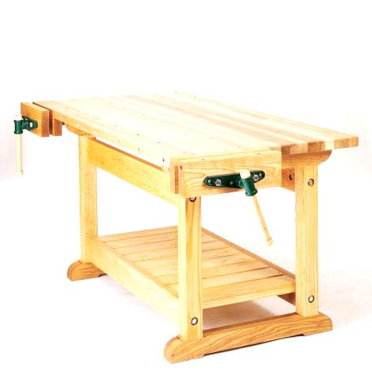
(a) Identify the feature labeled X in the workshop diagram above. (1 mark)

_______________________________________________________
(b) State two reasons why it is important to observe safety rules in a wood workshop. (2 marks)
(i) _________________________________________________________________________________________
(ii) ________________________________________________________________________________________
(c) True/False:
The "First Aid Kit" should be kept in a locked cupboard where students cannot reach it. [__________] (1 mark)
(d) Name the safety equipment shown below: (1 mark)


_____________________________________
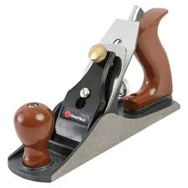
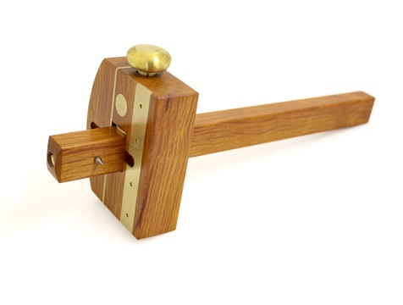
  - A technician at Nyeri High School has laid out tools for a marking-out exercise.
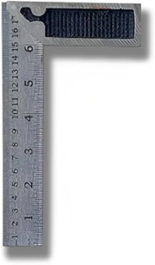
(a) Name the tools: (3 marks)

A B C
A: ____________________ B: ____________________ C: ____________________
(b) Classify tool C based on its function. (1 mark)
__________________________________________________
(c) Identify the tool used to hold a piece of wood firmly to the workbench while sawing. (1 mark)
___________________________________________________________________
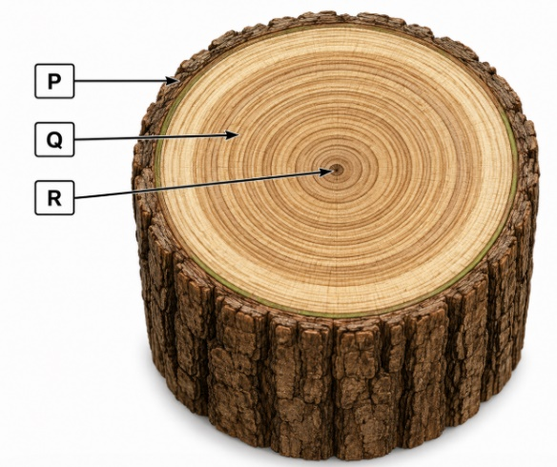
  - During a nature walk in Mau Forest, learners observed a cross-section of a fallen tree.

(a) Identify the parts: (3 marks)
P: _________________________ Q: _______________________ R: _______________________
(b) Distinguish between Softwoods and Hardwoods based on their physical leaves. (2 marks)
Softwood | Hardwood
  - A sawmill in Eldoret uses different methods to cut logs into timber.
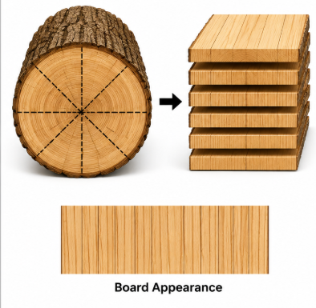
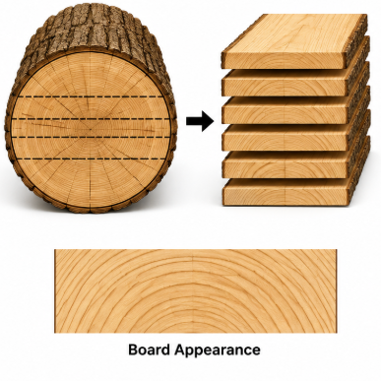
(a) Identify the conversion methods: (2 marks)

Method X: ____________________ Method Y: ____________________

(b) Explain why timber must be "seasoned" before use. (2 marks)
______________________________________________________________________________________________________________________________________________________________________________________________
(c) Mention one method of timber seasoning. (1 mark)
___________________________________________________________
  - A learner at Machakos Girls is choosing a glue for an outdoor garden bench.
(a) Select the best type of adhesive for a project that will be exposed to rain. (1 mark)
_____________________________________________________
(b) Describe one safety precaution when handling chemical wood glues. (2 marks)
______________________________________________________________________________________________________________________________________________________________________________________________
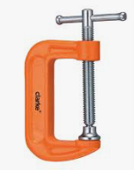
(c) Identify the tool shown below used to apply pressure while the glue sets: (2 marks)

_____________________________

SECTION B (50 MARKS)
  - A student at Precious Blood Senior School is truing up a piece of Cypress timber for a project.
(a) Outline the correct procedure for "Truing up" a piece of wood. (4 marks)
- _________________________________________________________________________________________
- _________________________________________________________________________________________
- _________________________________________________________________________________________
- _________________________________________________________________________________________
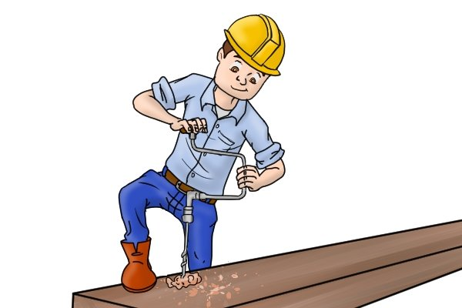
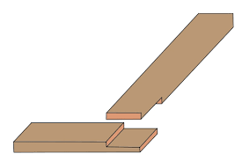
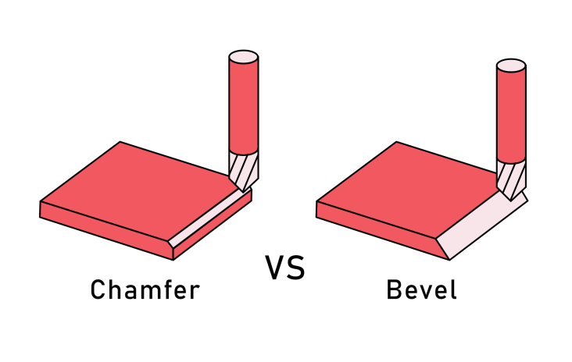
(b) Identify the processes shown in the diagrams below: (3 marks)

_________________________ _________________________ ______________________
(c) Describe the function of a Bench Hook. (3 marks)
- _________________________________________________________________________________________
- _________________________________________________________________________________________
- _________________________________________________________________________________________
(d) List two tools used for sharpening wood chisels. (2 marks)
- _________________________________________________________________________________________
- _________________________________________________________________________________________
(e) Explain the difference between a Bevel and a Chamfer. (3 marks)
Bevel | Chamfer

  - During a practical at Lukenya Senior School, learners are making a shoe rack.
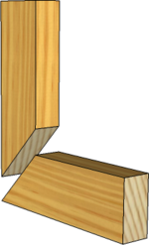
(a) Identify and Name the following joints from the pictures: (4 marks)
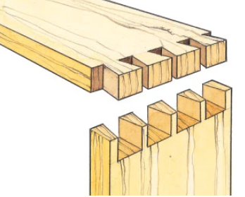
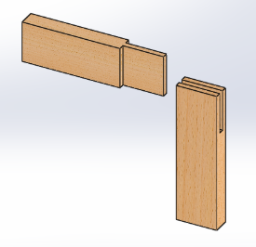
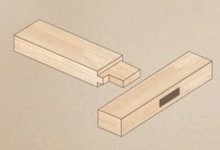

P Q R S
P: ___________________________________________
Q: ___________________________________________
R: ___________________________________________
S: ___________________________________________
(b) Classify the joints above into either Framing joints or Widening joints. (2 marks)
 | Framing joints | Widening joints
Q
R
S
T
(c) Identify the fasteners shown below: (3 marks)
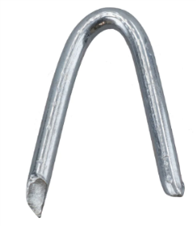
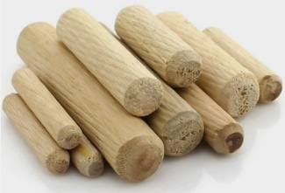
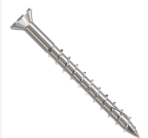

M N O
M: ____________________
N: ____________________
O: ____________________
(d) Explain the role of a "Pilot Hole" when using screws in hardwood. (3 marks)
- _________________________________________________________________________________________
- _________________________________________________________________________________________
- _________________________________________________________________________________________
(e) State three advantages of using joints instead of only using nails to join wood. (3 marks)
- _________________________________________________________________________________________
- _________________________________________________________________________________________
- _________________________________________________________________________________________
- A learner in Nakuru has finished assembling a coffee table and wants to apply varnish.
(a) List three materials or tools required for surface preparation before varnishing. (3 marks)
- _________________________________________________________________________________________
- _________________________________________________________________________________________
- _________________________________________________________________________________________

(b) Describe the process of "Raising the Grain" and why it is done. (3 marks)
- _________________________________________________________________________________________
- _________________________________________________________________________________________
- _________________________________________________________________________________________
(c) Identify the grade of sandpaper that should be used for the final sanding. (1 mark)
_________________________________________________________________________________________
(d) Explain two reasons for applying a "Clear Varnish" to a wood product. (3 marks)
- _________________________________________________________________________________________
- _________________________________________________________________________________________
Answer question 10 on A3 paper and any other three questions from this section in the spaces provided. Candidates are advised not to spend more than 20 minutes on question 10.
- The figure below shows a machine drawn in isometric projection.
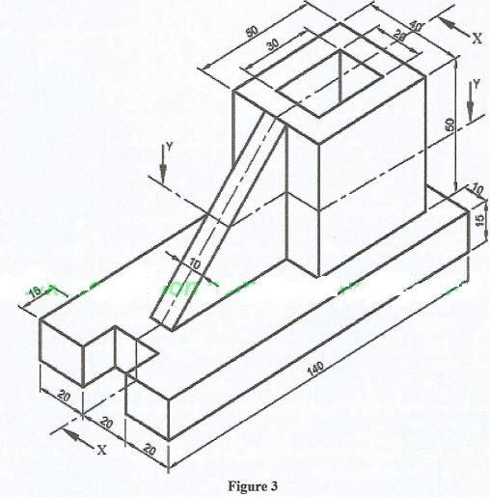
Draw the following views of the component Full Size in first angle projection: (15 marks)
- Sectional front elevation along the cutting plane X-X.
- Sectional plan along the cutting plane Y-Y
THIS IS THE LAST PRINTED PAGE

