KENYA CERTIFICATE OF BASIC EDUCATION

SENIOR SCHOOL ASSESSMENT

TERM 2: ENDTERM ASSESSMENT 2026
GRADE 10 – SPORTS AND RECREATION
Time: 2 Hours
LEARNER’S DETAILS
Name: _____________________________________________________________. School: ____________________________________________.
Assessment Number: _______________________________________________. Date: ____________________________________________.
School Code: ______________________________________________________. Signature: _______________________________________.

INSTRUCTIONS TO CANDIDATES
- Write your name in the spaces provided above.
- Write the name of your school and your stream in the spaces provided.
- Write your admission number and the date of the assessment in the spaces provided.
- This paper consists of two sections: A and B.
- Answer all questions in section A and section B.
- Answer the questions in English.
- All answers MUST be written in the spaces provided in the paper.
- Do NOT remove any page from this question paper

FOR OFFICIAL USE ONLY (EXAMINER’S USE)
SECTION | SECTION A | SECTION B | % SCORE | EE1 | EE2 | ME1 | ME2 | AE1 | AE2 | BE1 | BE2
SCORE RANGE | 40 MARKS | 50 MARKS |  | 90-100 | 75-89 | 58-74 | 41-57 | 31-40 | 21-30 | 11-20 | 1-10
POINTS |  |  |  | 8 POINTS | 7 POINTS | 6 POINTS | 5 POINTS | 4 POINTS | 3 POINTS | 2 POINTS | 1 POINT
LEARNER’S TOTAL SCORE

SECTION A (30 MARKS)

Answer ALL questions in this section
  - Three learners at Alliance High School are discussing the benefits of sports:
Wanjiku: "Sports help me stay focused in class and manage stress."
Otieno: "Our local tournament brought different communities together in peace."
Mutua: "I want to be a professional athlete like Eliud Kipchoge to earn a living."
(a) Identify the specific benefit of sports mentioned by Wanjiku. (1 mark)
______________________________________________________________________________

(b) Name the social benefit highlighted by Otieno's observation. (1 mark)
__________________________________________________________________________________________
(c) Outline how sports contribute to the national economy as suggested by Mutua. (2 marks)
- _________________________________________________________________________________________
- _________________________________________________________________________________________
(d) Mention one individual sport popular in the Kenyan highlands. (1 mark)
_________________________________________________________________________________________
_________________________________________________________________________________________
  - A sports scientist in Eldoret is assessing athletes using the following tools.
(a) Define the term Body Composition. (1 mark)
______________________________________________________________________________________________________________________________________________________________________________________________
(b) Identify the method of measuring body composition that uses the tools in the picture to calculate a numerical value. (1 mark)
______________________________________________________________________________________________________________________________________________________________________________________________
(c) Distinguish between Lean Body Weight and Fat Body Weight. (2 marks)
_____________________________________________________________________________________________________________________________________________________________________________________________________________________________________________________________________________________________
_______________________________________________________________________________________________
(d) State one factor, other than nutrition, that determines an individual’s body composition. (1 mark)
______________________________________________________________________________________________________________________________________________________________________________________________

  - Study the illustrations of learners at Nyeri High School performing various movements.
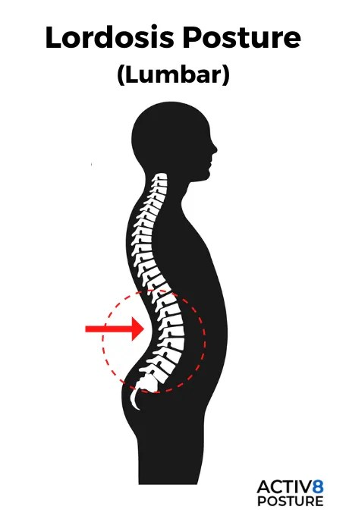
(a) Identify the postural defect labeled X (The one with an exaggerated inward curve of the lower back). (1 mark)

X

____________________________________________________________________
(b) Name the defect characterized by a "hunchback" appearance. (1 mark)
______________________________________________________________________________________________________________________________________________________________________________________________
(c) Explain how poor posture affects an athlete’s performance during a long-distance race. (2 marks)
______________________________________________________________________________________________________________________________________________________________________________________________
(d) True or False:
Correct posture during sitting helps prevent spinal strain. [__________] (1 mark)
  - Learners at Mama Ngina Girls are conducting a floor aerobics session.
(a) List the three main phases of a standard aerobics session. (3 marks)
- _________________________________________________________________________________________
- _________________________________________________________________________________________
- _________________________________________________________________________________________
(b) Identify the role of music in an aerobics session. (1 mark)
____________________________________________________

(c) Mention one piece of equipment that can be improvised for aerobics in a school setting. (1 mark) ______________________________________________________________________________________________________________________________________________________________________________________________
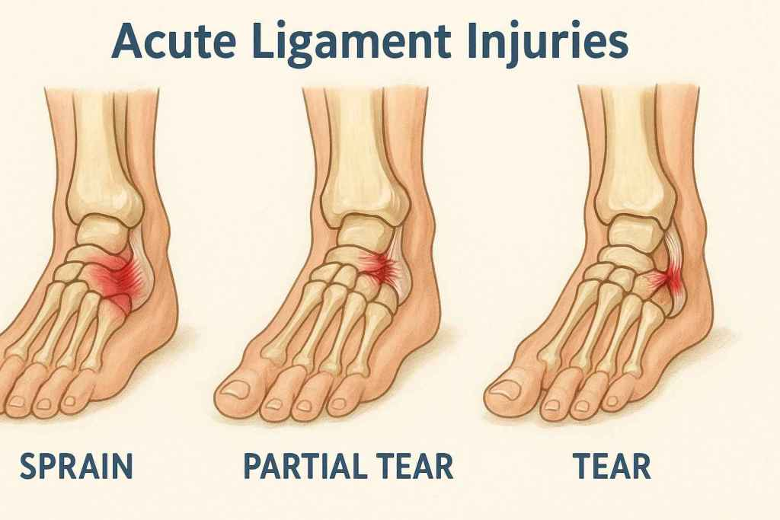
  - During a rugby match at St. Mary’s School, Yala, a player sustains the injury shown below.

(a) Classify the injury shown as either Acute or Chronic. (1 mark)
___________________________________________________________________
(b) Identify the injury where a bone is broken. (1 mark)
___________________________________________________________________
(c) Describe one strategy an athlete can use to avoid injuries while practicing on the road. (2 marks) ______________________________________________________________________________________________________________________________________________________________________________________________
(d) Name the first aider's role in a sports team. (1 mark) ______________________________________________________________________________________________________________________________________________________________________________________________
  - A coach at Kakamega High is using a training program for the school football team.
(a) State one principle of coaching. (1 mark) ______________________________________________________________________________________________________________________________________________________________________________________________

(b) List two elements that must be included in a standard training program. (2 marks)
- _________________________________________________________________________________________
- _________________________________________________________________________________________
(c) Explain why "Feedback" is important in the coaching process. (2 marks)
_______________________________________________________________________________________________________________________________________________________________________________________________________________

SECTION B: [50 MARKS]
Answer ALL questions in the spaces provided.
  - A Non-Governmental organization called GKH is promoting a "Wellness Saturday" at Afraha Stadium.
(a) Describe the Social Dimension of recreation as seen in the tug-of-war activity. (2 marks)
- _________________________________________________________________________________________
- _________________________________________________________________________________________
(b) Explain how recreational activities foster mental wellness. (3 marks)
- _________________________________________________________________________________________
- _________________________________________________________________________________________
- _________________________________________________________________________________________
(c) Design a simple three-point road safety poster message for cyclists participating in the event. (3 marks)

(d) Outline two criteria for an activity to be considered "recreational." (2 marks)
- _________________________________________________________________________________________
- _________________________________________________________________________________________
  - A basketball coach from Maseno School is preparing the team for the regional games.
(a) Identify and Name the two formations shown in the diagrams. (2 marks)

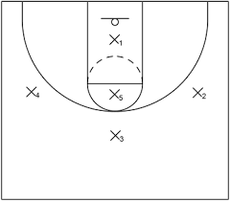
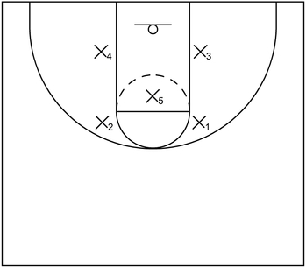

X Y
X: ___________________________________________.
Y: ___________________________________________.
(b) Compare the use of a "Man-to-Man" marking tactic versus a "Zone Defense" in Basketball. (4 marks)
Man to man marking | Zoe defence
(c) Explain how tactical skills enhance performance in middle-distance races (e.g., 800m). (3 marks)
- _________________________________________________________________________________________
- _________________________________________________________________________________________
- _________________________________________________________________________________________
(d) Describe the role of a "Pace-setter" in a track event. (3 marks)
- _________________________________________________________________________________________
- _________________________________________________________________________________________
- _________________________________________________________________________________________
- During a Netball match between Kenyatta Senior and Iten Senior, a dispute arises over a decision.
(a) Distinguish between a Meet Official and a Team Official. (4 marks)
_____________________________________________________________________________________________________________________________________________________________________________________________________________________________________________________________________________________________
(b) Match the official to their primary role: (4 marks)
Official | Role
Timekeeper | (i) Keeps the record of points scored
Referee/Umpire | (ii) Ensures the game starts and ends on time
Scorer | (iii) Inspects the field and equipment
Match Commissioner | (iv) Makes final decisions on fouls and play
(c) Explain the principle of Integrity in officiating. (3 marks)
- _________________________________________________________________________________________
- _________________________________________________________________________________________
- _________________________________________________________________________________________
(d) Describe two hand signals used by a football referee to communicate decisions. (3 marks)
- _________________________________________________________________________________________
- The Kenya Academy of Sports is visiting Marsabit to identify new talent.
(a) Examine three physical attributes a scout would look for in a potential sprinter. (3 marks)
- _________________________________________________________________________________________
- _________________________________________________________________________________________
- _________________________________________________________________________________________
(b) Design a simple 4-item Attributes Checklist for identifying a talented goalkeeper in football. (4 marks)
- _________________________________________________________________________________________
- _________________________________________________________________________________________
- _________________________________________________________________________________________
- _________________________________________________________________________________________
(c) Analyze the materials used in the improvised javelin shown. Is it safe for use? Explain. (3 marks)
- _________________________________________________________________________________________
- _________________________________________________________________________________________
- _________________________________________________________________________________________
(d) Discuss how talented sportsmen and sportswomen contribute to community development in Kenya. (4 marks)
- _________________________________________________________________________________________
- _________________________________________________________________________________________
- _________________________________________________________________________________________
- _________________________________________________________________________________________

THIS IS THE LAST PRINTED PAGE

