Build log
A running record of what has been added to the project: what each piece is, how it works inside, what the names and variables in the code mean, why it was chosen that way and which C#, PostgreSQL or tooling idea it teaches. Read it once from start to finish, then update it with every pull request.
Versión en español: BUILD-LOG-ES.md. Exported PDF/Word files live in `exports/`.
Source of truth for the work items: openspec/changes/mvp-reconciliation-core/tasks.md (85 tasks in 11 groups). This log explains them; the status map below is generated from them.

How the documentation is organised
Folder | What it holds | Why it is separate
docs/adr/ | Architecture decision records (ADR-001 to ADR-005) | One decision = one file; they are never edited, a later ADR replaces them
docs/build-log/ | This log in English and Spanish, and exports/ with the generated PDF/Word files | What changes every PR; exports stay apart from the source text
docs/requirements/ | BRS and SRS (English and Spanish) | Requirements documents that rarely change
docs/reference/ | The reference bank CSV format and the project brief with reading links | Reference material that tests read or that is cited
docs/diagrams/ | Database and role diagrams and the progress map (progress/) | Drawn or generated images, each with its .svg source
openspec/ | The specification and tasks of the mvp-reconciliation-core change | Source of truth for scope

Rule of thumb: before deleting or moving a file in docs/, search for its name with grep -rn (several xUnit tests read docs/adr/, docs/reference/ and docs/build-log/), and use git mv to keep history.

1. Status at a glance
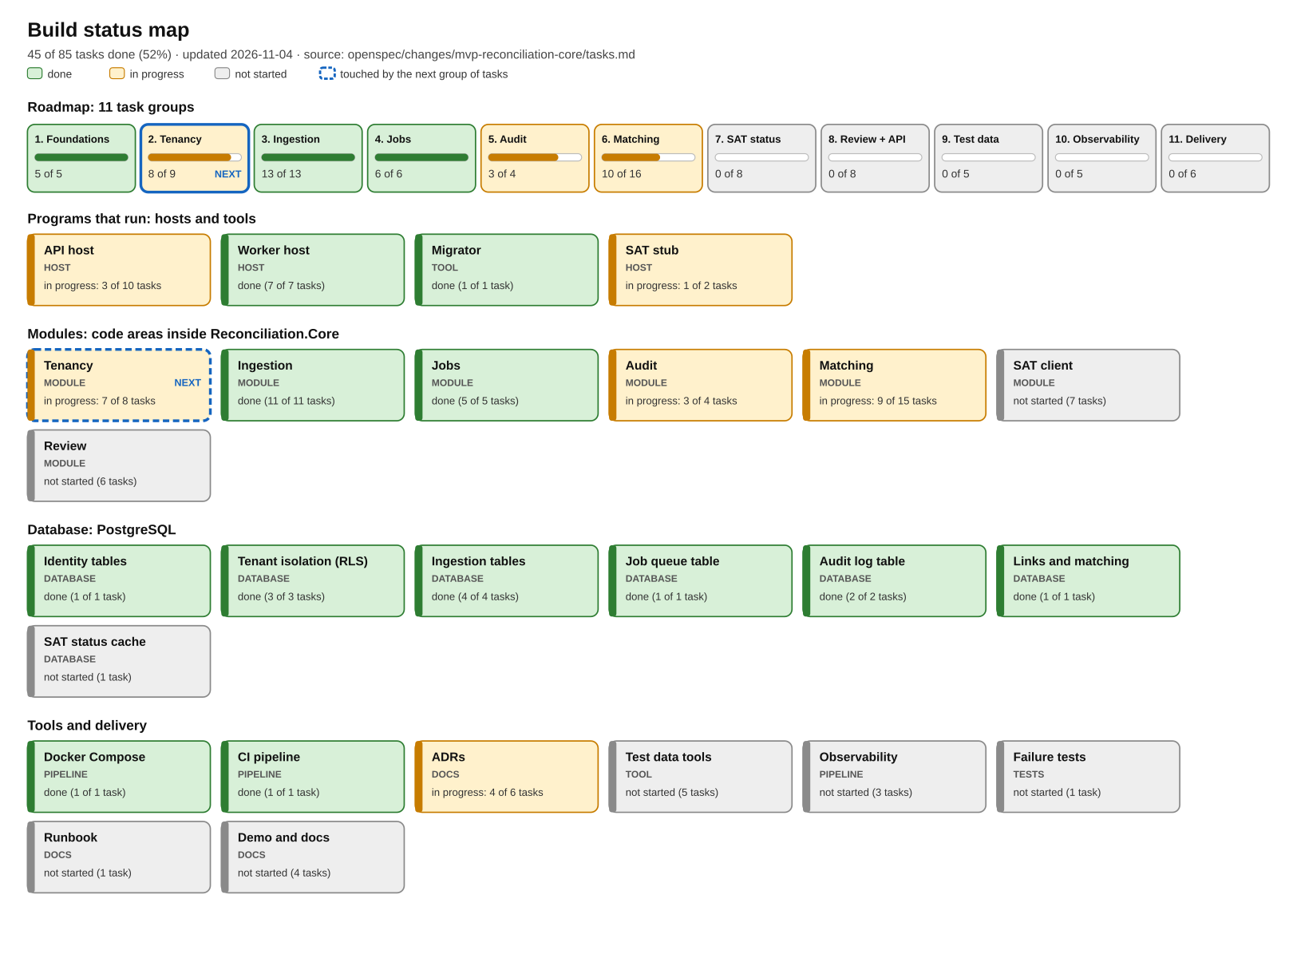
45 of 85 tasks complete. Groups 3/4 and matching 6A are complete; audit 5.3 and task 2.4 await group 7/8 decisions. Matching 6B remains deferred. Regenerate the image after ticking tasks: python3 tools/progress_diagram.py (add --lang es for Spanish).

What each type means
Type | What it is | Example here
Host | A program that keeps running and serves requests or does background work | API, worker, SAT stub
Module | An area of code inside the shared library with one business responsibility | Matching, Audit
Database | Tables, rules and security that live inside PostgreSQL | company, row-level security
Tool | A program that runs once to do a job and exits | Migrator, test-data generators
Pipeline | Automation that builds, tests or starts things | Docker Compose, CI
Docs / Tests | Written decisions, or code that checks the rest of the code | ADRs, xUnit tests

2. Architecture

2.1 Overview: what is built today
HTTP client (curl, browser, tests)
| HTTPS + header "Authorization: Bearer <JWT>" + "X-Company-Id: <uuid>"
v
+--------------------------+ +-----------------------------+
| API host (ASP.NET Core) | | Worker host (BackgroundSvc) |
| port 3000 (8080 outside) | | port 3001 (internal only) |
+------------+-------------+ +--------------+--------------+
| both reference the same library |
+---------------+---------------+-------------------+
v
+-------------------------------+
| Reconciliation.Core | Tenancy | Ingestion | Audit
| (seven modules, no Main) | Matching | Review | Sat | Jobs
+---------------+---------------+ (Review and Sat are placeholders)
| SQL via Npgsql + Dapper, CompanyScope for tenants; auth global
v
+-------------------------------+ +----------------------+
| PostgreSQL 17 | | Migrator (runs once) |
| forced RLS per company |<-------| creates tables, role |
| application role: cfdi_app | | and first operator |
+-------------------------------+ +----------------------+

SAT stub (port 8081): separate container, only /health today.
Every arrow is a boundary with a reason:
- Two hosts, one library. The API serves people and must answer quickly; the worker runs imports and matching now and will run later SAT queries. They share Reconciliation.Core, so business rules are written once (ADR-001: modular monolith with a separate worker, instead of microservices).
- Modules with boundaries. Tenancy (companies, users, roles, sessions), Ingestion (reading CFDI and CSV), Audit (log), Jobs (queue/dispatch), Matching (pure rules and orchestration), and placeholders Review and Sat. A module talks to another through explicit interfaces; matching orchestration loads the tenant ingestion/link tables while its pure engine has no SQL.
- PostgreSQL as the final referee. Even if the code forgets to filter by company, the database does not return another company's rows (section 2.3).
- The migrator is a separate program with a different database role: the schema owner (cfdi) creates and changes tables; the application (cfdi_app) can only do what it is granted.
The full design, including what does not exist yet (SAT client, telemetry), is this:
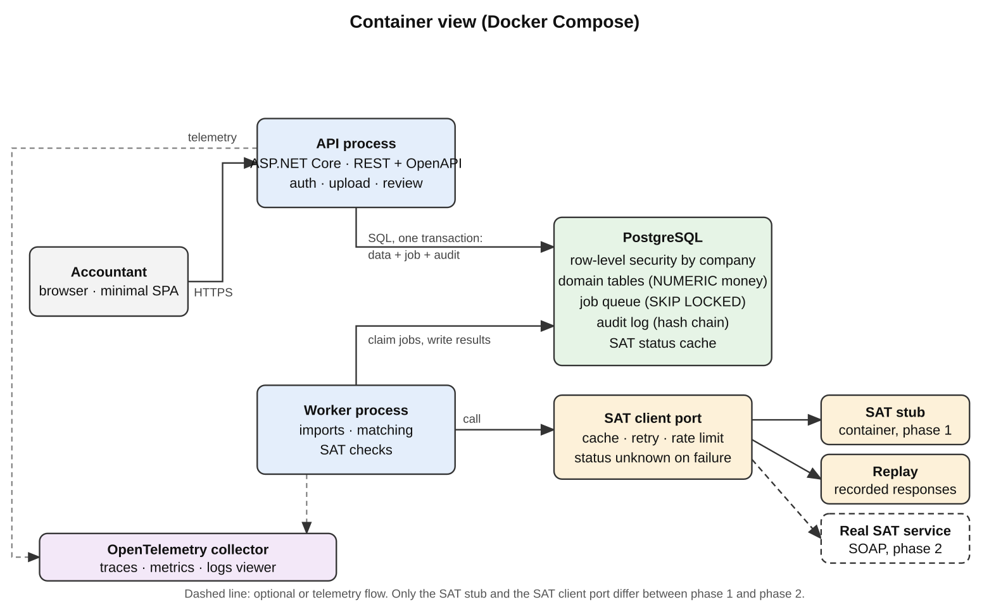
The API, polling worker, PostgreSQL tenancy/ingestion/session/job tables and SAT health stub exist. The audit hash chain and matching 6A also exist. Still missing: matching 6B, SAT handlers, review decisions and OpenTelemetry.

2.2 Life of an authenticated request
Example: an accountant uploads an invoice with POST /companies/{companyId}/imports/cfdi.
- Login. The client calls POST /auth/tokens with {"email","password"}. Before touching the database, LoginProtection reads the body (8 KiB maximum), normalises the email (trim and upper-case) and applies two fixed-window limits: 10 attempts per minute per email and 30 per minute per IP; beyond them it answers 429 with Retry-After. It then finds the user case-insensitively and performs exactly one PBKDF2 verification: against the real hash or, if the email does not exist, against a dummy hash (DummyPasswordHash) created once at start-up, so response time does not reveal which emails exist. On a match it returns a signed JWT (HMAC-SHA256) valid for 15 minutes with sub, sid and jti claims.
- Request. The client sends the file with Authorization: Bearer <token> and X-Company-Id: <uuid>.
- Authentication. ASP.NET validates signature, issuer, audience and expiry. If that fails the answer is 401.
- Per-company authorisation. CompanyRoleHandler requires X-Company-Id to match the route {companyId}, opens a transaction with that context and reads the user's role from membership. The accountant policy accepts administrator and accountant; a viewer gets 403.
- Company context. CompanyScope.ExecuteAsync opens a connection, starts a transaction and runs set_config('app.company_id', <uuid>, true); the true makes it last only for that transaction. For write operations, in the same command batch (NpgsqlBatch) it takes a lock on the company row (SELECT archived_at IS NOT NULL FROM company FOR UPDATE): if the company is archived it throws CompanyReadOnlyException and the API answers 409; the lock also serialises simultaneous changes (for example two administrators being demoted at the same time).
- Enqueue. Stream limits precede one transaction for queued originals plus job. No XML/CSV parsing runs in the request.
- Close. COMMIT returns 202 with jobId/uploadId; ROLLBACK leaves no files or job. Safe ProblemDetails includes uploadId on enqueue failure. The worker later commits one file at a time, and GET imports/{uploadId} returns its report.

2.2a Session renewal
add-session-renewal is tracked independently from the 85 MVP tasks. It adds no company-data route and does not change their Bearer contract. The API issues a 15-minute access JWT and a 256-bit base64url refresh credential; only SHA-256 token_hash is stored. sub identifies the user, sid the family and jti the access token. SessionService uses injected TimeProvider for issuance, validation, deadlines and events. SessionOptions validates at startup. CompanyRoleHandler still reads membership live; roles stay outside tokens and sessions.
- Login verifies the slow salted password hash and inserts a family, refresh digest and login event in one transaction.
- Renewal looks up the digest, locks auth_session with SELECT ... FOR UPDATE, re-reads the token, and rotates it atomically with its refresh event. It updates last_used_at; the new expiry is the lesser of idle time and the original cap.
- A replay through the inclusive grace boundary returns 409 and changes nothing. Later replay revokes the family and writes reuse_detected; other devices remain active. Clients coordinate with single-flight renewal.
- Logout revokes the owned family. Password change verifies the current password, hashes the new one and revokes all of that user's sessions with password_changed, atomically. Auth events are append-only for cfdi_app.
- Access stays stateless until expiry; no session lookup is added to company requests. Optional HttpOnly/Secure/ SameSite=Strict cookies use Path=/auth and require an allowed Origin for renewal; default transport remains JSON. Login keeps its email/IP limits; refresh and logout share a named IP limit. See ADR-004.

2.3 Security layers (defence in depth)
Layer | What it stops | Where it lives | How it is tested
Login attempt limit | Brute force and credential stuffing | LoginProtection.cs | ReviewHardeningTests
JWT authentication | Anonymous requests | Authentication.cs, fallback policy | AuthenticationTests
Membership and role per company | Using a company where you have no role, or an action the role cannot do | CompanyRoleHandler.cs | MembershipTests, IsolationTests
Transaction with context | Queries with no company assigned | CompanyScope.cs | CompanyScopeTests
Archived company is read-only | Writing to an archived company, or losing the last administrator through a race | CompanyScope.cs (row lock) | ReviewHardeningTests
Forced RLS in PostgreSQL | Seeing or writing another company's rows even if a WHERE is missing | Migrations M0002 and M0004 | Isolation guard over every table and route
Composite foreign keys | A row pointing at another company's record | FOREIGN KEY (company_id, x_id) | IngestionDatabaseTests
Unprivileged role | Bypassing RLS, deleting data | cfdi_app: no superuser, no BYPASSRLS, no DELETE | Tests that use the real role
Safe XML reading | XXE attacks and "bomb" files | SafeCfdiXmlReader.cs | SafeXmlTests
Input limits | Oversized files or CSVs; hostile file names | IngestionOptions, MultipartUpload.cs | ReviewHardeningTests, IngestionHttpTests
Safe downloads and errors | The browser interpreting an original; leaking internal detail | Content-Disposition: attachment, nosniff, ProblemDetails | ReviewHardeningTests

Why several layers: each covers a different failure. A 403 does not prove the RLS policy exists, and an RLS policy does not identify the user; both are needed, and each needs tests.

2.4 Life of an import
multipart -> streaming bounds and filename cleaning
-> ONE tenant transaction: queued import_file (pending_original + sha256) + job
-> 202 {jobId, uploadId}
worker -> claim_next_job -> running + attempt + heartbeat
-> safe XML / CSV validation; one bad file does not block the others
-> per-file fenced tenant transaction: processing -> imported / rejected / already_imported + audit
-> pending bytes cleared; accepted original immutable; progress -> succeeded
GET jobs/{jobId} -> state/history/progress; GET imports/{uploadId} -> stable per-file report
An enqueue failure leaves no partial upload. A later worker failure retains committed files and queued pending input, so a redelivery resumes without duplicate domain or audit effects. Processing is transaction-local. Accepted bytes are verified and finalized once; progress updates touch the job row instead of repeatedly rehashing the original.

2.5 Data model
Table | Why it exists | Key columns
company | Each customer (company) in the system | rfc (immutable, validated), date_tolerance_days (0–366), amount_tolerance, archived_at
app_user | People who log in | email (unique, case-insensitive), password_hash
membership | Links user, company and role | PK (company_id, user_id), role (administrator, accountant, viewer)
audit_entry | Per-company immutable hash chain | company_seq, occurred_at, actor_type, actor_id, items, detail, canonical, prev_hash, hash
audit_chain_head | Locked append position and trusted verification tail | company_id, last_seq, last_hash
import_file | An uploaded file and its outcome | upload_id, status, reason, original (bytes), pending_original, file_index, sha256, retained_until, original_file_id
cfdi | An imported invoice | uuid, type (I/P/E), direction, amounts numeric(18,2), is_global, review_reason
cfdi_relation | Relations between CFDIs (for example a credit note) | related_uuid, relation_code
cfdi_payment, cfdi_payment_doc | Payment complement and the invoices it settles | payment_index, installment, previous_balance, paid, remaining_balance
job, job_attempt | Durable queue, leases and attempts | company_id, type/state/input_ref, attempts, run_after, locked_until, progress, error history
bank_account | A bank account identified by a label | bank, account_reference
bank_movement | One line of the bank statement | movement_date, credit, debit, balance, reference

Conventions for company tables: id uuid is generated by the database (job_attempt instead has a compound key); mandatory company_id; RLS enabled
and forced; composite foreign keys; money in numeric(18,2), never double or float; indexes that start with company_id (M0005) so each company query walks only its own rows.
The as-built schema (migrations M0001 to M0009), drawn from the migrations themselves:
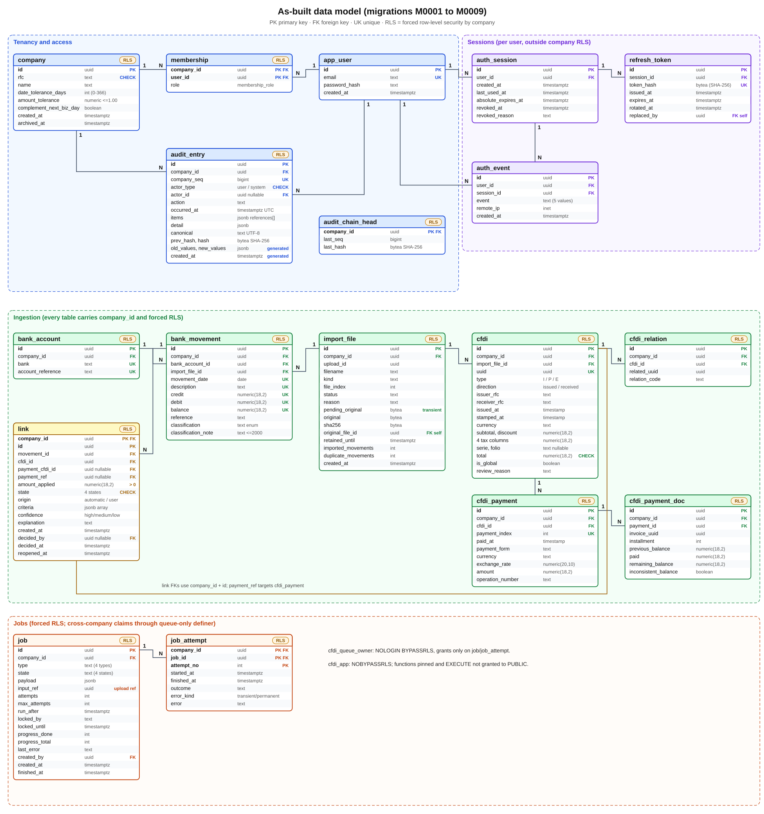
Blue is tenancy, purple is sessions (per user, outside company RLS), orange is jobs, and green is ingestion; the orange RLS badge marks tables with forced row-level security. The next two diagrams show the status rules of the data and who may do what:
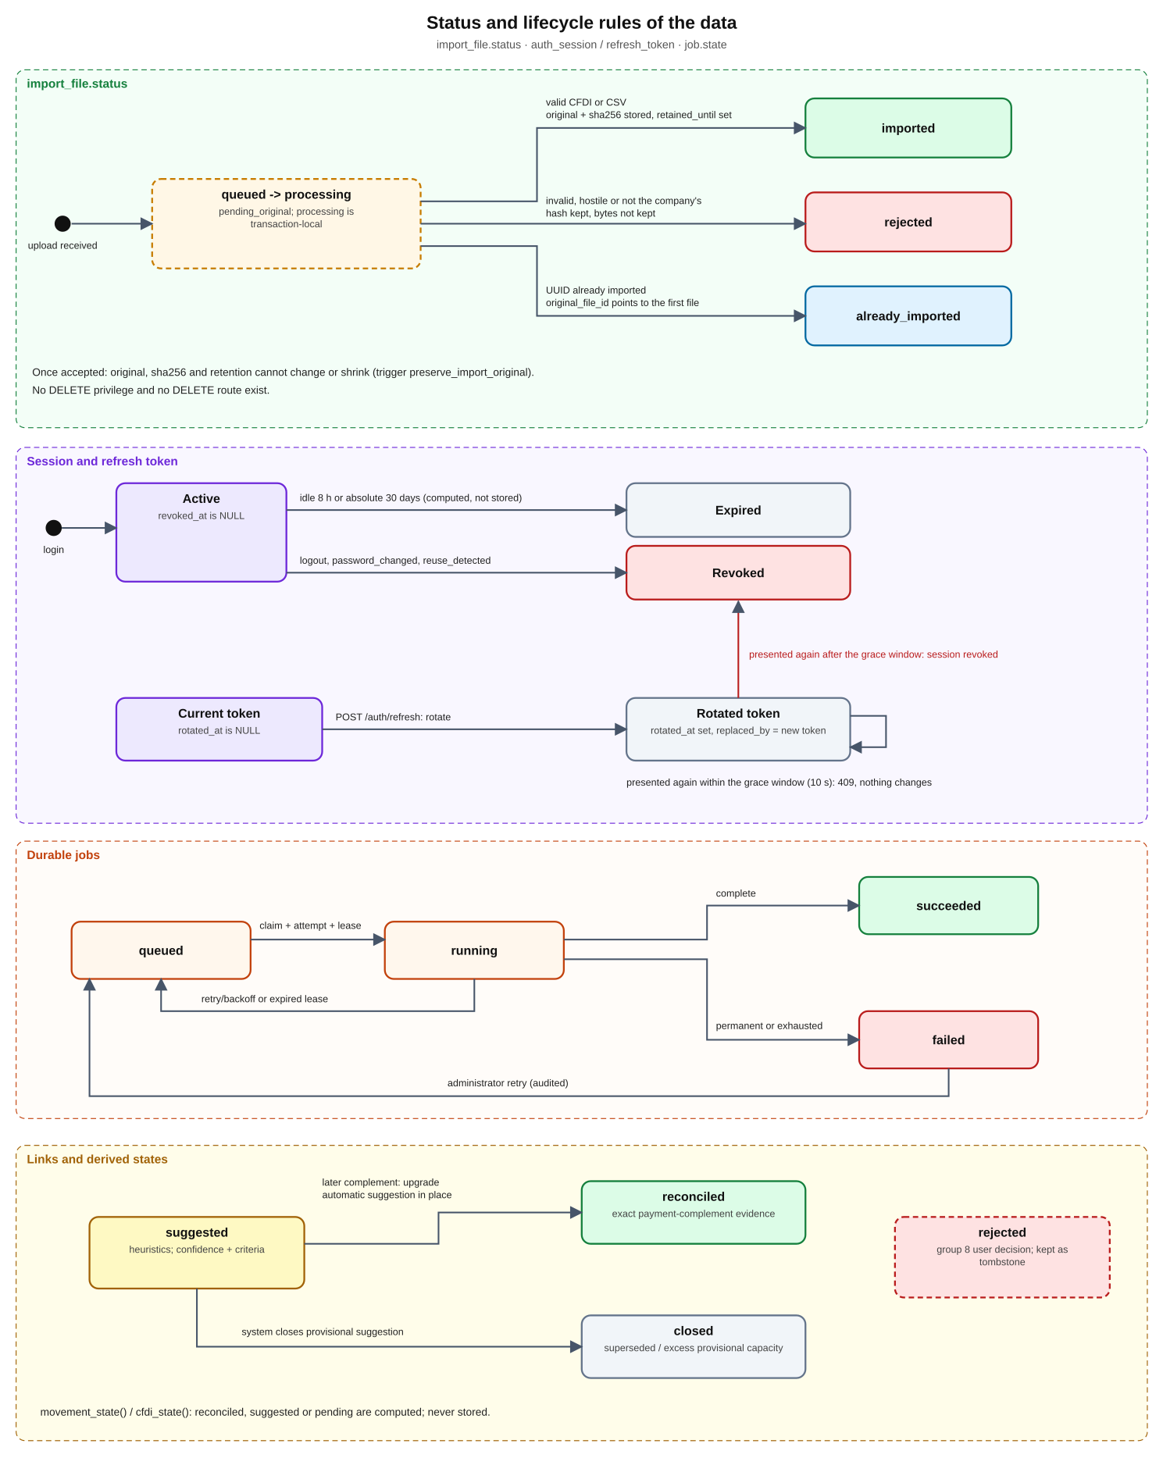
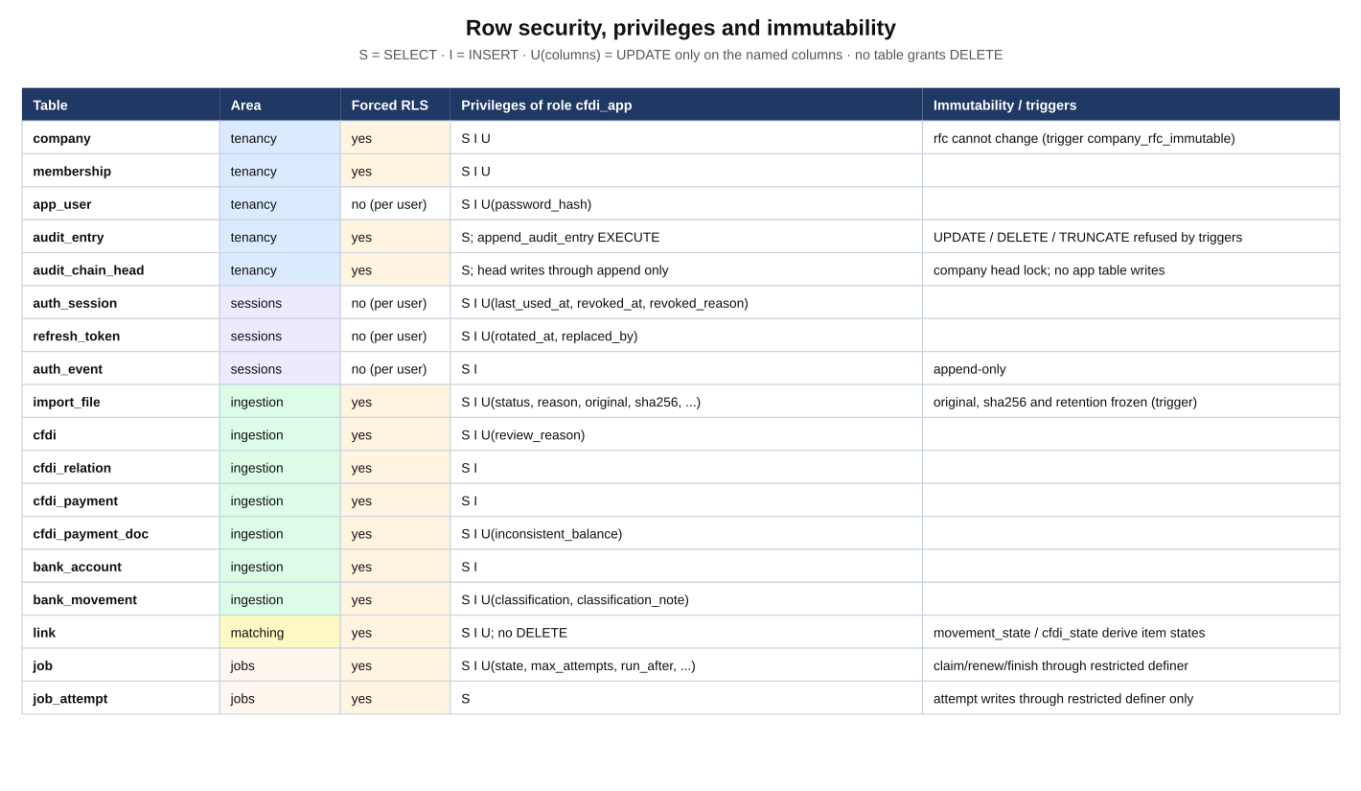
The original design-time model (planned tables for the whole MVP) is still in docs/diagrams/database/database-erd.png. Regenerate the three as-built diagrams with python3 tools/db_diagrams.py (add --lang es for Spanish).

2.6 Per-user authentication storage
The company/ingestion diagrams describe their tenant model. M0006 adds these global per-user tables outside company RLS; they have no company_id and do not use CompanyScope. Existing company policies and SQL names stay unchanged.
Table | Fields and purpose
auth_session | id, user_id, created_at, last_used_at, absolute_expires_at, revoked_at, revoked_reason: one device/family
refresh_token | id, session_id, token_hash, issued_at, expires_at, rotated_at, replaced_by: immutable digest/deadline and rotation link
auth_event | id, user_id, session_id, event, remote_ip, created_at: login/refresh/reuse/logout/password events, no credentials

Indexes cover the unique digest, family and user. cfdi_app has SELECT/INSERT, UPDATE only on named mutable columns, no DELETE, and no event UPDATE. app_user gains only UPDATE(password_hash). Down removes the new tables and that grant. All session timestamps are explicit UTC values from TimeProvider. Authentication events remain in auth_event, separate from the company audit chain; expired-row purging remains future work. Existing access can outlive revocation until its configured expiry.

2.7 Durable jobs
M0007 adds job and job_attempt, both tenant tables with forced RLS. JobStore.EnqueueAsync shares the caller's CompanyScope transaction. JobLoop is now a polling BackgroundService with configurable concurrent lanes; JobDispatcher claims due work, runs the handler under its company context and heartbeats until it finishes.
The cross-company boundary is claim_next_job: SECURITY DEFINER, owned by cfdi_queue_owner (NOLOGIN BYPASSRLS), with privileges only on job/job_attempt. cfdi_app stays NOBYPASSRLS, cannot become that owner, and receives EXECUTE only on pinned claim/renew/finish functions; PUBLIC cannot execute them. Renew/finish require worker, attempt and live lease. Reaping records lease_expired and either requeues or fails exhausted work. Every time is supplied from TimeProvider through optional SQL p_now; no HTTP route accepts or exposes p_now. See ADR-005.
Transient failures use capped exponential backoff plus jitter; invalid input fails at once. Attempts and original input remain for an audited administrator rerun. An import's remaining files stay queued with pending_original until successful rerun; no cleanup is implemented. Per-file lease checks and stable file ids prevent duplicate domain/audit effects after redelivery. The four types are import_cfdi, import_statement, reconciliation_run and status_check; reconciliation_run executes matching 6A; only status_check records its group 7 placeholder limit without domain effects.

3. Dictionary of names and variables

3.1 Environment variables and configuration
Name | Example value | Read by | What it means
ConnectionStrings__Default | Host=postgres;Port=5432;Username=cfdi_app;... | API, worker, migrator | PostgreSQL connection string. The double underscore is how .NET writes ConnectionStrings:Default in an environment variable. API and worker use role cfdi_app; the migrator uses owner cfdi
APP_DB_PASSWORD | synthetic placeholder | Migrator and Compose | Password the migrator uses to enable login for role cfdi_app (ALTER ROLE ... LOGIN PASSWORD)
Jwt__SigningKey / JWT_SIGNING_KEY | at least 32 random bytes | API | Secret key used to sign and verify tokens. If missing, short or equal to the old public sample value, the API will not start. Compose requires JWT_SIGNING_KEY (there is no default any more) and passes it to the API as Jwt__SigningKey; generate one with openssl rand -hex 32
OPERATOR_EMAIL, OPERATOR_PASSWORD | optional; password of 12+ characters | Migrator (up) | If present, the platform operator is created once; an existing operator's password is never reset (it only logs that the account was not modified)
Ingestion__MaxFileBytes | 10485760 (10 MiB) | Ingestion | Maximum size of one file. A larger one rejects only that file
Ingestion__MaxUploadBytes | 20971520 (20 MiB) | Ingestion | Maximum size of the whole upload, counting multipart headers. Exceeding it rejects the entire upload (413)
Ingestion__MaxFiles | 20 | Ingestion | Maximum number of files per upload (400 if exceeded)
Ingestion__MaxXmlNodes | 100000 | Ingestion | Maximum XML nodes and attributes; stops "bomb" files
Ingestion__MaxXmlDepth | 64 | Ingestion | Maximum XML nesting depth
Ingestion__MaxStatementLines | 100000 | Ingestion | Maximum rows in a bank statement; exceeding it rejects that whole file with its reason
Ingestion__MaxDescriptionLength | 500 | Ingestion | Maximum characters of the description; bounds the size of the unique-index keys of movements
Ingestion__RetentionYears | 10 (minimum 5, maximum 100) | Ingestion | Years the original is kept; sets retained_until
LoginRateLimit__EmailPermitLimit | 10 | API | Login attempts per normalised email in each fixed window
LoginRateLimit__IpPermitLimit | 30 | API | Login attempts per remote IP in each fixed window
LoginRateLimit__WindowSeconds | 60 | API | Window length; exceeding a limit returns 429 with Retry-After
RUN_BENCHMARKS | 1 (only when measuring) | Tests | Enables the opt-in performance benchmark; without it (and in CI) it is skipped

IngestionOptions.Validate() and LoginProtection check everything at start-up: a non-positive value, a retention outside 5–100 or a non-positive login window stops the program from starting, instead of failing later in the middle of an operation. The per-email limit can be abused to throttle a victim (an attacker exhausts their attempts); the default is generous and the IP limit helps, but production needs tuning and monitoring.

3.1a Session dictionary and configuration
Name | Default / meaning
Session__AccessTokenMinutes | 15; allowed 5–30; returned as expiresIn seconds
Session__IdleMinutes | 480; renewal inactivity deadline
Session__AbsoluteDays | 30; cap fixed at login, never extended
Session__ReuseGraceSeconds | 10; inclusive replay conflict window
Session__RefreshCookie | false; optional cookie instead of JSON refresh delivery
Session__AllowedOrigins__0 | allowed HTTPS frontend Origin, e.g. https://app.example.invalid; required for successful cookie renewal
RefreshRateLimit__IpPermitLimit | 60 per LoginRateLimit__WindowSeconds, shared by refresh/logout per IP
SessionOptions, TimeProvider | validated configuration and injected clock; tests use ManualTimeProvider without sleeps
accessToken, refreshToken, expiresIn | login/renewal response; refreshToken omitted in cookie mode
sid, token_hash, replaced_by | family id; SHA-256 of the wire credential; successor token id
reuse_detected | revocation/event reason after grace; 409 inside grace changes nothing
/auth/refresh, /auth/logout, /auth/password | renew; end the owned family; change own password and end all own families

3.1b Job names and configuration
Name | Default / meaning
Jobs__PollIntervalMilliseconds / JOBS_POLL_INTERVAL_MILLISECONDS | 500; idle poll interval
Jobs__Concurrency / JOBS_CONCURRENCY | 2; lanes per worker process
Jobs__LeaseSeconds / JOBS_LEASE_SECONDS | 60; heartbeat runs every third of the lease
Jobs__MaxAttempts / JOBS_MAX_ATTEMPTS | 5; initial budget and extra budget for administrator rerun
Jobs__BackoffBaseSeconds / JOBS_BACKOFF_BASE_SECONDS | 2; exponential retry base
Jobs__BackoffCapSeconds / JOBS_BACKOFF_CAP_SECONDS | 300; retry delay cap including jitter
JobLoop, JobDispatcher, IJobHandler | poll, claim/heartbeat/classify, and tenant handler boundary
job, job_attempt | durable state/input/progress and every attempt's outcome/error history
locked_by, locked_until, attempt_no | lease ownership/deadline and stale-worker fence
pending_original, file_index | private queued bytes, checked by sha256; stable upload order
claim_next_job, p_now, TimeProvider | restricted global claim and injected UTC; p_now is never an HTTP field
jobId, uploadId | 202 receipt; progress resource and stable existing import report

Options validate at startup. The uppercase names are Compose mappings to Jobs__*; JOBS_MAX_ATTEMPTS also configures API enqueue. pending_original is never in JSON or downloads. Accepted finalization moves exactly those bytes into original, clears pending bytes, and starts RetentionYears at acceptance. Rejected files keep only hash/reason.

3.2 HTTP headers, routes, fields and status codes
Name | Where it appears | Meaning
Authorization: Bearer <JWT> | Header | The token obtained at login
X-Company-Id | Header | The company the request acts on; must equal the route {companyId} and the user must be a member
{companyId} | Route | The company UUID
{uploadId} / upload_id | Route / column | UUID that groups the files of one upload
{invoiceId} | Route | Internal UUID (cfdi.id) of the invoice. It is not the fiscal UUID
{fileId} | Route | UUID of an import_file row
files | Multipart field | One or more uploaded files; names are cleaned (no control characters, 255 maximum)
bank | Multipart field | Bank format identifier; today only reference
accountReference | Multipart field | A label of 1–40 ASCII letters/digits, spaces, hyphens and underscores. Never a real account number
Retry-After | Response header | Seconds to wait after a login 429
Content-Disposition: attachment, X-Content-Type-Options: nosniff | Response headers | On downloads: force saving the file and forbid guessing its type

Code | When
400 | Malformed body or too many files
401 | No token, invalid token or wrong credentials
403 | Authenticated but without the required role in that company
404 | Resource does not exist or belongs to another company (deliberately not distinguished)
405 | Method not allowed; for example there is no DELETE
409 | Archived company: read-only; or a rotated refresh credential inside its reuse grace window
413 | Login body or upload larger than the limit
429 | Too many login or session renewal/logout attempts; Retry-After tells when to retry
500 | Unexpected error; a safe ProblemDetails is returned with no internal detail

3.3 Database names
Name | Meaning
app.company_id | PostgreSQL session variable holding the current company. RLS policies compare it with company_id
cfdi (user) | Schema owner; only the migrator uses it. It can bypass RLS, which is why the application does not use it
cfdi_app (role) | The application role: NOSUPERUSER NOBYPASSRLS, only SELECT/INSERT and UPDATE on specific columns
membership_role | Enumerated type: administrator, accountant, viewer
uuid (in cfdi) | The fiscal identifier of the CFDI (the SAT folio). It is unique per company
type | I income, E expense (credit note), P payment (payment complement)
direction | issued if the company is the issuer; received if it is the receiver
status (in import_file) | queued, transaction-local processing, imported, already_imported (repeated UUID), rejected
original_file_id | For a duplicate, points to the file that was already accepted
sha256 | 32-byte fingerprint of the file; lets you prove it did not change
retained_until | Date before which the original cannot be deleted or shortened
preserve_import_original | Trigger: only a queued/processing row may set its original (by becoming imported); an accepted original, its hash and its retention never change
date_tolerance_days | Days of difference allowed between bank and fiscal date when matching (default 3, maximum 366: company_date_tolerance_max)
amount_tolerance | Amount difference allowed when matching (default 0.01)
complement_next_biz_day | Deadline rule for payment complements; used in group 6
VersionInfo | FluentMigrator table with the applied versions (today 1 to 8)
numeric(18,2) | Money with 18 digits and exactly 2 decimals
numeric(20,10) | Exchange rate with up to 10 decimals

3.4 Frequent names in the C# code
Name | Meaning
actorId | UUID of the user performing the action; comes from the sub claim and is stored in the audit
uploadId | UUID generated for each upload (Guid.NewGuid())
UploadedFile(Name, Content, Hash, Error) | A file in memory with its SHA-256 fingerprint; Error carries the reason if it could not be read
FileImportOutcome | Result for one file: status, reason, ids and movement counts
ImportReport(UploadId, Files) | What the API returns: all results of one upload
UploadFailedException | Database error in the middle of an upload; carries the UploadId so what was already committed can be read
ParsedCfdi, PaidInvoice | Already-read representation of a CFDI and of each payment line (the balance flags are immutable)
InconsistentBalance | Mark on a payment line whose balance does not fit; it does not reject, it sends to review
IBankStatementParser | Contract for reading one bank's CSV; one implementation per bank
CompanyScope | Service that runs code inside a transaction with the company assigned
CompanyReadOnlyException | Thrown when writing to an archived company; the API turns it into 409
Policies, MembershipRoles | Constants with the policy names (company-member, administrator, accountant, platform-operator) and the role names
JwtTokenPolicy, PasswordPolicy | Constants: issuer/audience (reconciliation), zero clock skew and minimum password length (12); access lifetime comes from SessionOptions
CompanyHeader.Name | The name of the X-Company-Id header in one place
DummyPasswordHash | Dummy hash created at start-up to equalise the work when the email does not exist
LoginProtection | Login email/IP limits plus the named per-IP policy for /auth/refresh and /auth/logout
AuditLog.WriteAsync | Transactional writer calling append_audit_entry; every current company action uses it
AuditItem | A typed string identifier (kind/id) stored in the hashed items array
append_audit_entry | Restricted SQL function: context check, head lock, next sequence and hash
verify_audit_chain | Read-only SQL cursor checking content, continuity and head
AuditEndpoints | Company-member filtered reads, keyset paging and verification
DapperExtensions | Helpers that build Dapper commands with explicit parameter aliases
ImportFileStore | Stores the original files and their metadata

4. What exists today
Piece | Type | What it is for | Where
Solution file | Build | Groups the six projects so one dotnet build builds everything | Reconciliation.slnx
Shared build rules | Build | Every project uses the same settings: .NET 10, null checking, warnings are errors | Directory.Build.props, .editorconfig, global.json
Core library | Module area | The code both hosts share: tenancy, ingestion, matching, hash-chained audit and common database/health code | src/Reconciliation.Core
API host | Host | The web API users will call. Serves authentication, companies, members, settings, archive, imports, matching jobs, movement reads/classification, health and OpenAPI | src/Reconciliation.Api
Worker host | Host | Polls jobs concurrently, renews leases, records attempts/progress and reports health | src/Reconciliation.Worker
Migrator | Tool | Applies or reverts database changes (up, down) and creates the first operator | src/Reconciliation.Migrator
SAT stub | Host | A simulation of the SAT status service to develop without a real account. Today only a placeholder | src/Reconciliation.SatStub
PostgreSQL 17 | Database | Stores all data with forced RLS per company | docker-compose.yml, migrations M0001 to M0009
Docker Compose | Pipeline | Starts database, migrator, API, worker and stub with one command and waits for all to be healthy | docker-compose.yml, Dockerfile
CI pipeline | Pipeline | On every push: format, build, tests, migrations up/down/up and a full system start | .github/workflows/ci.yml
ADRs | Docs | Big decisions and the alternatives that were rejected | docs/adr/
Requirements and plan | Docs | BRS, SRS, diagrams and the OpenSpec change that defines the work | docs/requirements/, docs/diagrams/, openspec/
Tests | Tests | 369 xUnit cases: 362 passing, 4 pending scenarios and 3 opt-in benchmarks; real PostgreSQL | tests/Reconciliation.Tests
Progress map | Tool | Draws the status image from tasks.md | tools/progress_diagram.py

5. Pull request log
Most recent first. Each entry answers six questions: What it is (the piece), How it works (step by step),
Names and variables (what each new term means), Why this way (decision and rejected alternative), What you learn (C#, SQL or tooling idea) and Verified (how it was checked). Entries before PR-5 use the names the code had then; the PR-5 rename map translates them.

PR-9: Matching core
Purpose. Implement group 6A's explainable matching and movement classification, with exact amounts and preserved user decisions. MatchingEngine is pure in-memory code; reconciliation_run now executes it instead of a placeholder. M0009 adds tenant-scoped link, derived movement_state()/cfdi_state(), constrained classification notes, and nullable serie/folio for newly imported CFDI. Item states are computed, never stored. ADR-007 is the actual next decision record; task 6.8's reference to ADR-005 is stale because ADR-005 already describes the queue.
How it works. The worker locks its company row, loads the matching inputs with set-based SQL, and calls MatchingEngine. Stage 1 uses issued payment complements with exact payment/movement equality and a configured date window; it can allocate several document amounts to one movement. Only issued income invoices and credit movements participate. Stage 2 creates suggestions with one amount criterion plus independent date/RFC/identifier evidence. All money remains decimal/numeric. The worked invoice 11600 has its first 5800 movement reconciled by a complement and its second 5800 movement suggested from the remaining payable, with an explicit reason. The actual second description has a customer-name fragment, so residual amount alone earns low confidence; there is no name criterion.
The rubric is fixed by tests: exact net total 40, exact gross 35, exact partial remaining 30, or within-tolerance 25, in that precedence order. Exactly one amount criterion applies. Date adds 20 plus a rounded 0–10 proximity bonus; RFC adds 15; serie/folio or an eight-hex UUID fragment adds 30; reference equals operation number adds 30 when amounts equal. High is 70+, medium 45+, low 25+; lower scores create nothing. Eligibility requires amount evidence or a strong identifier. Date/RFC alone cannot invent a candidate. Identifier-only partial payments allocate the smaller remaining capacity and explain the missing amount match. Gross targets always remain suggested and say “amount equals total before retentions,” including a near-gross tolerance match.
Decisions and names. Suggestions are provisional against deterministic evidence: stage 1 reserves only reconciled links and active user decisions. A later complement upgrades the same automatic suggestion in place (link.upgraded) or closes a superseded one (link.closed) and creates its deterministic replacement. The existing closed state now also represents this approved system supersession. Cleanup closes excess automatic suggestions in lowest-confidence/newest/stable-id order, never touching user or reconciled links. Its deterministic sort is O(L log L), followed by an O(L) scan; total cost is linearithmic, not linear. A user rejection blocks the movement/invoice pair across later complement changes unless explicitly reopened. Stage 2 respects all active reservations and never allocates an existing link's leftover automatically; that credit remains uncovered for manual N:M in group 8. Lost heuristic evidence does not erase suggestions, and an unchanged rerun does nothing.
MatchingResult separates creations from before/after updates. The worker persists 500-row unnest batches and calls ADR-006's append_audit_entry in the SAME tenant transaction. System detail contains jobId/source, criteria and previous values; items are typed [{kind,id}] references for movement id, CFDI UUID and link id. A forced failure after matching and audit rolls back links and the audit head together. Short independent progress transactions keep heartbeat renewal available; a final lease fence prevents a stale worker's transaction from committing. Archived companies remain readable but refuse matching/classification writes. Task 5.3 remains unticked only for future user link decisions and SAT changes in groups 7/8; Automatic link and Tolerance changed are now real passing tests.
Spec tension. A reference-only movement of 1,939.27 creates a suggested link covering the sample invoice's net total. pendingAmount subtracts only reconciled amounts, while uncoveredAmount also subtracts suggested amounts. It therefore has pendingAmount 1,939.27 and uncoveredAmount 0 until confirmation/complement. This follows the explicit partially-paid scenario and is a spec tension with the retention wording “no amount pending.” Both values are exposed; a later product decision can choose the display meaning without changing money calculations. Earlier CFDI have NULL serie/folio and lack that criterion; originals permit a future backfill, but duplicate UUID import never rewrites them.
What I learned. Capping candidates by amount alone can hide a better RFC match. Date-sorted amount buckets therefore also have a date-sorted sub-index per RFC; standalone RFC posting lists are never enumerated. Merge nearest candidates from both indexes and direct strong-identifier postings, then choose score/date/stable id. MaxCandidatesPerMovement is 50. Company amount_tolerance is at most 1.00 in the API, DB and effective engine settings, so at most 201 cent buckets per target are probed (three at 0.01). Payment lazy deletion removes exhausted candidates once because stage-1 capacity only shrinks. The bound is O((M + C + P) log n + M*(B log n + K)), plus explicit strong-posting hits and O(L log L) existing-link cleanup; it is linearithmic. CI has a dense 2,000-by-2,000 comparison-count check, five FsCheck properties with 150 cases each, and a 200-case independent brute-force best-candidate oracle with injected K=1.
Measured benchmark. MatchingBenchmarks runs with RUN_BENCHMARKS=1 through the README SDK container (.NET 10.0.14, X64). Inputs are prepared before timing; one warmup and three measured runs cover the pure engine. For 20,000 movements and 20,000 unique-amount invoices, samples were 711.9954 / 577.4430 / 551.5009 ms, median 577.4430 ms, 20,000 scored comparisons. For dense 5,000-by-5,000 equal amounts, samples were 407.6211 / 376.9746 / 383.9658 ms, median 383.9658 ms, 248,775 comparisons. These are local observations, not a deployment promise or a CI wall-clock threshold. Each run produced one capacity-safe suggestion per movement.
Read and classify. Any member can GET movements with state/classification filters and date/id keyset pages of at most 200. Accountant/administrator PATCH accepts loan, partner_contribution, tax_payment, late_invoicing, other or explicit null, plus an optional bounded note. It records movement.classification_changed with the user and movement reference in the action transaction. Classification removes a movement from the pending list and the engine while preserving its derived state; clearing reopens it. Both routes have real positive and cross-company/foreign-resource baselines in TenantIsolationChecks. No DELETE route was added.
Validation and limits. Slices were committed red then green, with expected failures in red commit bodies and full SDK suite/format verification before each green commit. Domain rules, concurrent run dedupe, API uploads through the worker, upgrades, rollback, changed settings, role/archive guards and classification were exercised. Final SDK checks: build 0 warnings/0 errors; 369 tests, 362 passed and 7 explicit skips (four future domain scenarios, three opt-in benchmarks); dotnet format --verify-no-changes green. docker compose up --build --wait brought PostgreSQL/API/worker/SAT healthy and the migrator exited successfully. A live synthetic API upload and actual worker produced reconciled/suggested states, progress 2/2, two system link entries and a consistent six-entry chain. SDK migration up/down/up on that populated database preserved all six audit rows and hashes; rerunning matching afterward reproduced both states and a consistent eight-entry chain. Both Word/PDF exports and bilingual database/progress diagrams were regenerated and visually checked. PR 6B retains 6.4 and 6.11–6.15: credit notes, FX, deadlines, overpaid/global flags and cancellation cascades. User decision routes and manual N:M remain group 8. The architecture JSON was inspected: containers and PostgreSQL boundaries did not change, so it stays unchanged. Matching loads one company's inputs in memory; larger deployments need profiling. Only local commits; no push or merge.

PR-8: Audit log
Purpose. Give each company an append-only, tamper-evident history of current domain actions, with reads for every member role. Group 5 implements 5.1, 5.2 and 5.4; task 5.3 remains open for real links, decisions/classification and SAT changes in groups 6/7/8. The spec's auditor maps to viewer. Member removal does not exist yet; when it is added, its writes must use the same append function and tenant transaction. No access-changing removal route was added.
How it works. M0008 backfills existing audit_entry rows per company in created_at/id order. AuditLog.WriteAsync calls append_audit_entry in the same CompanyScope transaction as imports, company creation/settings/archive, member added/changed and job retry. audit_chain_head stores last_seq/last_hash; a FOR UPDATE lock serializes one company's writers, while other companies progress independently. Every new company_seq is gapless across committed entries. A rollback after the action and audit leaves neither an entry nor an advanced head. Imports record accepted, duplicate and rejected files; typed movement references include overlapping statements' existing movements. Worker-driven imports retain the initiating user actor and include job/worker provenance.
Items are an array of typed references, for example [{"kind":"cfdi","id":"synthetic-uuid"},{"kind":"movement","id":"synthetic-id"}]. IDs are strings; multiple movements are multiple elements. The canonical JSON array includes company, sequence, UTC microseconds, actor type/id, action, items and detail. The SHA-256 input is exact stored canonical UTF-8 text followed by 32 binary prev_hash bytes. Verification hashes those stored bytes and compares the parsed canonical fields with the columns, so an edited column with unchanged canonical is detected and PostgreSQL JSON spelling changes do not invalidate old rows. ADR-006 documents the full format and independently computed fixed vector.
The audit-only cfdi_audit_owner is NOLOGIN and NOBYPASSRLS; it owns the SECURITY DEFINER append function and has privileges only on audit tables. EXECUTE is revoked from PUBLIC, search_path begins with pg_catalog and ends with pg_temp, and app.company_id must match the requested company. cfdi_app has SELECT through FORCE RLS and no INSERT/UPDATE/DELETE/TRUNCATE. Mutation triggers reject even the table owner. old_values/new_values/created_at are generated from hashed detail/occurred_at. Down retains full actor/items/detail in legacy new_values._audit_v8 metadata for a later Up, including system actors with nullable actor_id.
verify_audit_chain is STABLE and SECURITY INVOKER under caller RLS, walking one company in sequence order and checking content, hash, previous hash, gaps and the tail against its head. Reads use GET /companies/{companyId}/audit-entries (from/to, actor, action, item, optional itemKind, afterSeq, limit 1–200) and GET /companies/{companyId}/audit/verification. Paging returns nextAfterSeq and reads at most limit+1 entries. Archived companies remain readable. The routes check live membership and matching X-Company-Id inside the tenant transaction; unknown and inaccessible companies get the same empty 404. TenantIsolationChecks exercises both routes and both audit tables automatically.
What I learned. A trigger's own audit insert rolls back when the trigger raises. AuditLog.RecordModificationRefusedAsync is therefore an internal guarded seam that records audit.modification_refused in a separate transaction after a refused mutation rolls back. No HTTP endpoint can modify audit rows: this is defense plus a tested seam for future catchers, not autonomous recording of every direct SQL attempt. Authentication/session events remain in auth_event; the earlier plan to fold them into this log is superseded.
Decisions and performance. Claude review selected typed references over a duplicated values array or a second expression index. A real EXPLAIN as cfdi_app then showed that non-LEAKPROOF jsonb containment cannot use the proposed GIN(items jsonb_path_ops) index under FORCE RLS, even after ANALYZE. We removed that unused index instead of adding write cost. The useful (company_id, company_seq) and (company_id, occurred_at, id) indexes remain. Item reads narrow by company index and then filter: O(n) in that company's entries. The CI plan check uses more than 20,000 entries across three companies and asserts a company index and no sequential scan. No built-in was marked LEAKPROOF and no RLS policy was weakened. An owner-only transactional GIN demonstration proves the index is usable without RLS; the demo index is rolled back. A future audited read-only SECURITY DEFINER search capability or partitioning is the escape hatch, not part of this PR.
The opt-in AuditBenchmarks command uses RUN_AUDIT_BENCHMARKS=1 in the README SDK container. It measures actual item-filter HTTP requests for one company at 20,000 and 100,000 entries, one warmup and three timed requests, plus full verification. Local PostgreSQL 17 on this machine: median item lookup 9.77 ms / 38.33 ms; full verification 244.94 ms / 1,166.16 ms at 20,000 / 100,000 entries respectively. Lookup samples were 14.00/9.77/9.31 ms and 38.33/38.42/37.10 ms. These observations are not capacity guarantees.
Validation and limits. The final SDK-container build completed with 0 warnings and 0 errors. The full suite passed 275 tests with 8 explicit skips (283 total); dotnet format --verify-no-changes passed. docker compose up --build --wait completed with PostgreSQL/API/worker/SAT healthy and the migrator exited successfully. A disposable PostgreSQL at local port 55439 demonstrated migration up/down/up with three legacy audit rows, plus a new system entry: all four verified after reapply. In the real HTTP demo, altering action at seq 2 while leaving canonical untouched returned {consistent:false, entries:1, firstInconsistentSeq:2, reason:canonical_mismatch}; restoring the action returned {consistent:true, entries:4}. No user data was used. The tests include fixed-vector hashing, 24 concurrent connections, independently locked companies, privileged tampering with unchanged canonical, deleted middle/tail, separately committed refusal attempts, transactional rollback, every current call site, paging/filters, archived viewers and automatic isolation guards. The three new skips are User confirms a link, Automatic link and SAT status change, with pending group 6/7/8 reasons; three earlier tenancy skips and two opt-in benchmarks remain. Full-chain verification is O(n), streaming in PostgreSQL without loading the log into application memory. Appending is O(1) in chain length, plus payload size. A superuser can rewrite the entire chain and head; external head anchoring is future work. Explicit Down/Up rebuilds hashes and is not a tamper-preserving archive. Local commits only; no push or merge.

PR-7: Jobs
What it is: group 4 (4.1–4.6): durable PostgreSQL jobs, tenant-scoped handlers, attempt history, retry/backoff, heartbeat/recovery, asynchronous imports and one active reconciliation run per company. The six tasks are green; 32 of 85 MVP tasks are complete. Sessions remain their independent change. ADR-005 is the queue ADR: ADR-004 was already occupied, so task 4.5's wording is stale; no spec or design was edited.
How it works: each slice has a red test commit with expected failure in its body, then a green feat/fix commit with the full suite and format check. Tests use real PostgreSQL/Testcontainers and injected TimeProvider, including controlled timers instead of sleeps. Transactional enqueue stores all queued files and the job atomically. A SECURITY DEFINER claim takes FOR UPDATE SKIP LOCKED, records an attempt and leases the row. JobLoop polls concurrently; JobDispatcher executes within CompanyScope, renews ownership and classifies actual exceptions, including wrapped import timeouts. Reaper/renew/finish and each per-file write fence by attempt/worker/live lease. Finished file ids are reused so a crash after a file commits produces no second invoice, movement or import audit entry.
Names and variables: job holds type/state/payload/input_ref/attempts/max_attempts/run_after/locked_by/locked_until, progress_done/progress_total, last_error and actor/timestamps. job_attempt records started/finished time, outcome, error_kind and safe reason. pending_original and file_index are private queued bytes/order; accepted bytes move into immutable original with hash/retention verification, rejection clears pending bytes. See dictionary 3.1b and ADR-005.
Why this way: PostgreSQL avoids a database/queue dual write. The volume budget is 100 jobs/minute sustained, backlog 10,000; it is a conservative review threshold, not a measured capacity claim. Redis and RabbitMQ/SQS need an outbox; the ADR records that migration path. The user-delegated decisions and conservative details are:
Decision | Result
Separate pending_original | CHECK permits bytes only in queued/processing and verifies their hash; acceptance moves the same bytes in one UPDATE, rejection clears them; queued bytes/hash cannot be substituted
Failed input retention | Remaining files stay queued with bytes until a successful administrator rerun; no cleanup/delete policy in this MVP (D15)
Dedicated definer owner | cfdi_queue_owner is NOLOGIN BYPASSRLS with rights only on job/job_attempt; cfdi_app remains NOBYPASSRLS; functions pin search_path and revoke PUBLIC execution
Optional SQL p_now | Worker supplies injected UTC from TimeProvider; HTTP neither accepts nor exposes it
Processing and order | Processing is transaction-local so rollback preserves queued input; file_index preserves ordering after atomic multi-file enqueue
Retry classification and bounds | Timeouts/deadlocks/serialization/connection errors retry with capped jitter; unknown failures fail conservatively with safe text; administrator rerun retains history and adds a fresh bounded budget
Migration Down | Refuses to discard queued/processing input; otherwise restores the M0005 retention rule and removes M0007 objects/role/grants
Future handlers | reconciliation_run/status_check explicitly succeed with “not implemented until group 6/7” resultNote; no matching or SAT capability is claimed

Before / after:
Before | After
Upload returns 200 after parsing/persistence | 202 {jobId, uploadId} after streaming checks and atomic enqueue; worker parses
Database failure can leave earlier files without a job | Enqueue rolls back all files/job; later per-file worker commits are resumable
Worker only reports health | Concurrent polling, heartbeat, attempt history and expired-lease recovery; health remains
Metadata-only importing placeholder inside importer | Durable queued pending bytes, transaction-local processing, one immutable accepted original
No queue ADR | ADR-005 compares Redis/broker/SQS and states the volume limit and outbox migration path

What I learned: SKIP LOCKED prevents duplicate claims but is not sufficient for stale workers: completion and individual domain transactions need fencing as well. A row lock held during one file protects that commit; replay then skips its stable file id and audit entry. Consistent hashes alone do not prove an upload is unchanged: tests caught queued bytes being replaced together with their hash, so the trigger also preserves identity. A wrapper around a timeout must retain its transient classification. Recovery also changes test fixtures: a deliberately unfinished job becomes claimable at its lease boundary, so an ordering test must finish work it is not testing for recovery.
Verified: 227 cases: 223 pass, four existing skips (group 8 Viewer cannot decide/Different roles, group 6 Tolerance changed, opt-in ingestion benchmark). Build has zero warnings/errors; dotnet format --verify-no-changes is clean. All dotnet commands run through the README SDK container, no host SDK or new NuGet dependency. Compose is healthy with the worker actually claiming imports. CLI migrations up/down/up pass on a disposable database through version 7, including forced RLS and grant rollback. Both status maps and as-built database diagrams are regenerated, as are the Word/PDF exports. Commits remain local; nothing is pushed.
Manual kill demonstration (performed, not a CI sleep test): use synthetic input and a temporary synthetic-only advisory-lock trigger to hold the worker inside a CFDI insert. Start the worker with a six-second lease and one lane, observe the job running, then execute:
# JWT_SIGNING_KEY is already set in the caller's environment; no credentials are printed.
docker compose kill worker
# Release the synthetic test gate, then restart the worker.
docker compose up -d worker
A bounded state poll observed two attempts: lease_expired, succeeded; progress 1/1; one CFDI, one file, one import audit entry. SHA-256 matched the retained original and pending_original was NULL. The temporary trigger/lock were removed, the synthetic company was archived, and default worker configuration was restored healthy. No real fiscal data or plaintext credentials were written to the log. Lease recovery and real import idempotency are also automated with a fake clock; this controlled process kill supplements those tests.

PR-6: Session renewal
What it is: the independent add-session-renewal change: short access, rotating refresh families, bounded renewal, logout, password change, append-only authentication events and optional browser cookie transport.
How it works: red tests were committed before each new behavior and followed by feature commits. Real PostgreSQL/Testcontainers, the real M0006 migrator and an injected fake clock verify storage, grants, races and expiry. Rotation locks the family, re-reads the credential and uses a second conditional-update guard. Every event shares its state-change transaction. Live membership remains in CompanyRoleHandler; no ORM, new NuGet package or company RLS policy is added for sessions. Existing Bearer routes and existing SQL/JSON names stay intact.
Names and variables: SessionOptions holds the six session settings; TimeProvider supplies UTC time; auth_session is the family; refresh_token stores only token_hash; auth_event records user/session/event/IP/time. The JWT sid links access to its family, while jti distinguishes access tokens issued at the same instant. A grace 409 differs from a revoked/unknown/expired 401. Cookie refresh requires an allowed Origin, and its secret never appears in JSON. See the architecture and dictionary above and ADR-004.
Why this way: a rotating 256-bit opaque secret needs only a fast SHA-256 digest. The row lock makes concurrent outcomes explicit; sixteen requests produce one winner and fifteen conflicts. The grace window tolerates tabs but can hide an immediate replay, so clients use single-flight. Stateless access retains the documented revocation latency (15 minutes by default). Optional refresh cookies preserve Bearer clients; server-side cookie sessions were rejected, and OIDC remains the production recommendation. IP budgets affect shared NATs. Chained auditing, expired-row purging, MFA/SSO/recovery and a UI remain outside this change's scope.
What I learned: a token lookup performed before a lock can be stale after waiting; read it again under the family lock. Password verification/session creation and password changes serialize on a user row without blocking foreign-key reads. A real denied event INSERT proves rollback instead of merely asserting transaction syntax. Already-green concurrency, expiry, legacy-Bearer and live-role regressions were committed as verification-only changes with user approval; no artificial failures or production changes were introduced. Test-host mutations prove the auth guard rejects an unregistered route and a refresh endpoint that ignores credentials.
Verified: 190 cases: 186 pass and 4 skip (the existing three group 6/8 scenarios and the opt-in ingestion benchmark). Build has zero warnings/errors; format verification passes. Migrations up/down/up run against a disposable database; cfdi_app cannot delete sessions/tokens or alter events and can update only password_hash on app_user. Compose is healthy. The README curl flow and live rotation/grace/password/logout checks pass without logging credentials. Word/PDF exports are regenerated and rendered for inspection. No MVP task/spec/design was edited; supplied session design/spec artifacts remain unchanged. Commits are local; nothing is pushed.

PR-5: Domain naming and de-duplication
What it is: a clean-up with no behaviour change. The code is rewritten in the project's vocabulary (company, CFDI, upload, file) and repetition is removed, preserving routes, JSON fields, SQL table and column names, report statuses and migration versions.
How it was done: five refactor blocks, each verified with the full suite before moving on:
- B1: locals and parameters get domain names.
- B2: named constants for policies, roles and money/password/JWT/upload limits; statuses and kinds are mapped explicitly to the strings that already exist in the database.
- B3: shared code: one audit write, Dapper commands, claims, transaction results, upload validation and error mapping, and test helpers.
- B4: CFDI reading/validation was split from persistence, and a payment's balance flags became immutable.
- B5: types and files renamed, with the README, ADR-003 and both logs updated together.
Names and variables new or changed:
Old name | New name | Why
TenantContext | CompanyScope | The transaction scope belongs to one company
CompanyManagement | CompanyAdminEndpoints | Company administration routes
ImportStorage | ImportFileStore | Stores retained upload files
CompanyAuthorization | CompanyRoleHandler | Authorises the role in the requested company
PlatformAuthorization | PlatformOperatorHandler | Authorises the platform operator
IngestionServices | IngestionServiceCollectionExtensions | Describes the dependency-injection registrations
SafeCfdiXml | SafeCfdiXmlReader | Reads XML with safety limits
PaymentDocument | PaidInvoice | One invoice paid by a complement
InvoiceResponse | CfdiResponse | Uses the CFDI domain term
ExistingInvoice | StoredCfdi | The stored result that enables idempotency
FileImportResult | FileImportOutcome | The outcome of one uploaded file
LoginRequest | TokenRequest | Token endpoint input
LoginUser | LoginAccount | The account used to log in
M0003CompanyManagement | M0003OperatorAndAudit | Describes operator and audit; version 3 is unchanged
M0004Ingestion | M0004IngestionTables | Describes the ingestion tables; version 4 is unchanged

Route parameters {id} became {companyId}. The PR-1 to PR-3 entries of this log keep the names the code had at the time; use the table above to translate them. The new constants (Policies, MembershipRoles, JwtTokenPolicy, PasswordPolicy, CompanyHeader) are in section 3.4.
Why this way: the name TenantContext spoke about architecture ("tenant"), not about the business; CompanyScope says what happens: a transaction scoped to one company. Deliberate decisions not to change: type visibility (kept as it was), the seven planned modules (they stay as the design's module map, with a "planned" comment) and the XML fiscal terms, which stay as the SAT uses them.
Review finding | Fix or decision
Generic names in locals and parameters | Domain names; explicit Dapper aliases; cancellationToken and transactionCancellationToken
Repeated policy, status and limit literals | Shared constants; enums mapped to the database strings, which do not change
Repeated SQL, audit, upload and test plumbing | DapperExtensions, one AuditLog.WriteAsync, one upload handler, transaction results, claims and fixture helpers
Long reading and persistence methods | Named stages, CfdiInsertRow and immutable PaidInvoice
Ambiguous type names | Table above; code, README, ADR-003 and logs updated together
Narrow visibility / delete empty modules / translate XML terms | Intentionally skipped (see above)

What you learn: renaming a local variable can change an inferred anonymous-object property that Dapper uses as a SQL parameter, which is why explicit aliases are written. Renaming a C# type does not change its JSON members. Transaction callbacks use transactionCancellationToken and endpoint methods use cancellationToken; the parameters of an override keep the base signature's name so the analysers stay quiet. A temporary Roslyn tool helped with the renames and was left outside the repository.
Verified: 126 cases: 122 pass and 4 skipped (three future scenarios and the opt-in benchmark); format clean after every refactor commit. The progress map keeps the same completed tasks: none was ticked for clean-up.

PR-4: Hardening and performance
What it is: fixing the findings of a security, correctness and performance review without changing the public data contracts.
How it was done: red tests first (ReviewHardeningTests, PerformanceRegressionTests) and a baseline measurement with an opt-in benchmark (RUN_BENCHMARKS=1) on real PostgreSQL 17: one warm-up plus three samples, same SDK container and same machine. The baseline was committed before the production code changed. Then the fixes were applied. Normal runs and CI skip the benchmark.
Workload | Median before (ms) | Median after (ms) | Improvement
50,000 statement lines | 13423.6802 | 4089.7699 | ≈ 3.28×
Payment with 300 related documents | 65.4256 | 17.5534 | ≈ 3.73×

Samples before: 13423.6802 / 13529.5307 / 13336.1982 and 65.4256 / 66.9515 / 63.3336. Samples after: 4230.7872 / 4089.7699 / 4083.4153 and 17.5399 / 17.5534 / 17.9515. These are local elapsed timings, not production latency guarantees, and they already include the new security checks and the indexes.
How each fix works:
Finding | Fix or decision
Hostile file names; partial uploads that cannot be discovered | Control characters and NUL are stripped, invalid Unicode is replaced and the name is capped at 255; if the database fails mid-upload, the error returns the uploadId of what was already committed
XML attribute amplification | Attributes count toward the node budget; the XML is parsed once through a bounded reader
Writes to an archived company; last-administrator race | A lock on the company row guards every write; an archived company answers 409; two simultaneous demotions leave at least one administrator
Different work for unknown emails | One dummy hash created at start-up; exactly one PBKDF2 verification per well-formed attempt
Login abuse | Two chained fixed windows: normalised email (10/min) and IP (30/min), configurable; 429 with Retry-After
Public default JWT key | Compose requires JWT_SIGNING_KEY and start-up rejects the old public value; CI supplies a synthetic one explicitly
Downloads that can be interpreted and buffered | attachment + nosniff; bytes are streamed (SequentialAccess, Results.Stream) while the company transaction stays open
Unbounded CSV and index keys that are too large | MaxStatementLines = 100000 and MaxDescriptionLength = 500; the whole file is rejected with its reason
Unlimited date tolerance; existing operator | Cap of 366 in the API and in M0005; start-up logs that an existing account was not modified
Error leakage; OpenAPI | AddProblemDetails + UseExceptionHandler give safe errors in every environment; OpenAPI stays anonymous per the spec (the suggestion to require authentication in production was dropped)
Row-by-row writes | 5000-row unnest chunks for movements; one batch of relations, payments and documents; duplicates within and across chunks keep their counts
Re-hashing the original | A transient metadata-only importing row is finalised once with the bytes, hash validation and counters; no importing row is ever committed; a failure rolls back all rows
Weak NULL-to-bytes guard | M0005 allows fixing the original only on the importing → imported transition; a committed rejected or duplicate original cannot change
Extra round trips for UUID, RFC and context | INSERT ... ON CONFLICT ... RETURNING with a SELECT fallback for duplicates; the (immutable) RFC is cached for 5 minutes; NpgsqlBatch folds context, lock and check together
Company lookups without an index | M0005 adds company-first indexes on files, payments and documents; membership already had its (company_id, user_id) primary-key index
Memory copies | Capacity hints, buffer plus explicit length, bytea bound as memory, one XML parse, CSV read with StreamReader and no full decoded string
UNIQUE on company.rfc | Not added: the same RFC may identify several workspaces
Column grants on app_user / SECURITY DEFINER | Deferred to the group 5 audit hardening
Role cache | Skipped: reading membership on every request makes a revocation take effect immediately

Names and variables new: Ingestion__MaxStatementLines, Ingestion__MaxDescriptionLength, LoginRateLimit__EmailPermitLimit, LoginRateLimit__IpPermitLimit, LoginRateLimit__WindowSeconds and RUN_BENCHMARKS (section 3.1); the importing status, the company_date_tolerance_max cap and the preserve_import_original trigger (section 3.3); DummyPasswordHash, CompanyReadOnlyException, UploadFailedException and LoginProtection (section 3.4); status codes 409, 413 and 429 (section 3.2); and M0005HardeningAndIndexes (version 5).
Why this way: most of the saving comes from sending fewer commands and not repeating work; PostgreSQL's per-row cost for constraints and indexes remains. Reading membership on every request was preferred over caching roles, even at the cost of one more query.
What you learn: fewer client/server round trips do not remove PostgreSQL's per-row work (constraints and indexes), so time is still proportional to rows. A pending row is private inside its transaction, so fixing a blob once avoids re-hashing a 10 MiB original on every update, with no new table and no deferred foreign keys. A streaming download holds a connection until the body finishes. The per-email limit can be abused to throttle a victim; the generous default and the IP limit reduce the abuse but do not eliminate it, and production needs monitoring and tuning.
Verified (PR-4 and PR-5): dotnet build with 0 warnings and 0 errors; dotnet test --solution Reconciliation.slnx passed 122 of 126 cases with four explicit skips; format verification clean. With RUN_BENCHMARKS=1, 123 passed and only the three future scenarios skipped. The post-refactor benchmark gave medians of 3983.3587 ms (50k lines) and 17.3551 ms (Pagos300), with samples 4143.5624 / 3983.3587 / 3926.9649 and 17.7486 / 17.3551 / 17.2354. docker compose up --build --wait completed with PostgreSQL, API, worker and SAT stub healthy and the migrator finished. Migrations up/down/up passed on a disposable database, preserving a synthetic original; VersionInfo stays at versions 1–5, the composite primary-key index of membership exists and all ten company tables have enabled and forced RLS. Both progress-map commands ran: 26/85 tasks, no new tasks. "Viewer cannot decide" and "Different roles" (group 8) and "Tolerance changed" (group 6) remain pending. The red commits record their expected failures before the fixes. Everything stays local; nothing was pushed. No open questions remain from this review.

PR-3: Domain model and ingestion (3.1–3.8, including 3.4b–3.4f)
What it is: the way data enters the system. It turns synthetic CFDI (XML) and reference bank CSV statements into company-isolated records with exact amounts and the original file preserved.
How it was built: each implementation follows its red-tests commit. Persistence uses real PostgreSQL through Testcontainers and the real migrator; the parsers are also tested directly with invalid and hostile inputs.
Verified: build with no warnings/errors, dotnet test --solution Reconciliation.slnx with 101 passing and 3 skipped, format check, Compose built and healthy, migrations up/down/up on a disposable database and both maps regenerated. Nothing was pushed.

Model, exact money and RLS (3.2, 3.8)
- What it is: migration M0004IngestionTables and the seven new tables: import_file, cfdi, cfdi_relation, cfdi_payment, cfdi_payment_doc, bank_account and bank_movement (see section 2.5).
- How it works: all carry company_id, enabled and forced RLS and a tenant_isolation policy. Foreign keys are composite, for example (company_id, cfdi_id), so a row of company A cannot point at company B's invoice even by mistake. The fiscal UUID is unique per company (UNIQUE(company_id, uuid)). A bank movement's identity is the combination account + date + description + credit + debit + balance, and INSERT ... ON CONFLICT DO NOTHING turns a repeat into a "duplicate" instead of an error.
- Names and variables: numeric(18,2) for money, numeric(20,10) for exchange rates; CHECK(total = subtotal - discount + transferred_tax - retained_tax + local_transferred_tax - local_retained_tax) forces the header total to match its parts.
- Why this way: a CHECK constraint protects even against a C# code bug; PostgreSQL is the last barrier. double was rejected: it cannot represent 0.10 exactly. With C# decimal and PostgreSQL numeric, 0.10 + 0.20 is exactly 0.30.
- What you learn: composite foreign keys as an isolation technique; GRANT UPDATE(column) to give permission on specific columns only; ON CONFLICT for idempotent operations.

Safe XML and declared fiscal values (3.3, 3.4, 3.4b–3.4e)
- What it is: SafeCfdiXmlReader (safe reading) and CfdiParser (interpreting CFDI 4.0 and payment complement 2.0).
- How it works: first a bounded pass counts nodes and depth (MaxXmlNodes, MaxXmlDepth) with DtdProcessing.Prohibit and XmlResolver = null, which prevents declaring external entities (XXE) and expanding entities (billion laughs). Only if it passes is the document loaded. Then the parser validates:
  - Header arithmetic includes discounts, transferred taxes and federal and local withholdings, without recomputing rates: declared values are verified, tax rules are not redone.
  - The synthetic sample imports with total 1,939.27. Line-item amounts with six decimals are accepted without recomputing or storing them separately. Header, payments and balances with more than two declared decimals are rejected, including extra zeros; the MVP treats other currencies as two decimals.
  - Old payment complement versions are rejected.
  - Each payment line checks previous balance - paid = remaining balance and continuity between consecutive instalments present in the upload. An inconsistency is stored with inconsistent_balance = true and a review_reason, without rejecting the complement. Missing instalments are not inferred and the paid invoice is not required to have been imported.
  - Relation codes (even unknown ones), the global-invoice/generic-RFC indicator and issue and stamp dates are stored. Ingestion keeps relations; it does not apply them to outstanding amounts (that is group 6).
- Names and variables: InvoiceUuid, Installment, PreviousBalance, Paid, RemainingBalance are the fields of each payment line; ReviewReason explains why an invoice needs review.
- Why this way: rejected files or files unrelated to the company do not affect valid lines. Rejecting more than two declared decimals avoids silently rounding a fiscal amount.
- What you learn: verifying declared values is different from recomputing tax rules. Local dates carry no time zone and allow up to six fractional digits; more precision is rejected so it is not changed when stored in PostgreSQL. LINQ to XML (XDocument) and XmlReaderSettings are the safe way to read XML in .NET.

Reports, originals and limits (3.4f, 3.5)
- What it is: CfdiImporter, ImportFileStore and MultipartUpload: they store each file with its outcome and read the upload with limits.
- How it works: each file has one import_file row, grouped by upload_id, with no batch table. Status, reason and SHA-256 are stored; a rejected file keeps its hash, not its bytes. A repeated UUID points to the original (original_file_id) and does not replace it. A transactional lock (pg_advisory_xact_lock) per company/UUID serialises concurrent duplicates, backed by the unique constraint. A trigger prevents changing originals/hashes or shortening retention; there is no DELETE privilege and no DELETE route. RetentionYears defaults to 10, is validated at start-up (minimum 5, conservative maximum 100) and sets retained_until.
- Limits and decisions: MaxFileBytes = 10 MiB, MaxUploadBytes = 20 MiB, MaxFiles = 20, MaxXmlNodes = 100000 and MaxXmlDepth = 64, configurable under Ingestion. Aggregate size or too many files reject the whole upload before anything is persisted (413/400). A file that is too large or invalid/hostile XML rejects only that file. Bytes are counted while the multipart body is read, even without Content-Length. The bytes of an oversize file are discarded while its hash is computed; the accepted buffer stays within the aggregate maximum. Reads and SQL receive cancellation.
- Why this way: a hash plus a clear rejection is preferred over storing junk. An advisory lock is simpler and cheaper than retrying after a duplicate error.
- What you learn: each file needs its own transaction so an invalid one does not roll back the rest; the full hash can be kept without storing the rejected content; CancellationToken lets work stop if the client disconnects. Full audit chaining remains in group 5.

Reference bank statements (3.1, 3.6, 3.7)
- What it is: ReferenceBankStatementParser and BankStatementImporter, plus the document docs/reference/bank-csv-reference-format.md.
- How it works: the exact header is fecha,concepto,abono,cargo,saldo; UTF-8, yyyy-MM-dd dates, amounts with a decimal point and two decimals. An invalid line rejects the whole file with its line number and creates no account or partial movements. An unknown bank reports reference. bank=reference and accountReference create or reuse the account per company/bank/label; there is no account CRUD.
- Names and variables: accountReference allows 1–40 ASCII letters/digits, spaces, hyphens and underscores; it is a label, never a full real number (suggestion: the last four digits). RASTREO:<key> or REF:<number> inside concepto fill reference; RASTREO takes precedence; with no token the reference is null. ImportedMovements and DuplicateMovements count new and repeated rows.
- Why this way: overlapping uploads of the same period do not duplicate movements; equal rows with a different balance are kept because they are different movements. As a conservative decision, a file with no movements is rejected and each line must have exactly one positive credit or debit. The original statement is also stored.
- What you learn: reusing the platform CSV reader avoids quoting and comma bugs; an interface (IBankStatementParser) lets real banks be added without touching the importer.

API and closing the tenancy scenarios
- What it is: IngestionEndpoints: two import POST routes and four GET query routes.
- How it works: every route validates membership and X-Company-Id. POST /companies/{companyId}/imports/cfdi and /imports/bank-statement require accountant or administrator. GET /companies/{companyId}/imports/{uploadId}, /cfdi/{invoiceId}, /cfdi/{invoiceId}/xml, /imports/files/{fileId}/original and /banks accept any member, including viewer. Files use the multipart field files.
- Tests: the isolation guard discovers routes, prepares successful cases, tries company B's ids under a valid company A context and compares all of B's tables before and after. "Cross-company attempt in the test suite" now checks 404 with a real invoice of B; "Delete attempt" checks 405 and an intact invoice/original. Tasks 2.6 and 2.9 are completed.
- What you learn: a 404 only proves isolation after checking that the owner can in fact read the resource.
Still skipped: "Viewer cannot decide" and "Different roles" wait for real group 8 links; "Tolerance changed" waits for a group 6 run. Task 2.4 remains unticked. Imports are synchronous until the group 4 jobs.

PR-2: Tenancy and access (group 2; six tasks complete, three pending)
What it is: isolating each company from PostgreSQL, authenticating the user and letting administrators manage access and settings. Identifiers and test credentials are synthetic.
How it was built: each slice had its red-tests commit first and then the implementation commit. Testcontainers runs the real migrator against PostgreSQL 17; the application connects as cfdi_app, with no superuser and no BYPASSRLS.
Verified: dotnet build with no warnings or errors, dotnet test --solution Reconciliation.slnx with 40 passing and 5 explicitly skipped cases, dotnet format --verify-no-changes, Compose healthy after building and migrations up/down/up on a separate disposable database. Reverting to zero and re-applying everything also worked.

Transactions and forced RLS (2.1, 2.2)
- What it is: CompanyScope and migration M0002TenantIsolation.
- How it works: CompanyScope.ExecuteAsync(companyId, action) opens a connection and transaction, runs set_config('app.company_id', ..., true) and hands that connection to the action. In PostgreSQL, company, membership and audit_entry have ENABLE and FORCE ROW LEVEL SECURITY with a policy comparing company_id with current_setting('app.company_id', true). With no context the variable is empty, nullif(..., '') yields NULL and no row matches: no rows are visible, and the attempt is logged. API and worker use the restricted role; the migrator uses the owner.
- Names and variables: app.company_id is the session variable; USING filters what can be read or modified and WITH CHECK filters what can be inserted; FORCE makes even the table owner obey the policy.
- Why this way: it was compared with a schema per company and a database per company (ADR-003): RLS keeps one schema and simple migrations, in exchange for requiring discipline in setting the context, which CompanyScope centralises.
- What you learn: SET LOCAL (or set_config(..., true)) ends with the transaction and avoids carrying context over when pooled connections are reused. RLS and the authenticated membership check solve different parts; both are needed.

Credentials and roles per company (2.3; 2.4 pending)
- What it is: Authentication.cs, CompanyRoleHandler.cs, CompanyEndpoints.cs.
- How it works: see the cycle in section 2.2. Identity's PasswordHasher produces PBKDF2 hashes with a random salt. If the email does not exist, login still does a slow verification against a synthetic hash so response time does not reveal which emails exist. The fallback policy requires authentication; only health, OpenAPI and login are anonymous. The policies are company-member (all three roles), accountant (administrator and accountant) and administrator; they query PostgreSQL on every request.
- Names and variables: sub is the claim with the user id; MapInboundClaims = false stops .NET renaming claims; a ClockSkew of 30 s tolerates small clock differences; ValidAlgorithms pins HMAC-SHA256 so a token cannot declare a weak algorithm.
- Why this way: not storing the role in the token avoids stale permissions after a change. Cost: one query per request; accepted for simplicity.
- What you learn: AuthorizationHandler<TRequirement> and named policies; WebApplicationFactory lets you test a policy without publishing fake domain endpoints.

Creation, settings and archive (2.7, 2.8; 2.9 completed in PR-3)
- What it is: CompanyAdminEndpoints, PlatformOperatorHandler, OperatorBootstrap and migration M0003.
- How it works: the migrator optionally creates an operator from OPERATOR_EMAIL / OPERATOR_PASSWORD. Only that operator can create a company and its first administrator (POST /companies). The RFC is validated with a regular expression and a trigger (company_rfc_immutable) prevents changing it. A new account requires a 12-character password; an existing one keeps its password and gets the same response shape. Settings changes (DateToleranceDays, AmountTolerance, ComplementNextBizDay) store old and new values plus the actor in audit_entry, in the same transaction. Archiving (POST /companies/{companyId}/archive) keeps the rows.
- Why this way: denying INSERT on the audit table proves the settings change rolls back; the action and its audit must share a transaction. The first Compose start found that the migrator needed the ASP.NET runtime image to use PasswordHasher; it was fixed.
- Demo shortcut: sending the password at creation simplifies this demo; production would use invitation or reset links and secret management. .env.example contains placeholders only.
- What you learn: JsonUnmappedMemberHandling.Disallow rejects unknown fields; PostgreSQL triggers enforce rules no code path can bypass.

Isolation tests and ADR (2.5, 2.6)
- What it is: TenantIsolationChecks, IsolationTests and docs/adr/ADR-003-tenant-isolation-rls.md.
- How it works: information_schema discovers tables with company_id; RLS enabled and forced and at least one policy are required. EndpointDataSource discovers routes; each protected route must have a success case, an anonymous rejection and a cross-company (or non-operator) rejection. B's rows are compared before and after. Deliberately removing membership_isolation produced four failures, including the policy guard; restoring it brought the suite back to green.
- Why this way: a new table or route without an isolation test fails the build, instead of relying on someone remembering.
- What you learn: removing a policy causes deny-by-default; a 403 alone does not prove the policy exists, which is why the PostgreSQL structure is also verified.
Pending from this PR: task 2.4 remains unticked. Two skipped tests keep their exact names: "Viewer cannot decide" and "Different roles" wait for real group 8 links; "Tolerance changed" waits for a group 6 run. Settings persistence and audit are tested now; the behaviour of the future run is not claimed. No task is marked complete because of a skipped test.

PR-1: Foundations (tasks 1.1 to 1.5), commit a10c3ab
What it is: a project that builds, starts and verifies itself automatically before any business logic exists.
Verified: clean build, 4 of 4 tests, clean format check, all four services healthy in Docker, migration up/down/up on a real database and GitHub Actions run 41122200072 succeeded.

Solution and shared build configuration (task 1.1)
- What it is: Reconciliation.slnx, Directory.Build.props, .editorconfig, global.json.
- How it works: Directory.Build.props applies automatically to every .csproj below it, so one place defines how every project is built. TreatWarningsAsErrors together with AnalysisLevel makes the compiler's code analysers block sloppy code. global.json pins the SDK and the test runner.
- Names and variables: Nullable turns on null checking; TreatWarningsAsErrors turns warnings into errors; AnalysisLevel chooses which quality rules apply.
- What you learn: a solution (.slnx) groups projects; a project (.csproj) builds one assembly (a .dll or a program). Two analysers already taught something: renaming namespace Shared to Common (a reserved word in VB) and using [LoggerMessage] instead of string logging (faster and checked at compile time).

Core library: modules and common code (task 1.1)
- What it is: src/Reconciliation.Core, with seven folders matching the design: Ingestion, Matching, Review, Audit, Tenancy, Sat, Jobs.
- How it works: the API and the worker reference it, so logic is written once. Each module has a small marker class implementing IModule (Common/IModule.cs). The design rule is that modules talk through interfaces and never through another module's tables.
- What you learn: an interface is a contract with no code; a class library is code with no Main, reused by programs.

Health check and database access (task 1.2)
- What it is: IDatabaseHealth, NpgsqlDatabaseHealth, HealthEndpoint, AddReconciliationDatabase.
- How it works: NpgsqlDatabaseHealth runs SELECT 1. MapHealth() publishes GET /health and answers 200 with {"status":"ok","database":"up"} or 503. Docker, CI and later a load balancer use it to know whether the program is alive and reaches the database. AddReconciliationDatabase reads ConnectionStrings:Default and fails with a clear message if it is missing.
- Names and variables: NpgsqlDataSource is the shared connection pool; ConnectionStringName = "Default".
- What you learn:
  - Dependency injection: AddReconciliationDatabase registers services once; ASP.NET hands them to whoever asks in a constructor. Tests swap the real check for a fake.
  - Extension methods (this IServiceCollection services) add methods to a type you do not own.
  - Primary constructors (class NpgsqlDatabaseHealth(NpgsqlDataSource dataSource)) and records (record HealthResponse(...)) remove boilerplate.
  - await using, async/await and CancellationToken for non-blocking database calls.
  - A minimal API route is simply app.MapGet("/health", ...).

API host (task 1.2)
- What it is: src/Reconciliation.Api/Program.cs, the users' entry point.
- How it works: a few lines of top-level statements: build, register services, enable authentication and authorisation, map endpoints, run. public partial class Program; lets tests start the whole app in memory.
- What you learn: WebApplication.CreateBuilder / Build / Run is the standard ASP.NET Core lifecycle.

Worker host (task 1.2)
- What it is: JobLoop, a BackgroundService, for long work that must not block web requests. It can also be started several times to process jobs in parallel.
- How it works: the host calls ExecuteAsync at start-up and cancels the token on shutdown. Today the loop only logs and waits; group 4 replaces it with the real job queue.
- What you learn: hosted services; partial methods with the [LoggerMessage] source generator (the compiler writes the logging code for you).

Database migrations (task 1.5)
- What it is: Reconciliation.Migrator and M0001CompanyUserMembership.
- How it works: each migration has Up() (create) and Down() (undo). The tool runs up or down through FluentMigrator, which records applied versions in a VersionInfo table. It returns exit code 0 on success and non-zero on failure so scripts and CI can react.
- Schema notes: the RFC is validated with a CHECK; money-like settings use numeric(18,2), never floating point; membership links a user to a company with a role.
- Why this way: database changes are versioned code, so every environment gets the same schema and any change can be undone.
- What you learn: raw string literals ("""...""") hold multi-line SQL; a migration must never be edited once shared; add another one.

SAT stub (task 1.2, placeholder)
- What it is: a stand-in for the real SAT service so the status lookup can be built and tested offline.
- How it works: an empty ASP.NET app with /health and a 501 for everything else. Task 7.2 turns it into a real simulation.

Docker image and Compose (task 1.2)
- What it is: a multi-target Dockerfile (api, worker, migrator, sat-stub) and docker-compose.yml.
- How it works: Compose starts PostgreSQL, waits until it is healthy, runs the migrator once, then starts the rest. Containers run as a non-root user. One command (docker compose up --build --wait) gives anyone the complete system, identical on every machine.
- Names and variables: ports are published only on 127.0.0.1 (API 8080, stub 8081, database 5432); the worker exposes its health on 3001 only inside the Compose network.
- What you learn: multi-stage builds (large SDK image to build, small runtime image to run); depends_on with service_healthy and service_completed_successfully describe start-up order.

Tests (tasks 1.1 / 1.2)
- What it is: tests/Reconciliation.Tests, using xUnit.
- How it works: [Fact] and [Theory] methods; WebApplicationFactory<Program> runs the real API in memory with a fake database check (HealthEndpointTests.cs); Testcontainers starts a real PostgreSQL for the tenancy and ingestion tests.
- What you learn: a fixture (IClassFixture) shares costly set-up between tests; fakes keep tests fast and real databases catch SQL mistakes.

CI and ADRs (tasks 1.3, 1.4)
- What it is: .github/workflows/ci.yml and docs/adr/ADR-001, ADR-002.
- How it works: on every push CI runs dotnet format --verify-no-changes, dotnet build, dotnet test, migrations up/down/up and docker compose up --build --wait. The ADRs explain why the structure and stack were chosen (modular monolith with a worker; C# and PostgreSQL) and which alternatives were rejected.
- What you learn: a pipeline is just the commands you would run by hand, written down. Reading ADR-002 shows the trade-offs between TypeScript, Java, Go, PHP, Ruby and Elixir that led to C#.
Findings to remember from this PR
- A FluentMigrator dependency had a known vulnerability. Because warnings are errors, the build stopped, and the fix was to pin a patched version (System.Security.Cryptography.Pkcs 10.0.14) instead of silencing the warning.
- The first scaffold was TypeScript. It was dropped when the stack changed to C#; nothing depended on it.

6. Next work: matching 6B and group 7
Matching 6A is implemented. Credit notes, FX, deadlines, overpaid/global flags and cancellation cascades stay deferred to 6B; the SAT handler remains group 7. Task 5.3 and task 2.4 await real user link decisions/SAT events in groups 7/8. Automatic link and changed-tolerance scenarios now run; four domain scenarios and three opt-in benchmarks remain skipped in the default suite. No deferred task is marked complete.

7. The rest of the road
Group | Adds | Main types
3. Ingestion | Safe reading of CFDI XML and bank CSV, with idempotent import and document and balance checks | Module, Database
4. Jobs | PostgreSQL job queue: workers claim jobs without clashing, retries, recovery after crashes | Module, Host, Database
5. Audit | Append-only, hash-chained log of every action, with a verification function | Module, Database
6. Matching | The rule pipeline that links movements to invoices, with reasons, credit notes, cancellations and deadlines | Module
7. SAT status | The SAT client with stub, cache, retries and replay, and later the real service | Module, Host
8. Review + API | Review queue, decisions, summaries, OpenAPI document and a minimal UI | Module, API
9. Test data | Anonymiser, statement generator, edge cases, demo seed and leak scan | Tool
10. Observability | Structured logs, traces and metrics, fault-injection tests, operations guide | Pipeline, Docs
11. Delivery | Cloud design ADR, architecture views, README walkthrough, recorded walkthrough | Docs

8. How to keep this log current
- Finish a pull request and tick its tasks in tasks.md (- [x]).
- Run python3 tools/progress_diagram.py and python3 tools/progress_diagram.py --lang es, and commit the new docs/diagrams/progress/status-map* files.
- Add a "PR-n" entry in section 5 with the same shape: What it is, How it works, Names and variables, Why this way, What you learn and Verified. If the PR introduces new environment variables, headers, columns or types, add them to section 3.
- Update section 2 (architecture) if a flow, module or table changed.
- Move "Next work" (section 6) to the following group.
- Regenerate the exports in exports/ (Word and PDF) from this file; never edit them by hand. Command: npm install --prefix /tmp/mdtools docx once, then NODE_PATH=/tmp/mdtools/node_modules node tools/md_to_docx.js <log>.md exports/<log>.docx and soffice --headless --convert-to pdf --outdir exports exports/<log>.docx.
- The pull request template (.github/pull_request_template.md) asks for this same information, so the description can be pasted into the log.

9. Short glossary
- Host: a program that keeps running (web server, background worker).
- Dependency injection (DI): the framework creates the objects your class needs and passes them in; they are easy to replace with fakes in tests.
- Migration: a versioned database change with Up and Down.
- Row-level security (RLS): a PostgreSQL feature that filters rows by policy, enforced by the database itself.
- JWT (JSON Web Token): a signed credential the client presents on every request; the server checks the signature without looking up a stored session.
- Claim: a piece of data inside the token (here, sub with the user id).
- PBKDF2: a slow, salted password-hashing algorithm; slow on purpose to hinder brute-force attacks.
- XXE: an attack where XML makes the server read external files or URLs; avoided by prohibiting DTDs and resolvers.
- Multipart: the HTTP format for sending files and fields together in one request.
- Idempotent: doing the same thing twice gives the same result as doing it once (uploading the same file twice creates one record).
- Transaction: a set of changes that is committed whole or not applied at all; COMMIT / ROLLBACK.
- Testcontainers: a library that starts a real database in Docker during tests.
- ADR: architecture decision record; a short note on one decision and the alternatives rejected.
- Healthy: the container's health check passed, so services that depend on it may start.

