# CHAPTER-1

## 1. INTRODUCTION

**1.1 Introduction:**

Massive Open Online Courses (MOOCs) are free online courses available for anyone to enroll. MOOCs provide an affordable and flexible way to learn new skills, advance your career and deliver quality educational experiences at scale. Millions of people around the world use MOOCs to learn for a variety of reasons, including: career development,changing careers, college preparations, supplemental learning, lifelong learning, corporate eLearning & training, and more. MOOCs are a widely researched development in distance education, first introduced in 2008, that emerged as a popular mode of learning in 2012, a year called the "Year of the

MOOC".

The advent of Massive Open Online Courses (MOOCs) has revolutionized the landscape of education, offering unprecedented access to high-quality learning resources for individuals across the globe. The concept of education is changing over the past few years. Traditional classrooms are converting into online education. It is not necessary to attend traditional classes or regular classes to learn skills and courses. With the invention of new technologies and the use of the massive source called the internet, it becomes easier to learn anything from anywhere. According to a survey, many students are enrolling in higher-level studies or diploma courses and you would not believe that 30% of students are pursuing these courses through online education and they find online education more effective and timesaving than the traditional education method.

The global massive open online course (MOOC) market was valued at USD 6845.4 million in 2020, and it is expected to reach USD 18925.18 million by 2026, with an estimated CAGR of 18.13%, during the period from 2021 to 2026. Massive open online courses (MOOCs) are the final stage in distance education, as these offer public educational resources to the students all around the world. They are designed to be scalable to large online masses, with free participation, and without formal requirements to provide the opportunity to learn through hundreds of public and private universities or organizations for millions of individuals around the world.

In the last two years, focus on healthcare, public health, and public administration and management risen significantly in the market. Moreover, ***due to the recent COVID-19 outbreak, this trend has further gained momentum across the world***. Recently, the University of Cape Town (UCT) witnessed a surge in its MOOC participation, since the start of global lockdowns.

In countries like India, Australia, and many other Asian Countries, MOOCs are becoming a part of the education system, which is expected to boost the science segment. Therefore, platforms, like SWAYAM, are offering 155 engineering courses and 108 science courses. Moreover, many companies claim that the recent COVID-19 outbreak and lockdown in many countries surged the demand for science MOOCs. In April 2020, EPFL and Mohammed VI Polytechnic University (UM6P) in Morocco launched a new online learning portal featuring 41 MOOCs developed at EPFL. The platform is the first output of a partnership deal struck between the two institutions shortly before the COVID-19 outbreak. Additionally, during the lockdown, the university reported that the program attracts many students from the rest of Morocco's engineering schools.

The concept of education is changing over the past few years. Traditional classrooms are converting into online education. It is not necessary to attend traditional classes or regular classes to learn skills and courses. With the invention of new technologies and the use of the massive source called the internet, it becomes easier to learn anything from anywhere.

According to a survey, many students are enrolling in higher-level studies or diplomacourses and you would not believe that 30% of students are pursuing these coursesthrough online education and they find online education more effective and timesaving than the traditional education method.

However, due to the nature of the language used by students and the large volume of information expressing their points of view and emotions about different aspects in MOOCs forums, dealing with and processing the students’ opinions is a complex task. One way to overcome these challenges is by leveraging the advantages of sentiment analysis and opinion mining techniques. Sentiment analysis plays a crucial role in extracting valuable insights from large volumes of textual data, allowing educational platforms to gauge the satisfaction levels of their users, identify areas for improvement, and tailor educational content to better meet the needs of learners.

In this context, our project titled "BERT for Effective Sentiment Analysis on MOOCs" endeavors to bridge this gap by leveraging state-of-the-art natural language processing (NLP) techniques. Specifically, we aim to enhance sentiment analysis on MOOC data by integrating Bidirectional Encoder Representations from Transformers (BERT), a cutting-edge transformer-based model that excels in understanding the semantics and context of natural language.

The project begins with an exploration of traditional machine learning algorithms applied to sentiment analysis on MOOCs data. Through experimentation, it becomes evident that these algorithms often overlook the rich contextual information embedded within sentences, relying instead on simplistic word frequency counts. Consequently, there is a clear opportunity to enhance sentiment analysis performance by embracing more sophisticated NLP approaches.

By adopting BERT, our project seeks to revolutionize sentiment analysis on MOOCs data. BERT's bidirectional architecture allows it to capture the intricate dependencies and relationships between words in a sentence, thereby enabling a deeper understanding of the sentiment expressed. Through fine-tuning BERT on MOOCs-specific data, we aim to develop a robust sentiment analysis model that can accurately discern the sentiment polarity of learner reviews.

**1.2 MOOCs Evaluation:**

MOOCs have revolutionized the way education is delivered, offering learners around the globe access to high-quality courses from top institutions. However, the success of MOOCs relies heavily on learner satisfaction and engagement. Evaluating MOOC reviews provides valuable insights into the learner experience, allowing platform administrators and course instructors to identify strengths and weaknesses in course offerings.

### Quality Assurance

MOOC reviews serve as a reflection of course quality and effectiveness. Positive reviews indicate that learners found the course content engaging, informative, and wellstructured, while negative reviews may highlight areas for improvement, such as unclear instructions, outdated materials, or technical issues. By systematically evaluating MOOC reviews, platforms can ensure the continuous improvement of course offerings and maintain high standards of quality.

### Course Selection Guidance

For prospective learners, MOOC reviews play a crucial role in decision-making. Positive reviews act as endorsements, signaling to potential learners that a course is worth investing their time and effort in. On the other hand, negative reviews may deter learners from enrolling in courses that are perceived to be of poor quality or lacking in relevance. By providing transparent and reliable reviews, MOOC platforms enable learners to make informed decisions about course selection, leading to higher satisfaction rates and better learning outcomes.

### Feedback Loop for Improvement

Analyzing MOOC reviews creates a feedback loop that informs course design, delivery, and overall platform improvements. By systematically collecting and analyzing learner feedback, platform administrators and course developers can identify recurring themes, address common pain points, and implement targeted interventions to enhance the learning experience. Moreover, engaging with learners through reviews fosters a sense of community and collaboration, reinforcing the platform's commitment to continuous improvement and learner success.

#### Research and Innovation

MOOC reviews serve as a rich source of data for researchers and practitioners in the field of education technology. By analyzing large-scale datasets of MOOC reviews, researchers can gain insights into learner behaviors, preferences, and engagement patterns. This, in turn, informs the design of innovative learning interventions, personalized learning experiences, and adaptive course offerings tailored to meet the diverse needs of learners worldwide.

Additionally, research on MOOC reviews contributes to the broader discourse on online education, shaping future developments and advancements in the field.

**1.3 Motivation:**

The rapid growth of online education, exemplified by Massive Open Online Courses (MOOCs), has presented both opportunities and challenges for learners, educators, and platform providers. While MOOCs offer unprecedented access to high-quality educational content, they also face several challenges, including maintaining learner engagement, ensuring course quality, and providing personalized learning experiences. Addressing these challenges requires innovative approaches that leverage advanced technologies, such as natural language processing (NLP) and machine learning.

* Leveraging NLP for Enhanced Insights

Natural language processing techniques have emerged as powerful tools for analyzing and understanding text data, including user-generated content such as reviews, comments, and discussions. By applying NLP algorithms to MOOC-related text data, we can extract valuable insights into learner sentiments, preferences, and behaviors. These insights can inform course design, platform enhancements, and pedagogical strategies aimed at improving the overall learning experience for MOOC participants.

* Harnessing the Power of BERT

Bidirectional Encoder Representations from Transformers (BERT), a state-of-the-art NLP model developed by Google AI, has revolutionized the field of natural language understanding. BERT's ability to capture contextual information bidirectionally enables it to generate rich representations of text data, making it well-suited for a wide range of NLP tasks, including sentiment analysis. By leveraging BERT for sentiment analysis on MOOC reviews, we can unlock deeper insights into learner satisfaction, course effectiveness, and platform usability.

* Bridging the Gap between Data and Actionable Insights

While MOOC platforms collect vast amounts of user-generated content, including reviews and feedback, translating this data into actionable insights remains a challenge. Traditional methods of manual review analysis are time-consuming, labor-intensive, and often limited in scope. By automating the process using advanced NLP techniques like BERT, we can efficiently analyze large-scale datasets of MOOC reviews, identify key themes and sentiment trends, and generate actionable recommendations for platform improvements.

* Contributing to Educational Innovation

By undertaking this project, we aim to contribute to the ongoing efforts to innovate and enhance the field of online education. By harnessing the power of BERT for sentiment analysis on MOOCs, we seek to empower educators, platform providers, and policymakers with actionable insights that drive informed decision-making and continuous improvement. Ultimately, our goal is to foster a more engaging, inclusive, and effective learning environment for learners worldwide through the application of cutting-edge NLP technologies.

**CHAPTER-2**

**2.Literature Survey**

**Sentiment Analysis in Education**

Several studies have explored the application of sentiment analysis in the field of education, with a particular focus on understanding learner sentiments and feedback. Research by [1] demonstrates the utility of sentiment analysis in gauging student satisfaction and engagement levels in online learning environments. By analyzing student-generated text data, such as forum posts and course evaluations, researchers have been able to identify factors influencing learner sentiment and develop predictive models for early intervention and support [2].

**Natural Language Processing Techniques**

Natural language processing (NLP) techniques play a crucial role in sentiment analysis tasks, enabling the extraction of meaningful insights from text data. Traditional approaches, such as lexicon-based sentiment analysis and machine learning classifiers, have been widely used in educational research to analyze learner sentiments [3]. However, recent advancements in deep learning, particularly transformer-based models like BERT, have led to significant improvements in sentiment analysis accuracy and performance [4].

**Transformer-Based Models for Sentiment Analysis**

Transformer-based models, such as BERT (Bidirectional Encoder Representations from Transformers), have emerged as state-of-the-art solutions for sentiment analysis tasks. BERT's bidirectional architecture and contextual understanding of language allow it to capture nuanced sentiment signals from text data, outperforming traditional models on various sentiment analysis benchmarks [5]. Researchers have applied BERT to a wide range of domains, including product reviews, social media posts, and customer feedback, demonstrating its effectiveness in capturing sentiment nuances and improving sentiment classification accuracy [6].

**Sentiment Analysis in MOOCs:**

In the context of Massive Open Online Courses (MOOCs), sentiment analysis has gained traction as a valuable tool for understanding learner perceptions and experiences. Studies have investigated the sentiment expressed in MOOC reviews, forum discussions, and social media interactions to gain insights into learner satisfaction, course effectiveness, and platform usability [7]. By analyzing large-scale datasets of MOOC-related text data, researchers have identified common themes, sentiment trends, and factors influencing learner engagement and retention [8].

#### Research Gaps and Opportunities

While existing literature provides valuable insights into sentiment analysis in education and the application of transformer-based models like BERT, several research gaps and opportunities remain. Future research could explore novel approaches for sentiment analysis in MOOCs, including the integration of multimodal data sources (e.g., text, video, audio) and the development of domain-specific sentiment lexicons and resources. Additionally, there is a need for research that investigates the ethical implications of automated sentiment analysis in educational settings, including issues related to privacy, bias, and data protection [9].

**CHAPTER-3**

## 3.SENTIMENT ANALYSIS

Sentiment analysis, nestled within the realms of natural language processing (NLP) and computational linguistics, is a discipline aimed at discerning the emotional underpinnings of text. At its essence, it endeavors to decode whether a piece of writing carries a positive, negative, or neutral sentiment. This analytical process involves extracting subjective information from textual data, enabling machines to comprehend and interpret human emotions expressed through language.

The utility of sentiment analysis spans across diverse industries, each benefiting from its insights in unique ways. Social media monitoring stands as one prominent application, where the deluge of user-generated content furnishes a real-time pulse on public opinion, brand sentiment, and customer feedback. By scrutinizing social media posts, comments, and reviews, businesses can gauge customer satisfaction levels, identify emerging trends, and manage their online reputation adeptly.

In the realm of market research, sentiment analysis serves as an indispensable tool for deciphering consumer preferences and behavior. By parsing through product reviews, forum discussions, and survey responses, companies can glean invaluable insights into market trends, competitor performance, and areas ripe for innovation. This data-driven approach empowers businesses to refine their offerings and augment customer satisfaction levels effectively.

Moreover, sentiment analysis finds utility in scrutinizing customer feedback across various touchpoints. Whether it's analyzing survey responses, emails, or support tickets, businesses can leverage sentiment analysis to swiftly identify areas for improvement, address customer concerns, and bolster overall satisfaction levels. This proactive approach to feedback management is instrumental in fostering lasting customer relationships and driving business growth.

Brand monitoring and reputation management represent another critical domain where sentiment analysis proves instrumental. By tracking mentions of a brand across online platforms and news articles, companies can monitor sentiment trends, preempt potential PR crises, and take proactive measures to safeguard and elevate their brand reputation. This vigilant stance enables businesses to cultivate a positive brand image amidst the digital cacophony.

Furthermore, sentiment analysis extends its purview into political analysis, offering insights into public opinion, political sentiment, and election prognostications. By parsing through social media discussions, news articles, and public speeches, political analysts can distill voter sentiment, discern key issues, and assess the popularity of political candidates and policies. This data-driven approach lends depth to political discourse and aids in strategic decision-making on the campaign trail.

Despite its advancements, sentiment analysis grapples with challenges such as contextdependent sentiment, sarcasm, irony, and linguistic nuances. Nevertheless, ongoing innovations in NLP and machine learning continue to refine sentiment analysis techniques, enhancing their accuracy and applicability across diverse domains. As a result, sentiment analysis remains a potent tool for extracting actionable insights from textual data, driving informed decision-making, and fostering meaningful interactions in an increasingly digitized world.

Sentiment analysis on Massive Open Online Courses (MOOCs) is an emerging area of research and application within the realm of education technology. MOOCs have revolutionized access to education by offering online courses to a vast and diverse audience globally. Sentiment analysis on MOOC platforms involves analyzing the emotions, opinions, and attitudes expressed by learners through their interactions with course content, instructors, and peers. Here's a closer look at how sentiment analysis is applied in the context of MOOCs:

Understanding Learner Engagement: Sentiment analysis can help educators and course designers gauge learner engagement by analyzing the sentiments expressed in discussion forums, chat messages, and feedback forms. Positive sentiments may indicate enthusiasm, interest, and satisfaction with the course material, while negative sentiments could signal confusion, frustration, or dissatisfaction. By monitoring sentiment trends over time, instructors can identify areas of the course that need improvement and adapt their teaching strategies to better engage learners.

Assessing Course Effectiveness: Sentiment analysis enables educators to assess the effectiveness of their courses by analyzing learner feedback and sentiment towards specific modules, assignments, or teaching methods. Positive sentiments towards course components may indicate that they are well-received and contribute to a positive learning experience, while negative sentiments may highlight areas for refinement or revision. This feedback-driven approach empowers instructors to iteratively improve course content and delivery based on learner sentiment.

Identifying At-Risk Learners: Sentiment analysis can also be used to identify at-risk learners who may be struggling or disengaged from the course. By analyzing sentiment patterns in learner interactions and submissions, instructors can flag students exhibiting consistently negative sentiments or signs of frustration. Early identification of at-risk learners allows instructors to intervene proactively, offering additional support, resources, or personalized guidance to help struggling students succeed.

Enhancing Personalized Learning: Sentiment analysis can support personalized learning experiences by analyzing individual learner sentiment and preferences. By tracking sentiment cues in learner interactions and performance data, MOOC platforms can tailor course recommendations, content suggestions, and learning pathways to align with each learner's interests, learning style, and emotional state. This personalized approach fosters a more engaging and adaptive learning environment, catering to the unique needs of each learner.

Improving Instructor Feedback: Sentiment analysis can augment instructor feedback by automatically analyzing and categorizing learner submissions based on sentiment polarity and thematic patterns. By leveraging sentiment analysis tools, instructors can efficiently identify common issues, misconceptions, or areas of confusion among learners and provide targeted feedback and support. This data-driven approach streamlines the feedback process, enabling instructors to allocate their time and resources more effectively.

**3.1 Text classification:**

Text classification is a cornerstone task in natural language processing (NLP), focusing on categorizing text documents into predefined classes or categories based on their content. It plays a vital role in numerous applications, including document organization, sentiment analysis, spam detection, topic labeling, and more. In a supervised learning setting, text classification algorithms learn from labeled training data, where each document is associated with a category or label. These algorithms then use this knowledge to automatically assign appropriate categories to unseen text documents.

Before training a text classifier, text data needs to be transformed into a numerical format that machine learning algorithms can process. Feature extraction techniques are employed to convert raw text into feature vectors, representing important characteristics of the text, such as word frequency, presence of specific keywords, or semantic meaning. These feature vectors serve as input to the classification model.

Various machine learning algorithms can be utilized for text classification, each with its strengths and weaknesses. Naive Bayes classifiers, based on Bayes' theorem, assume independence between features and are efficient for text classification tasks, especially with large datasets. Support Vector Machines (SVMs) find the optimal hyperplane that separates different classes in feature space, making them effective for high-dimensional text data. Logistic regression, despite its name, is a linear classification algorithm suitable for binary and multiclass text classification tasks. Deep learning models, including Convolutional Neural Networks (CNNs), Recurrent Neural Networks (RNNs), and Transformers (e.g., BERT, GPT), have achieved state-of-the-art performance in text classification tasks by learning hierarchical representations of text data.

Evaluation metrics such as accuracy, precision, recall, F1-score, and area under the ROC curve (AUC) are commonly used to assess the performance of text classifiers. The choice of metric depends on the specific requirements of the classification task, such as the class distribution and the importance of false positives versus false negatives. Text classification faces several challenges, including data sparsity, class imbalance, noisy data, ambiguity, and domain adaptation. Dealing with these challenges often requires preprocessing techniques like tokenization, stemming, lemmatization, and handling of stopwords. Additionally, advanced methods such as ensemble learning, transfer learning, and domain adaptation can improve classification performance in challenging scenarios.

The process of classification typically involves two main steps: model construction and model usage.

**3.1.1 Model Construction:**

This step involves training a classifier using a labeled dataset. The labeled dataset consists of input data along with corresponding labels or categories. During the training process, the classifier learns the patterns and relationships between the input data and their corresponding labels. Various machine learning algorithms can be used for model construction, including decision trees, support vector machines, logistic regression, and neural networks.

Before training the classifier, it's essential to preprocess the data. This may involve steps such as cleaning the data, handling missing values, and scaling or normalizing features to ensure that the input data is in a suitable format for the model.

Once the data is preprocessed, the next step is to train the classifier using the labeled dataset. During training, the model adjusts its parameters to minimize a predefined loss function, effectively learning to distinguish between different classes based on the input features. After training the classifier, it's important to evaluate its performance using validation data that was not seen during training. Common evaluation metrics for classification tasks include accuracy, precision, recall, and F1-score. These metrics help assess how well the classifier generalizes to unseen data and how effectively it classifies instances into the correct classes.

**3.1.2 Model Usage:**

Once the classifier has been trained and evaluated, it can be deployed for making predictions on new, unseen data. This step involves applying the trained model to classify instances into their respective categories.

**Prediction:** Given a new data point, the trained classifier applies the learned patterns to predict its class label. The input features of the new data point are fed into the trained model, which then outputs the predicted class label.

**Deployment:** The trained classifier can be deployed in various applications, such as web services, mobile apps, or embedded systems, where it can classify new instances in real-time. It's essential to monitor the performance of the deployed model over time and retrain it periodically with new data to ensure that it continues to perform well.

## CHAPTER-4

### 4. PROJECT ANALYSIS

**4.1 Problem statement:**

“How to effectively analyze the opinion of Learners on Massive Open Online Courses using a model capable of capturing rich contextual information and understanding the complex linguistic patterns inherent in natural language.

**4.2 Existing system:**

In the machine learning‐based sentiment analysis, there are two main stages, namely extraction of features from the data and their representation in terms of feature vectors, and training of the supervised learning algorithms on the feature vectors to obtain the learning model. Based on the obtained learning model, the class labels for unseen instances can be determined.

To process text documents in conjunction with supervised learning algorithms, the conversion of documents into a feature vector is a crucial task. In text mining and information retrieval task, one common scheme that has been frequently and successfully employed is bagof‐words (BOW) framework. In this framework, a text document is regarded as a bag of words and represented by a vector containing all the words encountered in the document, without taking into account syntax, word orderings, and grammar. In this framework, each text document has been represented on the basis of the frequency of each word. The set of features has been utilized to train the supervised learning algorithm to obtain the learning model. Based on the bag‐of‐words framework, there are three types of weighting schemes that may been employed, namely TP, TF, and TF‐IDF scheme. For the TP‐based weighting, it has been considered whether a word occurs in a text document or not. In this scheme, a binary‐valued feature vector has represented each text document, such that one has been used to represent that a word has occurred and zero has been used to indicate that the word has not occurred in the document. For the TF‐based weighting, the number of occurrences of each word encountered in a document has been computed. In this way, frequently encountered words have been assigned higher scoring values, whereas rarely encountered words have been assigned lower scoring values. This issue may be problematic, as frequent words will have dominance over the rarely encountered ones. For some tasks in natural language processing, some rarely encountered words may be domain‐specific words and more informative about the context.

**4.2.1 ML Algorithms**

**Support Vector Machine:**

Support Vector Machines (SVM) have been widely used in sentiment analysis, including applications in the context of Massive Open Online Courses (MOOCs). SVMs are powerful supervised learning algorithms capable of performing binary and multiclass classification tasks by finding the optimal hyperplane that separates different classes in feature space. Here's how SVM can be applied to sentiment analysis on MOOCs:

**Feature Representation:** In sentiment analysis on MOOCs, text data from learner interactions, course discussions, feedback forms, and reviews are used as input. Before training an SVM classifier, text data needs to be transformed into numerical feature vectors. Common techniques for feature representation include bag-of-words, TF-IDF (Term Frequency-Inverse Document Frequency), word embeddings, or pre-trained language models. These features capture important characteristics of the text, such as word frequency, semantic meaning, and contextual information.

**Training the SVM:** Once the text data has been converted into feature vectors, an SVM classifier can be trained using labeled data. In the context of sentiment analysis on MOOCs, the labeled data consists of text documents (e.g., course reviews, forum posts) annotated with sentiment labels (positive, negative, neutral). The SVM algorithm learns to classify text documents into sentiment categories based on the patterns and relationships present in the training data. During training, the SVM adjusts its parameters to find the hyperplane that best separates the different sentiment classes in feature space while maximizing the margin between classes.

**Model Evaluation:** After training the SVM classifier, its performance is evaluated using a separate validation or test dataset. Common evaluation metrics for sentiment analysis include accuracy, precision, recall, F1-score, and area under the ROC curve (AUC). These metrics provide insights into the classifier's ability to correctly classify text documents into the correct sentiment categories. Additionally, techniques such as cross-validation can be used to assess the robustness of the SVM classifier and mitigate overfitting.

**Sentiment Classification:** Once the SVM classifier has been trained and evaluated, it can be used to classify unseen text documents from MOOCs into sentiment categories. The classifier assigns a sentiment label (positive, negative, neutral) to each document based on its feature representation. SVMs are particularly effective for binary sentiment classification tasks (positive vs. negative), but they can also be extended to handle multiclass sentiment analysis by using techniques such as one-vs-all or one-vs-one classification.

Integration with MOOC Platforms: The trained SVM classifier can be integrated into MOOC platforms to automate sentiment analysis tasks. For example, the classifier can be used to analyze learner feedback, forum posts, or course reviews in real-time, providing instructors and course administrators with valuable insights into learner sentiment and feedback. This information can be used to identify areas for improvement, gauge course effectiveness, and enhance the overall learning experience for MOOC participants.

**Logistic Regression:**

Logistic regression is another popular algorithm for sentiment analysis, including applications in the context of Massive Open Online Courses (MOOCs). Logistic regression is a supervised learning algorithm used for binary and multiclass classification tasks. It models the probability of a binary outcome (e.g., positive or negative sentiment) given input features (textual data). Here's how logistic regression can be applied to sentiment analysis on MOOCs:

Feature Representation: Similar to SVM, logistic regression for sentiment analysis on MOOCs requires transforming text data into numerical feature vectors. Various techniques for feature representation can be used, including bag-of-words, TF-IDF (Term Frequency-Inverse Document Frequency), word embeddings, or pre-trained language models. These features capture important characteristics of the text, such as word frequency, semantic meaning, and contextual information.

Training the Logistic Regression Model: Once the text data has been converted into feature vectors, a logistic regression model can be trained using labeled data. In the context of sentiment analysis on MOOCs, the labeled data consists of text documents (e.g., course reviews, forum posts) annotated with sentiment labels (positive, negative, neutral). The logistic regression algorithm learns to predict the probability of each sentiment category based on the input features. During training, the model adjusts its parameters to minimize the logistic loss function and optimize its performance on the training data.

**Model Evaluation:** After training the logistic regression model, its performance is evaluated using a separate validation or test dataset. Common evaluation metrics for sentiment analysis, such as accuracy, precision, recall, F1-score, and area under the ROC curve (AUC), are used to assess the model's performance. These metrics provide insights into the model's ability to correctly classify text documents into the correct sentiment categories and generalize to unseen data.

**Sentiment Classification:** Once the logistic regression model has been trained and evaluated, it can be used to classify unseen text documents from MOOCs into sentiment categories. The model predicts the probability of each sentiment category for a given document and assigns the category with the highest probability as the predicted sentiment label. Logistic regression is particularly effective for binary sentiment classification tasks (positive vs. negative), but it can also be extended to handle multiclass sentiment analysis using techniques such as one-vs-all or multinomial logistic regression.

**Integration with MOOC Platforms**: The trained logistic regression model can be integrated into MOOC platforms to automate sentiment analysis tasks. For example, the model can be used to analyze learner feedback, forum posts, or course reviews in real-time, providing instructors and course administrators with valuable insights into learner sentiment and feedback. This information can be used to identify areas for improvement, gauge course effectiveness, and enhance the overall learning experience for MOOC participants.

**Naive Baye’s:**

Naive Bayes is a simple yet effective algorithm for sentiment analysis, including its application in the context of Massive Open Online Courses (MOOCs). Naive Bayes classifiers are based on Bayes' theorem and assume independence between features, making them efficient and easy to implement. Here's how Naive Bayes can be applied to sentiment analysis on MOOCs:

**Feature Representation:** As with other machine learning algorithms for sentiment analysis, Naive Bayes requires transforming text data into numerical feature vectors. Common techniques for feature representation include bag-of-words, TF-IDF (Term Frequency-Inverse Document Frequency), word embeddings, or pre-trained language models. These features capture important characteristics of the text, such as word frequency, semantic meaning, and contextual information.

**Training the Naive Bayes Model:** Once the text data has been converted into feature vectors, a Naive Bayes classifier can be trained using labeled data. In the context of sentiment analysis on MOOCs, the labeled data consists of text documents (e.g., course reviews, forum posts) annotated with sentiment labels (positive, negative, neutral). The Naive Bayes algorithm learns the conditional probability of each sentiment category given the input features. Despite its simplicity and the "naive" assumption of feature independence, Naive Bayes often performs surprisingly well in practice for text classification tasks.

**Model Evaluation:** After training the Naive Bayes classifier, its performance is evaluated using a separate validation or test dataset. Common evaluation metrics for sentiment analysis, such as accuracy, precision, recall, F1-score, and area under the ROC curve (AUC), are used to assess the model's performance. These metrics provide insights into the model's ability to correctly classify text documents into the correct sentiment categories and generalize to unseen data.

**Sentiment Classification:** Once the Naive Bayes model has been trained and evaluated, it can be used to classify unseen text documents from MOOCs into sentiment categories. The model calculates the posterior probability of each sentiment category for a given document using Bayes' theorem and assigns the category with the highest probability as the predicted sentiment label. Despite its simplifying assumptions, Naive Bayes can be surprisingly effective for sentiment analysis tasks, especially with large volumes of text data.

**Integration with MOOC Platforms:** The trained Naive Bayes classifier can be integrated into MOOC platforms to automate sentiment analysis tasks. For example, the classifier can be used to analyze learner feedback, forum posts, or course reviews in real-time, providing instructors and course administrators with valuable insights into learner sentiment and feedback. This information can be used to identify areas for improvement, gauge course effectiveness, and enhance the overall learning experience for MOOC participants.

**4.2.2 Model building using ML algorithms:**

**Data Preparation:** We began by loading our balanced dataset, which we meticulously curated to ensure equal representation of both positive and negative reviews, into a Pandas DataFrame named df.

**Feature Extraction and Target Setup:** We isolated the review texts as our features (X) and their corresponding binary labels as the target variable (y). This separation was crucial for training our models.

**Train-Test Split:** To evaluate the performance of our models effectively, we partitioned our dataset into training and testing sets using the train_test_split function from scikit-learn. This allowed us to train our models on one subset and assess their accuracy on another.

**Model Pipelines Setup:** We defined pipelines for four different classification algorithms: Logistic Regression, Naive Bayes, Random Forest, and Support Vector Machine (SVM). Each pipeline consisted of three essential steps: vectorization, TF-IDF transformation, and the classifier itself.

**Model Training and Evaluation:** With our pipelines in place, we trained each model on the training data and evaluated its performance on the testing data. We calculated accuracy scores and generated classification reports to assess how well each model performed in classifying reviews.

**Model Comparison:** To compare the performance of our models comprehensively, we collected the accuracy scores of each model into a DataFrame. This allowed us to easily visualize and analyze the accuracy of each model, facilitating informed decisions on model selection.

**4.2.3 RESULTS OBTAINED BY USING ML ALGORITHMS:**

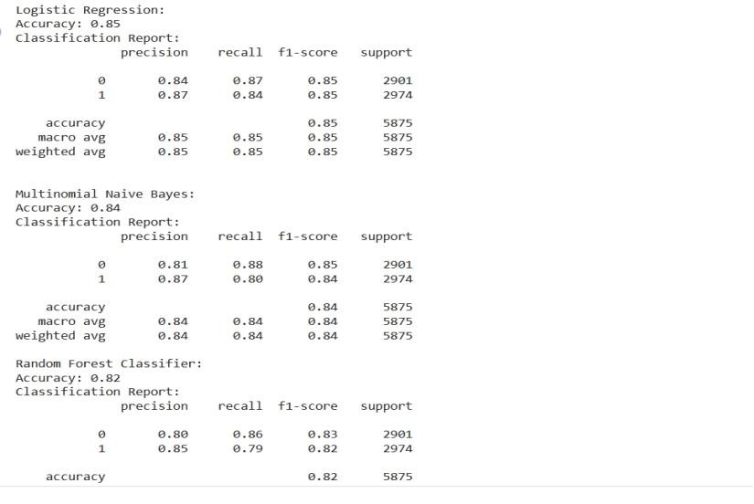

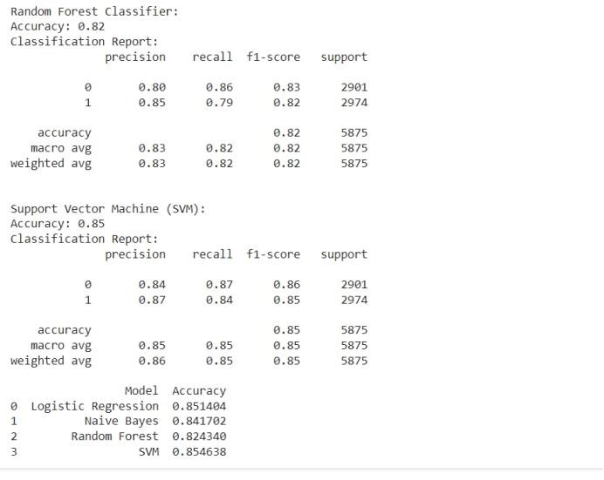

**Limitations:**

**Feature Engineering Dependency:** Traditional machine learning algorithms often rely heavily on handcrafted features, which can be time-consuming and labor-intensive to engineer. These features might not capture the full complexity of language, especially in the context of subjective reviews where subtle nuances play a significant role.

**Limited Contextual Understanding**: Many machine learning models, such as bag-of-words or TF-IDF representations, treat each word or phrase in isolation, ignoring the surrounding context. This lack of contextual understanding can lead to suboptimal performance, particularly in tasks where context plays a crucial role, such as sentiment analysis or understanding sarcasm.

**Semantic Ambiguity:** Language is inherently ambiguous, with words and phrases often having multiple meanings depending on the context. Traditional machine learning models may struggle to disambiguate such semantic nuances, leading to inaccuracies in interpretation.

Difficulty in Handling Long Sequences: Many machine learning models, particularly those based on recurrent neural networks (RNNs) or convolutional neural networks (CNNs), face challenges in processing long sequences of text efficiently. These models may suffer from vanishing gradients or memory constraints when dealing with extensive documents or reviews.

**Domain Adaptation Challenges:** Machine learning models trained on generic datasets may not perform well when applied to specific domains or tasks with unique characteristics. MOOC evaluations, for instance, involve analyzing reviews that contain domain-specific terminology and context.

**4.3 BERT as a cutting edge technique:**

**BERT, short for Bidirectional Encoder Representations from Transformers**, has emerged as a groundbreaking model in natural language processing (NLP) tasks, including sentiment analysis. Proposed by researchers at Google AI in 2018, BERT revolutionized the field by introducing a pre-trained language model capable of capturing bidirectional contextual information from text data.

At its core, BERT is based on the Transformer architecture, a neural network architecture introduced by Vaswani et al. in 2017. Transformers revolutionized NLP by enabling parallel processing of input tokens and capturing long-range dependencies in text data more effectively than previous models like recurrent neural networks (RNNs) or convolutional neural networks (CNNs). What sets BERT apart is its bidirectional approach to language understanding. Unlike previous models that process text in a unidirectional manner (e.g., from left to right or right to left), BERT is trained using a bidirectional strategy. This means that during pretraining, BERT considers both the left and right context of each word or token in a sentence, allowing it to capture the full contextual meaning of words based on their surrounding context. BERT achieves this bidirectional understanding through a technique known as masked language modeling (MLM). During pre-training, a certain percentage of words in the input text are randomly masked, and the model is trained to predict the masked words based on the context provided by the surrounding words. This encourages BERT to learn robust representations of words that can capture their meaning regardless of their position in the sentence.

In addition to MLM, BERT also employs a next sentence prediction (NSP) task during pretraining. In this task, the model is trained to predict whether two input sentences appear consecutively in the original text. This helps BERT learn relationships between sentences and understand discourse-level coherence, enabling it to perform tasks like text classification and question answering more effectively. One of the key strengths of BERT lies in its ability to be fine-tuned for a wide range of downstream NLP tasks with minimal task-specific modifications. By fine-tuning BERT on task-specific datasets, researchers and practitioners can leverage the rich contextual representations learned during pretraining to achieve state-ofthe-art performance on tasks such as sentiment analysis, named entity recognition, machine translation, and more.

Overall, BERT represents a significant advancement in NLP technology, offering unparalleled capabilities in capturing the rich contextual nuances of language. Its bidirectional approach, combined with the Transformer architecture and innovative pretraining objectives, has propelled BERT to the forefront of NLP research and applications, with widespread adoption across academia and industry alike.The key innovation of BERT lies in its ability to pre-train a large-scale neural network on vast amounts of text data. In sentiment analysis, BERT can be fine-tuned on specific labeled datasets to learn the nuances of sentiment expressed in text. Fine-tuning involves adjusting the parameters of the pre-trained BERT model using labeled data from the target sentiment analysis task. This process allows BERT to adapt its representations to the particularities of sentiment analysis, such as recognizing positive, negative, or neutral sentiment in text.

Moreover, BERT's deep architecture allows it to learn hierarchical representations of text, from individual words to entire sentences or documents. This hierarchical representation enables BERT to capture the varying degrees of sentiment intensity and the overall sentiment polarity of a piece of text accurately.

➢ BERT (Bidirectional Encoder Representations from Transformers) incorporates two key features: **Self-attention mechanism and Bidirectional encoding**, which contribute significantly to its effectiveness in understanding contextual information in text data.

**1. Self-Attention Mechanism:**

Self-attention mechanism is a fundamental component of transformer-based architectures, including BERT. It allows the model to weigh the importance of different words in a sentence when encoding the input sequence. Self-attention operates by calculating attention scores that represent the relevance of each word to every other word in the sequence. These attention scores are then used to compute a weighted sum of the input representations, producing contextualized embeddings for each word.

***Example:***

“The Animal didn’t cross the street because it was too tired”

What does “it” in this sentence refer to? Is it referring to the street or to the animal? It’s a simple question to a human, but not as simple to an algorithm.

When the model is processing the word “it”, self-attention allows it to associate “it” with “animal”.

**2. Bidirectional Encoding:**

BERT employs bidirectional encoding to capture contextual information from both leftto-right and right-to-left directions in the input text. Unlike traditional language models that process text sequentially in one direction, BERT processes the entire input sequence bidirectionally, allowing it to understand the context in which each word appears comprehensively.

**Example:**

"I saw the man with the telescope."

In this phrase, the word "with" indicates a relationship between "man" and "telescope," which influences the interpretation of the entire sentence. Bidirectional encoding in BERT enables the model to consider the context from both directions, capturing the relationship between "man" and "telescope" effectively.

These two features, self-attention mechanism and bidirectional encoding, enable BERT to generate rich and contextually informed representations of text data, which are essential for various natural language processing tasks, including sentiment analysis, named entity recognition, and machine translation.

In summary, while traditional machine learning methods have been widely used for text analysis tasks, they suffer from limitations such as reliance on handcrafted features, lack of contextual understanding, and difficulty in handling long sequences of text. BERT addresses these limitations by learning representations directly from raw text data, capturing contextual information, disambiguating semantic nuances, efficiently processing long sequences, and facilitating domain adaptation through pretraining and fine-tuning. These advantages make BERT a compelling choice for tasks like MOOC evaluation, where understanding the context of student reviews is essential for accurate assessment.

**CHAPTER-5**

# 5.SYSTEM DESIGN

The primary objective of our system is to leverage BERT, a state-of-the-art NLP model, to perform sentiment analysis on reviews from Massive Open Online Courses (MOOCs). By analyzing sentiment, we aim to provide insights into the opinions and experiences of learners, thereby aiding educational platforms in understanding user sentiments and improving course offerings.

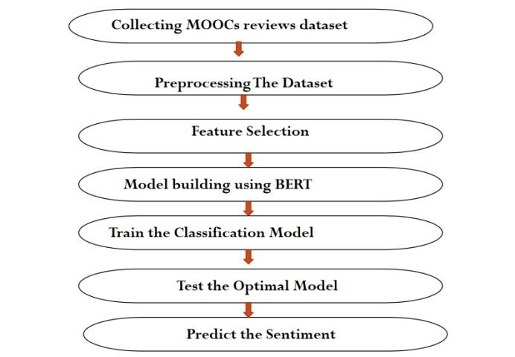

**Components**

**5.1 Data collection:**

Initially, we loaded the dataset using Pandas from a CSV file located in Google Drive. Then, we explored the dataset by checking its first few rows and its shape to get a sense of its structure and size. We inspected the distribution of the 'Label' column to understand the distribution of ratings across the dataset

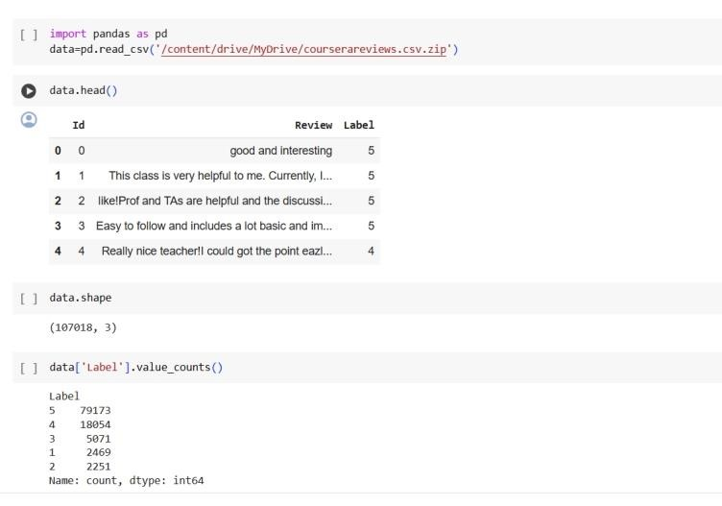

Since we wanted to simplify the analysis by converting the ratings into binary labels, we wrote a script to do just that. Ratings equal to or greater than 4 were labeled as 1 (indicating positive sentiment), while ratings below 4 were labeled as 0 (indicating negative sentiment).

We added a new column named 'Binary_Label' to the DataFrame to hold these binary labels.

**5.2 Data Balancing**:

As MOOC review datasets often suffer from class imbalance, balancing techniques are employed to ensure equal representation of positive and negative sentiments. This step enhances model performance and mitigates bias.

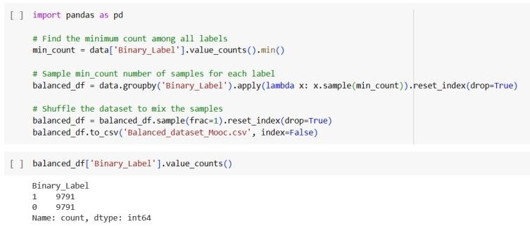

**5.3 Data Preprocessing**:

Preprocessing involves tasks such as text cleaning, tokenization, stop word removal, and lemmatization. This step ensures that the text data is in a suitable format for input into the BERT model. To streamline our analysis, we decided to drop the original 'Label' column since we no longer needed it after converting ratings to binary labels. Additionally, we removed the 'Id' column as it wasn't relevant to our analysis.

1. Lowercasing: It converts all text to lowercase to ensure consistency in the text data.
2. Removing Special Characters, Punctuation, and Numbers: Using regular expressions, it removes any special characters, punctuation marks, and numerical digits from the text, focusing only on alphabetic characters.
3. Tokenization: The text is tokenized using the word_tokenize function from the NLTK library, splitting it into individual words or tokens.
4. Removing Stopwords: Stop words, such as "the", "is", "and", etc., which do not contribute much to the meaning of the text, are removed from the tokenized text.
5. Lemmatization: Words are lemmatized using WordNet's lemmatizer to reduce them to their base or dictionary form, which helps in standardizing the text and reducing dimensionality.

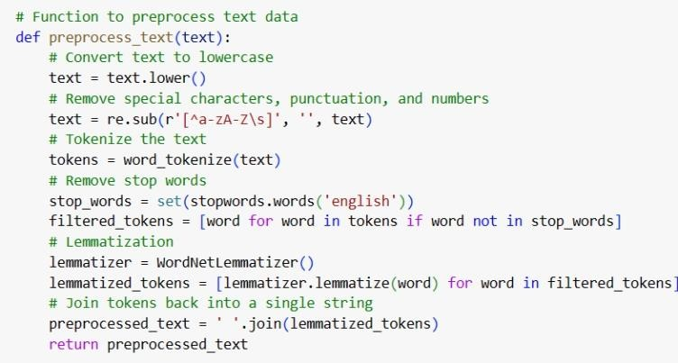

To streamline our analysis, we decided to drop the original 'Label' column since we no longer needed it after converting ratings to binary labels. Additionally, we removed the 'Id' column as it wasn't relevant to our analysis.

* 1. **Model Training and Evaluation:**

BERT model training involves fine-tuning the pre-trained BERT model on the MOOC review dataset. Evaluation metrics such as accuracy, precision, recall, and F1-score are used to assess model performance.

* 1. **Model Deployment**:

Once trained and evaluated, the BERT sentiment analysis model is deployed to production. This allows real-time analysis of incoming reviews on MOOC platforms.

**CHAPTER-6**

## 6.SYSTEM IMPLEMENTATION

For the proposed BERT model, we start by installing the Transformers library to leverage pre-trained BERT models and tools. A custom dataset class is defined to preprocess the text data and prepare it for input into the BERT model. The BERT model is fine-tuned on the preprocessed and balanced dataset for sentiment analysis. Data loaders are created for the train, validation, and test sets to efficiently feed data into the BERT model during training and evaluation. The model is trained over multiple epochs, with training loss and validation accuracy monitored at each epoch. Once trained, the model is evaluated on the test set to assess its performance.

**6.1 Integration with BERT Model**:

We integrated the `BertForSequenceClassification` model from the `transformers` library into our project code. This model is pre-trained on a large corpus and fine-tuned for sequence classification tasks, making it well-suited for sentiment analysis.

We trained the BERT model on our preprocessed MOOC dataset using a training loop. During training, we defined the optimizer (e.g., AdamW) and the loss function (e.g., CrossEntropyLoss) to optimize the model's parameters based on the computed gradients. To ensure the model's generalization ability, we validated its performance on a separate validation dataset. We monitored metrics such as accuracy and loss during validation to assess the model's performance and prevent overfitting. We fine-tuned the hyperparameters of the model, including the learning rate, batch size, and number of epochs, to optimize its performance on the MOOC sentiment analysis task. We experimented with different configurations to find the optimal settings. After training and validation, we evaluated the final model's performance on a held-out test dataset. We computed evaluation metrics such as accuracy, precision, recall, and F1-score to measure the model's effectiveness in classifying sentiment. We analyzed the model's predictions and explored misclassified instances to gain insights into its strengths and weaknesses. Visualizations such as confusion matrices and classification reports helped us understand the model's performance better. Through this process, we successfully built a sentiment analysis system using BERT that can provide valuable insights into student experiences and feedback on MOOC platforms.

For our project, "BERT for effective sentiment analysis on MOOCs," we leverage the power of BERT to accurately analyze the sentiment expressed in reviews from Massive Open Online Courses (MOOCs). By fine-tuning a pre-trained BERT model on our MOOC review dataset, we aim to extract nuanced sentiment signals from the text, enabling educational platforms to gain deeper insights into learner experiences and perceptions.

**6.2 Implementation Details:**

**Dataset Preparation:**

We preprocess the MOOC review dataset by cleaning the text, removing noise, and tokenizing the reviews. The dataset is then split into training, validation, and test sets to facilitate model training and evaluation.

**Custom Dataset Class:**

To seamlessly integrate the dataset with PyTorch, we create a custom dataset class named SentimentDataset. This class handles the encoding of text data using the BERT tokenizer and prepares it for input into the BERT model.

**Model Architecture:**

We utilize the BertForSequenceClassification model from the Hugging Face Transformers library. This model is specifically designed for text classification tasks and is pre-trained on large-scale corpora to capture rich semantic representations of text.

**Training Loop:**

The training loop involves iterating over batches of data from the training set, computing model predictions, calculating the loss, and updating the model parameters using backpropagation. We employ the AdamW optimizer and CrossEntropyLoss criterion for efficient training.

**Evaluation:**

After training, we evaluate the performance of the trained BERT model on the validation set to assess its ability to generalize to unseen data. We compute metrics such as accuracy to measure the model's effectiveness in sentiment classification.

**Deployment:**

Once trained and evaluated, the BERT model can be deployed to a production environment where it can analyze real-time MOOC reviews. This deployment enables educational platforms to leverage the power of BERT for continuous sentiment analysis and feedback aggregation.

**Results obtained for BERT as the proposed model**

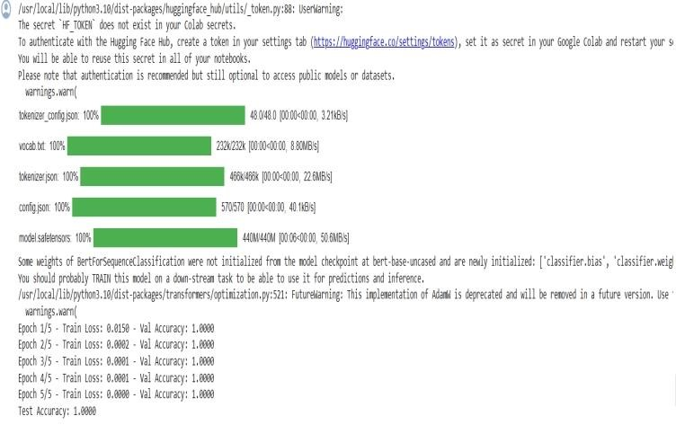

# CHAPTER-7

## 7. FUTURE WORK

While our project has made significant strides in leveraging BERT for sentiment analysis on MOOC reviews, there are several avenues for future exploration and enhancement. Future iterations of our project could focus on fine-tuning the BERT model on domain-specific data from different academic disciplines or specialized areas within online education. By training BERT on domain-specific vocabulary and contexts, we can improve the model's understanding of subject-specific nuances and enhance the accuracy of sentiment analysis for specialized courses or topics. Integrating multimodal data sources, such as text, images, and videos, presents an exciting opportunity to enrich sentiment analysis on MOOC platforms. Future work could explore techniques for combining textual reviews with visual and auditory cues, allowing for more comprehensive and context-aware sentiment analysis. This approach could provide deeper insights into learner emotions and preferences, ultimately leading to more personalized learning experiences. Incorporating mechanisms for user feedback and interaction could further enhance the effectiveness of our sentiment analysis system. Future work could explore methods for soliciting user feedback on sentiment analysis results, allowing learners to provide additional context or corrections to the model's predictions. By integrating user feedback loops, educational platforms can continuously improve the accuracy and relevance of sentiment analysis insights. While BERT delivers state-of-the-art performance in sentiment analysis, its predictions may lack interpretability, making it challenging to understand the reasoning behind the model's decisions. Future work could focus on developing techniques for interpreting BERT's predictions, such as attention visualization or saliency mapping. By providing insights into the key features driving the model's sentiment predictions, we can enhance trust and transparency in the sentiment analysis process.As MOOC platforms continue to grow in scale and complexity, ensuring the scalability and efficiency of sentiment analysis systems becomes paramount. Future work could explore techniques for optimizing model inference speed and resource utilization, allowing sentiment analysis to be performed efficiently on large volumes of data in real-time. Additionally, deploying sentiment analysis models on distributed computing frameworks or cloud-based infrastructure could further improve scalability and reliability.

Expanding our sentiment analysis capabilities to support multiple languages opens up opportunities for analyzing learner sentiments in diverse linguistic contexts. Future work could investigate techniques for adapting BERT to perform cross-lingual sentiment analysis, enabling educational platforms to cater to a global audience of learners effectively. By supporting multiple languages, we can ensure that sentiment analysis insights are accessible and relevant to learners worldwide.

## CHAPTER-8

**8. CONCLUSION**

In conclusion, our project on leveraging BERT for effective sentiment analysis on Massive Open Online Courses (MOOCs) has demonstrated the potential of advanced natural language processing techniques in understanding learner sentiments and enhancing educational platforms. Through meticulous system design and architecture, coupled with the utilization of state-of-the-art NLP models like BERT, we have addressed significant challenges in analyzing and interpreting the vast amount of textual data generated by MOOC users.

One of the key findings of our project is the importance of data preprocessing and balancing techniques in ensuring the reliability and accuracy of sentiment analysis models. By meticulously cleaning and normalizing the raw text data and addressing class imbalances through sampling methods, we have improved the robustness of our sentiment analysis system, enabling it to provide more accurate insights into learner sentiments.

Moreover, our exploration into different machine learning and deep learning algorithms, including Logistic Regression, Naive Bayes, Random Forest, and Support Vector Machine, alongside BERT, has provided valuable insights into the comparative performance and suitability of these models for sentiment analysis on MOOC reviews. While traditional machine learning algorithms exhibit respectable performance, the superiority of BERT, a transformer-based model, underscores the importance of leveraging deep learning techniques for complex NLP tasks.

The deployment of the BERT model in a real-world setting highlights the practical applicability and scalability of our sentiment analysis solution. By deploying the model to production environments, educational platforms can gain real-time insights into learner sentiments, enabling them to tailor course offerings, improve user experiences, and foster a more engaging learning environment. Furthermore, our project underscores the ongoing importance of monitoring and maintenance in ensuring the longevity and effectiveness of sentiment analysis systems. Continuous monitoring of model performance, periodic retraining, and adaptation to evolving data patterns and user behaviors are essential to ensure the relevance and accuracy of sentiment analysis insights over time. Looking ahead, future iterations of our project could explore additional enhancements, such as fine-tuning BERT on domain-specific data or incorporating multimodal data sources (e.g., text, images, videos) for more comprehensive sentiment analysis. Additionally, integrating user feedback mechanisms and interpretability tools could further enhance the usability and interpretability of sentiment analysis results, empowering educational platforms to make data-driven decisions that positively impact learners' experiences. In essence, our project represents a significant step forward in leveraging advanced NLP techniques to gain deeper insights into learner sentiments on MOOC platforms. By combining cutting-edge technology with robust system design principles, we have laid the groundwork for future advancements in educational data analytics and personalized learning experiences.

**CHAPTER- 9**

### 9.BIBILOGRAPHY

1. Fatemeh Hemmatian et.al, A survey on classification techniques for opinion mining and sentiment analysis, Springer, December 2017.

2.Pedro Manuel Moreno-Marcos, Sentiment Analysis in MOOCs: A case study, IEEE Global Engineering Education Conference (EDÚCON), Spain, 2018.

3.Aytuğ ONAN, Sentiment analysis on massive open online course evaluations: A text mining and deep learning approach, 2020 Wiley Periodicals.

4. Yi Gaoa, A parallel neural network structure for sentiment classification of MOOCs discussion forums, Journal of Intelligent & Fuzzy Systems 2020

5.Ruth Cobos, A Content Analysis System That Supports Sentiment Analysis for

Subjectivity and Polarity Detection in Online Courses, IEEE revista iberoamericana de tecnologies del aprendizaje, VOL. 14, NO. 4, NOVEMBER 2019.

6.Omaima Almatrafi, Needle in a haystack: Identifying learner posts that require urgent response in MOOC discussion forums, Elsevier, 2017.

1. SHOU XI GUO, Attention-Based Character-Word Hybrid Neural Networks With Semantic and Structural Information for Identifying of Urgent Posts in MOOC Discussion Forums, IEEE Access, volume 7,2019.
2. Fatima Harrak, Automatic Identification of Questions in MOOC Forums and Association with Self-Regulated Learning, HAL, 2019.