CHAPTER FOUR
RESULTS AND DISCUSSION
Note for the group. This chapter combines the questionnaire results, supplied by the client team, with the technical evaluation of the system and the simulation. The comparison with manual entry was run on a small scale and is reported as indicative. The speed criterion is reported as Scheduled. Delete this note before submission.

4.1 Introduction
This chapter reports the evaluation of Verity, the intelligent order processing system developed in this project. It has two parts that are brought together in Section 4.6. Section 4.2 reports the questionnaire given to staff of logistics and distribution businesses and to business customers, before and after a demonstration of Verity. Sections 4.3 to 4.5 report the technical evaluation, namely the implemented system with its testing, and a controlled simulation in which orders with known planted errors were submitted to the live validation engine.
The comparison with manual order entry was run on a small scale, with two participants and 40 orders, and its results are reported as indicative. The time a person spends entering an order in Verity was not measured, so the speed criterion is given the status Scheduled. All other figures in this chapter come from files and database queries produced during the evaluation, and each is listed with its source in the traceability table that accompanies the chapter.

4.2 Questionnaire results

4.2.1 Responses and respondents
The questionnaire was administered by the client team between 17 and 26 October 2026 to staff of logistics and distribution businesses and to business customers who place orders with them. Respondents answered Part I before watching the same demonstration of Verity lasting six to eight minutes, and Part II after it. Table 4.1 summarises the responses. Every one of the 200 respondents gave consent and confirmed having watched the demonstration. Every respondent also answered all ten usability items, so all 200 responses are valid. This reaches the upper end of the range of 100 to 200 respondents set in Section 1.5. The optional name and e-mail fields were removed before the analysis, so no result can be linked to a person.
Table 4.1: Questionnaire responses and validity
Measure | Staff | Customers | All
Responses received | 120 | 80 | 200
Consent given | 120 | 80 | 200
Demonstration watched | 120 | 80 | 200
All ten usability items answered | 120 | 80 | 200
Valid responses | 120 | 80 | 200
Share of valid responses | 60.0 percent | 40.0 percent | 100 percent
Source: questionnaire dataset supplied by the client team, collected 17 to 26 October 2026, analysed with 06_questionnaire/analyze_dataset.py.
Table 4.2 profiles the respondents. They came from businesses of every size in the questionnaire, from fewer than ten staff to 250 or more, and from several types of business. The largest single role was Other with 49 respondents, which limits what can be said about particular job roles. Of all respondents, 45, or 22.5 percent, said that their business operates mainly outside Nigeria. The questionnaire did not screen them out, so they are kept in the analysis.
Table 4.2: Profile of the respondents
Question | Answer | Staff | Customers | All, n (%)
Main role | Other | 15 | 34 | 49 (24.5)
Main role | Purchasing | 22 | 20 | 42 (21.0)
Main role | Management | 8 | 26 | 34 (17.0)
Main role | Warehouse | 22 | 0 | 22 (11.0)
Main role | Dispatch or delivery | 19 | 0 | 19 (9.5)
Main role | Finance or accounts | 19 | 0 | 19 (9.5)
Main role | Order or sales desk | 15 | 0 | 15 (7.5)
Years in this kind of work | 1 to 3 | 45 | 21 | 66 (33.0)
Years in this kind of work | Over 7 | 27 | 25 | 52 (26.0)
Years in this kind of work | 4 to 7 | 22 | 19 | 41 (20.5)
Years in this kind of work | Under 1 | 26 | 15 | 41 (20.5)
Type of business | Other | 23 | 24 | 47 (23.5)
Type of business | Wholesale or distribution | 32 | 15 | 47 (23.5)
Type of business | Freight or haulage | 25 | 13 | 38 (19.0)
Type of business | Building materials or construction supply | 18 | 19 | 37 (18.5)
Type of business | Manufacturing | 22 | 9 | 31 (15.5)
Staff in the business | Under 10 | 33 | 28 | 61 (30.5)
Staff in the business | 10 to 49 | 37 | 20 | 57 (28.5)
Staff in the business | 50 to 249 | 22 | 21 | 43 (21.5)
Staff in the business | 250 or more | 28 | 11 | 39 (19.5)
Orders on a typical day | Under 20 | 38 | 22 | 60 (30.0)
Orders on a typical day | 51 to 100 | 26 | 25 | 51 (25.5)
Orders on a typical day | 20 to 50 | 27 | 20 | 47 (23.5)
Orders on a typical day | Over 100 | 29 | 13 | 42 (21.0)
Main operating location | Outside Nigeria | 31 | 14 | 45 (22.5)
Main operating location | Another Nigerian state | 27 | 16 | 43 (21.5)
Main operating location | Ibadan | 20 | 22 | 42 (21.0)
Main operating location | Abuja | 23 | 16 | 39 (19.5)
Main operating location | Lagos | 19 | 12 | 31 (15.5)
Source: questionnaire dataset supplied by the client team, collected 17 to 26 October 2026, analysed with 06_questionnaire/analyze_dataset.py.

4.2.2 How orders are handled now
Table 4.3 describes how orders are handled now. Phone calls were the channel used most widely, by 109 respondents, and an online portal was already used by 104. Orders were retyped by hand or copied and pasted into the records by 101 respondents, 50.5 percent. The usual check was a reread by the person who typed the order, reported by 118 respondents, while 87 reported an automatic check. Only 47 respondents had a complete record of who changed or approved an order, and 148, 74.0 percent, said that stock shortages were usually found only after the order had been confirmed.
The question on the main channel needs care. Only 82 of the 200 respondents named as their main channel one that they had also ticked among the channels they use. The table therefore reports the main channel for those 82 consistent answers only.
Table 4.3: Current order handling
Question | Answer | Respondents, n (%)
Channels used, select all | Phone call | 109 (54.5)
Channels used, select all | Online portal | 104 (52.0)
Channels used, select all | WhatsApp | 83 (41.5)
Channels used, select all | Spreadsheet | 80 (40.0)
Channels used, select all | E-mail | 79 (39.5)
Channels used, select all | Paper form | 77 (38.5)
Main channel, consistent answers only | Online portal | 19 (23.2)
Main channel, consistent answers only | Phone call | 19 (23.2)
Main channel, consistent answers only | Spreadsheet | 16 (19.5)
Main channel, consistent answers only | WhatsApp | 14 (17.1)
Main channel, consistent answers only | Paper form | 7 (8.5)
Main channel, consistent answers only | E-mail | 7 (8.5)
How the order enters the records | Entered directly by the customer | 55 (27.5)
How the order enters the records | Retyped by hand | 54 (27.0)
How the order enters the records | Copied and pasted | 47 (23.5)
How the order enters the records | Imported automatically | 44 (22.0)
Checks before processing, select all | The person who typed it rereads it | 118 (59.0)
Checks before processing, select all | A colleague checks it | 109 (54.5)
Checks before processing, select all | Other | 89 (44.5)
Checks before processing, select all | The system checks it automatically | 87 (43.5)
Checks before processing, select all | No check | 10 (5.0)
Customers can see stock before ordering | Not sure | 56 (28.0)
Customers can see stock before ordering | Always | 52 (26.0)
Customers can see stock before ordering | Sometimes | 51 (25.5)
Customers can see stock before ordering | Never | 41 (20.5)
Record of who changed or approved an order | No record | 55 (27.5)
Record of who changed or approved an order | A partial record | 55 (27.5)
Record of who changed or approved an order | A complete record | 47 (23.5)
Record of who changed or approved an order | Not sure | 43 (21.5)
When stock shortages are found | At picking | 54 (27.0)
When stock shortages are found | Before the order is confirmed | 52 (26.0)
When stock shortages are found | At dispatch | 49 (24.5)
When stock shortages are found | After delivery | 45 (22.5)
Source: questionnaire dataset supplied by the client team, collected 17 to 26 October 2026, analysed with 06_questionnaire/analyze_dataset.py.

4.2.3 Effects of order errors
The answers to section C, on how often errors occur, how many orders they affect, which types respondents had met, where they are found and how long they take to correct, were supplied as numeric codes. The codes cannot be matched to the options of the questionnaire with certainty, and the select-all question on error types holds a single number for each respondent, so section C is not reported. Table 4.4 gives the answers to section D on the effects of errors.
Between 39.0 and 42.5 percent of respondents agreed that order errors in their business cause each of the six effects, and every mean lay close to the midpoint of the scale. No effect was agreed by a majority. The respondents therefore did not report a clear view that order errors are a serious problem in their business.
Table 4.4: Effects of order errors, all respondents
Item | Order errors in my business... | Mean | SD | Agree % | 95% CI
D1 | Order errors cause delivery delays | 3.12 | 1.22 | 39.0 | 32.5 to 45.9
D2 | Order errors add cost | 3.19 | 1.29 | 40.5 | 33.9 to 47.4
D3 | Order errors lead to customer complaints | 3.03 | 1.36 | 39.5 | 33.0 to 46.4
D4 | Order errors make stock records wrong | 3.12 | 1.32 | 42.5 | 35.9 to 49.4
D5 | Order errors take a lot of time to rework | 3.06 | 1.26 | 40.0 | 33.5 to 46.9
D6 | Order errors lead to payment disputes | 3.08 | 1.29 | 39.0 | 32.5 to 45.9
Source: questionnaire dataset supplied by the client team, collected 17 to 26 October 2026, analysed with 06_questionnaire/analyze_dataset.py. Agree means 4 or 5 on the five-point scale.

4.2.4 Importance of the checks
Section E asked how important each check of an order system is. Table 4.5 sets each check beside the part of Verity that provides it, and Figure 4.1 shows the share rating each check as important. Between 33.5 and 40.0 percent rated each check 4 or 5, and no check reached half. Respondents did not single out any check as more important than the others, so the ratings neither support nor contradict the set of checks built into Verity.
Table 4.5: Importance of the checks and the part of Verity that provides each
Item | Check | Provided in Verity by | Mean | Important % | 95% CI
E1 | Product code checked against the catalogue | SKU | 3.06 | 40.0 | 33.5 to 46.9
E2 | Quantity within allowed limits | Quantity limits | 2.94 | 37.0 | 30.6 to 43.9
E3 | Customer account checked, for example approved and not on hold | Customer status | 2.96 | 36.5 | 30.1 to 43.4
E4 | Price checked against the price list | Pricing | 2.92 | 33.5 | 27.3 to 40.3
E5 | Warning for a duplicate order | Duplicate order | 2.91 | 35.5 | 29.2 to 42.3
E6 | Stock checked when the order is placed | Stock availability | 2.94 | 36.5 | 30.1 to 43.4
E7 | Required fields cannot be left empty | Mandatory fields | 3.03 | 37.5 | 31.1 to 44.4
E8 | Delivery date and address checked | Delivery date and address | 2.95 | 33.5 | 27.3 to 40.3
E9 | Warning when a quantity is far above the customer's usual | Unusual quantity | 3.02 | 39.0 | 32.5 to 45.9
E10 | Order status visible in real time | Status timeline | 3.02 | 38.0 | 31.6 to 44.9
E11 | Payment proof checked before goods are released | Payment verification by Finance | 2.94 | 36.0 | 29.7 to 42.9
E12 | Delivery confirmed by a code that only the customer sees | Delivery code | 2.94 | 36.0 | 29.7 to 42.9
Source: questionnaire dataset supplied by the client team, collected 17 to 26 October 2026, analysed with 06_questionnaire/analyze_dataset.py. Important means 4 or 5 on the five-point scale.
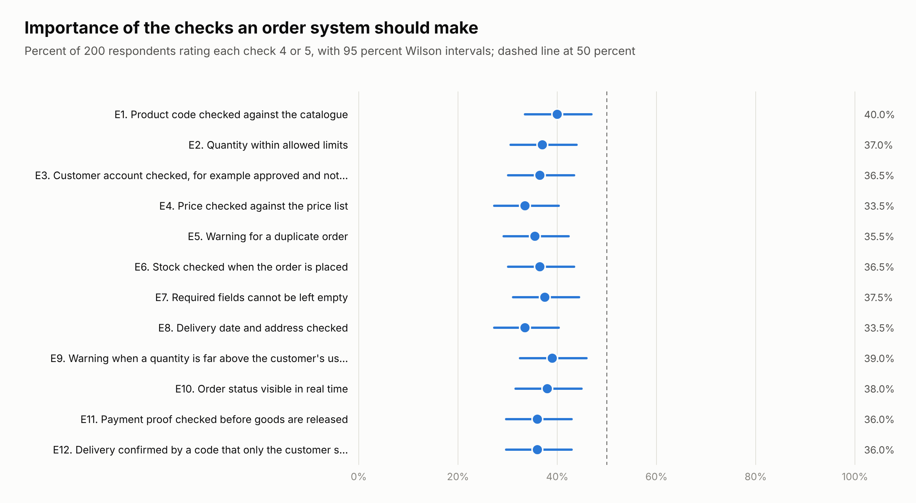
Figure 4.1: Share of respondents rating each check as important, with 95 percent Wilson intervals
Source: 06_questionnaire/figures/figQ3_checks_data.csv, from the questionnaire dataset.

4.2.5 Reliability of the scales
Table 4.6 gives Cronbach's alpha for each multi-item scale (Cronbach, 1951). The System Usability Scale reached 0.928 and the scales for usefulness and ease of use reached 0.704 and 0.725, which is adequate for reporting them as scales. The two facilitating-conditions items, on having a device and having internet access, gave an alpha of -0.275. They do not form a scale and are reported as separate items.
Table 4.6: Reliability of the multi-item scales
Scale | Items | Cronbach's alpha
System Usability Scale | S1 to S10, even items recoded | 0.928
Perceived usefulness | PU1 to PU3 | 0.704
Perceived ease of use | PEU1 to PEU3 | 0.725
Facilitating conditions | FC1 and FC2 | -0.275
Effects of order errors | D1 to D6 | 0.833
Importance of checks | E1 to E12 | 0.865
Source: questionnaire dataset supplied by the client team, collected 17 to 26 October 2026, analysed with 06_questionnaire/analyze_dataset.py.

4.2.6 Usability
Table 4.7 gives the System Usability Scale scores, calculated as Brooke (1996) describes. The mean for all respondents was 48.86, with a 95 percent interval of 45.35 to 52.38. This is significantly below the benchmark of 68 recommended by Sauro and Lewis (2016), with t = -10.74 on 199 degrees of freedom and p below 0.001. Staff gave a mean of 49.50 and customers 47.91, and the difference between them was not significant, with a Welch t of 0.44 and p = 0.66. Only 45 of the 200 respondents, 22.5 percent, scored Verity above 68.
On the adjective scale of Bangor et al. (2009) the mean corresponds to Poor, and on the acceptability ranges of Bangor et al. (2008) it falls in the range Not acceptable, although the upper end of the interval reaches the Marginal range. On the curved grading scale of Sauro and Lewis (2016) it receives the grade F. The scores were widely spread, with a standard deviation of 25.21, and Figure 4.2 shows that respondents in both groups gave scores across the whole range.
Table 4.7: System Usability Scale scores against the benchmark of 68
Statistic | Staff | Customers | All
n | 120 | 80 | 200
Mean | 49.50 | 47.91 | 48.86
SD, sample | 25.37 | 25.09 | 25.21
95% CI | 44.91 to 54.09 | 42.32 to 53.49 | 45.35 to 52.38
t against 68 | -7.99 | -7.16 | -10.74
p, two-sided | below 0.001 | below 0.001 | below 0.001
Scored above 68 | 28 of 120 | 17 of 80 | 45 of 200
Adjective, Bangor et al. (2009) | Poor | Poor | Poor
Acceptability, Bangor et al. (2008) | Not acceptable | Not acceptable | Not acceptable
Grade, Sauro and Lewis (2016) | F | F | F
Source: questionnaire dataset supplied by the client team, collected 17 to 26 October 2026, analysed with 06_questionnaire/analyze_dataset.py.
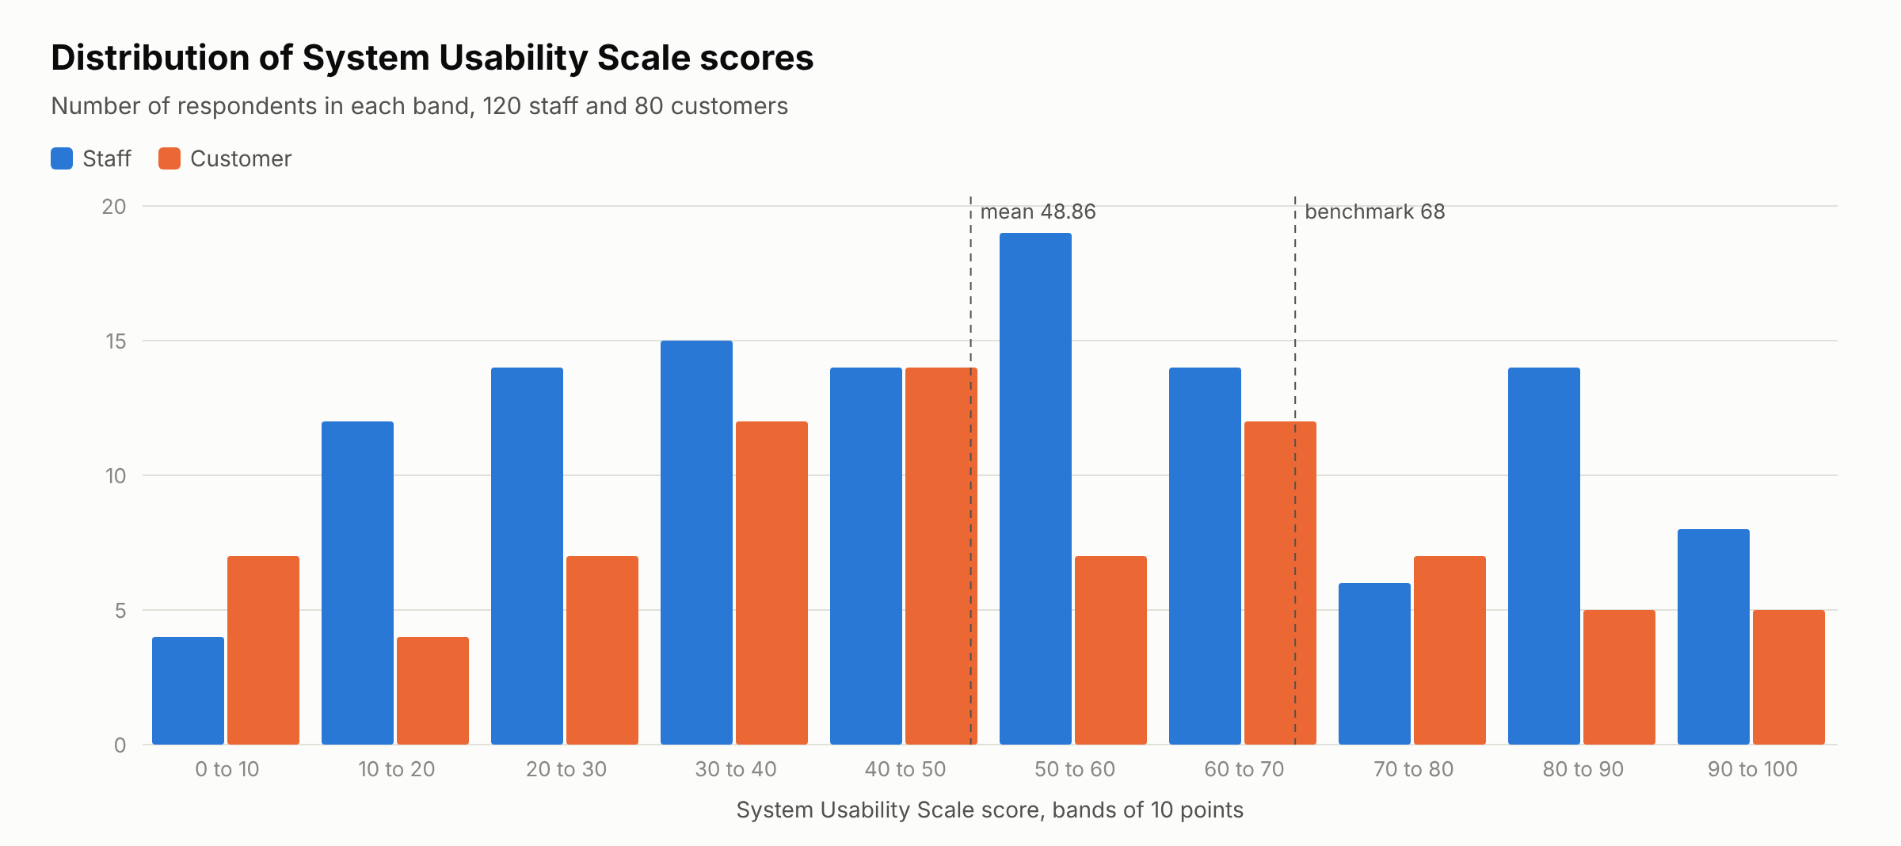
Figure 4.2: Distribution of System Usability Scale scores by respondent group
Source: 06_questionnaire/figures/figQ1_sus_data.csv, from the questionnaire dataset.

4.2.7 Usefulness, ease of use and intention
Table 4.8 and Figure 4.3 give the answers on usefulness, ease of use, intention and the conditions for use. No item was agreed by a majority. Agreement that Verity would reduce errors in orders was 35.0 percent, and agreement that respondents would use Verity if it were available was 38.5 percent. The item agreed most often was having the phone or computer needed to use Verity, at 47.5 percent. Asked in Part I whether business customers would be willing to enter their own orders online, 53 of the 200 respondents answered Yes, 26.5 percent, with a 95 percent interval of 20.9 to 33.0 percent.
Intention to use was related more closely to perceived usefulness than to ease of use. The correlation of the intention item with the mean of the usefulness items was 0.41, p below 0.001, while its correlation with the mean of the ease-of-use items was 0.15, p = 0.035. Its correlation with the usability score was also weak, at 0.17, p = 0.013. This matches the finding of Davis (1989), reviewed in Section 2.4.1, that usefulness is the stronger influence on acceptance. Only 33.5 percent agreed that using Verity would be their own choice, which suggests that many respondents expect use to be required by an employer or supplier. Venkatesh et al. (2003) treat voluntariness as a moderator of the effect of social influence on intention, which they found to be stronger where use is mandatory.
Table 4.8: Usefulness, ease of use, intention and conditions for use
Item | Statement | Staff mean | Customer mean | All mean | Agree % | 95% CI
PU1 | Using Verity would reduce errors in orders. | 2.97 | 2.85 | 2.92 | 35.0 | 28.7 to 41.8
PU2 | Verity would reduce the time spent correcting orders. | 3.0 | 2.94 | 2.98 | 36.0 | 29.7 to 42.9
PU3 | Verity would be useful in my work or in my dealings with suppliers. | 2.86 | 2.7 | 2.79 | 32.0 | 25.9 to 38.8
PEU1 | Learning to use Verity would be easy for me. | 2.85 | 2.89 | 2.87 | 30.0 | 24.1 to 36.7
PEU2 | Ordering through Verity would be at least as easy as sending an order by e-mail or WhatsApp. | 2.9 | 2.99 | 2.94 | 34.0 | 27.8 to 40.8
PEU3 | It would be easy for me to get Verity to do what I want. | 2.98 | 2.92 | 2.96 | 31.0 | 25.0 to 37.7
BI1 | I would use Verity if it were available to me. | 3.09 | 2.85 | 3.0 | 38.5 | 32.0 to 45.4
FC1 | I have the phone or computer I would need to use Verity. | 3.23 | 3.42 | 3.31 | 47.5 | 40.7 to 54.4
FC2 | I have the internet access I would need to use Verity reliably. | 3.03 | 3.15 | 3.08 | 40.5 | 33.9 to 47.4
VOL1 | Using Verity would be my own choice and not something my employer or main supplier requires. | 2.84 | 2.9 | 2.87 | 33.5 | 27.3 to 40.3
Source: questionnaire dataset supplied by the client team, collected 17 to 26 October 2026, analysed with 06_questionnaire/analyze_dataset.py. Agree means 4 or 5 on the five-point scale.
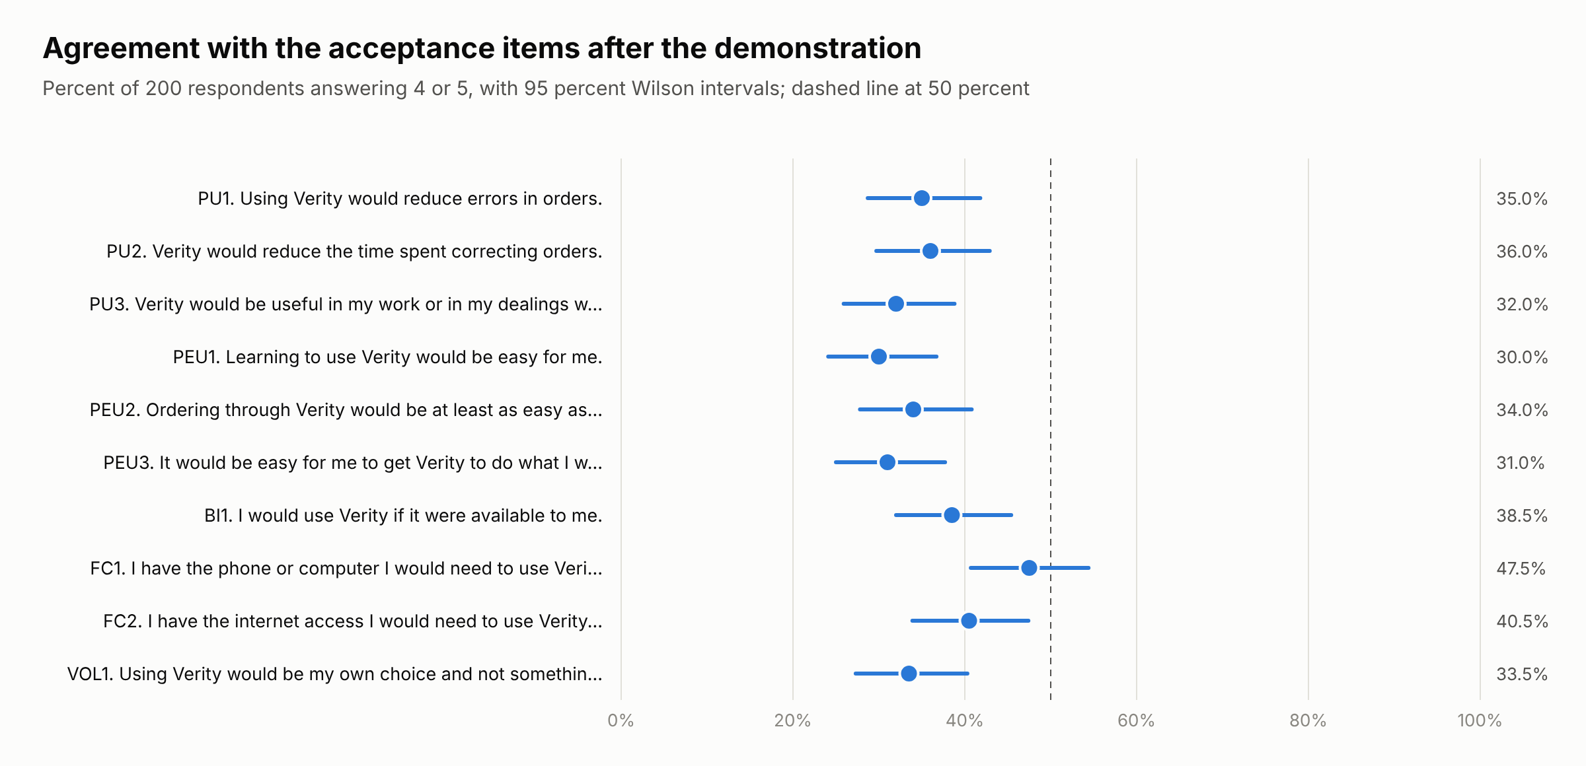
Figure 4.3: Agreement with the acceptance items, with 95 percent Wilson intervals
Source: 06_questionnaire/figures/figQ2_acceptance_data.csv, from the questionnaire dataset.

4.2.8 Open answers
Table 4.9 and Table 4.10 list the answers given most often to the two open questions. The problem named most often was the answer that mobile access and low data use are important, given by 26 respondents, followed by the answer that corrections take time when the original order cannot be traced, given by 24. The features requested most often were to keep a history of changes and approvals, by 29 respondents, and to allow users to see correction history, by 27. Both are already part of Verity through its audit trail and status history, which suggests that the demonstration did not make them visible.
Table 4.9: Biggest order-handling problem, most frequent answers
Answer | Respondents
Mobile access and low data use are important | 26
Corrections take time when the original order cannot be traced | 24
Delivery dates can be unclear when an order changes | 23
Price and product codes need to be checked manually | 21
Staff need a simple way to track order status | 20
Order details sometimes have to be retyped between channels | 19
Duplicate orders can be difficult to identify | 18
Customers need clearer confirmation after submitting an order | 18
Source: questionnaire dataset supplied by the client team, collected 17 to 26 October 2026, analysed with 06_questionnaire/analyze_dataset.py.
Table 4.10: Additional features requested, most frequent answers
Answer | Respondents
Keep a history of changes and approvals | 29
Allow users to see correction history | 27
Include duplicate-order alerts | 22
Make delivery details mandatory where needed | 21
Add live stock visibility and low-stock warnings | 20
Keep the interface simple for occasional users | 20
Send confirmation when an order is received | 19
Make the form work well on mobile devices | 17
Source: questionnaire dataset supplied by the client team, collected 17 to 26 October 2026, analysed with 06_questionnaire/analyze_dataset.py.

4.3 Implemented system and testing

4.3.1 System components and order lifecycle
Verity is a web application with a React interface hosted on Vercel and a Supabase back end built on PostgreSQL 17. All business rules run inside the database as functions, and row-level security decides which records each signed-in user can read. Table 4.11 summarises the components that were built.
Table 4.11: Components of the implemented system
Component | What it does
Customer portal | Registration, order entry from the catalogue or from an uploaded Excel or CSV sheet, order status, payment proof upload, delivery code
Ops Desk | Approval queue with validation results, customer screening, cancellations and delivery overrides
Finance | Payment proof verification, invoices, refunds and credit notes
Warehouse | Picking, shortage handling, stock levels and new products held hidden until priced
Dispatch and driver | Driver and vehicle assignment, delivery log with CSV download, delivery confirmation by customer code
Administrator | Users and roles, prices, regions and settings such as automatic approval
Database | 17 order statuses, 36 permitted transitions, 9 validation rules, status history and audit log
Source: Verity source code and database, docs/chapter4_final/01_system_facts.
Every order follows a lifecycle built from 17 statuses, shown in Table 4.12. The database accepts only the 36 transitions listed in its transition table, so an order cannot skip a step such as payment verification, and each change is written to the status history with the time and the user who made it.
Table 4.12: Order lifecycle statuses in order
No. | Status | Meaning
1 | draft | Customer is filling the form
2 | submitted | Sent; validation runs instantly
3 | validation_failed | A blocking rule failed; customer fixes and resubmits
4 | pending_approval | Passed validation (may carry warnings); waits for Ops Desk
5 | rejected | Ops Desk refused, with reason
6 | awaiting_payment | Stock reserved, invoice issued, payment window running
7 | payment_verification | Proof uploaded; Finance checking
8 | payment_rejected | Proof not accepted; customer may re-upload
9 | paid | Payment confirmed; released to warehouse
10 | picking | Warehouse collecting items
11 | shortage_hold | Less stock found than ordered; customer chooses
12 | packed | Packed; delivery code generated
13 | assigned | Driver and vehicle assigned
14 | out_for_delivery | Driver confirmed pickup
15 | delivery_failed | Attempt failed; Dispatch reschedules
16 | delivered | Correct delivery code entered (or logged Ops override)
17 | cancelled | Cancelled by customer, Ops Desk or expired payment window
Source: order_status type and order_transitions table, 01_system_facts/order_statuses.csv and state_machine_transitions.csv.

4.3.2 Validation rules
Validation is carried out by nine rules that run every time a customer submits an order. Seven of them block the order until the customer corrects it and two raise a warning that sends the order to a person for review. Table 4.13 maps the nine rules to the seven checks set out in Table 2.1. The customer-details check is served by two rules, one for the account status and one for the delivery address, and the unusual-quantity rule is an addition that no check in Table 2.1 requires.
Table 4.13: Validation rules mapped to the seven checks of Table 2.1
Rule | What it checks | Severity | Check in Table 2.1 | Data quality dimension in Table 2.1
Mandatory fields | Items, delivery address and delivery date present | Blocking | Mandatory fields | Completeness
SKU / product active | Every line is a catalogue product that is active; unmatched upload lines also reported here | Blocking | SKU | Accuracy
Quantity limits | Whole number within product minimum and maximum | Blocking | Quantity | Accuracy
Stock availability | Quantity not above on hand minus reserved | Blocking | Stock | Currency
Customer status | Customer account is active | Blocking | Customer details | Completeness
Pricing | Line price equals current price list within tolerance 0.01 | Blocking | Pricing | Accuracy and consistency
Delivery date and address | Date not in past; address is customer's own, active, in an allowed region | Blocking | Customer details | Completeness
Duplicate order | Same items and quantities from same customer within 24 hours | Warning | Duplicate orders | Uniqueness
Unusual quantity | Quantity above 3 x customer's average for the product (needs at least 3 earlier orders) | Warning | None, an additional check | None
Source: _validate function, 01_system_facts/validation_rules_and_run4_coverage.csv.

4.3.3 Functional testing
Functional testing exercised the order lifecycle end to end against the live database while acting as each role. Every test ran inside a transaction that was rolled back, so no test data remained. The fourteen cases of the earlier test run were repeated and twelve new cases were added for inactive customers, stale prices, automatic approval, CSV import and export, and webhooks. Table 4.14 lists all 26 cases. Of these, 23 passed and 3 failed.
Table 4.14: Functional test cases
No. | Test case | Expected result | Actual result | Result
1 | Customer submits a valid prepaid order, 20 bags of cement and 10 iron rods, automatic approval on | Auto-approved, stock reserved, invoice issued | Status awaiting_payment, 20 bags reserved, total ₦286,487.50 | Pass
2 | Customer resubmits the same items within 24 hours | Duplicate warning, customer must confirm | Held as draft with needs_confirmation true, after confirming sent to pending_approval with outcome warn | Pass
3 | Order with no address, past date, quantity below minimum, quantity above stock, fractional quantity and unknown SKU | All problems reported together, order blocked | Six fail results in one response, status validation_failed | Pass
4 | Customer uploads payment reference | Order moves to payment verification | Status payment_verification | Pass
5 | Finance confirms payment | Order paid and released to warehouse | Status paid | Pass
6 | Warehouse finds 6 of 10 rods | Shortage hold, customer asked to choose | record_pick returned shortage_hold | Pass
7 | Customer accepts partial delivery | Order packed, refund raised for missing items plus tax | Status packed, refund ₦30,960, delivery code visible to customer (1 reveal row) | Pass
8 | Dispatch assigns a driver and the driver confirms pickup | Assigned then out for delivery | Status assigned, timeline shows out_for_delivery | Pass
9 | Driver enters a wrong delivery code | Rejected, attempts reduced | ok false, "Wrong code. Ask the customer to check it.", attempts_left 4 | Pass
10 | Driver enters the correct code | Order delivered | ok true, status delivered | Pass
11 | Finance pays the refund | Credit note issued | Credit note CN-9002 recorded (number advanced from CN-9001 in the first run because sequences are not rolled back) | Pass
12 | Driver attempts to approve an order | Refused | "You do not have permission to do this." | Pass
13 | Warehouse adds a new product, then it is activated with no price | Saved hidden from customers, activation refused | Saved inactive at ₦0 with 40 on hand, 1 Admin notification, activation refused by check constraint products_active_needs_price | Pass
14 | Dispatch attempts to add a product | Refused | "You do not have permission to do this." | Pass
15a | Customer account awaiting review tries to save an order | Blocked | save_draft refused, "Your account is not active, so you cannot place orders." | Pass
15b | Customer account on hold tries to save an order | Blocked | save_draft refused, same message | Pass
15c | Customer account blocked tries to save an order | Blocked | save_draft refused, same message | Pass
15d | Draft saved while active, account put on hold, then submitted | Blocked at submission by the customer status rule | customer_status fail, "The customer account is not active.", status validation_failed | Pass
16a | Admin raises the cement price from ₦9,500 to ₦9,900 between save_draft and submit_order | Stale price blocked | pricing fail, "price changed from 9500.00 to 9900.00. Save the order again to update it.", status validation_failed | Pass
16b | Customer uploads a sheet that quotes cement at an old price of ₦9,000 | Stale price blocked | Not blocked. The parser ignores the price column and the line was saved at the list price ₦9,500, so the customer is charged the correct price but is not told that the sheet price was out of date | Fail
17a | Clean prepaid order under ₦500,000 with automatic approval on | Approved automatically | Status awaiting_payment, auto_approved true, events draft, submitted, awaiting_payment, total ₦335,077.50 | Pass
17b | Same kind of order with automatic approval off | Sent to the Ops Desk | Status pending_approval, events draft, submitted, pending_approval, total ₦363,242.50 | Pass
18 | CSV import with one line whose SKU is not in the catalogue | Matched lines imported, unmatched line reported to the customer, order blocked until fixed | 2 lines imported, row 4 kept as unmatched, sku fail "Row 4: XYZ-404 - not in the catalogue", status validation_failed | Pass
19 | CSV export of orders | Orders list can be downloaded as CSV | Not implemented. No order export exists in src or in the database functions | Fail
20 | CSV export of the delivery log by Dispatch | Delivery log downloaded as CSV | The application CSV code applied to the 3 rows delivery_log() returned for Dispatch produced a 12-column file with 3 data lines. The browser download step was not run because the live site is not reachable from the test container | Pass
21 | Webhook sent on an order status change, payload logged | Webhook fired and payload logged | Not implemented. No webhook table, trigger, edge function or pg_net extension exists | Fail
Source: rolled-back tests run on 27 October 2026, 02_functional_tests/raw_test_output_2026-10-27.json, raw_warehouse_product_test_2026-10-27.txt and test_delivery_log_csv.mjs.
Three results are failures and are reported as such. In case 16b the uploaded sheet quoted cement at ₦9,000 against a list price of ₦9,500. The upload reader ignores the price column and the line was saved at the list price, so the customer was charged correctly but was not told that the sheet was out of date. The pricing rule therefore guards against a price that changes after an order is saved, as case 16a shows, but not against an outdated price on an incoming sheet. Case 19 failed because the system has no CSV export of orders, and case 21 failed because no webhook is sent when an order changes status. The only CSV export that exists is the delivery log used by Dispatch. Case 20 was passed by running the application code that builds that file on the rows the database returned for the Dispatch account, and the browser download step itself was not exercised.

4.3.4 Access-control testing
Access control was tested by querying the database directly as each role, bypassing the interface, so that the result shows what a user could reach even without the application screens. Table 4.15 gives the number of rows each account could read. Customers saw only their own company records and no product or audit rows, and the driver could read no business records at all. Attempts by a customer to change a price and to switch off automatic approval changed no rows.
Table 4.15: Rows visible to each account when querying the database directly
Account | Customers | Products | Orders | Invoices | Payments | Audit log | Simulation rows | Write attempt changed
admin | 3 | 12 | 3 | 3 | 3 | 85 | 500 | not tried
ops | 3 | 12 | 3 | 3 | 3 | 0 | 500 | not tried
finance | 3 | 12 | 3 | 3 | 3 | 0 | 0 | not tried
warehouse | 3 | 12 | 3 | 0 | 0 | 0 | 0 | not tried
dispatch | 3 | 0 | 3 | 0 | 0 | 0 | 0 | not tried
driver1 | 0 | 0 | 0 | 0 | 0 | 0 | 0 | not tried
buyer (customer) | 1 | 0 | 2 | 2 | 2 | 0 | 0 | 0
orders (customer) | 1 | 0 | 1 | 1 | 1 | 0 | 0 | 0
Source: row-level security check run on 27 October 2026, 02_functional_tests/rls_results_2026-10-27.csv and rls_check.sql.
The settings table, which holds values such as the tax rate and the automatic-approval switch, was readable by every signed-in account including drivers and customers. It could not be changed by them, but it is wider read access than the other tables allow.

4.3.5 Manual end-to-end test
Besides the scripted tests, the system was tested by hand on 30 October 2026, signing in with the demonstration account of each role in turn. Two orders were taken from the first entry by the customer to delivery, and the status history recorded every step with its time and the account that took it. Table 4.16 lists the steps. Order ORD-9371 went through without problems and was delivered 6 minutes 17 seconds after it was started. While building it the customer saw a stock message for electric cable and changed the order before submitting it.
Order ORD-9370 was used for the exceptions. Its first submission was blocked by the stock rule and it was corrected and resubmitted 65 seconds later. At picking the Warehouse found less stock than ordered and the customer accepted a partial delivery. Finance then paid the refund of ₦4,407.50 with credit note CN-9003. On the road the first driver entered a wrong delivery code once and then recorded a vehicle breakdown. Dispatch reassigned the order to a second driver, who delivered it with the customer code 13 minutes 28 seconds after it was started. Together the two orders passed through 14 of the 17 statuses and were handled by 6 of the seven roles. The three statuses for rejection and cancellation were not reached, either in this test or in the scripted tests of Table 4.14.
The accounts were used in quick succession, a few seconds to a few minutes apart, so the times show that each step responded at once rather than how long the steps take in operation. They are not a measure of processing time and do not replace the comparison with manual entry that Objective 4 requires.
Table 4.16: Manual end-to-end test of two orders on 30 October 2026
Order | Step | Done by | Time after start, min:s | Note recorded
ORD-9371 | Order started by the customer | Customer | 0:00
ORD-9371 | Submitted | Customer | 1:46
ORD-9371 | Passed validation, waiting for Ops Desk | Customer | 1:46
ORD-9371 | Approved, invoice issued | Ops Desk | 2:35 | Good to go
ORD-9371 | Payment proof uploaded | Customer | 3:13 | Proof uploaded (attempt 1)
ORD-9371 | Payment confirmed | Finance | 3:37 | Payment confirmed by Finance
ORD-9371 | Picking started | Warehouse | 3:53
ORD-9371 | Packed | Warehouse | 4:00
ORD-9371 | Driver assigned | Dispatch | 5:01 | Assigned to driver
ORD-9371 | Picked up by driver | Driver | 5:48 | Driver confirmed pickup
ORD-9371 | Delivered with the customer code | Driver | 6:17 | Delivery code accepted
ORD-9370 | Order started by the customer | Customer | 0:00
ORD-9370 | Submitted | Customer | 7:10
ORD-9370 | Blocked by validation | Customer | 7:10 | Blocking rule failed
ORD-9370 | Submitted | Customer | 8:15
ORD-9370 | Passed validation, waiting for Ops Desk | Customer | 8:15
ORD-9370 | Approved, invoice issued | Ops Desk | 8:37 | Approved by Ops Desk
ORD-9370 | Payment proof uploaded | Customer | 9:09 | Proof uploaded (attempt 1)
ORD-9370 | Payment confirmed | Finance | 9:47 | Payment confirmed by Finance
ORD-9370 | Picking started | Warehouse | 10:00
ORD-9370 | Shortage found | Warehouse | 10:09 | Less stock found than ordered
ORD-9370 | Packed | Customer | 11:12 | Partial delivery accepted
ORD-9370 | Driver assigned | Dispatch | 11:36 | Assigned to driver
ORD-9370 | Picked up by driver | Driver | 12:02 | Driver confirmed pickup
ORD-9370 | Delivery failed | Driver | 12:38 | Vehicle breakdown
ORD-9370 | Driver assigned | Dispatch | 13:02 | Assigned to driver
ORD-9370 | Picked up by driver | Driver | 13:23 | Driver confirmed pickup
ORD-9370 | Delivered with the customer code | Driver | 13:28 | Delivery code accepted
Source: status history of orders ORD-9371 and ORD-9370 in the live database, 02_functional_tests/manual_walkthrough_2026-10-30.json and manual_walkthrough.sql.

4.4 Simulation design and dataset

4.4.1 Procedure
Validation accuracy was measured with a controlled simulation. Orders were generated by a test script and submitted through the same database functions a customer uses, save_draft followed by submit_order, so the rules saw them exactly as they would see a real order. Each order was either clean or carried one planted error of a known type. The script held the planted error only in its own variables and wrote it to a results table after the run, so nothing the validation engine could read revealed which orders were erroneous. Each run took place inside a transaction that was rolled back, which removed every simulated customer and order and left the live data unchanged. The status history and the timing of each order were captured before the rollback.

4.4.2 Replicates and planted errors
The final simulation used three replicates. Replicate 1 used the random seed 0.42 and is the headline result, while replicates 2 and 3 used the seeds 0.43 and 0.44. The further replicates show how much the measures move when the same design is drawn again. Each replicate contained 500 orders, made up of 200 clean orders and 300 erroneous orders, with 20 orders for each of fifteen planted error types. Twelve of the types are errors that a rule is designed to catch. The remaining three are realistic mistakes that no rule targets, shown at the foot of Table 4.17. Including them means the accuracy figures reflect mistakes the rules were not written for as well as those they were. Automatic approval was switched off so that every order passing validation went to the Ops Desk queue. Table 4.17 describes each planted error type.
Table 4.17: Planted error types and how each was created
Planted error | How it was planted | Rule expected to catch it
SKU not in catalogue | An extra upload line with an unknown code such as XX-417 | SKU
Discontinued product | Sharp sand added after it was marked inactive for the run | SKU
Missing delivery address | No address chosen | Mandatory fields
Missing delivery date | No date chosen | Mandatory fields
Delivery date in the past | Date 1 to 5 days before the run date | Delivery date and address
Quantity below minimum | Minimum order quantity less one | Quantity limits
Quantity above maximum | Maximum order quantity plus 1 to 50 | Quantity limits
Fractional quantity | Minimum order quantity plus 0.5 | Quantity limits
Quantity above available stock | Available stock plus one, within the order limits | Stock availability
Duplicate order | Same items as the latest clean order that reached approval, else as an earlier history order | Duplicate order
Customer account not active | Draft saved while active, account put on hold or blocked before submission | Customer status
Price changed after saving | List price of one line raised by 5 percent between saving and submitting | Pricing
Wrong but valid product | A neighbouring product such as 16 mm rods for 12 mm, within all limits | None
Plausible quantity typing slip | Cement or iron rods entered at ten times the intended quantity | None
Wrong saved address | The other of the two saved addresses chosen | None
Source: run_simulation_final, supabase/migrations/0007_simulation_final.sql.

4.4.3 Customers, catalogue and dataset
The simulation used twenty customer profiles and the twelve-product catalogue of the first run. As Section 1.5 sets out, the profiles were set up for the test on the pattern of realistic business customers and do not belong to real customers. Each customer had two saved addresses in one of six delivery regions and four earlier orders, which give the unusual-quantity rule a history to compare against. Table 4.18 lists the companies and Table 4.19 describes the replicate 1 dataset. Figure 4.4 shows how the orders were spread across the delivery regions.
Table 4.18: Customer profiles used in the simulation
Company | Contact person | Region | Orders
Adeyemi & Sons Construction Ltd | Folake Adeyemi | Ikeja | 26
Agege Steel Works | Yusuf Adebanjo | Ikeja | 19
Ajah Sunrise Housing Co-op | Blessing Okoro | Lekki-Ajah | 25
Apapa Port Works Supplies | Garba Usman | Lagos Mainland | 26
Bodija Interiors | Segun Olatunji | Ibadan | 42
Eko Bridge Contractors | Tolulope Ogunleye | Lagos Island | 36
Greenfield Estates Nigeria | Ngozi Eze | Lekki-Ajah | 23
Gwarinpa Homes Ltd | Fatima Sani | Abuja | 19
Ibadan Prime Homes Ltd | Oluwaseun Afolabi | Ibadan | 31
Kanu Brothers Building Supplies | Chukwuemeka Kanu | Lagos Mainland | 30
Lekki Coastal Developers | Amina Bello | Lekki-Ajah | 28
Magodo Residential Ltd | Funmilayo Adeleke | Ikeja | 19
Marina Point Facilities | Kemi Lawson | Lagos Island | 17
Northgate Realty Abuja | Ibrahim Musa | Abuja | 16
Ola-Ade Hardware & Tiles | Babatunde Oladipo | Ikeja | 21
Oyo Central Builders | Adewale Akinyemi | Ibadan | 22
Surulere Paint & Finish | Uche Nwosu | Lagos Mainland | 23
Victoria Island Fit-Out Ltd | Chiamaka Obi | Lagos Island | 26
Yaba Tech Hub Builders | Emeka Okafor | Lagos Mainland | 28
Zuma Rock Engineering | Hauwa Abdullahi | Abuja | 23
Source: test customer profiles, replicate 1, database run 5, 03_simulation/replicate1_orders.csv.
Table 4.19: Description of the replicate 1 dataset
Measure | Value
Orders | 500
Clean, rule-targeted and no-rule orders | 200, 240, 60
Customers | 20
Orders per customer | 16 to 42
Mean lines per order | 2.31
Mean units per order | 126.5
Order value, mean | ₦1,594,495.04
Order value, median | ₦981,367.50
Order value, range | ₦8,815.00 to ₦20,725,462.50
Total order value | ₦797,247,520.00
Orders by region | Lagos Mainland 102; Ibadan 93; Ikeja 80; Lagos Island 76; Lekki-Ajah 74; Abuja 55; No address given 20
Source: replicate 1, database run 5, 07_analysis/metrics_final.json dataset.
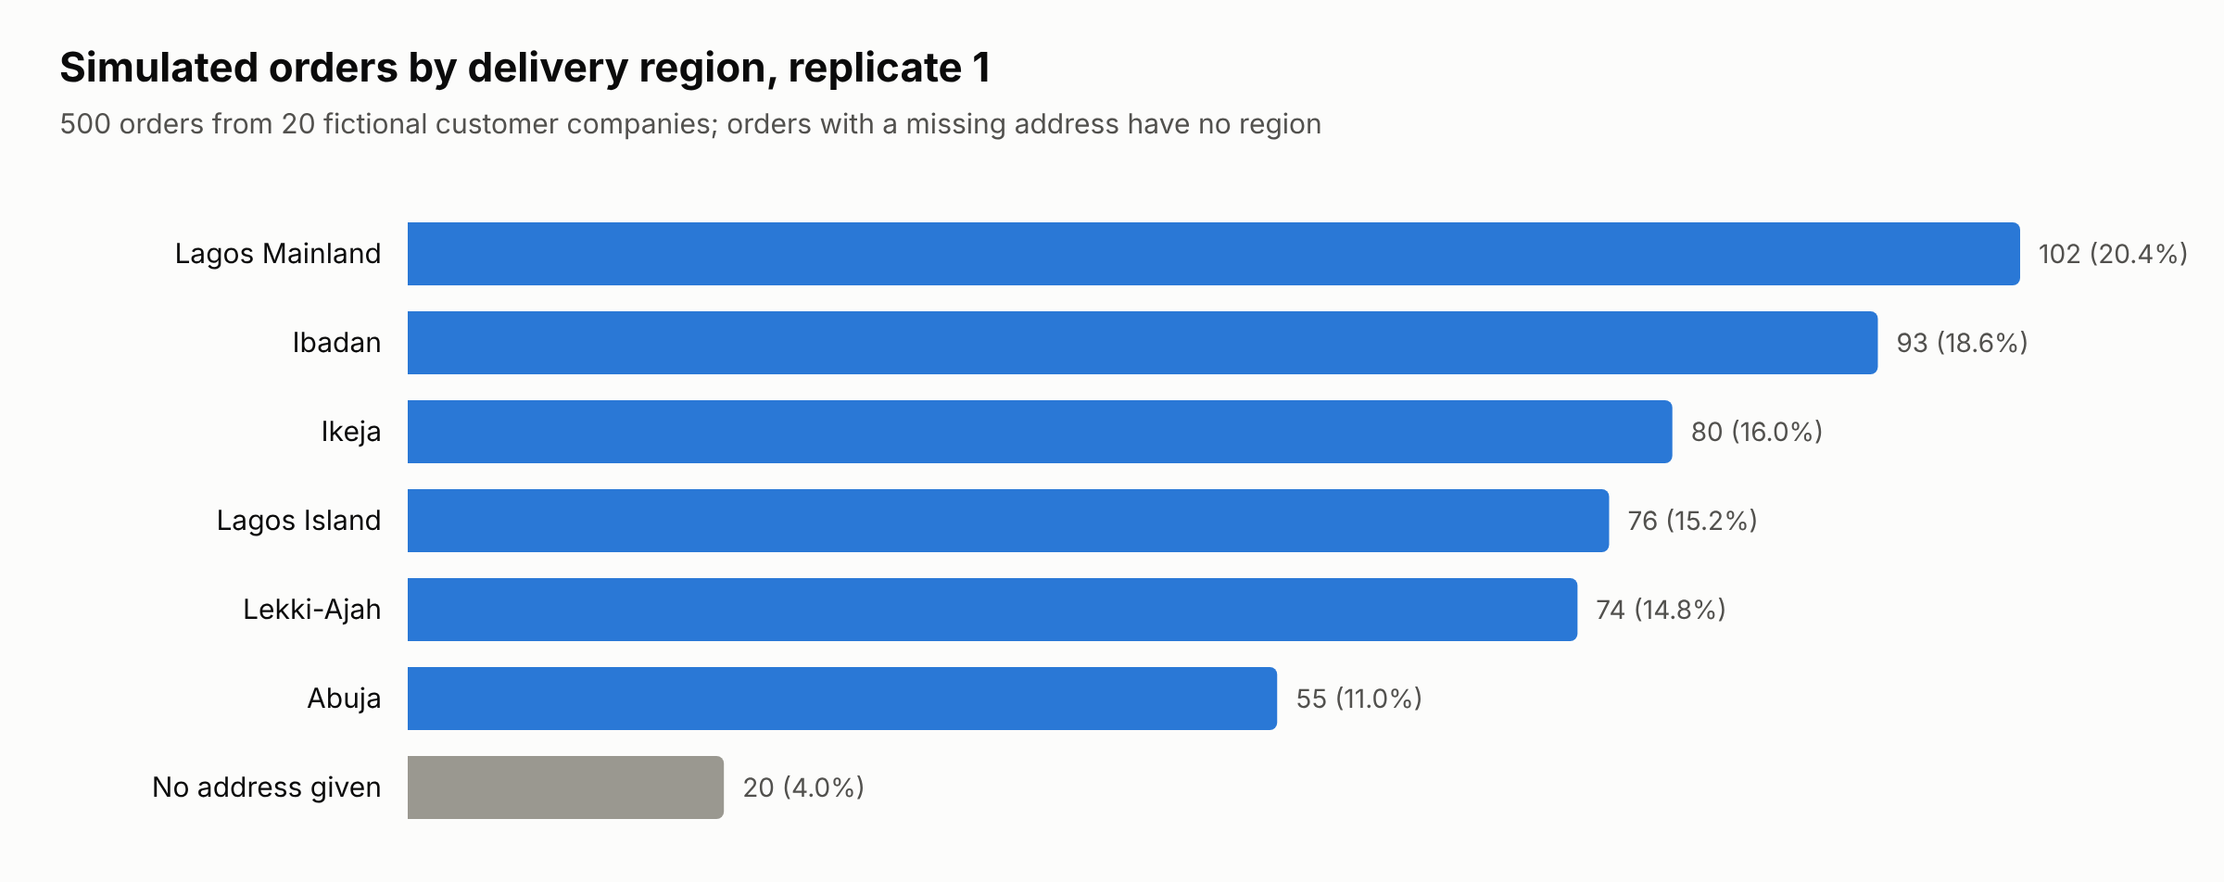
Figure 4.4: Simulated orders by delivery region, replicate 1
Source: 07_analysis/figures/fig4_1_regions_data.csv, from replicate 1, database run 5.
Table 4.20 shows one order of each kind from replicate 1, with the decision the system took and the first message it showed. Every order of all three replicates is listed in the accompanying workbook, Verity_Simulation_Data_Final.xlsx.
Table 4.20: Sample of simulated orders and the decision taken, replicate 1
Order | Company | Total | Planted error | Decision | First message shown
ORD-3788 | Bodija Interiors | ₦418,175.00 | Clean order (no error) | Passed | none
ORD-3800 | Marina Point Facilities | ₦869,030.00 | SKU not in catalogue | Blocked | Row 4: XX-680 - not in the catalogue
ORD-3784 | Marina Point Facilities | ₦1,656,575.00 | Discontinued product | Blocked | SAND-T is no longer sold. Remove it.
ORD-3782 | Bodija Interiors | ₦559,000.00 | Missing delivery address | Blocked | Choose a delivery address.
ORD-3783 | Gwarinpa Homes Ltd | ₦1,078,225.00 | Missing delivery date | Blocked | Choose a delivery date.
ORD-3789 | Marina Point Facilities | ₦522,665.00 | Delivery date in the past | Blocked | The delivery date is in the past.
ORD-3805 | Magodo Residential Ltd | ₦621,995.00 | Quantity below minimum | Blocked | PVC pipe, 2 inch, 6 m: quantity must be between 2 and 500.
ORD-3793 | Lekki Coastal Developers | ₦15,103,642.50 | Quantity above maximum | Blocked | Aluminium roofing sheet, 0.55 mm: quantity must be between 10 and 1000.
ORD-3785 | Victoria Island Fit-Out Ltd | ₦732,075.00 | Fractional quantity | Blocked | PVC-4 - Quantity must be a whole number
ORD-3786 | Bodija Interiors | ₦6,077,405.00 | Quantity above available stock | Blocked | Iron rod, 12 mm: not enough stock for this quantity. Reduce it.
ORD-3838 | Victoria Island Fit-Out Ltd | ₦764,970.00 | Duplicate order | Warned | Iron rod, 12 mm: 97 is far above this customer's usual 29.
ORD-3798 | Gwarinpa Homes Ltd | ₦24,940.00 | Customer account not active | Blocked | The customer account is not active.
ORD-3802 | Oyo Central Builders | ₦234,350.00 | Price changed after the order was saved | Blocked | Cement, 50 kg bag: price changed from 9500.00 to 10000.00. Save the order again to update it.
ORD-3806 | Gwarinpa Homes Ltd | ₦1,030,925.00 | Wrong but valid product | Passed | none
ORD-3792 | Ajah Sunrise Housing Co-op | ₦3,445,805.00 | Plausible quantity typing slip | Warned | Cement, 50 kg bag: 190 is far above this customer's usual 23.
ORD-3812 | Ola-Ade Hardware & Tiles | ₦859,677.50 | Wrong saved address | Passed | none
Source: replicate 1, database run 5, first order of each kind in 03_simulation/replicate1_orders.csv.

4.4.4 Relation to the first run
The first run of the simulation, run 4, is kept as the first run and is not replaced. It used 500 orders whose types were drawn at random, so group sizes were unequal, and it planted no inactive-customer or stale-price errors. A defect in its test script also submitted 13 of its 35 wrong-product orders with an empty line, which the quantity rule blocked. Those 13 blocks were artefacts of the script, not detections. The final simulation corrected the defect and added the two missing types, with twenty orders of every type, so its results are the ones assessed in this chapter.

4.5 Simulation results

4.5.1 Overall outcomes
Figure 4.5 shows what happened to each group of orders in replicate 1. Of the 200 clean orders, 172 passed and 28 were warned. All 240 orders with a rule-targeted error were stopped, 220 by a blocking rule and 20 by the duplicate warning. Of the 60 orders with an error that no rule targets, 24 were warned and 36 passed. After submission 220 orders were in validation failed and 258 were waiting for approval. The other 22 were held as drafts until the customer confirmed a possible repeat.
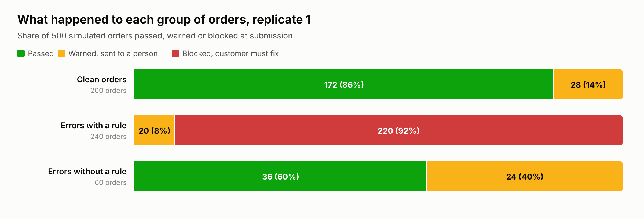
Figure 4.5: Outcome of each group of orders in replicate 1
Source: 07_analysis/figures/fig4_2_outcomes_data.csv, from replicate 1, database run 5.

4.5.2 Detection by planted error type
Table 4.21 gives the detection rate for each planted error type with a 95 percent Wilson interval, which behaves better than the simple normal interval for small groups and for rates near zero or one (Brown et al., 2001; Wilson, 1927). Every one of the twelve rule-targeted types was flagged in all 20 of its orders, and in each case by the rule designed for it. Figure 4.6 shows the same rates graphically.
Table 4.21: Detection by planted error type, replicate 1
Planted error | Has rule | Flagged | Detection % | 95% CI | Caught by expected rule
Clean order (no error) |  | 28 flagged | 14.0 false alarms | 9.9 to 19.5
SKU not in catalogue | Yes | 20/20 | 100.0 | 83.9 to 100.0 | 20
Discontinued product | Yes | 20/20 | 100.0 | 83.9 to 100.0 | 20
Missing delivery address | Yes | 20/20 | 100.0 | 83.9 to 100.0 | 20
Missing delivery date | Yes | 20/20 | 100.0 | 83.9 to 100.0 | 20
Delivery date in the past | Yes | 20/20 | 100.0 | 83.9 to 100.0 | 20
Quantity below minimum | Yes | 20/20 | 100.0 | 83.9 to 100.0 | 20
Quantity above maximum | Yes | 20/20 | 100.0 | 83.9 to 100.0 | 20
Fractional quantity | Yes | 20/20 | 100.0 | 83.9 to 100.0 | 20
Quantity above available stock | Yes | 20/20 | 100.0 | 83.9 to 100.0 | 20
Duplicate order | Yes | 20/20 | 100.0 | 83.9 to 100.0 | 20
Customer account not active | Yes | 20/20 | 100.0 | 83.9 to 100.0 | 20
Price changed after the order was saved | Yes | 20/20 | 100.0 | 83.9 to 100.0 | 20
Wrong but valid product | No | 5/20 | 25.0 | 11.2 to 46.9 | 5 by other rules
Plausible quantity typing slip | No | 14/20 | 70.0 | 48.1 to 85.5 | 14 by other rules
Wrong saved address | No | 5/20 | 25.0 | 11.2 to 46.9 | 5 by other rules
Source: replicate 1, 07_analysis/metrics_final.json by_type, workbook sheet R1 Summary section D.
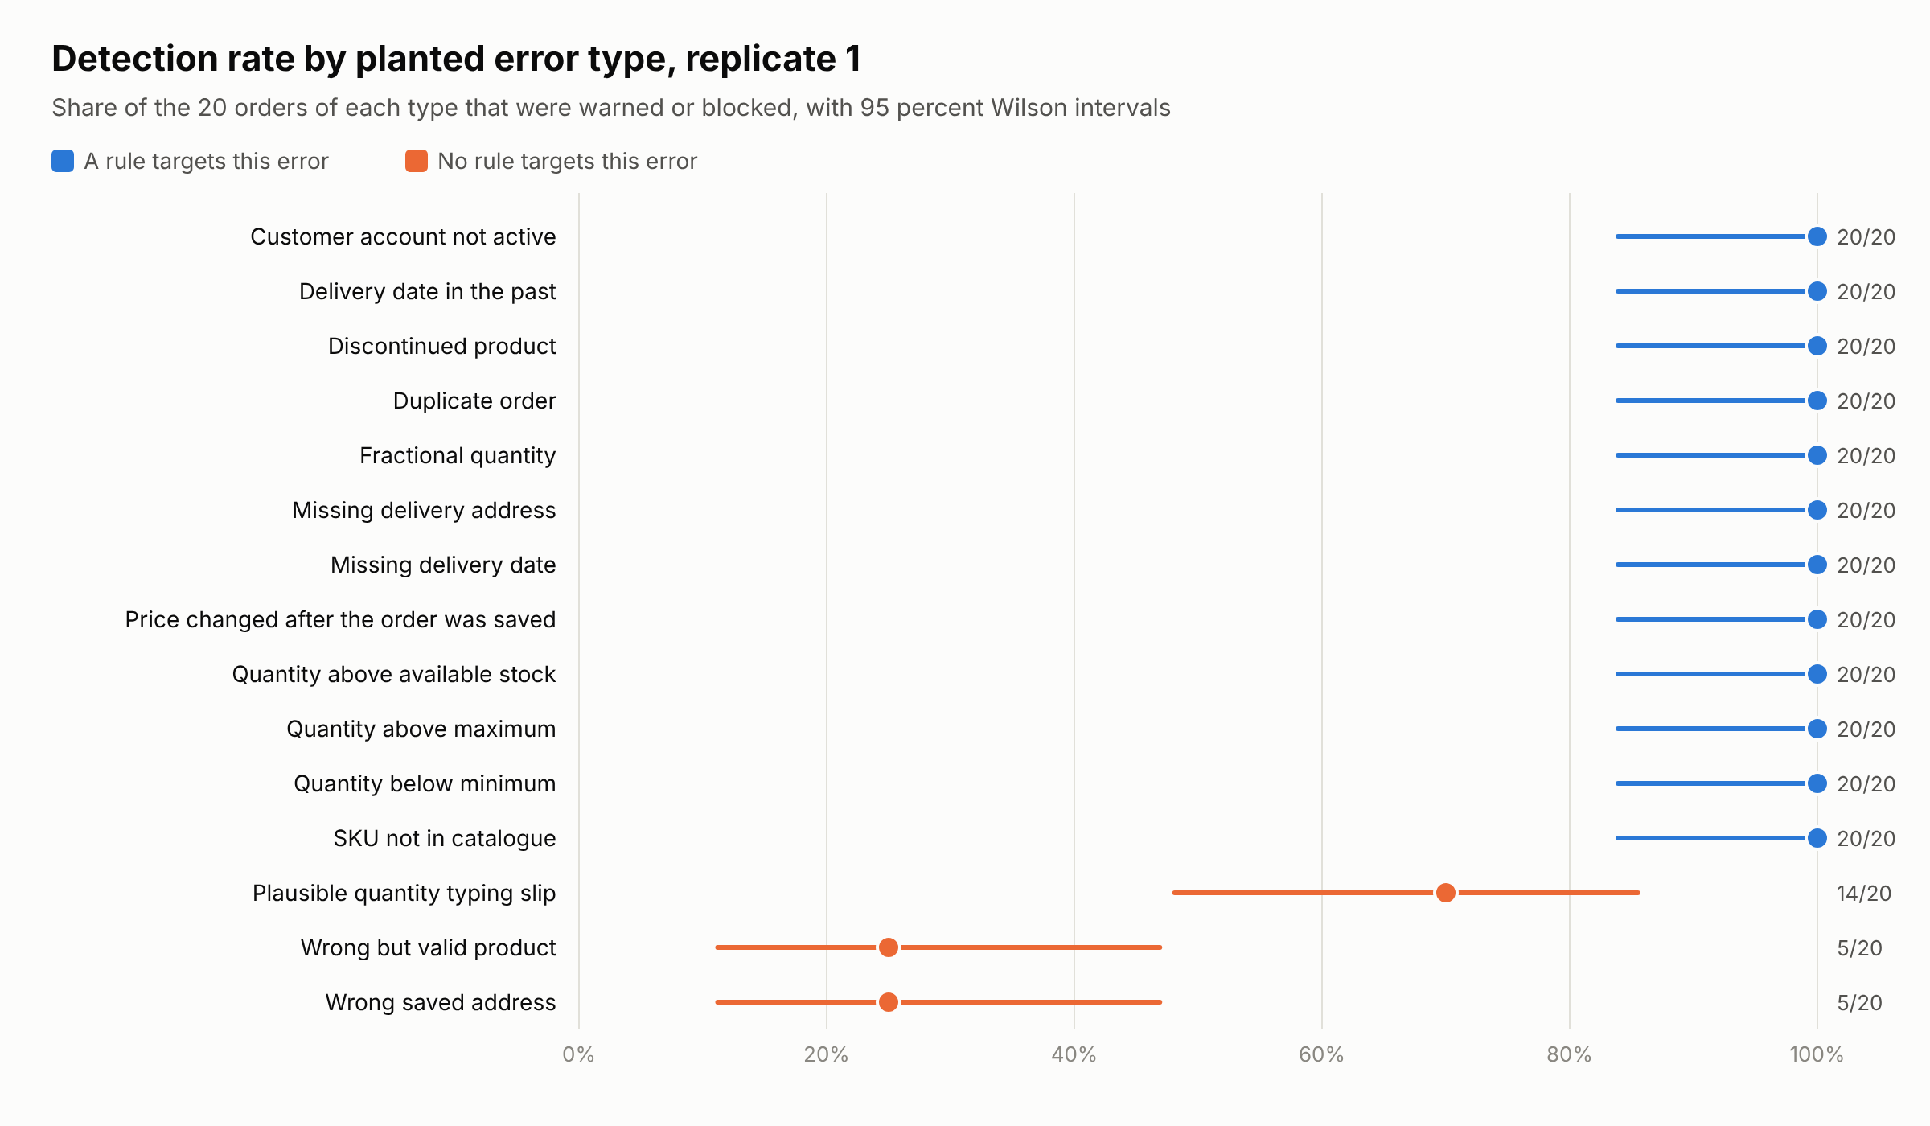
Figure 4.6: Detection rate by planted error type with 95 percent Wilson intervals, replicate 1
Source: 07_analysis/figures/fig4_3_detection_data.csv, from replicate 1, database run 5.
The three types without a rule tell a different story. The quantity typing slip was flagged in 14 of 20 orders, and in each of these the unusual-quantity warning named the very line that carried the slip, so this is genuine detection by a rule that was not designed for it. The wrong product and the wrong address were each flagged in 5 of 20 orders, but in none of those cases did the warning concern the planted error. The warnings were about other lines or, once, about a possible repeat, so these flags are coincidental. A wrong but valid product or address is in effect invisible to the engine, which is what one would expect of rules that check whether a value is allowed rather than whether it is what the customer meant.

4.5.3 Classification performance
For the binary measures an order counts as flagged when it is warned or blocked and as positive when it carries a planted error. The primary measure uses all 300 erroneous orders against the 200 clean orders, and the secondary measure uses only the 240 rule-targeted orders against the same clean orders. Table 4.22 defines the measures. Table 4.23 gives both confusion matrices for replicate 1 and Table 4.24 gives the measures with their intervals.
Table 4.22: Definitions of the classification measures
Measure | Definition | Formula
Accuracy | Share of all orders the system judged correctly, erroneous orders flagged and clean orders passed | (TP + TN) / all orders
Precision | Of the orders flagged, the share that really carried an error | TP / (TP + FP)
Recall | Of the orders that carried an error, the share the system flagged | TP / (TP + FN)
Specificity | Of the clean orders, the share passed without a flag | TN / (TN + FP)
False-alarm rate | Of the clean orders, the share flagged | FP / (FP + TN)
F1 score | Harmonic mean of precision and recall | 2 x P x R / (P + R)
Source: standard definitions. TP true positive, FN false negative, FP false positive, TN true negative.
Table 4.23: Confusion matrices, replicate 1
Measure set | Error flagged | Error passed | Clean flagged | Clean passed | Orders
Primary, all errors | 264 | 36 | 28 | 172 | 500
Secondary, rule-targeted errors | 240 | 0 | 28 | 172 | 440
Source: replicate 1, 07_analysis/metrics_final.json confusion_all_errors and confusion_rule_targeted, workbook R1 Summary sections B and C.
Table 4.24: Validation measures with 95 percent Wilson intervals, replicate 1
Measure | Primary % | Primary 95% CI | Secondary % | Secondary 95% CI
Accuracy | 87.2 | 84.0 to 89.8 | 93.6 | 91.0 to 95.6
Precision | 90.4 | 86.5 to 93.3 | 89.6 | 85.3 to 92.7
Recall | 88.0 | 83.8 to 91.2 | 100.0 | 98.4 to 100.0
Specificity | 86.0 | 80.5 to 90.1 | 86.0 | 80.5 to 90.1
False-alarm rate | 14.0 | 9.9 to 19.5 | 14.0 | 9.9 to 19.5
F1 score | 89.2 | not a single proportion | 94.5 | not a single proportion
Source: replicate 1, 07_analysis/metrics_final.json, workbook R1 Summary sections B and C.
On the primary measure the engine reached an accuracy of 87.2 percent, with a 95 percent interval of 84.0 to 89.8 percent. The whole interval lies below the 90 percent target, so the primary measure does not meet it. Recall was 88.0 percent, held down by the 36 errors without a rule that passed unflagged. On the secondary measure accuracy was 93.6 percent, with an interval of 91.0 to 95.6 percent, and recall was 100.0 percent. Precision was similar on both measures because the false alarms are the same clean orders in each. Figure 4.7 shows the measures with their intervals and marks the values from replicates 2 and 3.
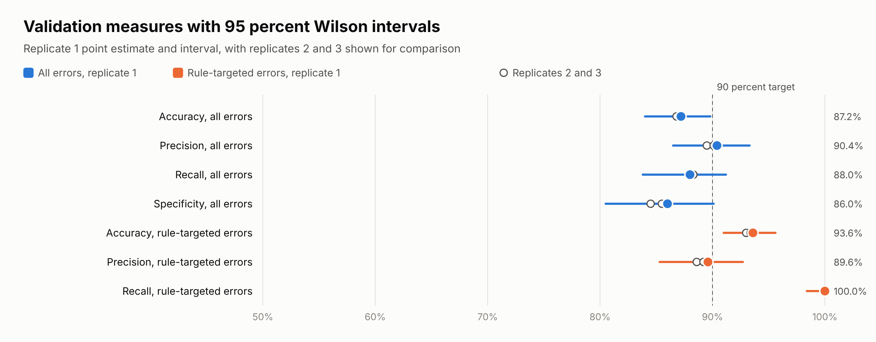
Figure 4.7: Validation measures with 95 percent Wilson intervals
Source: 07_analysis/figures/fig4_4_measures_data.csv, from replicates 1 to 3, database runs 5 to 7.

4.5.4 Rule activity and false alarms
Table 4.25 shows how often each rule fired. The seven blocking rules fired only on erroneous orders and never on a clean one. The stock rule also fired on the 40 orders whose quantity was above the maximum or whose product was discontinued, because both also exceed the stock on hand. All 28 false alarms on clean orders came from the two warning rules, 27 from the unusual-quantity rule and 1 from the duplicate rule. The unusual-quantity rule fired on 94 orders in all, and on 13.5 percent of clean orders. Figure 4.8 shows the same counts by kind of order.
Table 4.25: Rule activity and false alarms, replicate 1
Rule | Severity | Orders fired | On its target type | On other error types | On clean orders | False alarms per clean order, 95% CI
Mandatory fields | Blocking | 40 | 40 | 0 | 0 | 0.0 (0.0 to 1.9)
SKU and product active | Blocking | 40 | 40 | 0 | 0 | 0.0 (0.0 to 1.9)
Quantity limits | Blocking | 60 | 60 | 0 | 0 | 0.0 (0.0 to 1.9)
Stock availability | Blocking | 60 | 20 | 40 | 0 | 0.0 (0.0 to 1.9)
Customer status | Blocking | 20 | 20 | 0 | 0 | 0.0 (0.0 to 1.9)
Pricing | Blocking | 20 | 20 | 0 | 0 | 0.0 (0.0 to 1.9)
Delivery date and address | Blocking | 20 | 20 | 0 | 0 | 0.0 (0.0 to 1.9)
Duplicate order | Warning | 22 | 20 | 1 | 1 | 0.5 (0.1 to 2.8)
Unusual quantity | Warning | 94 | 0 | 67 | 27 | 13.5 (9.4 to 18.9)
Source: replicate 1, 07_analysis/metrics_final.json rules, workbook R1 Summary section E.
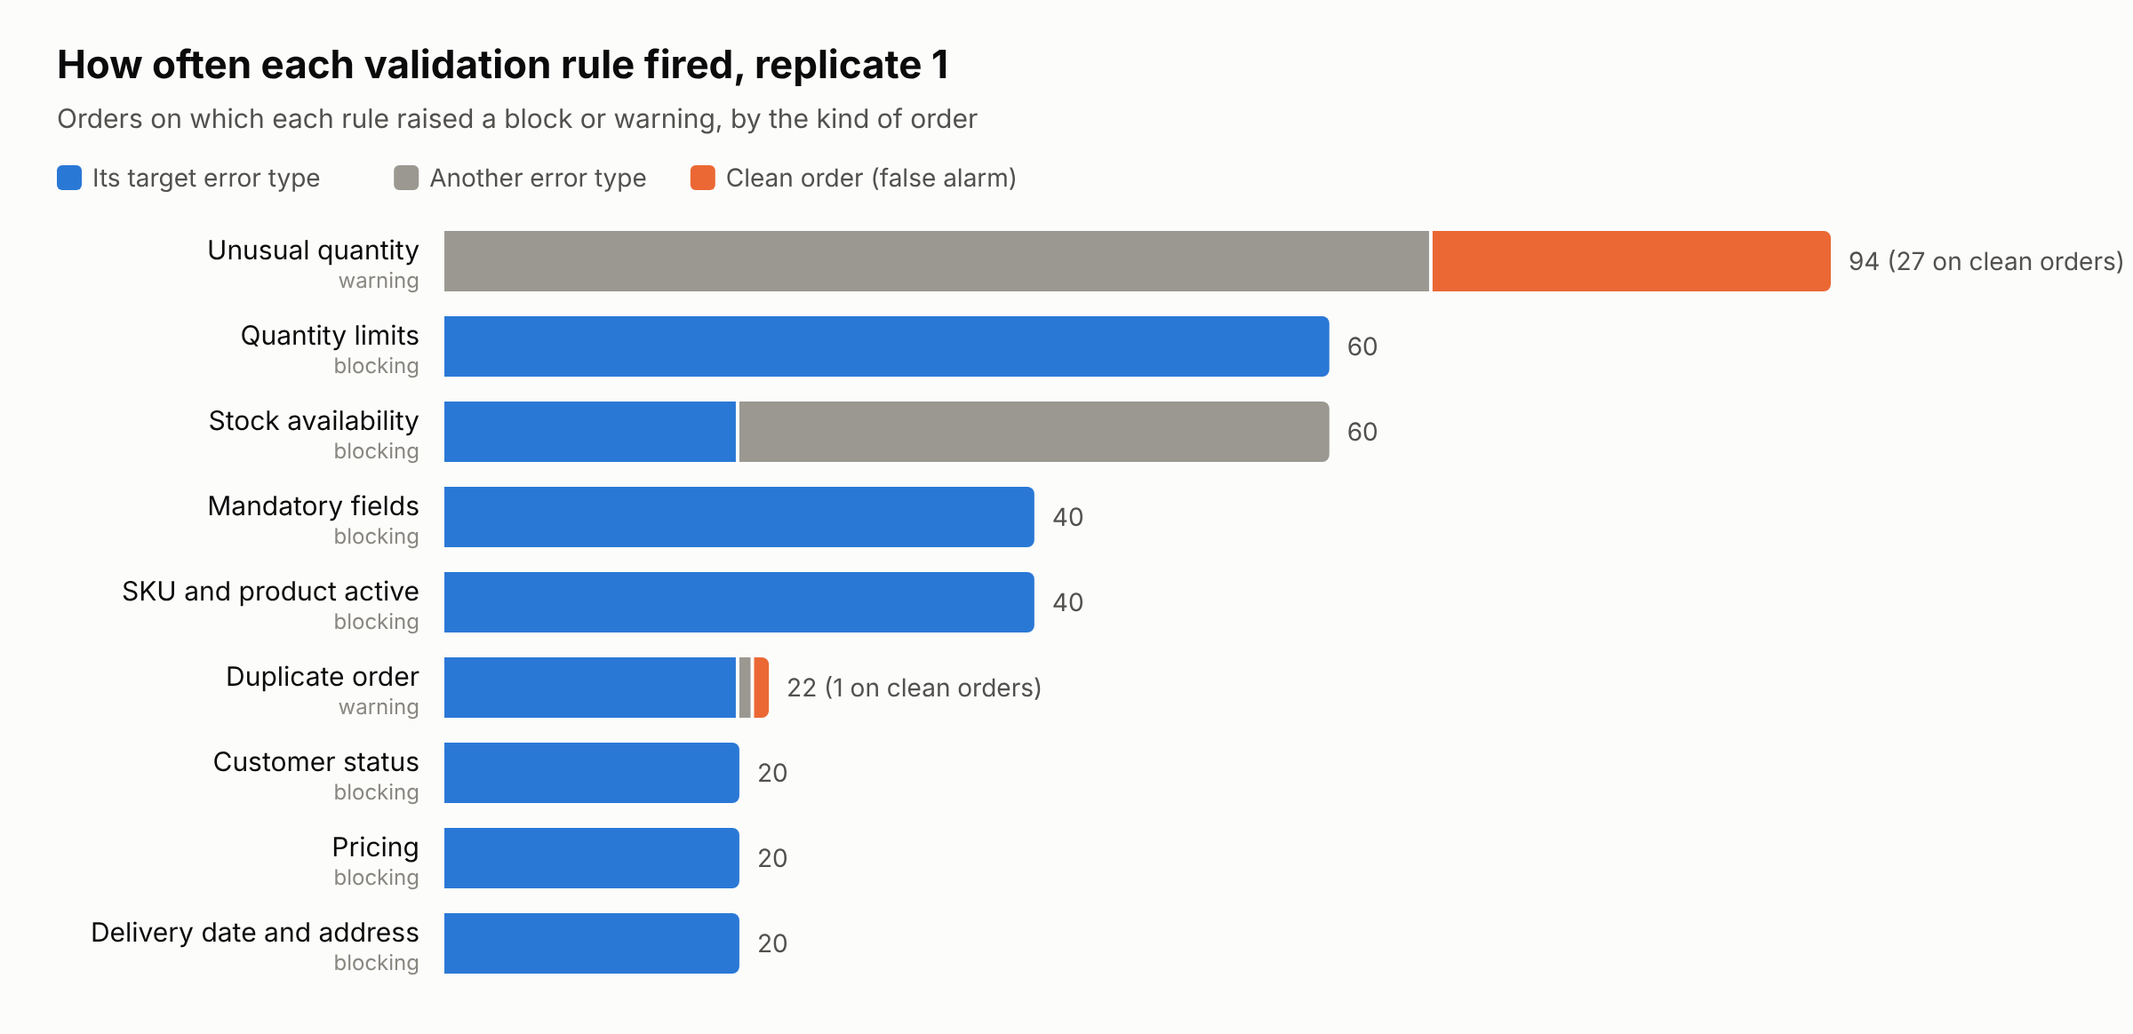
Figure 4.8: Number of orders on which each validation rule fired, by kind of order, replicate 1
Source: 07_analysis/figures/fig4_5_rules_data.csv, from replicate 1, database run 5.

4.5.5 Processing time
Validation time was measured as the clock time of submit_order inside the database, which validates the order and records the status change. It excludes network time and any time a person spends. Table 4.26 gives the statistics for replicate 1 and Figure 4.9 shows their distribution. The standard deviation is the sample value. The mean was 28.72 ms and the median 22.16 ms, with a 95th percentile of 74.72 ms and a maximum of 124.31 ms. The time measured from the draft event to the last event in the status history gave a mean of 29.78 ms over the 478 orders that had more than one event.
Table 4.26: Validation time per order in milliseconds, replicate 1
Statistic | All orders | Passed | Warned | Blocked
Orders | 500 | 208 | 72 | 220
Mean | 28.72 | 27.85 | 31.84 | 28.53
SD, sample | 23.27 | 21.34 | 25.28 | 24.33
Median | 22.16 | 22.31 | 22.59 | 21.56
95th percentile | 74.72 | 71.59 | 80.19 | 75.57
Minimum | 2.45 | 2.88 | 4.81 | 2.45
Maximum | 124.31 | 94.84 | 114.3 | 124.31
Source: replicate 1, 07_analysis/metrics_final.json validation_ms, workbook R1 Summary section F.
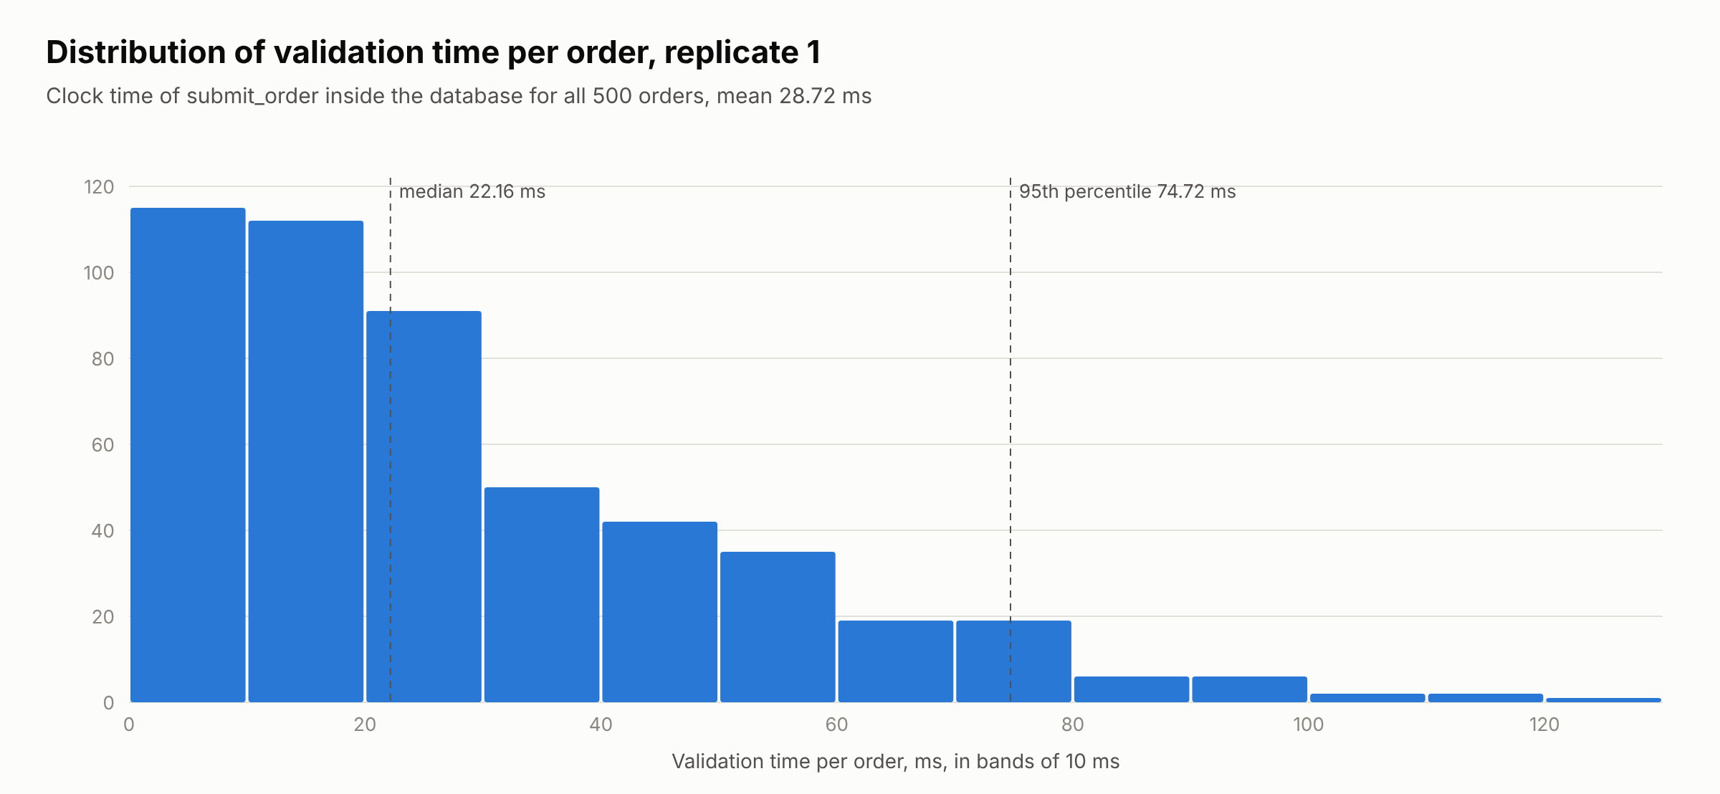
Figure 4.9: Distribution of validation time per order, replicate 1
Source: 07_analysis/figures/fig4_6_validation_time_data.csv, from replicate 1, database run 5.
The time was not stable across the run. Figure 4.10 shows that in replicate 1 the mean rose from 6.90 ms for the first 100 orders to 58.76 ms for the last 100, and replicate 2 followed the same path. The rules that look back over a customer's earlier orders have more orders to examine as the run goes on, which is consistent with this rise. Replicate 3 stayed between 2.08 and 2.54 ms throughout. The test script was the same in every run. It is assumed, but was not confirmed, that the database chose a different query plan in that run. In every replicate a single order was validated in well under a second.
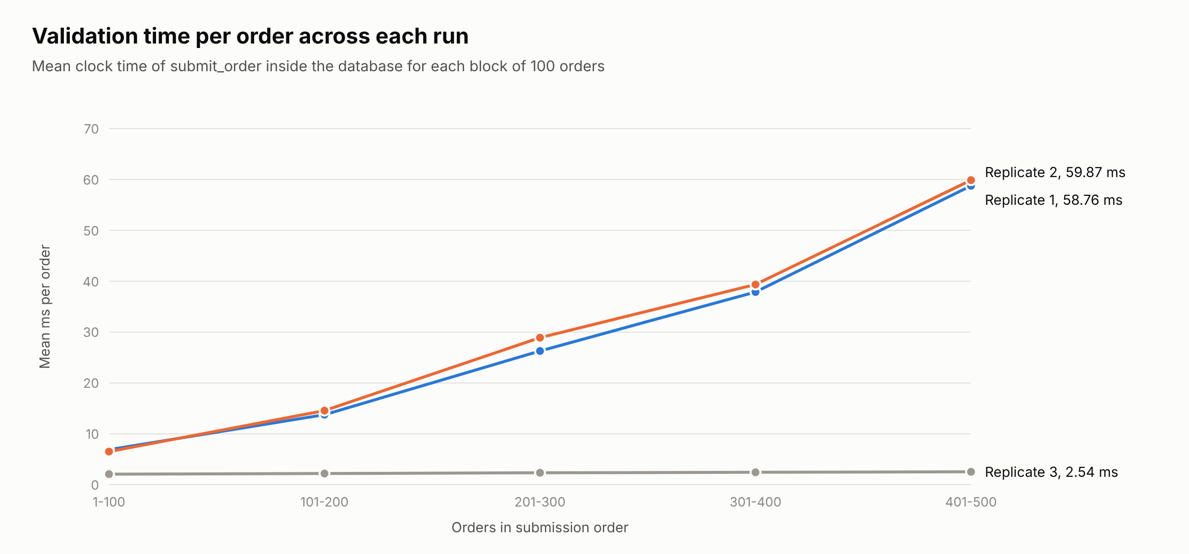
Figure 4.10: Validation time per order across each run, mean of each block of 100 orders
Source: 07_analysis/figures/fig4_7_timing_blocks_data.csv, from replicates 1 to 3, database runs 5 to 7.

4.5.6 Variation between replicates
Table 4.27 sets the key measures of the three replicates side by side. No accuracy or detection measure moved by more than 1.7 percentage points between replicates, so the headline figures do not depend on the particular seed. The timing measures moved by an order of magnitude, as described above.
Table 4.27: Key measures in each replicate
Measure | Replicate 1 | Replicate 2 | Replicate 3 | Range
Accuracy, all errors | 87.2 | 86.8 | 87.2 | 86.8 to 87.2
Precision, all errors | 90.4 | 89.5 | 90.1 | 89.5 to 90.4
Recall, all errors | 88.0 | 88.3 | 88.3 | 88.0 to 88.3
Specificity | 86.0 | 84.5 | 85.5 | 84.5 to 86.0
False-alarm rate | 14.0 | 15.5 | 14.5 | 14.0 to 15.5
F1, all errors | 89.2 | 88.9 | 89.2 | 88.9 to 89.2
Accuracy, rule-targeted errors | 93.6 | 93.0 | 93.4 | 93.0 to 93.6
Precision, rule-targeted errors | 89.6 | 88.6 | 89.2 | 88.6 to 89.6
Recall, rule-targeted errors | 100.0 | 100.0 | 100.0 | 100.0 to 100.0
F1, rule-targeted errors | 94.5 | 93.9 | 94.3 | 93.9 to 94.5
No-rule errors flagged | 40.0 | 41.7 | 41.7 | 40.0 to 41.7
Mean validation time, ms | 28.72 | 29.84 | 2.33 | 2.33 to 29.84
Median validation time, ms | 22.16 | 22.88 | 2.34 | 2.34 to 22.88
95th percentile validation time, ms | 74.72 | 78.92 | 2.84 | 2.84 to 78.92
Mandatory-field completion, orders reaching approval | 100.0 | 100.0 | 100.0 | 100.0 to 100.0
Source: 07_analysis/metrics_final.json replicate_range, workbook sheet Replicate range.

4.5.7 Sensitivity of the unusual-quantity warning
Because the unusual-quantity rule caused nearly all false alarms and also caught the quantity slips, its setting was examined. Replicate 1 was replayed through the live functions with the threshold set from three to five times the customer's average in steps of one, and with four or ten earlier orders per customer. The replay with the live setting reproduced replicate 1 exactly, with no difference in any order, so the six settings in Table 4.28 are compared on identical orders. These runs are for discussion only and the live setting was left at three.
Table 4.28: Unusual-quantity sensitivity on replicate 1
Threshold | Earlier orders | Clean flagged | False-alarm % | 95% CI | Slips flagged | Slip detection % | 95% CI | Accuracy, all errors %
3 x average | 4 | 28/200 | 14.0 | 9.9 to 19.5 | 14/20 | 70.0 | 48.1 to 85.5 | 87.2
4 x average | 4 | 20/200 | 10.0 | 6.6 to 14.9 | 12/20 | 60.0 | 38.7 to 78.1 | 88.0
5 x average | 4 | 17/200 | 8.5 | 5.4 to 13.2 | 11/20 | 55.0 | 34.2 to 74.2 | 88.2
3 x average | 10 | 38/200 | 19.0 | 14.2 to 25.0 | 16/20 | 80.0 | 58.4 to 91.9 | 85.4
4 x average | 10 | 23/200 | 11.5 | 7.8 to 16.7 | 14/20 | 70.0 | 48.1 to 85.5 | 88.0
5 x average | 10 | 16/200 | 8.0 | 5.0 to 12.6 | 12/20 | 60.0 | 38.7 to 78.1 | 88.6
Source: replays of database run 5 as runs 8 to 13, 04_sensitivity/sensitivity_results.csv, workbook sheet Sensitivity.
Raising the threshold from three to five times the average with four earlier orders cut false alarms on clean orders from 14.0 to 8.5 percent, but the share of quantity slips caught fell from 70.0 to 55.0 percent. A longer history of ten orders caught more slips at the same threshold but also raised false alarms, to 19.0 percent at three times the average. The intervals for the slips are wide because each rests on 20 orders, so these differences show a direction rather than settled values. Figure 4.11 shows the trade-off.
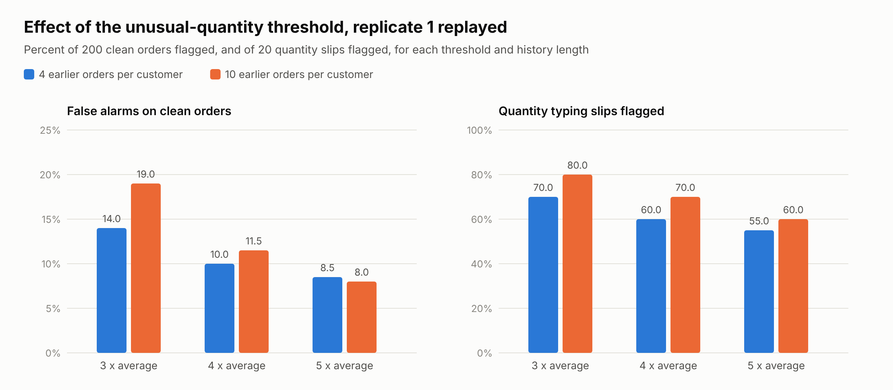
Figure 4.11: Effect of the unusual-quantity threshold and history length on false alarms and slip detection
Source: 07_analysis/figures/fig4_8_sensitivity_data.csv, from replays of database run 5.

4.5.8 Mandatory-field completion
Mandatory-field completion was measured on the orders that reached approval. All 258 of the 258 orders that reached the approval queue in replicate 1 had every mandatory field filled, with a 95 percent interval of 98.5 to 100.0 percent, and the same was true in the other replicates. This follows from the design, since the mandatory-fields rule blocks any order without them, and the simulation confirms that no such order got through.

4.5.9 Comparison with manual entry
Two participants who had not seen the answer key each handled 20 of the order messages of the comparison pack by hand on 30 October 2026, as orders are handled today. Each checked the message against the reference sheets of the pack and typed the order into an entry sheet without correcting it, noting the time at the start and at the end. The 40 orders were taken from replicate 1 of the simulation, so the outcome of Verity on each of them was already known. In Verity the customer enters the order against the live catalogue and no member of staff retypes it, so an error reaches the record only when the system does not flag it. The comparison used the definitions fixed before any data were collected. By hand an error reached the record when a planted error was not flagged or when any field was typed differently from the message. Table 4.29 gives the results.
Table 4.29: Manual entry and Verity on the same 40 orders
Measure | Manual entry | 95% CI | Verity | 95% CI
Orders with an error reaching the record | 29 of 40, 72.5 percent | 57.2 to 83.9 | 6 of 40, 15.0 percent | 7.1 to 29.1
Planted errors flagged | 6 of 26 | 11.0 to 42.1 | 20 of 26 | 57.9 to 89.0
Rule-targeted errors flagged | 6 of 19 | 15.4 to 54.0 | 19 of 19 | 83.2 to 100.0
Errors with no rule flagged | 0 of 7 | 0.0 to 35.4 | 1 of 7 | 2.6 to 51.3
Orders with a field typed differently from the message | 19 of 40 | 32.9 to 62.5 | not applicable
Clean orders wrongly flagged | 0 of 14 | 0.0 to 21.5 | 1 of 14 | 1.3 to 31.5
Time per order, median and mean | 180 s and 246 s |  | not measured for a person
Source: Entry sheets of participants P01 and P02, answer key of the comparison pack and replicate 1 of the simulation, scored with score_manual_vs_simulation.py.
An error reached the record in 72.5 percent of the orders handled by hand and in 15.0 percent of the same orders through Verity, a reduction of 79.3 percent, and the two 95 percent intervals do not overlap. The manual errors had two sources. The participants flagged 6 of the 26 planted errors, and 19 of the 40 orders were typed with at least one field that differed from the message, most often the address or an order line. The slips included a delivery date of 5 November typed for 3 November and a quantity of 60 typed for 1. All 6 errors that would have passed Verity were errors that no rule targets, and 3 of them were wrong addresses. One counted manual slip, an address written with Rd for Road, would not misdirect a delivery. Without it the manual rate is 70.0 percent and the reduction 78.6 percent.
By hand the participants took a median of 180 seconds per order, and orders they flagged took a median of 600 seconds. The time a person spends entering an order in Verity was not measured, so this baseline cannot yet be turned into a saving of time. With 40 orders and two participants the comparison is indicative only. Its Verity side rests on the simulation rather than on people entering the orders, so it assumes that a customer entering an order in Verity makes the planted mistakes and no others.

4.6 Evaluation against the success criteria and discussion

4.6.1 Evaluation against the objectives
Table 4.30 sets each objective of Section 1.3, in its Chapter One wording, against its success criterion and the result of this evaluation.
Table 4.30: Objectives of Section 1.3 and their success criteria
Objective, Chapter One wording | Criterion | Result | 95% CI | Status
1. To design and develop a web-based order processing system that replaces manual order entry done through Excel sheets and through e-mail and WhatsApp messages. | A working web-based system through which orders are entered and processed without rekeying | Built and deployed. Orders are entered in the portal, from an uploaded Excel or CSV sheet, or from a pasted message. 23 of 26 functional tests passed. CSV export of orders and webhooks are not built | not applicable | Met
2. To implement an automatic validation engine that checks SKU, quantity, customer details, pricing, duplicate orders, stock and mandatory fields, and to achieve at least 90 percent validation accuracy. | At least 90 percent validation accuracy | Primary 87.2 percent, all errors. Secondary 93.6 percent, rule-targeted errors. Replicates 86.8 to 87.2 and 93.0 to 93.6 | 84.0 to 89.8 and 91.0 to 95.6 | Partly met
3. To reduce manual data-entry errors by at least 60 percent and to achieve 100 percent completion of mandatory fields. | At least 60 percent fewer manual entry errors | An error reached the record in 29 of 40 orders by hand and 6 of the same 40 through Verity, a reduction of 79.3 percent. Two participants, indicative | 57.2 to 83.9 and 7.1 to 29.1 | Met, indicative
3. As above | 100 percent completion of mandatory fields | 258 of 258 orders reaching approval, 100 percent in all three replicates | 98.5 to 100.0 | Met
4. To improve order processing speed by 30 to 50 percent through digital approval, payment confirmation, fulfilment and delivery workflows. | 30 to 50 percent faster processing | Manual handling took a median of 180 s per order. Verity validates in 2.34 to 22.88 ms, but the time a person spends entering an order in Verity was not measured | not applicable | Scheduled
5. To evaluate the usability and acceptance of the system through a questionnaire and a test run of 500 simulated orders. | Test run of 500 simulated orders | 500 orders in each of three replicates, 1,500 in all | not applicable | Met
5. As above | Usability and acceptance shown by the questionnaire | System Usability Scale mean 48.86, significantly below 68. 38.5 percent would use Verity | 45.35 to 52.38 | Not met
Source: Section 1.3 and Sections 4.2 to 4.5 of this chapter. Accuracy judged on the primary measure with the secondary measure in support.
Objective 1 is rated Met because orders can be entered and taken through the whole lifecycle without being retyped by staff. Two features named in the scope of Section 1.5 are missing, the CSV export of orders and the webhooks for connection to other systems, and the route for pasting a WhatsApp message was built but not covered by a functional test. The accuracy part of Objective 2 is rated Partly met. On the primary measure accuracy did not reach 90 percent in any replicate, and the upper end of the replicate 1 interval was 89.8 percent. On the rule-targeted errors it exceeded 90 percent in every replicate and the whole interval lay above the target. Both measures share the same false alarms, so the gap between them comes from the 36 errors without a rule that were missed, 30 of them wrong products or wrong addresses.
Objective 3 is Met on indicative evidence. Its mandatory-fields criterion is Met, and in the comparison with manual entry an error reached the record in 15.0 percent of orders through Verity against 72.5 percent by hand, a reduction of 79.3 percent against a target of 60 percent. The comparison covered 40 orders handled by two participants, below the 80 paired orders planned, so it is indicative only. The speed criterion of Objective 4 is Scheduled. Manual handling took a median of 180 seconds per order, but the time a person spends entering the same order in Verity was not measured, so no saving can yet be stated. The simulated test run required by Objective 5 is Met, but its usability and acceptance part is Not met. The mean usability score was significantly below the benchmark of 68, and no acceptance item was agreed by a majority of respondents.

4.6.2 Answers to the research questions
Each research question of Section 1.4 is restated below in its Chapter One wording and answered from the evidence of this chapter.
Research question 1. How can an order processing system be designed to replace manual order entry in a logistics company.
Verity shows that it can be done by having the customer enter the order against the live catalogue and by running every later step as one controlled lifecycle of 17 statuses, with each role limited to its own actions and every change recorded. Customers can also upload a spreadsheet or paste a message, which the system reads into the same validated form. Of 26 functional tests, 23 passed, and the failures concern features that are missing or incomplete, as Section 4.3 reports.
Research question 2. How accurately can an automatic validation engine detect erroneous orders.
Every error that a rule targets was detected in all three replicates, which gave an accuracy of 93.6 percent on those errors. When realistic errors that no rule targets were included the accuracy was 87.2 percent, below the 90 percent target, and most of the errors that passed were of a kind no rule can detect.
Research question 3. By how much does the system reduce manual data-entry errors compared with manual entry.
In the comparison of Section 4.5.9 an error reached the record in 72.5 percent of orders handled by hand and in 15.0 percent of the same orders through Verity, a reduction of 79.3 percent. The reduction comes from two sources. Verity stops every error a rule targets, which the participants mostly missed, and it removes retyping, which caused slips in nearly half of the manual orders. Errors that lie inside the allowed values, such as a wrong but valid product, pass both. With two participants the answer is indicative.
Research question 4. By how much does the system improve order processing speed.
Validation itself takes milliseconds per order, but the question concerns end-to-end processing time against manual handling. By hand the participants took a median of 180 seconds per order. The time a person spends entering the same order in Verity was not measured, so the gain cannot yet be stated.
Research question 5. How usable and acceptable do intended users find the system.
Intended users found Verity of poor usability on the evidence of the demonstration. The mean System Usability Scale score was 48.86, significantly below the benchmark of 68, and staff and customers did not differ. Acceptance was also low, since 38.5 percent said they would use Verity if it were available, and intention was linked more to perceived usefulness than to ease of use.

4.6.3 Link between the questionnaire and the technical evaluation
The two parts of the evaluation point in different directions. The simulation shows an engine that stopped every planted error a rule targets, yet only 35.0 percent of respondents agreed that Verity would reduce errors in orders. The respondents judged Verity from a demonstration lasting six to eight minutes, so the gap may reflect what the demonstration showed rather than what the system does. The open answers support this reading. The two features requested most often, a history of changes and approvals and a history of corrections, are already provided by the audit trail and the status history, and the problem named most often concerned mobile access and low data use. The importance ratings of Table 4.5 do not favour any check over the others, so they give no user priority against which the detection rates of Table 4.21 can be read. Section C, which would have shown the error types respondents meet most often, could not be decoded, so the planted error types cannot yet be compared with the errors seen in practice.

4.6.4 Discussion
Section 2.4.3 adopted the information systems success model of DeLone and McLean (2003) as the frame that links what the simulation measures to the outcomes the study expects. In that frame the validation engine stands for information quality, and the reductions in error and processing time sought by Objectives 3 and 4 stand for net benefits. The evidence on information quality is strong for the errors the rules were written for. Every one of them was stopped in every replicate, and no order reached approval with a mandatory field missing. It is weaker in two respects. Of the 200 clean orders, 28 received a warning that turned out to be unnecessary, and warnings of this kind cost staff time and can teach users to ignore them. The engine also missed most errors that lie inside the allowed values. On system quality, validation responded within a fraction of a second, although its response time grew with the number of orders in two of the replicates. The small comparison with manual entry gives first evidence of net benefits, since far fewer errors reached the record through Verity than by hand, and it begins to close the second gap identified in Section 2.6, the lack of a comparison between validated digital entry and manual entry. The gain in speed remains to be measured. The questionnaire adds evidence on use and user satisfaction, and both are weak. A usability score of 48.86 and an intention to use of 38.5 percent mean that, in the terms of the model, the system quality shown in the simulation would not by itself lead to net benefits.
The questionnaire results also bear on the acceptance theories of Section 2.4. In line with Davis (1989), intention was linked more closely to perceived usefulness than to ease of use, so the most direct route to acceptance is to show users the errors and rework the system removes. Fewer than half of the respondents agreed that their use would be voluntary. Where use is mandatory, Venkatesh et al. (2003) found that the expectations of managers and peers weigh more on intention, so the support of management would matter for adoption. The low usability score still matters in that setting. It is assumed here, though not tested, that staff required to use a system they find difficult may work around it.
The pattern of what the engine missed matches the evidence reviewed in Section 2.2.2. Barchard and Pace (2011) found that only a small share of data entry errors are blank or outside the allowable range, so most cannot be caught by looking for obviously wrong values. The simulation shows the same limit from the system side. The rules check that each value is allowed, so they cannot tell when a customer chooses an allowed value by mistake, and a wrong but valid product or address passed in most cases. The unusual-quantity warning partly closes the gap for quantities, at the cost of false alarms, and the sensitivity analysis shows that the balance can be tuned but not removed. Errors in product choice or address would need a different kind of check, such as confirming the order back to the customer before approval.
Two further results bear on the design set out in Chapter Two. Section 2.2.3 argued, following Elmagarmid et al. (2007), that an order system can prevent duplicates at intake rather than clean them afterwards, and all 20 planted duplicates in each replicate were held for the customer to confirm. Table 2.1 expects the pricing check to stop an outdated price. The engine did so when the price changed after an order was saved, but an outdated price quoted on an uploaded sheet was replaced by the list price without telling the customer, as functional test 16b shows. Finally, the integration route of Section 2.3.5 is only partly in place, since CSV import works but CSV export of orders and webhooks have not been built.

4.7 Limitations
The orders were generated for the test, not taken from real customers. Each carried at most one planted error, and the proportion of erroneous orders was fixed at 60 percent. Real orders may carry several errors, and it is assumed that they are erroneous far less often, which would lower precision for the same false-alarm rate. The figures are therefore a test of the engine under known conditions, not an estimate of its performance in daily use.
Only three kinds of error without a rule were planted. Real mistakes outside the rules may be more varied, so the primary accuracy could be higher or lower in practice.
Each run took place inside one database transaction, so the database clock stood still during the run. The script used the wall clock for timing and status history, but every order counted as submitted at the same moment, which keeps all earlier orders within the 24-hour duplicate window. The customer histories were also synthetic.
Validation time was measured inside the database and excludes network delay and the time people spend. It varied between replicates by an order of magnitude and grew within two of them. The cause was not confirmed, so the timing results describe the conditions of these runs only.
The sensitivity analysis was run on replicate 1 alone, and each slip detection rate rests on 20 orders.
The delivery-log export was tested by running its code outside the browser, because the live site could not be reached from the test environment.
The comparison with manual entry covered 40 orders handled by two participants, so its results are indicative only. Its Verity side rests on the simulation outcome for the same orders rather than on people entering them in Verity, and the time a person spends entering an order in Verity was not measured, so no gain in speed is reported.
The questionnaire respondents judged Verity from a demonstration video rather than by using it themselves, so their usability scores describe an impression of the system rather than experience of it. The questionnaire was administered by the client team to the people it could reach, which is not a random sample, and 45 respondents worked mainly outside Nigeria.
The answers to section C of the questionnaire were supplied as numeric codes that could not be matched to the options with certainty, so frequency and type of order errors could not be reported. On the main channel, only 82 of the 200 answers were consistent with the channels the same respondent had ticked.

4.8 Summary
Verity was built as a working order processing system with a controlled order lifecycle and nine validation rules, protected by role-based access. Of 26 functional tests, 23 passed and the 3 failures were reported. In three replicates of 500 simulated orders the engine flagged every error that a rule targets, and accuracy on that basis was between 93.0 and 93.6 percent. When realistic errors that no rule targets were included, accuracy was between 86.8 and 87.2 percent, below the 90 percent target. Nearly all false alarms came from the unusual-quantity warning, which also caught most quantity slips. Every order that reached approval had its mandatory fields. In the questionnaire, 200 respondents gave Verity a mean usability score of 48.86, significantly below the benchmark of 68, and 38.5 percent said they would use it, so the usability and acceptance part of Objective 5 is Not met. In a small comparison with manual entry, an error reached the record in 15.0 percent of orders through Verity against 72.5 percent by hand, an indicative reduction of 79.3 percent, while the gain in speed remains to be measured.

References
Bangor, A., Kortum, P. T., & Miller, J. T. (2008). An empirical evaluation of the System Usability Scale. International Journal of Human–Computer Interaction, 24(6), 574–594. https://doi.org/10.1080/10447310802205776
Bangor, A., Kortum, P., & Miller, J. (2009). Determining what individual SUS scores mean: Adding an adjective rating scale. Journal of Usability Studies, 4(3), 114–123.
Barchard, K. A., & Pace, L. A. (2011). Preventing human error: The impact of data entry methods on data accuracy and statistical results. Computers in Human Behavior, 27(5), 1834–1839. https://doi.org/10.1016/j.chb.2011.04.004
Brooke, J. (1996). SUS: A "quick and dirty" usability scale. In P. W. Jordan, B. Thomas, B. A. Weerdmeester, & I. L. McClelland (Eds.), Usability evaluation in industry (pp. 189–194). Taylor & Francis.
Brown, L. D., Cai, T. T., & DasGupta, A. (2001). Interval estimation for a binomial proportion. Statistical Science, 16(2), 101–133. https://doi.org/10.1214/ss/1009213286
Cronbach, L. J. (1951). Coefficient alpha and the internal structure of tests. Psychometrika, 16(3), 297–334. https://doi.org/10.1007/BF02310555
Davis, F. D. (1989). Perceived usefulness, perceived ease of use, and user acceptance of information technology. MIS Quarterly, 13(3), 319–340. https://doi.org/10.2307/249008
DeLone, W. H., & McLean, E. R. (2003). The DeLone and McLean model of information systems success: A ten-year update. Journal of Management Information Systems, 19(4), 9–30. https://doi.org/10.1080/07421222.2003.11045748
Elmagarmid, A. K., Ipeirotis, P. G., & Verykios, V. S. (2007). Duplicate record detection: A survey. IEEE Transactions on Knowledge and Data Engineering, 19(1), 1–16. https://doi.org/10.1109/TKDE.2007.250581
Sauro, J., & Lewis, J. R. (2016). Quantifying the user experience: Practical statistics for user research (2nd ed.). Morgan Kaufmann.
Venkatesh, V., Morris, M. G., Davis, G. B., & Davis, F. D. (2003). User acceptance of information technology: Toward a unified view. MIS Quarterly, 27(3), 425–478. https://doi.org/10.2307/30036540
Wilson, E. B. (1927). Probable inference, the law of succession, and statistical inference. Journal of the American Statistical Association, 22(158), 209–212. https://doi.org/10.1080/01621459.1927.10502953

