Appendix A: Design of System Architecture
EnerTrack Smart Plug Hardware Architecture and Component Description

A.1 System Architecture Overview
The EnerTrack smart plug is built around an ESP32-based controller that measures load consumption, controls relay switching, stores offline telemetry, plays local voice prompts, and synchronizes device state with the mobile app through Firebase when internet is available.
The AC mains side is separated from the low-voltage control side. The HLK-10M05 module converts AC mains to 5V DC for the electronics, while the PZEM-004T-100A measures the electrical parameters of the load. The ESP32 reads the sensor data, controls the relay, timestamps readings through the RTC, stores offline records on the SD card, and gives local feedback through buttons, a green LED, and the DFPlayer Mini.
Layer | Main Hardware | Function in EnerTrack
Power supply | HLK-10M05 | Converts AC mains to isolated 5V DC for the low-voltage circuit.
Controller | ESP32 DevKit V1-compatible board | Runs firmware, Wi-Fi pairing, Firebase sync, relay control, telemetry processing, and automation logic.
Measurement | PZEM-004T-100A | Measures voltage, current, power, energy, frequency, and power factor from the monitored load.
Switching | Relay module | Turns the connected appliance ON or OFF under ESP32 control.
Storage and time | Micro SD Card Module and DS1302 RTC | Preserves offline logs and timestamps readings when internet is unavailable.
User feedback | Push buttons, green LED, and DFPlayer Mini | Provides local control, setup indication, and voice status prompts.

A.2 System Operation Flow
- AC mains enters the smart plug enclosure and supplies both the appliance path and the internal power supply.
- The HLK-10M05 converts mains voltage into 5V DC for the ESP32 and low-voltage modules.
- The PZEM-004T-100A monitors the appliance line and reports electrical values to the ESP32 through UART.
- The ESP32 controls the relay output using GPIO26 and updates the mobile app/cloud state.
- When internet is available, telemetry and device state are synchronized to Firebase.
- When internet is unavailable, readings are timestamped using the RTC and stored on the SD card for later upload.
- The DFPlayer Mini plays voice prompts for pairing, database registration, relay actions, schedule/budget events, and protection states.
- The reset button, manual relay button, and green LED provide direct local interaction without depending only on the app.

A.3 Component Specifications, Picture Holders, and Working Description

ESP32 Microcontroller
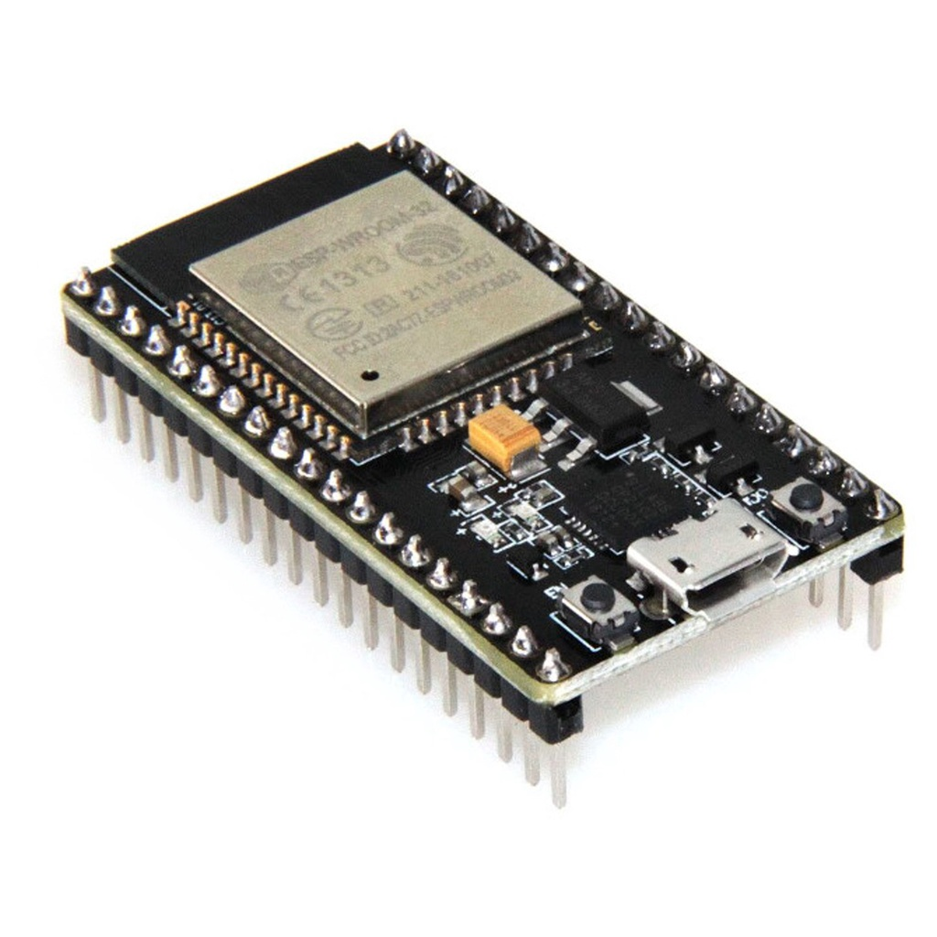 | Specification  Model used: ESP32 DevKit V1-compatible development board; ESP32-WROOM-32 class module.  Detected chip: ESP32-D0WD-V3, revision v3.1.  Processor: Dual-core Tensilica LX6, commonly up to 240MHz.  Wireless: Built-in Wi-Fi and Bluetooth/BLE capability.  Flash: 4MB SPI flash detected on the connected board.  USB interface: Silicon Labs CP210x USB-to-UART bridge.  Arduino board setting: ESP32 Dev Module with Huge APP partition scheme.  Project role: Main controller for pairing, telemetry, relay control, offline logging, voice prompts, and cloud synchronization.  Description of Its Working  The ESP32 serves as the central controller of the EnerTrack smart plug. After booting, it loads saved Wi-Fi and device credentials, connects to the network, and starts the local services needed for telemetry, relay control, and cloud synchronization.  It reads electrical values from the PZEM meter, sends updated device state to Firebase, checks cloud commands for relay/protection actions, writes offline records to the SD card when needed, and triggers voice prompts through the DFPlayer Mini.

PZEM-004T-100A Energy Meter
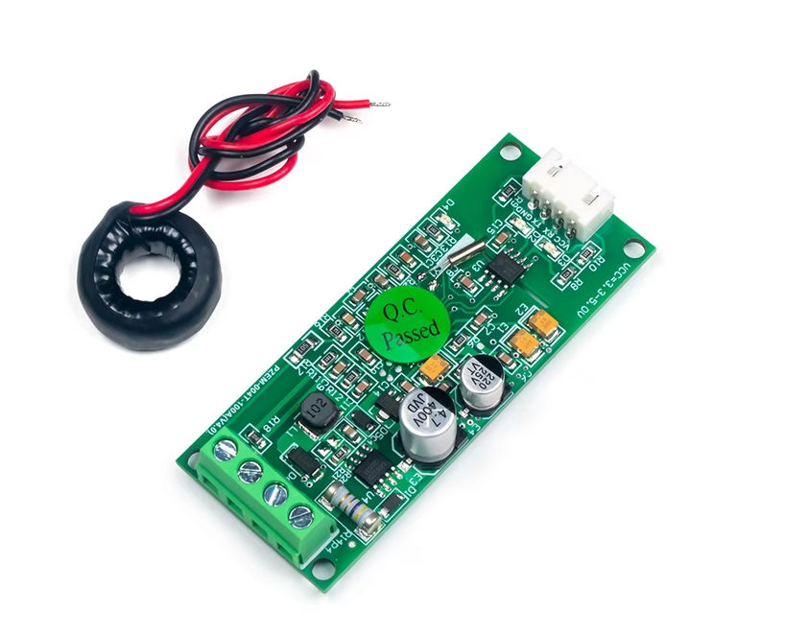 | Specification  Module type: AC multi-function energy monitoring module with external 100A current transformer.  Measured values: Voltage, current, active power, energy, frequency, and power factor.  Voltage range: Typically 80-260VAC for the monitored AC line.  Current range: 0-100A through the external CT clamp.  Communication: UART / Modbus RTU, commonly 9600 bps.  EnerTrack pins: PZEM TX to ESP32 GPIO16; PZEM RX to ESP32 GPIO17.  Project role: Provides the live electrical readings used by the app, statistics, automation, and cost calculations.  Description of Its Working  The PZEM module measures the AC load by sensing voltage from the monitored line and current through the external CT clamp. From these values, it calculates power, accumulated energy, frequency, and power factor.  The ESP32 requests these readings through the UART/Modbus connection. EnerTrack then uses the readings for the home screen, device details, monthly statistics, usage history, cost estimates, and protection decisions.

Relay Module
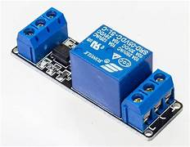 | Specification  Module type: Electromechanical relay switching module.  Control pin: ESP32 GPIO26.  Control logic: Active HIGH in the current firmware configuration.  Power: 5V relay module supply with common ground to ESP32.  Load path: Switches the AC line to the connected appliance through the relay contacts.  Project role: Turns the appliance ON or OFF from the mobile app, physical button, schedule, budget, or protection logic.  Description of Its Working  The relay module acts as the electrical switch of the smart plug. The ESP32 sends a digital signal to the relay input; when energized, the relay contact changes state and allows or stops power flow to the connected appliance.  Because the relay physically switches the appliance path, the app, manual push button, schedule automation, budget automation, and protection logic all pass through the ESP32 before changing the relay state.

DFPlayer Mini MP3 Module
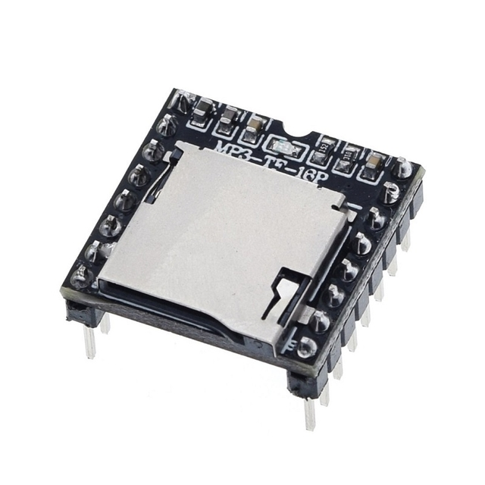 | Specification  Module type: Serial MP3 / voice playback module.  Storage: microSD / TF card using FAT16 or FAT32 file system.  Communication: UART TTL serial, default 9600 bps.  Power: Typically powered from 5V.  Audio output: Built-in amplifier for small speaker output through SPK1 and SPK2.  EnerTrack pins: DFPlayer TX to ESP32 GPIO32; DFPlayer RX to ESP32 GPIO33.  Track path: Voice files are stored in /MP3 using numeric filenames such as 0001.mp3.  Project role: Plays local voice status lines during setup, relay events, budget/schedule actions, and protection events.  Description of Its Working  The DFPlayer Mini stores prepared MP3 voice prompts on its own microSD card. The ESP32 does not generate audio directly; instead, it sends a serial command containing the track number that should be played.  When a relevant event occurs, such as setup starting, database registration succeeding, relay turning on or off, or automation triggering, the ESP32 queues the correct voice track and the DFPlayer plays it through the speaker.

Micro SD Card Module
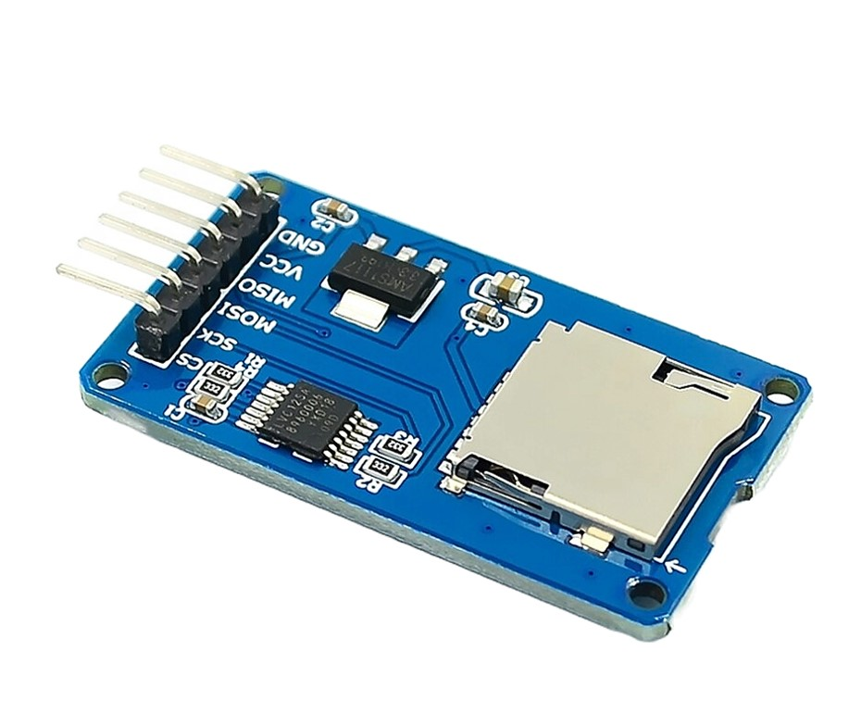 | Specification  Module type: Micro SD / TF card reader-writer module.  Communication: SPI interface.  File system: FAT16 / FAT32; FAT32 cards are recommended.  EnerTrack pins: SCK GPIO18, MISO GPIO19, MOSI GPIO23, CS GPIO5.  Power: 5V module supply, with common ground to ESP32.  Firmware SPI speed: Configured at 1MHz for improved reliability.  Project role: Stores offline telemetry and archived sync files so readings are not lost during internet loss.  Description of Its Working  The SD card module gives the ESP32 removable local storage. The ESP32 writes readings to the card when internet is unavailable or when records need to be archived locally.  When the network returns, the firmware can read pending offline logs from the SD card and upload them to the cloud. This makes the module the offline backup layer of EnerTrack's data system.

HLK-10M05 AC-DC Power Module
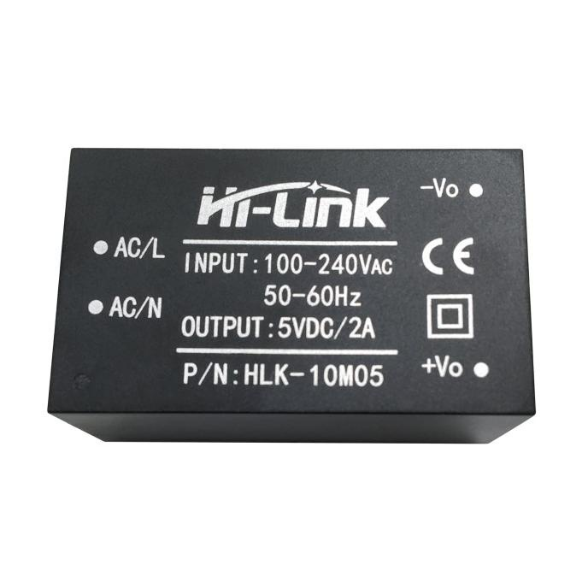 | Specification  Module type: Isolated AC-DC switching power supply.  Input: 85-264VAC input range, suitable for 100-240VAC mains.  Output: 5V DC, rated 2A, maximum 10W.  Efficiency: At least about 80% at full load based on module datasheet values.  Project role: Provides the main 5V supply for the ESP32, relay module, SD module, DFPlayer Mini, and other low-voltage circuits.  Safety note: Requires insulated enclosure, fuse protection, proper wire separation, and safe AC/DC clearance.  Description of Its Working  The HLK-10M05 converts household AC mains into regulated 5V DC for the smart plug electronics. Its isolated output powers the ESP32 and supporting low-voltage modules.  The module does not power the appliance load directly. The appliance still receives AC through the monitored and relay-switched load path, while the HLK module powers only the controller side of the system.

Push Buttons
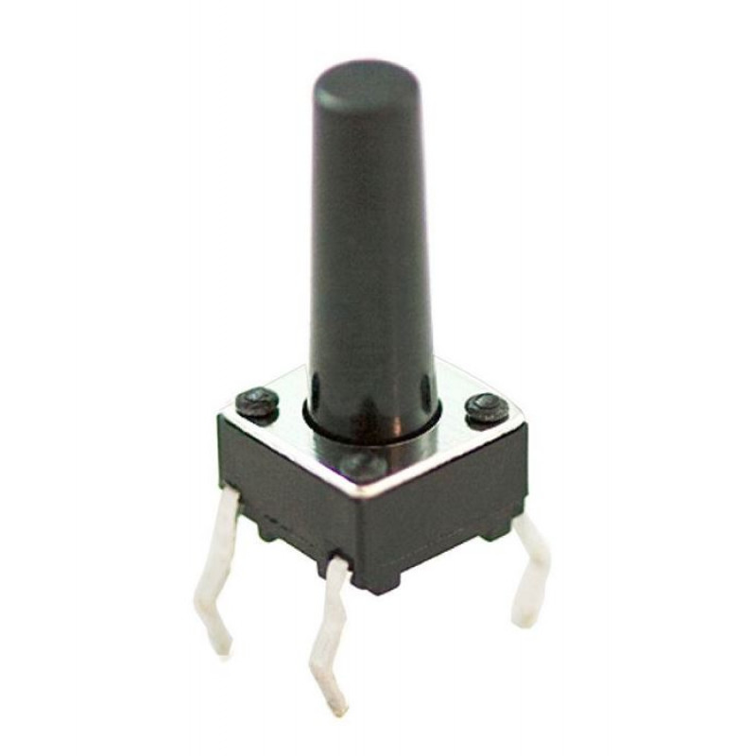 | Specification  Button type: Momentary normally-open push buttons.  Logic: Active LOW using ESP32 internal pull-up resistors.  Reset button: ESP32 GPIO27; hold for about 3 seconds to reset pairing state.  Manual relay button: ESP32 GPIO25; locally toggles relay ON/OFF.  Project role: Allows local reset and relay control without needing the mobile app.  Description of Its Working  The reset button is used for pairing reset, while the manual relay button directly toggles the relay. After a manual toggle, the ESP32 updates the device state so the app can reflect the actual relay condition.

DS1302 Real-Time Clock Module
PICTURE HOLDER  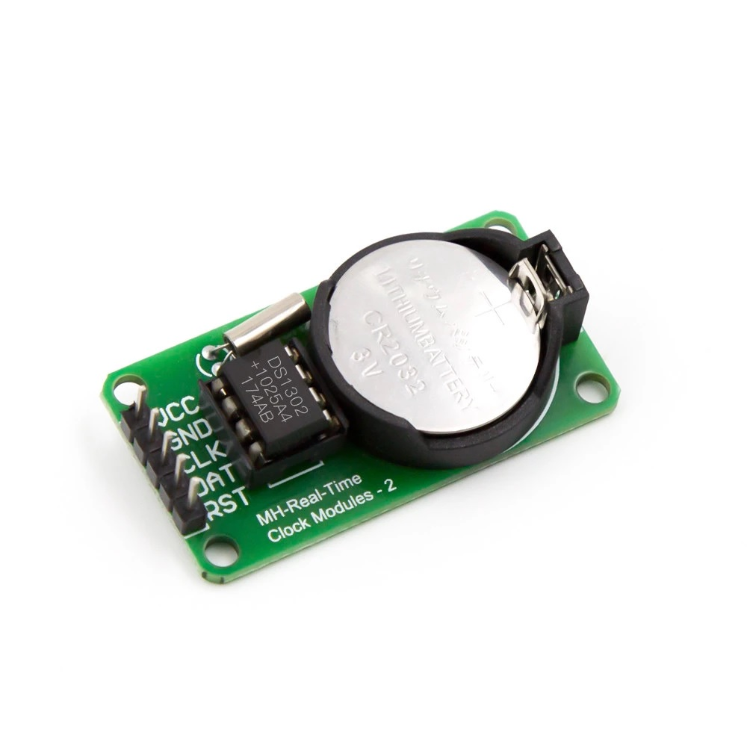 | Specification  Module type: Real-time clock/calendar module.  Communication: 3-wire serial interface.  Time data: Seconds, minutes, hours, day, date, month, and year.  Backup: Battery-backed timekeeping using a coin cell on the module.  EnerTrack pins: CLK GPIO21, DAT/I-O GPIO22, RST/CE GPIO4.  Project role: Keeps accurate local timestamps for offline SD card logs when internet time is unavailable.  Description of Its Working  The RTC keeps date and time even when the ESP32 has no internet connection. The ESP32 reads the RTC through its three-wire interface whenever it needs a local timestamp.  This is important for offline data logging. If the smart plug is disconnected from the internet, SD card records can still be saved with usable dates and times, then later synced without losing their original time context.

Green Status LED
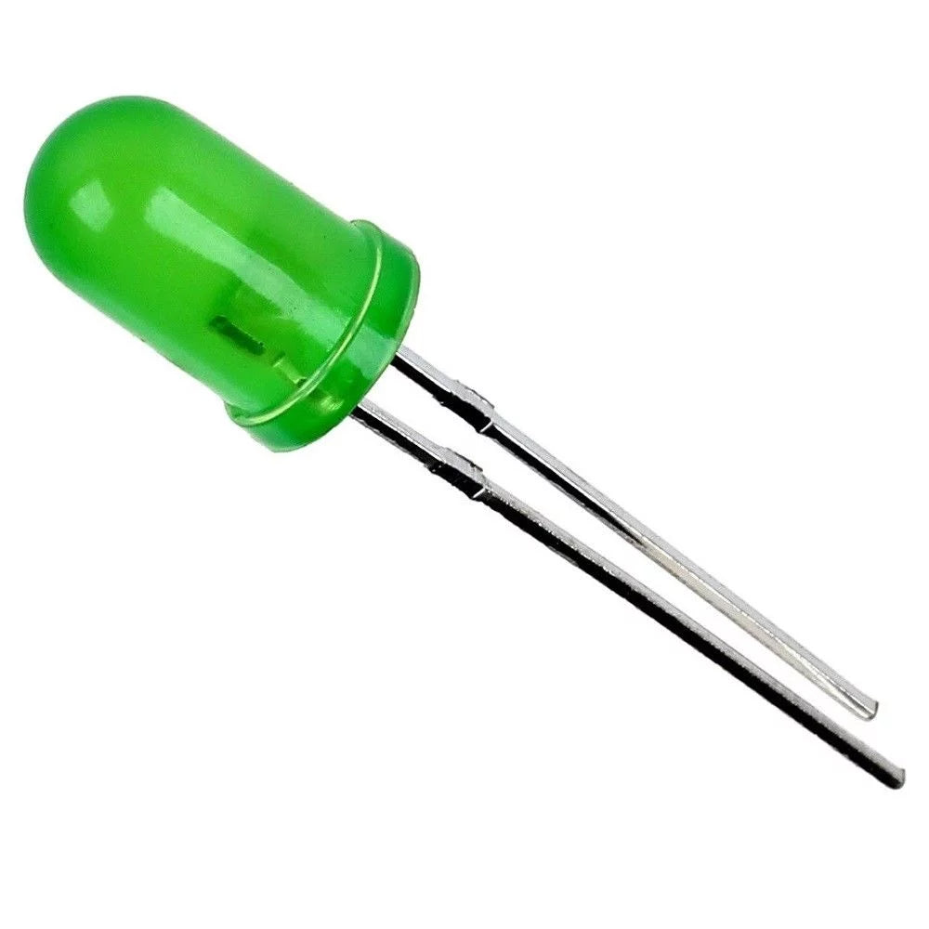 | Specification  Component type: Standard green indicator LED.  Logic: Active HIGH digital output from ESP32.  EnerTrack pin: GPIO2 through a current-limiting resistor.  Recommended resistor: 330 ohm to 1k ohm, depending on desired brightness.  Project role: Provides visual feedback for pairing, boot, connection, and local status indication.  Description of Its Working  The LED gives quick local status feedback during boot, pairing, setup, and connection-related states. This helps the user understand the device condition even without opening the app.

A.4 Pin and Connection Summary
Function / Module | ESP32 Pin | Connection Note
PZEM RX/TX | GPIO16 / GPIO17 | UART link between ESP32 and PZEM-004T-100A.
Relay control | GPIO26 | Digital output controlling relay module input.
Pairing reset button | GPIO27 | Active LOW momentary input to GND.
Manual relay button | GPIO25 | Active LOW momentary input to GND.
Green status LED | GPIO2 | Active HIGH output through current-limiting resistor.
RTC CLK / DAT / RST | GPIO21 / GPIO22 / GPIO4 | 3-wire DS1302 RTC interface.
SD SCK / MISO / MOSI / CS | GPIO18 / GPIO19 / GPIO23 / GPIO5 | SPI connection to Micro SD Card Module.
DFPlayer TX / RX | GPIO32 / GPIO33 | UART voice prompt module connection.
Low-voltage supply | 5V / GND | Powered from HLK-10M05 DC output; all low-voltage grounds are common.

A.7 Mobile App User Interface
The app user interface consists of the main navigation screens and supporting dialogs used to monitor, control, configure, and review EnerTrack smart plug data.
- Authentication Screen
- Home Screen
- Stats Screen
- Devices Screen
- Add Device / Pairing Interface
- Device Details Screen
- Settings Screen
- Profile Settings Screen
- Notifications Screen
- Search Interface
- Family Sharing Interface
- Energy Calendar Dialog
- Export / Report Preview Interface
Each interface has a specific role in the system. The table below describes the function of each screen and provides a placeholder where the corresponding screenshot can be inserted.
No. | Screen / Interface | Functionality | Screenshot
1 | Authentication Screen | Allows the user to create an account, sign in, and start a secured app session. This screen protects the app data so devices, usage logs, electricity rates, notifications, and shared-device access are tied to the correct account. | SCREENSHOT HOLDER  Authentication Screen
2 | Home Screen | Serves as the main smart plug dashboard. It displays the selected device status, relay state, signal status, live electrical readings, this-month consumption, estimated cost, protection state, live graph, and electrical details. It also lets the user select a device and control the relay when permission allows. | SCREENSHOT HOLDER  Home Screen
3 | Stats Screen | Displays energy trends, monthly and lifetime reports, estimated cost, insights, leaderboard ranking, energy calendar, and usage logs. It also lets the user export usage reports and filtered logs for documentation or billing review. | SCREENSHOT HOLDER  Stats Screen
4 | Devices Screen | Lists the user's smart plug devices and shared devices. It provides access to device cards, pairing a new smart plug, opening device details, and managing family sharing invitations or permissions. | SCREENSHOT HOLDER  Devices Screen
5 | Add Device / Pairing Interface | Guides the user through smart plug pairing. It handles Wi-Fi setup, smart plug detection, device naming, location assignment, device password creation, database registration verification, and the final restart instruction after pairing. | SCREENSHOT HOLDER  Add Device / Pairing Interface
6 | Device Details Screen | Shows detailed information for one selected smart plug. It includes live readings, monthly and lifetime values, energy trends, usage logs, schedule and budget automation, protection settings, SD/offline sync information, sharing controls, and maintenance actions such as device removal. | SCREENSHOT HOLDER  Device Details Screen
7 | Settings Screen | Contains account and app preferences. It lets the user update electricity rate settings, enable or disable push notifications, switch appearance/theme options, review export status, download saved reports, and access profile/account actions. | SCREENSHOT HOLDER  Settings Screen
8 | Profile Settings Screen | Allows the user to manage profile information and account-related actions. It is used for editing profile details, updating account credentials where supported, and performing account maintenance such as account deletion. | SCREENSHOT HOLDER  Profile Settings Screen
9 | Notifications Screen | Shows app notifications such as family invitations, electricity rate reminders, command results, protection events, device sharing updates, and system alerts. The user can review, mark as read, or clear notifications. | SCREENSHOT HOLDER  Notifications Screen
10 | Search Interface | Provides quick access to pages and major features. The user can search for devices, main tabs, export actions, live graph, add-device flow, and settings-related shortcuts. | SCREENSHOT HOLDER  Search Interface
11 | Family Sharing Interface | Lets the owner invite another user by email, assign which devices can be shared, and control the shared user's permission level. Invited users can accept invitations through the app notification flow. | SCREENSHOT HOLDER  Family Sharing Interface
12 | Energy Calendar Dialog | Displays daily energy use inside a monthly calendar view. It helps the user inspect which days have recorded consumption and review per-device breakdowns for a selected date. | SCREENSHOT HOLDER  Energy Calendar Dialog
13 | Export / Report Preview Interface | Shows generated CSV or PDF export records before download. It helps the user confirm the selected report or log content, then save the exported file to the device. | SCREENSHOT HOLDER  Export / Report Preview Interface

