**Otto-von Guericke University Magdeburg**



**Faculty of Economics and Management**

**Master Thesis**

**Choice Set Size Effect on Contracting in Supply Chain**

Author:

**Diego Arinze Uchendu**

**221616**

**Master Degree in Operations Research and Business Analytics**

April 23, 2021

Supervisor:

**Prof. Dr. Sven Müller**

**Chair of Operations Management**

I Table of Contents

Declaration III

II List of abreviations IV

III List of symbols V

IV List of figures VII

V List of tables VIII

Abstract IX

1 Introduction 1

2 Literature Review 2

2.1. Contracts in Supply chain 2

2.2. Supply chain coordination with Capacity reservation contract 2

2.3. Buyer's Considerations in contract negotiations 4

2.4. Choice Overload 4

2.5. Multinomial logit model in choice selection 6

3. Capacity Reservation Contract 7

3.1. Problem Definition 7

4. Buyer utility function and Choice Probability 10

5. Model Formulation 12

5.1. MINLP 12

5.2. MILP 15

6. Result 20

6.1. Model Comparison 20

6.2. Choice Set Effect 20

6.3. Shiny App 23

7. Conclusion 26

Appendix 1: R Shiny Code (Contract Menu and Some Results) 27

Appendix 2: MINLP GAMS CODE 35

Appendix 2: MILP GAMS CODE 39

Appendix 3: R Shiny Graphs 42

Bibliography 43

# 

# Declaration

I declare that this work is mine and also state that all documents used have been recognized and cited according to the University rules.

I have not copied the work of others in any form or manner.

Signed: ..............................................................................

Date: .................................

# II List of abbreviations

TSMC Taiwan semiconductor manufacturing company

SKU Stock keeping units

MNL Multinomial logit

EV Extreme value

MINLP Mixed integer non linear program

MILP Mixed integer linear program

# III List of symbols

$P_{ni}$ Probability of a choice maker $n$ selective an alternative $i$

$U_{ni}$ Utility of choice maker $n$ selective an alternative $i$

$V_{ni}$ Deterministic part of Utility of choice maker $n$ selective an alternative $i$

$ε_{ni}$ Stochastic part of Utility capturing the characteristics of choice maker $n$ and attributes of alternative $i$

$s$ Supplier manufacturing an electronic component

$b_{i}$ $i (low or high)$ buyer type demanding for the component to manufacture an end product.

$d$ demand for a manufactured component

$μ$ Average market demand for the manufactured component

$ξ$ Buyer’s private forecast information for the manufactured component

$ϵ$ demand uncertainty for the manufactured component

$p(ξ)$ Prior probability that buyer has private forecast information $ξ$

$K_{j}$ Capacity with Characteristics $j$

$Z_{l}$ Reservation fee with characteristic $l$

r Retail price

w Wholesale price

$C1$ unit cost of component

$C2$ Capacity installation cost

$π^{s}$ Supplier’s profit

$π^{b}$ Buyer’s profit

$π^{sc}$ Supply chain profit

$M$ Cardinality of choice set

$U_{i,j,l}$ The utility of the buyer type $b_{i}$ choosing a contract $(K_{j},Z_{l})$

$v_{i,j,l}$ The deterministic part of utility of the buyer type $b_{i}$ choosing a contract $(K_{j},Z_{l})$

$\overline{v_{i}}$ The deterministic part of utility of the buyer type $b_{i}$ choosing no contract

$ϵ_{i,j,l}$ The stochastic part of utility capturing the characteristics of buyer type $b_{i}$ and attributes of contract alternatives $(K_{j},Z_{l})$

$β_{π^{b}}$ Coefficient of Buyer’s profit $π^{b}$

$β_{m}$ Coefficient of cardinality of choice set $M$

# IV List of figures

Figure 1: *Supply chain between supplier and buyer* 8

Figure 2: *Expected Supplier Profit MINLP* 13

Figure 3: *Expected Supplier Profit MILP* 16

Figure 4: *Choice probability check and Contract selection* 17

Figure 5: *Offered Contract vs. Supplier Profit with contract Estimate*  22

Figure 6: *Contract Menu Generator* 24

Figure 7: *Compare Old and New Model Linear Model effect on contract* 25

Figure 8: *Expected Supplier Profit compared* 25

Figure 9: *Old Model effect on Supplier Profit* 42

Figure 10: *New Model Effect on Supplier Profit* 42

# V List of tables

Table 1: *Candidate contracts for both buyer types* 9

Table 2: *Buyers and chosen contracts from a supplier* 10

Table 3: Specification Table 11

Table 4: *Offered contract* 14

Table 5: *Contract per reservation fee and cardinality* 18

Table 6: *Contract per Capacity and cardinality* 18

Table 7: *Contract per cardinality and choice set size* 19

Table 8: *Model Comparison* 20

Table 9: *Supply chain Profit* 21

Table 10:*Offered contracts with only profit as the attribute* 21

Table 11:*Offered contracts with profit and Contract cardinality as attributes* 22

Table 12: *Choice set Effect on Opt-out Probability and Expected Profit* 23

Table 13: *Contract menu scale* 24

# Abstract

This study evaluates how the number of contract options presented to a buyer (she) from a supplier(he) affects the buyer's decision on contract selection.

Using a capacity reservation contract, the supplier aims to reduce his holding cost of stock by offering contracts to enable him to get the buyer's private forecast information while ensuring that the buyer selects a contract.

This study used choice-based optimization involving a multinomial logit model to ensure that a contract is selected. To account for the buyer's behavior towards how much she will make and how different sets of contracts affect her when deciding whether to pick a contract or not using a mixed-integer linear program.

Numeric studies show that the supply chain profit is better shared among parties involved while ensuring that the supplier's profit is maximized.

# 1 Introduction

The choices made in a supply chain can have a critical effect on a firm's survival; these choices are binding and can last for months, years, in some cases, decades. These choices usually come as a set of items or alternatives to choose.

According to (Özer and Wei 2006), how a contract is designed can play an essential role in how demand forecast information is shared.

Sometimes, demand uncertainty induced by unforeseen circumstances can significantly affect a supply chain. In 2020, a virus called Covid19 caused many disruptions in many industries in the supply chain, like low demand in the travel industry, transportation of goods, and humans. According to (Dragan 2021). This disruption caused some short down of production capacities. In some cases, additional safety regulations caused slowed down in logistics activities. According to (King et al. 2021), lead times for silicon chips used by Automobiles, computing, consumer electronics, etc., increased by 15 weeks.

A sharp swing in demand made companies like Taiwan Semiconductor Manufacturing Company (TSMC**)** plan to increase their capacity by 68% to $28 billion in 2021 (King et al., 2021)**.** Also this shortage could persist into 2022 **(**Mckellop 2021). There was a 59.1% year on year march 2020 drop in demand for total seat number reservation in Europe for airlines(centreforaviation.com 2021)**.**

Using a capacity reservation contract which ensures that a supplier gets credible demand forecast from the buyer Özer and Wei (2006), a supplier (he) can present a contract containing different levels of capacities with corresponding reservation fees in other to reduce holding cost of inventory. A good example of this is Apple (buyer) accounting for 53% of TSMC(supplier) 5nm chips capacity in 2021, with Qualcomm reserving 24% of TSMC capacity **(**Jeet 2021**)**

This supplier should be able to meet the demand of his buyers (she) who uses those components to manufacture an end product. Özer and Wei (2006).

This paper focuses on helping this supplier maximize his revenue while ensuring the buyer's participation in the contract by showing buyers the correct number of contracts. An extension of the existing model from (Römer et al,2020) factored buyer's profit as attribute when a buyer wants to make choice of contract; from the contract menu, the buyer is expected to pick the contract maximizes her utility. This helps in reducing choice overload, which according to (Scheibehenne et al.,2010) can make a choice-maker demotivated from making any choice. A higher number of alternative contracts can lead to opt-out scenarios where the choice maker (buyer) will not select a contract that is a component for manufacturing her end product.

The structure of the paper is as follows. The review of past writings on relevant literature is done in section 2. Section 3

# 2 Literature Review

## 2.1. Contracts in Supply chain

One of the significant attributes in choosing a contract is profit maximization in which both parties, the supplier and buyer, want to attain. The supplier must offer contracts that will induce the buyer to choose capacities(Order quantities) that maximize the supply chain's performance (Cachon 2003).

According to (Shen et al. 2018), matching demand with supply hinders supply chain performance; this usually brings about the bullwhip effect.

To ensure that goods are available at the right time, buyers need supply information while suppliers need to know customer demands; due to lack of knowledge of this information from both parties, this leads to information asymmetry in the supply chain (Sahin and Robson 2002).

According to (Amrani et al. 2012), partners in supply chain networks can experience several adverse effects due to information asymmetry such as backorders, customer dissatisfaction, late product arrival, etc. . A contract is needed to reduce these adverse effects of information asymmetry. Supply chain partners use contracts to ensure the stability and safety of their internal operations in a specific time horizon (Amrani et al., 2012).

According to Özer and Wei (2006), there are several contracts; only a few contracts can help achieve credible forecast information. These are the capacity reservation contract and advanced purchase contract.

## 2.2. Supply chain coordination with Capacity reservation contract

In a supply chain, the availability of information regarding the nature of future demand plays a crucial role in companies' planning decisions. The planning can be in the form of the amount of capacity a manufacturer can accumulate in anticipation of future demand. It is tough to foresee future demand in real life since customer preferences change all the time, and innumerable factors influence these. The uncertainty surrounding demand and uncertain prices brought about by market fluctuations influences demand forecasting accuracy immensely.

 Let us consider a supply chain made up of a manufacturer who produces a particular product type and a supplier who provides the manufacturers' components for production. To avoid long lead times (which negatively affects future demand), the supplier needs to ensure that they have adequate capacity to anticipate the manufacturer's demand. The decision on how much capacity to secure is greatly influenced by the purchase history of the manufacturer. This manufacturer on the other hand orders from the supplier in anticipation of demand from the retailer (final customers). The manufacturer is closer to the final consumer; therefore, they have more relevant demand information than the supplier. This phenomenon is known as information asymmetry.

Since the manufacturer has access to more relevant and up-to-date information, they may decide to exploit this to their advantage, often leading to business imbalance. On the other hand, the supplier may decide to adopt a conservative approach to capacity accumulation to reduce their risks. Anticipating this, the manufacturer may inflate the information they send to suppliers. This scenario often leads to the supplier securing either excessive or insufficient capacity, which affects prices and overall product availability. Information asymmetry results in adverse selection, moral hazard monopoly of knowledge, and forecast manipulation, which are all factors that contribute to the bullwhip effect, which has negative impacts on the supply chain efficiency and overall profits for all parties involved. (Lee et al. 1997)

To improve the supply chain's overall efficiency and increase the profits of all parties involved, manufacturers and suppliers often enter contracts. Some of these contracts include buy-back contracts, quantity flexibility contacts, and capacity reservation contracts to name a few. The focus of this section will be on capacity reservation contracts in the supply chain and how they are used to extract forecasting information. According to (Özer and Wei 2006),  a capacity reservation contract is a contract that is entered into by the supplier and the manufacturer whereby the suppliers reserve a given amount of component capacity units from the manufacturer. By doing this, the manufacturer shares credible demand-related information that the supplier uses to make more effective capacity planning decisions, which leads to reduced costs and uninterrupted product delivery for retailers. (Li et al., 2021).

Capacity reservation contracts reduce the negative impacts of information asymmetry by providing a means through which the manufacturer can access more reliable demand information (Vertical information sharing), enabling them to make better forecasting decisions. The manufacturer benefits from this contract since future capacity reservations are offered to them at wholesale prices. (Lv et al. 2015), (Serel et al. 2001) discuss further how vertical information sharing, via reservation contract schemes, impacts a firm's payoff.

## 2.3. Buyer's Considerations in contract negotiations

This section will discuss the buyer's aspect and what attributes buyers consider in contract negotiations.

(Cachon & Swinney 2009) studies the buyers' interaction with a retailer that sells products with uncertain demands over a finite selling season. They found that buyers act strategically: they choose not only whether to buy a product but when to buy the product and time their purchase based on their expectations of the retailer's markdown behavior and their disutility from purchasing late in the season.

(Yang et al., 2015). explores strategic customer behavior and compares the impact of a quick response in supply chain performance. The results showed that if the extra cost of quick response is relatively low, the value of quick response could be more significant in centralized systems than in decentralized systems.

(Park et al. 2006). presents new models to expand the scope of traditional models for the planning problem of chemical processes, considering the option of signing contracts and considering four primary cases have been considered: fixed price, discount after a certain amount, bulk discount, and fixed duration contracts. In the case of contracts signed with suppliers, direct benefits can be derived for the company, even in the deterministic case, owing to economies of scale.

## 2.4. Choice Overload

Choices and decision-making processes are an integral part of human life. The choices people face lead the way for future decisions they make. In virtually all areas of the supply chain ranging from retail sales to material supplies, Retailers view a variety of offerings as a way of pleasing customers and increasing their propensity to earn more revenue.

The existence of large varieties of assortments provides choice makers with freedom. However, many choices overwhelm decision-makers and result in significant regret, especially when decision-making processes are time-bound (Inbar et al., 2011).This situation can be aptly described sing a term called choice or assortment overload, and it exists for various reasons and in different circumstances. For instance, retailers may choose to add value to products by making varieties of stock-keeping units(SKU) available to consumers (Oppewal and Koelemeijer, 2005). However, the cost of carrying assortment SKUs is high; thus, the higher the number of SKUs, the higher the operational cost.

But adding a product to the assortment increases the probability of "no choice" (Abeliuk et al., 2015).

Despite studies showing that choice overload does lead to regret for decision makers, there have also been studies demonstrating that large choice sets are auspicious because humans have immense ability to manage and insatiable desire. According to (Iyengar & Lepper 2000), three studies show that despite the seeming desirability of vast more choices, large choice sets have dire consequences for human motivation and satisfaction. This is further evidenced in an experiment in which participants offered a large set of alternatives with limited time experienced more difficulty and frustration in deciding participants with far less set of alternatives (Haynes 2009).

In a further study, choice set complexity, preference uncertainty, decision task difficulty, and decision goal have been identified as key drivers of choice overload (Chernev et al., 2015).

In the light of the dilemma of choice overload faced by decision-makers, it has been suggested that choice sets should be restricted on the one hand. This is made possible due to new ways information can be extracted about the performance of an alternative. Like the use of Scanners to get attributes of this alternative, then with information collected, the decision on what alternative does not contribute much can be removed (Oppewal and Koelemeijer, 2005).

On the other hand, restructuring choice architectures to enhance decision quality while maintaining the size of the choice set has been espoused (Besedeš et al., 2015).

## 2.5. Multinomial logit model in choice selection

The multinomial logit (MNL) model is a family of the logit model. The MNL model incorporates the same assumptions as to the binary logit model, just that it is not restricted to two alternatives. These assumptions, as listed by (Koppelman and Bhat 2006,p.26) are;

* The error components are Gumbel extreme-value distributed over location ($η$) and scale ($μ$), that is EV ($η,μ$) thus producing a closed-form probability model,
* The error components are identically and independently distributed across observations/individuals,
* The error components are identically and independently distributed across alternatives.

The alternatives set in which a decision-maker is supposed to choose within is known as the choice set. Here all the alternatives are included such that the choice set is finite and exhaustive, and the alternatives are mutually exclusive. (Train 2012). These characteristics assure that no external choice be made and that a decision-maker or individual is liable to one choice at a particular time. This brings us to the selection problem.

For a decision-maker $(n)$ to select an alternative $(i)$, the utility probability $(P)$ for the chosen alternative must be greater than that of the other alternatives. Since utility is difficult to be perceived, researchers came with methods for calculating them and the MNL model is one of them.

$$P_{ni}={prob(U}_{ni}>U_{nj}) where i=1,2,….,j and ∀ i≠j (1)$$

The utility model is divided into two visible part, which is known as deterministic utility, and the unobservable part which is represented as the error component. . The deterministic utility is made up of the attributes of the alternatives (total travel time, total cost…) and the characteristics of the decision-maker (income, gender, experience…). The above formula is then broken down as below

$$P_{ni}=Prob\left(V_{ni}+ε_{ni}>V_{nj}+ε_{nj }∀ j≠i\right) (2)$$

Considering the three assumptions of the MNL model listed above, a generalized formula to calculate these probabilities is given by

$$P_{ni}= \frac{exp⁡(V_{i})}{\sum_{j=1}^{J}{exp⁡(V_{j})}} (3)$$

Results from the computed probability obtained will then be compared to each alternative in the choice set, and the one with the maximum utility will be selected. The MNL model is important because the choice sets vary with the decision-maker and the selected time. Also, the characteristics of the decision-maker can be incorporated into the explanatory variables. (McCracken et al. 1998).

We cannot speak of the MNL model without mentioning its independence of irrelative alternatives (IIA) property. This property explains that the ratio of two alternatives does not change irrespective of whether only both alternatives are available or if other choices could be selected. (McCracken et al. 1998).

This property is the principal disadvantage of the multinomial logit as the correlation between alternatives does not exist, whereas this is not always true. Since some alternatives usually share some common characteristics or attributes. An example of this is the red/blue bus problem.

# 3. Capacity Reservation Contract

## 3.1. Problem Definition

A Supplier wants to offer contracts to his buyers, but first, he has to ascertain the demand for his components with $d=μ+ξ+ϵ$ where demand follows a cumulative distribution function.

The supplier has two types of buyers, low type buyer whose demand $d≤μ$, where $μ$ is the average market demand, and high type buyer, where $d>μ$. But his buyer has no incentive to reveal her private forecast information $ξ$. Therefore the supplier assumes $ξ$, with zero mean varying between [$\underline{ξ},\overline{ξ}$ ] value for each buyer type, based on his prior probability distribution of $p(ξ)$. Also accounted in demand calculation is the demand uncertainty $ϵ$, lying in the interval [$\underline{ϵ},\overline{ϵ}$ ]. Both $ϵ$  and $ξ$  are continuously distributed variables (Römer et al. 2020).

This supplier has to provide a contract that contains with capacity $K_{j}$, where $j$ is capacity level ranging from no components to supply. Thus the minimum production capacity is $K^{min}=0$, to the maximum capacity $K^{max}=|K|$. With $J∈ N$.

$$K^{min}=μ +\underline{ξ} +\underline{ϵ} \left(4\right)$$

$$K^{max}=μ +\overline{ξ} +\overline{ϵ} \left(5\right)$$

Using this, we can now determine the boundaries for the reservation fees the buyer need to pay the supplier for a given capacity $K_{j}$.

Factored in this is the retail price $r$ per unit component from buyer to her customer and wholesale price $w$ per unit component sold from supplier to his buyer. Then the and reservation fees $Z_{l}$ where $l$ ranges from no fees charged denoted by $Z^{min}$ to maximum reservation fees charge denoted by $Z^{max}$ can be determined.

$$Z^{min }=\left(r-w\right)⋅E(min⁡(μ+\underline{ξ} +\underline{ϵ} ) \left(6\right)$$

$$Z^{min }=\left(r-w\right)⋅E(min⁡(μ+\underline{ξ} +\underline{ϵ} ) \left(7\right)$$

The supplier can then offer a list of contracts for the buyer the choose one contract $(K_{j}Z_{l})$ but in doing so, the supplier has to select a list of contacts that will maximize his profit while ensuring that the buyer does not opt-out; thus, the buyer should also make a profit.

Considering the profit of both supplier and the buyer, the component supplier manufactures a component at a $C1≥0$ per unit. The supplier installs capacity $K$ at the cost of $C2≥0$ done in anticipation of demand $d$.

The supplier's profit if a buyer chooses a contract and that of the buyer is as seen in equations (8) and (9), respectively.

r: retail price.

$$r>c_{1}+c_{2}$$

W: Wholesale price per unit

C1: unit cost of Tyre.

C2: capacity installation cost

Order

Supplier

Demand uncertainty

Deliver

Buyer

*Figure 1: Supply chain between supplier and buyer*

$$π^{s}\left(K_{j},Z_{l},ξ_{i}\right)=\left(w-c_{1}\right)⋅E\left[\min\left(μ+ξ_{i}+ϵ,K_{j}\right)\right]-c_{2}K_{j}+Z_{l} (8)$$

$$π^{b}\left(K_{j},Z_{l},ξ_{i}\right)=\left(r-w\right)⋅E\left[\min\left(μ+ξ_{i}+ϵ,K_{j}\right)\right]-Z_{l} (9)$$

With these, the supplier can then generate candidate contracts $C$ from which he can select some contracts to offer to the buyer.

If the buyer chooses a contract $(K_{j},Z_{l})$ that Maximizes her Profit $π^{b}$. In doing so, she reveals $ξ_{i}$ her Forecast Information (Özer and Wei 2006). This will now enable the supplier to plan for his capacity.

**3.2. Reservation Contract**

In planning for production capacity for production of components, the supplier saw that average market demand is $μ=2$ components, private forecast information of buyer is uniformly distributed $ξ\sim U(-1,1)$ and demand uncertainty $ϵ\sim U(-1,1)$. The capacity levels can be determined with a maximum capacity $K^{max}=5$ and minimum capacity of $K^{min}=0$. The Capacity levels considering a step size of 1 and Reservation fee levels having a step size of 0.25 are listed below achieved.

$K_{j}$ = Capacity Level $K_{j}=\left\{0,1,2,…,4\right\}, \left|K\right|=5$

$Z_{l}$ = Reservation Fee $K_{j}=\left\{0,0.25,0.5,..,4.5,4.75,5\right\} , \left|Z\right|=21$

Optimum contracts can be generated with this, sample as seen in the table below.

|  |  |  |  |  |
| --- | --- | --- | --- | --- |
| Buyer Type (b) | **Reservation Fee (Z)** | Capacity (K) | Buyer Profit ($π^{b}$) | Supplier Profit ($π^{s}$) |
| b1 | 0 | 2 | 1.5 | 0 |
| b1 | 0.25 | 2 | 1.25 | 0.25 |
| b1 | 0.5 | 2 | 1 | 0.5 |
| b2 | 0 | 2 | 3 | 1 |
| b2 | 0.25 | 2 | 2.75 | 1.25 |
| b2 | 0.5 | 2 | 2.5 | 1.5 |

*Table 1: Candidate contracts for both buyer types*

Presented in Table 1 is a part of the full table for two buyer types, for each buyer typed has $\left|K\right|×\left|Z\right|=105$ unique contracts and $\left|b\right|×\left|K\right|×\left|Z\right|=210$ unique variables.

Assuming buyer type $b_{i}$ take contract $\left(K_{j},Z_{l}\right)=(2,0)$. If this buyer is a low type buyer b1, with $ξ= -1$, meaning $d≤μ$, thus $d=μ+ξ+ϵ$ becomes $d=4-1-1$ here $d≡K_{j}$. This means the buyer wants two components but not ready to pay any reservation fee. The buyer's expected profit is $π^{b}=1.5$ while that of supplier is $π^{s}=0$.

# 4. Buyer utility function and Choice Probability

The utility of the buyer $b_{i}$ choosing a contract $(K_{j},Z_{l})$ is denoted as $U_{i,j,l}$.

$U_{i,j,l}=v_{i,j,l}+ϵ_{i,j,l } (10)$

$v_{i,j,l}$ is the deterministic part of utility while $ϵ_{i,j,l}$ is the stochastic part of utility contains values of a not factored attribute of the contract alternative and characteristics of the buyer.

As seen in Table 2, using arbitrary example for observations (buyers) and Choice cardinality, which is the number of contracts offered to the buyer to choose from and real values from candidate contracts for buyer profit and corresponding contract, a buyer considers her profit before choosing a contract from list of contracts offered by the supplier. In contrast, the choice cardinality attribute $M$ is a characteristic of a buyer whose values can be different for buyersbut the value of $M≥1$ same for all buyers.

|  |  |  |  |
| --- | --- | --- | --- |
| Obs | Buyer Profit $$π^{b}\left(K_{j},Z_{l},ξ_{i}\right)$$ | Choice Card (M) | Contract ${(K}_{j},Z_{l}$ ) |
| 1 | -1 | 3 | (2,2.5) |
| 2 | 0 | 2 | (4,4.5) |
| 3 | 0.125 | 1 | (3,4) |
| 4 | 0 | 0 | Opt-out |

*Table 2: Buyers and chosen contracts from a supplier*

From table 2, you can detect the buyer types if contracts are chosen, e.g. the first observation shows that buyer is a low type buyer because $d≤μ and d≡K$, thus $μ=2 and K=2, ∴d=2$. While observation 2 and 3 are high type buyers as buyer's demand is greater than average market demand.

The deterministic utility of choosing a contract $(K_{j},Z_{l})$ can have several alternatives which depends on the parameters of the $\overline{v_{i}}$  denoting opt-out alternative for buyer $b_{i}$, thus the utility of choosing no contract and $v_{i,j,l}$ represents the utility of buyer type $b_{i}$ of choosing a contract $(K_{j},Z_{l})$.

$\overline{v_{i}}=0 (11)$

$v_{i,j,l}=β_{π^{b}}⋅π^{b}\left(K_{j},Z_{l},ξ_{i}\right)-β_{m}M (12)$

|  |  |  |  |  |  |  |  |  |
| --- | --- | --- | --- | --- | --- | --- | --- | --- |
| Alt | $ξ_{ low}$ = -1 | | | | $ξ_{ high}$ =1 | | | |
| ${(K}_{j},Z_{l}$) | $$β_{π^{b}}$$ | **0** | $$β_{m}$$ | **0** | $$β_{π^{b}}$$ | **0** | $$β_{m}$$ | **0** |
| (2,2.5) | $$π^{b}\left(K_{2},Z_{2.5},ξ_{low}\right)$$ |  | M |  | $$π^{b}\left(K_{2},Z_{2.5},ξ_{high}\right)$$ |  | M |  |
| (4,4.5) | $$π^{b}\left(K_{4},Z_{4.5},ξ_{low}\right)$$ |  | M |  | $$π^{b}\left(K_{4},Z_{4.5},ξ_{low}\right)$$ |  | M |  |
| Opt-out |  | 1 |  | 1 |  | 1 |  | 1 |

Table 3: Specification Table

Choice set cardinality $M$ has a positive impact on the utility to opt-out, meaning the more significant the choice set at a certain point, the more significant is the probability to choose nothing. Then equations (11) and (12) changes to equations (13) and (14).

$\overline{v_{i}}=β_{m}M (13)$

$v_{i,j,l}=β_{π^{b}}⋅π^{b}\left(K_{j},Z_{l},ξ_{i}\right) (14)$

Alternatively, the choice set cardinality $M$ was included in the utility of contract alternative $v_{i,j,l}$ as seen in equation (12). This will mean a negative effect $β_{m}$ on the utility of contract alternative. Thus setting $\overline{v_{i}}=0$ as seen in equation (11). Thus, the higher the choice set cardinality $M$ the lower the utility of choosing a contract.

Also, buyer's profit has a positive effect on buyers' utility. Meaning the higher the profit, the higher the likelihood of choosing a contract. Thus, Buyers will like to choose contracts her utility while choosing from fewer contracts to avoid choice overload.

Both coefficients $β_{π^{b} }$ and ${ β}_{m}$ are generic, meaning having the same effect for all contracts as seen in Table 3.

Probability of a choice-maker in this case the buyer type $b_{i}$ choosing a contract $(K_{j},Z_{l})$.

$$P_{i,j,l}= \frac{e^{v_{i,j,l }}}{\sum_{j^{'}=1}^{J}{\sum_{l^{'}=1}^{L}{e^{v_{i,j^{'},l^{'}}}+e^{{\overline{v}}_{i}}}}} (15)$$

Probability of $b_{i}$ choosing an alternative is $0≤P_{i,j,l}≤1$ and the ${\sum_{j,l∈C_{i}}{P_{i,j,l}} }_{=}1 ∀ i .$

Independence for Irrelevant Alternatives Property (IIA)

$$\frac{P_{i,j,l}}{\overline{P_{i}}}=\frac{e^{v_{i,j,l}}}{e^{\overline{v_{i}}}}=e^{(v_{i,j,l}-v_{i})}=1 (16)$$

The ratio of the choice probability of choosing a buyer type $b_{i}$ choosing a contract $(K_{j},Z_{l})$ versus choosing no contract should be 1.

# 5. Model Formulation

## 5.1. MINLP

This MINLP formulation is used to gets optimum menu contracts from candidate contracts like in Table 1 that maximizes Supplier profit.

Model sets, parameters, and variables according to (Römer et al. 2020)

**Sets**

* $I$ Set of different private information $i$
* $J$ Set of different capacity levels $j$
* $L$ Set of different reservation fee levels $l$

**Parameters**

* $π^{s}(K_{j},Z_{l},ξ_{i})$ Profit of the supplier if a buyer chooses contract $(K_{j},Z_{l})$ given the buyer's private forecast information $ξ_{i}$ **.**
* $π^{b}(K_{j},Z_{l},ξ_{i})$ Profit of buyer for choosing contract $(K_{j},Z_{l})$ given the buyer's private forecast information $ξ_{i}$ **.**
* **M** Choice set cardinality for buyer $b_{i}$
* $β_{π^{b}}$ Profit estimate of for buyer profit $π^{b}(K_{j},Z_{l},ξ_{i})$
* $β_{m}$ Choice set cardinality estimate for choice set cardinality $M$
* $p(ξ_{i})$ A prior probability that buyer $b_{i}$ has private forecast information $ξ_{i}$ **.**
* $v_{i,j,l}$ Deterministic utility for buyer $b_{i}$ choosing contract $(K_{j},Z_{l})$**.**
* $\overline{v_{i}}$ Opt-out utility for buyer $b_{i}$ choosing no contract.
* $Z_{l}$ Contract Reservation fee in level $l$.

**Variables**

* $X_{i,j,l}$ Choice Probability of a buyer $b_{i}$ choosing a contract $(K_{j},Z_{l})$.
* $Y_{i,j,l}$ 1 if the contract $(K_{j},Z_{l})$ is offered, otherwise 0.
* $E[π^{s}]$ Expected profit of the Supplier (Objective function)

$max E\left[π^{s}\right]=\sum_{i=1}^{I}{p(ξ_{i})} \sum_{j=1}^{J}{\sum_{l=1}^{L}{X_{i,j,l}⋅π^{s}(K_{j},Z_{l},ξ_{i})}} (17)$

$$subject to.$$

$$X_{i,j,l}= \frac{e^{v_{i,j,l } }⋅Y_{j,l}}{\sum_{j'=1}^{J}{\sum_{l^{'}=1}^{L}{e^{v_{i,j^{'},l^{'} } }⋅Y_{j,l}}} +e^{\overline{v_{i}}}} ∀ i,j,l (18)$$

$${\sum_{j=1}^{J}{Y_{j,l}}≤1 ∀l (19) }^{ }$$

$${\sum_{l=1}^{L}{Y_{j,l}}≤1 ∀j (20) }^{ }$$

$${\sum_{j=1}^{J}{\sum_{l=1}^{L}{Y_{j,l}}}≤M ∀l (21) }^{ }$$

$$X_{i,j,l}≥0 ∀i,j,l (22)$$

$$Y_{j,l}∈\left\{0,1\right\} ∀j,l (23)$$

Equation (17) represents an Objective function that maximizes the supplier's expected profit. As illustrated in figure 2, The supplier knows that Buyer type $b_{i}$ has forecast information $ξ_{i}$ with $p(ξ_{i})$, this buyer type chooses a contract $(K_{j},Z_{l})$ with a choice probability of $X_{i,j,l}$ which results in supplier profit $π^{s}(K_{j},Z_{l},ξ_{i})$.

$$X_{\left\{1,1,1\right\}}⋅π^{s}(K_{1}, Z_{1}, ξ_{1})$$

$$l1$$

$$p_{(ξ_{1})}$$

$$j1$$

$$X_{\left\{1,1,2\right\}}⋅π^{s}(K_{1}, Z_{2}, ξ_{1})$$

$$l2$$

$$j2$$

$$i1$$

$$p_{(ξ_{2})}$$

$$X_{\left\{1,1,|z|\right\}}⋅π^{s}(K_{1}, Z_{|z|}, ξ_{1})$$

…

…

$$|Z|$$

$$|K|$$

$$i2$$

*Figure 2: Expected Supplier Profit MINLP*

Equation (18) represents an MNL choice probability $X_{i,j,l}$ **,** for a buyer type $b_{i}$ choosing a contract $(K_{j},Z_{l})$ which is determined by $Y_{j,l}$ **.**

How the contract is selected are represented from (19) to (21) and illustrated in Table 4

|  |  |  |  |  |  |
| --- | --- | --- | --- | --- | --- |
| J,L | j=1 | j=2 | j=3 | j=|K| |  |
| l=1 |  |  |  |  |  |
| l=2 |  |  |  |  |  |
| l=3 |  |  |  |  |  |
| l=|Z| |  |  |  |  |  |
|  |  |  |  |  |  |

*Table 4: Offered contract*

Equation (19) ensures selecting a contract from all manufacturing capacity levels with given a reservation fee. In table 4, given $l=2$ one of the contracts from ${(K_{1,}Z}_{2})$ to ${(K_{|K|,}Z}_{2})$ can be selected from capacity levels from $1$ to $|K|$.

Equation (20) ensures the selection of a contract from all reservation fee levels  with given a manufacturing capacity $K_{j}$. Given $j=2$, one contract from ${(K_{2,}Z}_{1})$ to ${(K_{2,}Z}_{|Z|})$ can be selected from reservation fee levels from $1$ to $|Z|$.

Equation (21) limits the choice set size to be offered to $M$, as illustrated in the last row and column of Table 4.

Equations (22) and (23) set boundaries for choice probability being positive and selecting the contract to be binary, respectively.

## 5.2. MILP

Converting MINLP to MILP using the best performing linear reformulation by Haase (2009) compared with other models by Haase and Müller (2014).

**Set**

$M$ Set of different Choice set cardinality $m$

**Parameters**

$v_{i,j,l,m}$ utility component of buyer type $b_{i}$ choosing contract ${(K}_{j, }Z_{l})$ with a choice set cardinality $m$.

$C$ Maximum Choice set cardinality of contracts offered, $C=|M|$

$Ratio_{i,j,l,m}$ Helps ensure IIA property is implemented

**Variables**

$X_{i,j,l,m}$ Choice probability of buyer type $b_{i}$ choosing contract ${(K}_{j},Z_{l})$ given a choice set cardinality $m$.

$\overline{X_{i}}$ Opt-out choice probability for buyer type $b_{i}$

$Y_{j,l,m}$ 1 if contract ${(K}_{j},Z_{l})$ is chosen at choice set cardinality $m$.

$E[π^{s}]$ Expected profit of the supplier.

$$max E\left[π^{s}\right]=\sum_{i=1}^{I}{p(ξ_{i})} \sum_{j=1}^{J}{\sum_{l=1}^{L}{π^{s}\left(K_{j},Z_{l},ξ_{i}\right) }}\sum_{m=1}^{M}{X_{i,j,l,m}} (24)$$

$$subject to.$$

$$\overline{X_{i}}+ \sum_{j=1}^{J}{\sum_{l=1}^{L}{\sum_{m=1}^{M}{X_{i,j,l,m}}≤1 ∀i } } (25)$$

$$X_{i,j,l,m}≤Y_{j,l,m} ∀i,j,l,m (26)$$

$$X_{i,j,l,m}≤ \frac{a_{i,j,l,m}}{\overline{a_{i}}} \overline{X_{i}} ∀i,j,l,m (27)$$

$$\sum_{j=1}^{J}{\sum_{m=1}^{M}{Y_{j,l,m}}≤1} ∀l (28)$$

$$\sum_{l=1}^{L}{\sum_{m=1}^{M}{Y_{j,l,m}}≤1} ∀j (29)$$

$$\sum_{j=1}^{J}{\sum_{l=1}^{L}{\sum_{m=1}^{M}{Y_{j,l,m}}}≤C} (30)$$

$$\sum_{m=1}^{M}{{m⋅Y}_{j,l,m} ≤C } ∀j,l (31)$$

$$X_{i,j,l,m}≥0 ∀i,j,l,m (32)$$

$$C≥0 ∀i (33)$$

$$Y_{j,l,m}∈\left\{0,1\right\} ∀j,l,m (34)$$

From equation (25) to (27), including (24) are a linear reformulation of $X_{i,j,l}$ from equation (18).

Equation (24) is the objective function for expected supplier profit with choice set cardinality considered, as seen in Figure 3. Thus, the choice probability of a buyer type $b_{i}$ choosing a contract $(K_{j},Z_{l})$ from a set of contracts with cardinality  **.**

…

…

…

*Figure 3: Expected Supplier Profit MILP*

Equation (25) ensures that the sum of choice probabilities of choosing contracts and choosing no contract is at most 1.

$$j1,l2,m1$$

$$X_{i1,j1,l2,m2}$$

$$j1,l1,m1$$

$$0$$

$$0$$

$$j1,l2,m2$$

$$i1$$

$$j1,l1,m2$$

$$X_{i1,j1,l1,m2}$$

$$i1$$

$$0$$

$$0$$

$$0$$

$$\overline{X_{i1}}$$

$$0$$

$$j1,l1,m3$$

$$j1,l2,m3$$

$$\overline{X_{i1}}$$

$$j1,l1,mc$$

$$no$$

$$j1,l2,mc$$

$$no$$

*Figure 4: Choice probability check and Contract selection*

Note: $K_{j1}=K_{1}, Z_{j1}=Z_{1}, mc=C$

Maximum number of contract that can be offered $C=\left|M\right|$

From the above figure representing equation (25), buyer type $b_{1}$ can choose contracts $(K_{1},Z_{1})$ or $(K_{1},Z_{2})$ from a set of cardinality $M=\{m1,m2,m3,mz\}$, or $b_{1}$ can also choose to opt-out. $∴ \overline{X_{i}}+X_{1,1,1,2}+X_{1,1,2,1}+…≤1$

(26) If a contract is offered, it allows the choice probability of selecting that contract to be greater than zero.

Expanding (27) ${{(X}_{i,j,l,m}=a}_{i,j,l,m}=e^{v_{i,j,l,m}})$ and $(\overline{X_{i}}=\overline{ a_{i}}=e^{\overline{v_{i}}})$, therefore $Ratio_{i,j,l,m} = \frac{a_{i,j,l,m}}{\overline{a_{i}}}$ see equation (16). This ensures ratio between contract and opt-out is obeyed.

(28) and (29) ensures that a contract is established in one cardinality or not at all.

|  |  |  |  |  |  |
| --- | --- | --- | --- | --- | --- |
|  | J=1, m=1 | J=1,m=2 | J=2,m=1 | J=2,m=2 | $$\sum_{j=1}^{J}{\sum_{m=1}^{M}{Y_{j,l,m}}≤1}$$ |
| l=1 | $$Y_{1,1,1}$$ | $$Y_{1,1,2}$$ | $$Y_{2,1,1}$$ | $$Y_{2,1,2}$$ | $$\sum_{j=1}^{J}{\sum_{m=1}^{M}{Y_{j,1,m}}≤1}$$ |
| l=2 | $$Y_{1,2,1}$$ | $$Y_{1,2,2}$$ | $$Y_{2,2,1}$$ | $$Y_{2,2,2}$$ | $$\sum_{j=1}^{J}{\sum_{m=1}^{M}{Y_{j,2,m}}≤1}$$ |

*Table 5: Contract per reservation fee and cardinality.*

From Table 5, reservation fee level $l=1$, one of the contracts from ${(K_{1,}Z}_{1})$ to ${(K_{2,}Z}_{1})$ can be selected from capacity levels from $1$ to $2$ and cardinality levels $m=\{1,2\}$., e.g., Assuming contract $(K_{1}, Z_{1})$ in cardinality m=2, then $Y_{1,1,2}=1,$ and the rest are zero.

|  |  |  |  |  |  |
| --- | --- | --- | --- | --- | --- |
|  | l=1, m=1 | l=1,m=2 | l=2,m=1 | l=2,m=2 | $$\sum_{l=1}^{L}{\sum_{m=1}^{M}{Y_{j,l,m}}≤1}$$ |
| j=1 | $$Y_{1,1,1}$$ | $$Y_{1,1,2}$$ | $$Y_{1,2,1}$$ | $$Y_{1,2,2}$$ | $$\sum_{l=1}^{L}{\sum_{m=1}^{M}{Y_{1,l,m}}≤1}$$ |
| j=2 | $$Y_{2,1,1}$$ | $$Y_{2,1,2}$$ | $$Y_{2,2,1}$$ | $$Y_{2,2,2}$$ | $$\sum_{l=1}^{L}{\sum_{m=1}^{M}{Y_{2,l,m}}≤1}$$ |

*Table 6: Contract per Capacity and cardinality.*

Table 6 describes equation (29), given capacity level $j=1$, one of the contracts from ${(K_{1,}Z}_{1})$ to ${(K_{1,}Z}_{2})$ can be selected from reservation fee levels $l=\{1,2\}$ and cardinality levels $m=\{1,2\}$., e.g., Assuming contract $(K_{1}, Z_{1})$ in cardinality m=2, then $Y_{1,1,2}=1,$ and the rest are zero.

(30) ensures that a number of contracts $C$ are established. E.g., the summation of contracts selected in tables 5 and 6 should not exceed $C$.

|  |  |  |  |
| --- | --- | --- | --- |
|  | m=1 | m=2 | $$\sum_{m=1}^{M}{{m⋅Y}_{j,l,m} ≤C }$$ |
| j=1,l=1 | $$1⋅Y_{1,1,1}$$ | $$2⋅Y_{1,1,2}$$ | $$\sum_{m=1}^{M}{{m⋅Y}_{1,1,m} ≤C }$$ |
| j=1,l=2 | $$1⋅Y_{1,2,1}$$ | $$2⋅Y_{1,2,2}$$ | $$\sum_{m=1}^{M}{{m⋅Y}_{1,2,m} ≤C }$$ |
| j=2,l=1 | $$1⋅Y_{2,1,1}$$ | $$2⋅Y_{2,1,2}$$ | $$\sum_{m=1}^{M}{{m⋅Y}_{2,1,l,m} ≤C }$$ |
| j=2,l=2 | $$1⋅Y_{2,2,1}$$ | $$2⋅Y_{2,2,2}$$ | $$\sum_{m=1}^{M}{{m⋅Y}_{2,2,m} ≤C }$$ |

*Table 7: Contract per cardinality and choice set size*

Equation (31) for a contract $(K_{j},Z_{l})$ the total number of contract alternatives or contract cardinality should not exceed $C$, given a contract $(K_{2},Z_{1})$ and choice set $m=\{1,2\}$. Remember not all contracts are selected; if $(K_{2},Z_{1})$ was selected in $m=2$, then $1⋅0+2⋅1≤Z$, then $2≤C$.

# 6. Result

Implementation of the MINLP and MILP was done in General Algebraic Modeling System 32.2.0 (GAMS). For MINLP using BONMIN solver and executed MILP model using CPLEX solver on 64-bit system running Windows 10 Home with Intel® Core™ i3-6006U CPU @ 2.00GHz 1.99 GHz.

Data for modeling can be generated using code in Appendix 1; results from GAMS extracted into Excel were automated using R and R shiny app to compare results between the old model from (Römer et al. 2020) and the new model as in equation (12).

## 6.1. Model Comparison

Changing the parameters, $β_{π^{b}} , β_{m}, and M$ to any values, the expected profit of the supplier remains the same for both MINLP and MILP, but different contracts can be selected.

Comparison between MINLP and MILP, choice set cardinality variable M for MINLP and C represents for MILP. Using MINLP variables to represent the table below.

With $β_{π^{b}}=1$ and $β_{π^{b}}=1$

|  |  |  |  |  |
| --- | --- | --- | --- | --- |
| M | MINLP (CPU(s)) | MILP (CPU(s)) | MINLP $E[π^{s}]$ | MILP $E[π^{s}]$ |
| 1 | 7.1 | 3.6 | 1.369 | 1.369 |
| 5 | 18.0 | 6.16 | 0.341, | 0.343 |
| 10 | 35.27 | 6.7 | 0.004 | 0.004 |
| 15 | 44.7 | 9.7 | 0.000031 | 0.000027 |

*Table 8: Model Comparison*

Table 8: shows the average seconds it takes to run this model, as observed. For MINLP, this shows that increase in the choice set cardinality affects the execution time of this model, also the execution time of MINLP is much higher that of MILP, but the $E[π^{s}]$ for both models are almost similar, both in many cases precisely the same.

## 6.2. Choice Set Effect

The Attribute of the alternative Profit is a significant reason for picking a contract; both the supplier and buyer want to increase their profit, but the supply chain profit remains the same. The expected profit of the supply chain is the summation of profits of supplier and buyer, $E\left[π^{sc}\right]=E\left[π^{b}\right]+E[π^{s}]$ (Römer et al. 2020). Using Supply chain parameters from Table 1. Table 9 shows Supply chain profit $E\left[π^{sc}\right]$.

|  |  |  |
| --- | --- | --- |
| Capacity | Profit ( $ξ_{low})$ | Profit($ξ_{high}$) |
| 0 | 0 | 0 |
| 1 | 1.375 | 2 |
| 2 | 1.5 | 4 |
| 3 | 1 | 5.375 |
| 4 | 0.5 | 5.5 |

*Table 9: Supply chain Profit*

Profit for both buyer types are shown, with supply chain profits lower, when low type buyer is involved.

Illustrating how contracts are assigned and with profit as the only attributes affecting the utility of buyer type $b_{i}$ in choosing contract $(K_{j},Z_{l})$, $v_{i,j,l}=β_{π^{b}}⋅π^{b}\left(K_{j},Z_{l},ξ_{i}\right)$.

Given parameters, $M=4$ and $β_{π^{b}}=1$, the optimal contract below was generated.

|  |  |  |  |  |  |  |
| --- | --- | --- | --- | --- | --- | --- |
| Nr | $$K_{j}$$ | $$Z_{l}$$ | Buyer Profit($ξ_{low}$) | Buyer Profit($ξ_{high}$) | Supplier Profit($ξ_{low}$) | Supplier Profit($ξ_{high}$) |
| 1 | 1 | 4.25 | -3.125 | -2.75 | 4.5 | 4.75 |
| 2 | 2 | 5 | -3.5 | -2 | 5 | 6 |
| 3 | 3 | 4.5 | -3 | -0.375 | 4 | 5.75 |
| 4 | 4 | 4.75 | -3.25 | -0.25 | 3.75 | 5.75 |

*Table 10: Offered contracts with only profit as the attribute*

As seen above, this contract sets does not favor the Buyer, A low type buyer selecting contract Nr 2, demand of 2 components and with a reservation fee of €5, will have a loss of €3.5, with a supply chain profit of €1.5, this enables the supplier to gain a profit of €5. And $E\left[π^{s}\right]=€3.95$ considering all the four contracts.

Adding the choice set as an attribute as seen in equation (12), with $M=4$, $β_{π^{b}}=1$ and $β_{m}=1$, this shifts some of the supply chain profit to the buyer.

|  |  |  |  |  |  |  |
| --- | --- | --- | --- | --- | --- | --- |
| Nr | $$K_{j}$$ | $$Z_{l}$$ | Buyer Profit($ξ_{low}$) | Buyer Profit($ξ_{high}$) | Supplier Profit($ξ_{low}$) | Supplier Profit($ξ_{high}$) |
| 1 | 1 | 1.5 | -0.375 | 0 | 1.75 | 2 |
| 2 | 2 | 1 | 0.5 | 2 | 1 | 2 |
| 3 | 3 | 0.75 | 0.75 | 3.375 | 0.25 | 2 |
| 4 | 4 | 1.25 | 0.25 | 3.25 | 0.25 | 2.25 |

*Table 11: Offered contracts with profit and Contract cardinality as attributes*

As seen in Table 11, the buyer's profit increased, and the reverse happened for the supplier when compared to Table 10 and $E\left[π^{s}\right]=€0.595$.



*Figure 5: Offered Contract vs. Supplier Profit with contract Estimate*

Figure 5 shows Offered contract, which is $M$ in equation (12) and $β_{m}$ being contract estimate. The increase in $M$ or $β_{m}$ leads to a decrease in $E[π^{s}]$. The reason for this is that as $β_{m}$ reduces the utility of buyer choosing a contract; thus, an increase in $M$ will result in to decrease in choice probability and an increase in the probability of opt-out. This can be seen in Table 12.

|  |  |  |  |
| --- | --- | --- | --- |
| M | $$\overline{X_{1}}$$ | $$\overline{X_{2}}$$ | $$E[π^{s}]$$ |
| 1 | 0.881 | 0.269 | 1.369 |
| 2 | 0.873 | 0.293 | 1.238 |
| 3 | 0.868 | 0.363 | 0.918 |
| 4 | 0.905 | 0.463 | 0.595 |
| 5 | 0.982 | 0.625 | 0.343 |

*Table 12: Choice set Effect on Opt-out Probability and Expected Profit*

Table 12 shows how an increase in choice set M, affect the choice probability of buyer to opt-out both for low buyer type $\overline{X_{1}}$ and high buyer type $\overline{X_{2}}$ and Supplier's Expected profit $E[π^{s}]$.

An increase in choice set Generally results in an increase in both $\overline{X_{1}}$ and $\overline{X_{2}}$ and decrease in $E[π^{s}]$.

The values of the no choice probabilities $\overline{X_{i}}$ displayed are high as a result the assumption of the ratios between $\frac{β_{π^{b} }}{β_{m}}=1$ as $M$ increases, but $\overline{X_{2}}> \overline{X_{1}}$ because better contracts options were offered to high type buyer when compared with low type buyer, thus $b_{2}$ is less likely to opt-out than $b_{1}$.

Illustrating with table 11, Contracts Nr1 to Nr2 are offered to low type buyer, if her demand $d=2$ means that her $d≤μ$ since $μ=2$. This buyer has revealed her private forecast information by selecting contract Nr2. Then contracts with $K≤2$ are offered.

Contracts Nr3 to Nr4 are offered to high type buyers, with high private forecast information $d>μ$.

## 6.3. Shiny App

The development of R shiny app, complemented GAMS in several ways, the first part as seen in Figure 6.

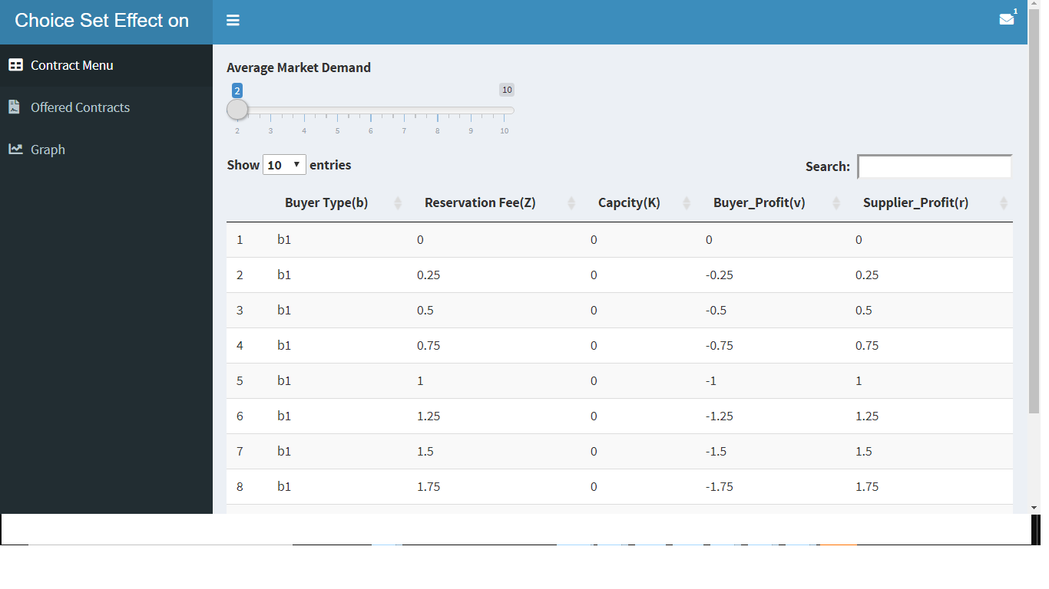

*Figure 6: Contract Menu Generator*

This Generated contract Menu based on Average Market Demand $μ$ as in the slider in figure 6, from this contract values, starting with $μ=2$ being the value used for this research as defined in section 3.2 Reservation Contract, or scale up to $μ=10$, used by (Römer et al. 2020). The higher the average market demand, the higher the computational time.

|  |  |  |  |  |
| --- | --- | --- | --- | --- |
|  |  | |Z| | contracts | $X_{i,j,l}$ variables |
| 2 | 5 | 21 | 105 | 210 |
| 4 | 9 | 37 | 333 | 666 |
| 6 | 13 | 57 | 741 | 1482 |
| 8 | 17 | 73 | 1241 | 2482 |
| 10 | 21 | 93 | 1953 | 3906 |

*Table 13: Contract menu scale*

Table 13 represents contracts and variables generated as the slider shifts between 2 to 10.

These Data generated is then used to populate the GAMS Mathematical model as defined in section 5.

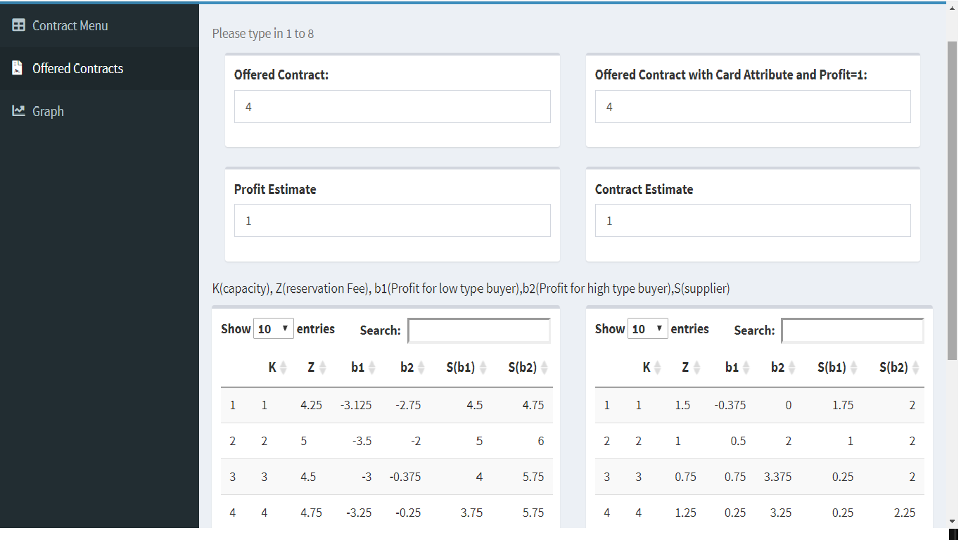

*Figure 7: Compare Old and New Model Linear Model effect on contract*

Seen in Figure 7 is the comparison between Models from (Römer et al. 2020) at the left (Offered Contract M, Profit Estimate $β_{π^{b}}$) and the model in equation (12) displayed to the right (Offered Contract M, Profit Estimate $β_{π^{b}}=1$ and Contract Estimate $β_{m}$) .

One can compare both models by changing the values in those boxes and can notice the properties explained in section 6.2 about $E\left[π^{s}\right]$ still persist.

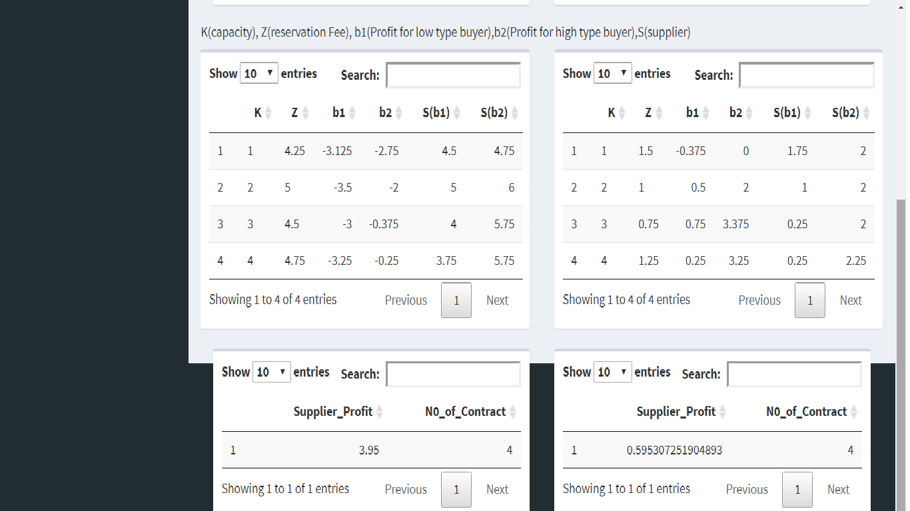

*Figure 8: Expected Supplier Profit compared*

You can notice this in Figure 8, as $E\left[π^{s}\right]$ at the right (when choice set cardinality as attribute) is always smaller than $E\left[π^{s}\right]$ at the left (Model from Römer et al (2020)) because choice set cardinality as an attribute enables the buyer to gain more profit from $E\left[π^{sc}\right]$.

The graphical comparison can of how Offered Contracts (Number of Contracts) effect $E\left[π^{s}\right]$ in Appendix 3, Figures 9 and 10, and for more numeric comparisons, visit <https://diegouchendu.shinyapps.io/contract_app/>.

# 7. Conclusion

A choice-based Optimization model from (Römer et al. 2020) was adapted to include choice set cardinality as an attribute. This changed several values from the original paper like buyer expected profit increased, due to better contracts was offered to buyers, this came as a result higher choice probability of a buyer which affects the expected profit of the supplier can only be attained when a reduced contract size is shown to a buyer. This links with the choice probability representing the bounded rationality of a buyer (basov 2009).

Also seen is the comparison between MINLP and MILP, these models approximately have the same values for the objective function supplier expected profit, but MILP is much faster, showing the efficacy the model conversion from linear reformulation by Haase (2009) presented by reformulations for MNL (Haase and Müller 2014).

However, it is also worth finding how other attributes of a contract and characteristics of a buyer affect the buyer's choice probability.

# Appendix 1: R Shiny Code (Contract Menu and Some Results)

library(shiny)

library(shinydashboard)

library(kableExtra)

library(pracma)

library(xlsx)

library(ggplot2)

library(tidyverse)

library("openxlsx")

contract <- function(mu){

#mu<-2

eta<-c(-mu/2,mu/2)

a<- -mu/2

b<- mu/2

p= c(1/2,1/2); # probability of eta (xi)

n=length(p);

c=0;

ck=0.5;

w=1;

r=2.5;

#R=0;

#Sout=0;

#th= c(.1,.1);

#CR=(r-c-ck)/(r-c)

#}

K<- vector(mode = "numeric",2)

Z<- vector(mode = "numeric",2)

K[1] <- mu+ eta[1]+a

#paste0("Min Capacity ",K[1])

K[2] <- mu + eta[2]+b

#paste0("Max Capacity ",K[2])

Kmin <- K[1]

etamin <- eta[1]

min.fee <- function(r,w,a,b,Kmin,mu,etamin){

tmp1<- function(s) punif(s,a,b)

Zmin=(r-w)*(Kmin-integrate(tmp1,lower= -Inf,upper = (Kmin-mu-etamin))$value)

return(Zmin)

}

Zmin <- min.fee(r,w,a,b,Kmin,mu,etamin)

#paste0("Min Fees ",Zmin)

funk25=function(s) punif(s,a,b)

Kmax <- K[2]

etamax <- eta[2]

max.fee <- function(r,w,a,b,Kmax,mu,etamax){

tmp1<- function(s) punif(s,a,b)

Zmax=(r-w)*(Kmax-integrate(tmp1,-Inf, (Kmax-mu-etamax))$value)

return(Zmax)

}

Zmax=max.fee(r,w,a,b,Kmax,mu,etamax)

Zmax=ceiling(Zmax)

#paste0("Max Fees ",Zmax)

Schrittweite_k = 1

#Schrittweite_z = 1

Schrittweite_z=0.25

Schrittfaktor_k = 1/Schrittweite_k

Schrittfaktor_z = 1/Schrittweite_z

k_set<- seq(Kmin,Kmax,Schrittweite_k)

z_set<- seq(Zmin,ceil(Zmax),Schrittweite_z)

rows= (length(k_set)*length(z_set))*2#(2* ((ceil(Zmax)*Schrittfaktor_z)+1)*((Kmax+1)*Schrittfaktor_k)) + 1 # +1 includes header

#rows

con = matrix(0,nrow =rows ,ncol = 6) # only the head column is created

#con[1,] <- c(paste(c('b','c','K','Z','v','r'), sep= " "))

colnames(con)<-c('b','c','K','Z','v','r')

# Main code

#i=2

i=1

for(type in 1:2){

if(type==1){

name= 'b1'

etas=eta[1]

connum=1

}else{

name = 'b2'

etas=eta[2]

connum=1;

}

for(k in k_set){

#loop from 0 to 20 for z, thus the highest z value is 23 accouting to Zmax * Schrittfactor_k

for(z in z_set){

#loop from 0 to 23 for z, thus the highest z value is 23 accouting to Zmax * Schrittfactor_z

seit= z # Steps of Discritization of set payment

#if(seit > 2*k){

#next

#}

#if(seit < 0.5* k){

#next

#}

B= (r-w) * (k-integrate(funk25,-Inf,k-mu-etas)$value )-seit

S= (w-c)*(k-integrate(funk25,-Inf,k-mu-etas)$value)+seit-ck*k

SC=(r-c)*(k-integrate(funk25,-Inf,k-mu-etas)$value)-ck*k

con[i,1]=name

con[i,2]=connum

con[i,3]=paste(k)

con[i,4]=paste(seit)

con[i,5]=round(B,6)

con[i,6]=round(S,6)

#con= rbind(con,c(con[i,1],con[i,2],con[i,3],con[i,4],con[i,5],con[i,6]))

i= i+1 # next line

connum=connum+1 # next contract

}

}

}

#head(con)

# con[1:20,]

#kable(unique(con),digits = c(1,1,1,1,1,1),"pandoc",caption = "Discretized Candidate contracts")

--#excel_file<- paste0("contract_set",b,".xlsx")

--#write.xlsx(data.frame(b=c("b1","b2"),row.names = NULL), file = excel_file,sheetName = "buyer",row.names = FALSE, append = FALSE)

--#write.xlsx(data.frame(K=k_set,row.names = NULL), file = excel_file,sheetName = "capacity",row.names = FALSE, append = TRUE)

# Add a second data set in a new worksheet

--#write.xlsx(data.frame(Z=z_set,row.names = NULL), file = excel_file, sheetName="sidepayment", row.names = FALSE, append=TRUE)

# Add a third data set

#con[,c(1,4,3,5)]

--#write.xlsx(unique(data.frame(con[,c(1,4,3,5)],row.names = NULL)), file = excel_file,sheetName="utility", row.names = FALSE, append=TRUE)

--#write.xlsx(unique(data.frame(con[,c(1,4,3,6)],row.names = NULL)), file = excel_file,sheetName="revenue", row.names = FALSE, append=TRUE)

return(data.frame(con))

}

Data<- read.xlsx("New_irrational_12.xlsx",sheet = 5)

#Data[,1:2]

contract_set1<- read.xlsx("contract_set1.xlsx",sheet = 6)

#head(contract_set1)

select_contract<- function(oc,ce){

contract_by_offered<-Data2%>% filter(Offered_Contract==oc & Profit_Estimate== ce)

contract_low_high<-contract_set1 %>% inner_join(contract_by_offered,by=c("Z"="Res_Fees","K"="Capacity"))%>% select(b,Z,K,v,r)

contract_low_high<-contract_low_high%>%filter(b=="b1")%>%inner_join(contract_low_high%>%filter(b=="b2"),by=c("Z"="Z","K"="K"))%>%select(K,Z,v.x,v.y,r.x,r.y)%>%`colnames<-`(c("$K_j$","$Z_l$","$Buyer (??=-1)$", "$Buyer(??=1)$","$Supplier(??=-1)$","$Supplier(??=1)$"))

return(contract_low_high)

}

select_contract2<- function(oc,ce){

contract_by_offered<-Data%>% filter(Offered_Contract==oc & Contract_Estimate== ce)

contract_low_high<-contract_set1 %>% inner_join(contract_by_offered,by=c("Z"="Res_Fees","K"="Capacity"))%>% select(b,Z,K,v,r)

contract_low_high<-contract_low_high%>%filter(b=="b1")%>%inner_join(contract_low_high%>%filter(b=="b2"),by=c("Z"="Z","K"="K"))%>%select(K,Z,v.x,v.y,r.x,r.y)

#ξ %>%kable()

return(contract_low_high)

}

Data2<- read.xlsx("Existing_irrational_12_p1.xlsx",sheet = 5)

#Data#[,1:2]

contract_set1<- read.xlsx("contract_set1.xlsx",sheet = 6)

ui <- dashboardPage(

dashboardHeader(title = "Choice Set Effect on Contract in Supply Chain",

dropdownMenu( type = 'message',

messageItem(

from = 'LinkedIn',

message = "",

icon = icon("linkedin"),

href = "https://www.linkedin.com/in/diego-uchendu-1970188b/"

)

)),

dashboardSidebar(

sidebarMenu(

menuItem("Contract Menu",

tabName = "contract_menu",

icon = icon("table")),

menuItem("Offered Contracts",

tabName = "Offered_Contracts",

icon = icon("file-contract")),

menuItem("Graph",

tabName = "Graph",

icon = icon("chart-line"))

)

),

dashboardBody(

tabItems(

tabItem(tabName = "contract_menu",

sliderInput(inputId ="Demand",

label = "Average Market Demand",

min=2,

max=10,

value = 2),

fluidRow(column(12,DT::dataTableOutput("table")))

),

tabItem(tabName = "Offered_Contracts",

helpText("Please type in 1 to 8"),

box(numericInput(inputId = "Offered_Contract",

label = "Offered Contract:",

min = 1,

max = 8,

value = 4)),

box(numericInput(inputId = "Offered_Contract2",

label = "Offered Contract with Card Attribute and Profit=1:",

min = 1,

max = 8,

value = 4)),

box(numericInput("Estimate",

"Profit Estimate",

min=1,

max=9,

value=1) ),

box(numericInput("Estimate2",

"Contract Estimate",

min=1,

max=9,

value=1) ),

#selectInput(inputId = "graph",

#label = "Choice Set Effect",

#choices =list("No Choice Cardinality","Choice Cardinality")),

h5("K(capacity), Z(reservation Fee), b1(Profit for low type buyer),b2(Profit for high type buyer),S(supplier)"),

fluidRow(box(fluidRow(column(12,DT::dataTableOutput("table_menu")))),

box(fluidRow(column(12,DT::dataTableOutput("table_menu2"))))),

box(DT::dataTableOutput("Supplier_Profit")),

box(DT::dataTableOutput("Supplier_Profit2"))

),

tabItem(tabName = "Graph",

plotOutput('plot1'),

plotOutput('plot2')

)

)

)

)

server <- function(input,output,session){

output$table <- DT::renderDataTable(DT::datatable({

data<- contract(mu=input$Demand)

data<-data[,c("b","Z","K","v","r")]

colnames(data)<-c("Buyer Type(b)","Reservation Fee(Z)","Capcity(K)","Buyer_Profit(v)","Supplier_Profit(r)")

#if(input$Buyer_type=="Rational_buyer"){

#data<- contract(mu=input$Demand)

#data<-data[,c("b","Z","K","v","r")]

#data<-subset(data,v>0 & r>0)

#}

data

}))

output$table_menu <- DT::renderDataTable(DT::datatable({

#if(input$graph=="No Choice Cardinality"){

data2<- data.frame(select_contract(input$Offered_Contract,input$Estimate))

colnames(data2)<- c("K","Z","b1","b2","S(b1)","S(b2)")

#}

data2

}))

output$table_menu2 <- DT::renderDataTable(DT::datatable({

#if(input$graph=="Choice Cardinality"){

data2_2<- data.frame(select_contract2(input$Offered_Contract2,input$Estimate2))

colnames(data2_2)<- c("K","Z","b1","b2","S(b1)","S(b2)")

#"Buyer(Low Forecast)","Buyer(high Forecast)","Supplier(Low Forecast)","Supplier(high Forecast)

data2_2

}))

output$Supplier_Profit<-DT::renderDataTable(DT::datatable({

#if(input$graph=="No Choice Cardinality"){

Data_profit<- read.xlsx("Existing_irrational_12_p1.xlsx",sheet = 1)

data3<-Data_profit%>% filter(Offered_Contract==input$Offered_Contract & Profit_Estimate== input$Estimate)%>% select(Supplier_Profit,N0_of_Contract)

#}

data3

}))

output$Supplier_Profit2<-DT::renderDataTable(DT::datatable({

#if(input$graph=="Choice Cardinality"){

Data_profit<- read.xlsx("New_irrational_12.xlsx",sheet = 1)

data3_2<-Data_profit%>% filter(Offered_Contract==input$Offered_Contract2 & Contract_Estimate== input$Estimate2)%>% select(Supplier_Profit,N0_of_Contract)

#}

data3_2

}))

output$plot1 <- renderPlot({

Data_profit2<- read.xlsx("Existing_irrational_12_p1.xlsx",sheet = 1)

#Existing_irrational_5$Offered_Contract<- factor(Existing_irrational_5$Offered_Contract,levels = c('1','2','3','4','5'))

#ggplot(Existing_irrational_5,aes(x=Offered_Contract ,y= Supplier_Profit))+geom_bar(aes(fill= Profit_Estimate ),stat = "identity",width = 0.25)+scale_fill_brewer(palette = "Dark2")+labs(y="Expected Supplier Profit",x="Number of Contract")+facet_grid(~Profit_Estimate)+ theme_bw()+ggtitle("Offered Contract Vs Supplier Profit with Profit Estimate")

Data_profit2$Offered_Contract<-as.numeric(Data_profit2$Offered_Contract)

Data_profit2$Profit_Estimate<-as.numeric(Data_profit2$Profit_Estimate)

sub_profit<- subset(Data_profit2,Offered_Contract<=8 & Profit_Estimate<=8)

sub_profit$Offered_Contract<- factor(sub_profit$Offered_Contract,levels = c('1','2','3','4','5','6','7','8'))

sub_profit$Profit_Estimate<- factor(sub_profit$Profit_Estimate,levels = c('1','2','3','4','5','6','7','8'))

ggplot(sub_profit,aes(x=Offered_Contract ,y= Supplier_Profit))+geom_bar(aes(fill= Profit_Estimate ),stat = "identity",width = 0.25)+scale_fill_brewer(palette = "Dark2")+labs(y="Expected Supplier Profit",x="Number of Contract")+facet_grid(~Profit_Estimate)+ theme_bw()+ggtitle("Offered Contract Vs Supplier Profit with Profit Estimate")

})

output$plot2 <- renderPlot({

Data_profit<- read.xlsx("New_irrational_12.xlsx",sheet = 1)

#New_irrational_5$Offered_Contract<- factor(New_irrational_5$Offered_Contract,levels = c('1','2','3','4','5'))

#ggplot(New_irrational_5,aes(x=Offered_Contract ,y= Supplier_Profit))+geom_bar(aes(fill= Contract_Estimate ),stat = "identity",width = 0.25)+scale_fill_brewer(palette = "Dark2")+labs(y="Expected Supplier Profit",x="Offered Contract")+facet_grid(~Contract_Estimate)+ theme_bw()+ggtitle("Offered Contract Vs Supplier Profit with Contract Estimate")

Data_profit$Offered_Contract<-as.numeric(Data_profit$Offered_Contract)

Data_profit$Contract_Estimate<-as.numeric(Data_profit$Contract_Estimate)

sub_profit<- subset(Data_profit,Offered_Contract<=8 & Contract_Estimate<=8)

sub_profit$Offered_Contract<- factor(sub_profit$Offered_Contract,levels = c('1','2','3','4','5','6','7','8'))

sub_profit$Contract_Estimate<- factor(sub_profit$Contract_Estimate,levels = c('1','2','3','4','5','6','7','8'))

ggplot(sub_profit,aes(x=Offered_Contract ,y= Supplier_Profit))+geom_bar(aes(fill= Contract_Estimate ),stat = "identity",width = 0.25)+scale_fill_brewer(palette = "Dark2")+labs(y="Expected Supplier Profit",x="Offered Contract")+facet_grid(~Contract_Estimate)+ theme_bw()+ggtitle("Offered Contract Vs Supplier Profit with Contract Estimate")

})

}

shinyApp(ui=ui,server = server)

# Appendix 2: MINLP GAMS CODE

** CONTRACT MODEL**

Set

b,k,z;

alias(k,kk);

alias(z,zz);

Parameter

v(b,z,k)

r(b,z,k)

vmax

nc(b)

beta_pi

beta_m

m;

Variable

F;

binary variable

Y(z,k);

positive variable

X(b,z,k);

Equation

ZF;

ZF.. F =e= sum((b,z,k), X(b,z,k)*r(b,z,k));

Equation

CP;

CP(b,z,k).. X(b,z,k) =e= exp((beta_pi*v(b,z,k))-(beta_m*m))*Y(z,k) / ( sum((zz,kk), exp((beta_pi*v(b,zz,kk))-(beta_m*m))*Y(zz,kk)) + exp(beta_pi*nc(b)) );

Equation

SK;

SK(k).. sum(z, Y(z,k)) =l= 1;

Equation

SZ;

SZ(z).. sum(k, Y(z,k)) =l= 1;

Equation

Max;

Max.. sum((z,k), Y(z,k)) =l= m;

model contract_nlp /all/;

** SOLVE AND OUT LOOP PARAMETER**

parameter

mv v(bc) scaled with mu

mnc nc(b) scaled with mu

noc numer of contracts

muval value of choice_set size

Fval Objective Value

yval Which contracts are offered per iteration

xnoval no choice probability

xval choice prob buyer

bval choosen buyer value

sval choosen supplier profit

help help

incr;

$onecho > contracts.txt

dset=b rng=buyer!a2 rdim=1

dset=k rng=capacity!a2 rdim=1

dset=z rng=sidepayment!a2 rdim=1

par=v rng=utility!a2 rdim=3

par=r rng=revenue!a2 rdim=3

$offecho

*$call GDXXRW Input_data_Ozer_and_Wei_2006_solution.xlsx index = index!a1

$call GDXXRW contract_set1.xlsx trace=3 @contracts.txt

$GDXIN contract_set1.gdx

*$CALL GDXXRW contract_set1.xlsx index = index!a1

*$gdxin contract_set1.gdx

$loaddc b, k , z, v, r

vMax = smax((b,z,k),abs(v(b,z,k)));

nc(b) = 0 ;

v(b,z,k) = v(b,z,k);

r(b,z,k) = r(b,z,k) / 2;

** offer only contracts with positive profit for buyer and supplier

*y.fx(z,k)$(v('b1',z,k)<=0 or v('b2',z,k)<=0)=0;

*y.fx(z,k)$(r('b1',z,k)<=0 or r('b2',z,k)<=0)=0;

option optcr =0;

option minlp=bonmin;

*sbb

set l_beta_m /1*1/;

set l_m /1*1/;

incr=1;

beta_pi = 1;

beta_m=1;

m=1;

loop(l_m ,

loop(l_beta_m,

* mv(b,z,k) = beta_pi*v(b,z,k)-beta_m*m;

* mnc(b) = beta_pi*nc(b);

** offer only contracts with positive profit for buyer and supplier

solve contract_nlp maximizing F using MINLP;

*generate output Data

* mv(l_m,l_beta_m,'b1',z,k)$(x.l('b1',z,k)>0.01) = v('b1',z,k);

* mv(l_m,l_beta_m,'b2',z,k)$(x.l('b2',z,k)>0.01) = v('b2',z,k);

muval(l_m,l_beta_m) = m;

xval(l_m,l_beta_m,b,z,k) = eps;

xval(l_m,l_beta_m,'b1',z,k)$(x.l('b1',z,k)>0.01) = x.l('b1',z,k);

xval(l_m,l_beta_m,'b2',z,k)$(x.l('b2',z,k)>0.01) = x.l('b2',z,k);

* bval(l_m,l_beta_m,z,k)$(x.l('b1',z,k)>0.01 or x.l('b2',z,k)>0.01) = v(b,z,k);

yval(l_m,l_beta_m,z,k)$(x.l('b1',z,k)>0.01 or x.l('b2',z,k)>0.01) = y.l(z,k);

noc(l_m,l_beta_m) = sum((z,k), yval(l_m,l_beta_m,z,k));

noc(l_m,l_beta_m)$(noc(l_m,l_beta_m)=0) = eps;

Fval(l_m,l_beta_m) = eps;

Fval(l_m,l_beta_m)$(F.l>0) = sum((b,z,k), r(b,z,k) * x.l(b,z,k));

beta_m =beta_m+incr;

*m =m+incr;

);

beta_m = 1;

m = m + incr;

);

execute_unload "contract_set1.gdx";

*Output Data

execute 'gdxxrw.exe contract_set1.gdx o=New_irrational_12_contract1.xlsx EpsOut=0 par=Fval.L rng=Fval!A1 rdim=2 cdim=0 par=noc.L rng=numbercontracts!A1 rdim=2 cdim=0 par=muval.l rng=Mu!A2 rdim=2 cdim=0 par=xval.l rng=Probability!A1 rdim=5 cdim=0 par=yval.l rng=chosen_contract!A1 rdim=4 cdim=0 '

* par=mv.l rng=buyer_profit!A1 rdim=2 cdim=0

display F.l, y.l, X.l,v,r;

# Appendix 2: MILP GAMS CODE

Set

m choice cardinality /1*5/

b

k

z;

*alias(m,mm);

alias(k,kk);

alias(z,zz);

Parameter

v(b,z,k)

r(b,z,k)

vmax

nc(b)

beta_pi

beta_m

ZC

*/1 1,2 2, 3 3, 4 4, 5 5, 6 6,7 7,8 8,9 9,10 10/

mm(m) /1 1,2 2, 3 3, 4 4, 5 5/

Ratio(b,z,k,m)

;

Variable

F;

binary variable

Y(z,k,m);

positive variable

X(b,z,k,m)

ZX(b);

Equation

ZF;

ZF.. F =e= sum((b,z,k), r(b,z,k)* sum( (m),X(b,z,k,m)));

Equation

CC;

CC(b).. ZX(b) + sum((zz,kk,m), X(b,zz,kk,m)) =l=1;

Equation

LC;

LC(b,z,k,m).. X(b,z,k,m)=l= Y(z,k,m);

Equation

CP;

CP(b,z,k,m).. X(b,z,k,m) =l= Ratio(b,z,k,m) * ZX(b);

Equation

SK;

SK(k).. sum((z,m), Y(z,k,m)) =l= 1;

Equation

SZ;

SZ(z).. sum((k,m), Y(z,k,m)) =l= 1;

Equation

Max;

Max.. sum((z,k,m), Y(z,k,m)) =l= ZC;

Equation

NAC;

NAC(z,k).. sum(m, mm(m)*Y(z,k,m)) =l= ZC;

model contract_mip /all/;

** SOLVE AND OUT LOOP PARAMETER**

parameter

mv v(bc) scaled with mu

mnc nc(b) scaled with mu

noc numer of contracts

muval value of scale parameter

Fval Objective Value

yval Which contracts are offered per iteration

xnoval no choice probability

xval choice prob buyer

help help

incr;

$onecho > contracts.txt

dset=b rng=buyer!a2 rdim=1

dset=k rng=capacity!a2 rdim=1

dset=z rng=sidepayment!a2 rdim=1

par=v rng=utility!a2 rdim=3

par=r rng=revenue!a2 rdim=3

$offecho

$call GDXXRW contract_set1.xlsx trace=3 @contracts.txt

$GDXIN contract_set1.gdx

$loaddc b, k , z, v, r

vMax = smax((b,z,k),abs(v(b,z,k)));

nc(b) = 0;

v(b,z,k) = v(b,z,k);

r(b,z,k) = r(b,z,k) / 2;

option optcr =0;

option mip=cplex;

beta_pi = 1;

beta_m=1;

ZC=card(m);

mv(b,z,k) = beta_pi*v(b,z,k)- (beta_m* ZC);

mnc(b) = (beta_pi*nc(b)) ;

Ratio(b,z,k,m)= exp(mv(b,z,k)- mnc(b) );

* P(b,z,k)= exp(mv(b,z,k)) / (exp(mv(b,z,k)) + exp(mnc(b) ) );

** offer only contracts with positive profit for buyer and supplier

solve contract_mip maximizing F using mip;

display F.l, y.l, X.l,ZX.l,v,r, vmax;

# Appendix 3: R Shiny Graphs

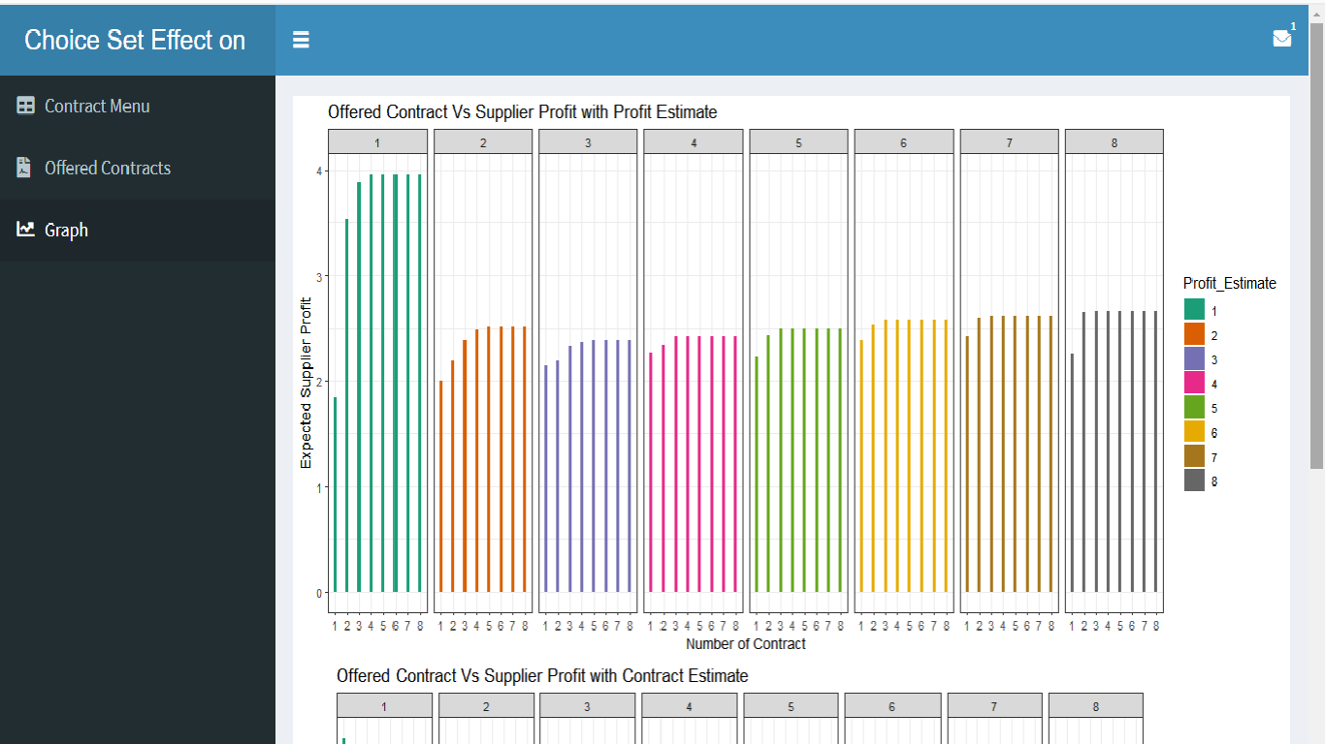

*Figure 9: Old Model effect on Supplier Profit*

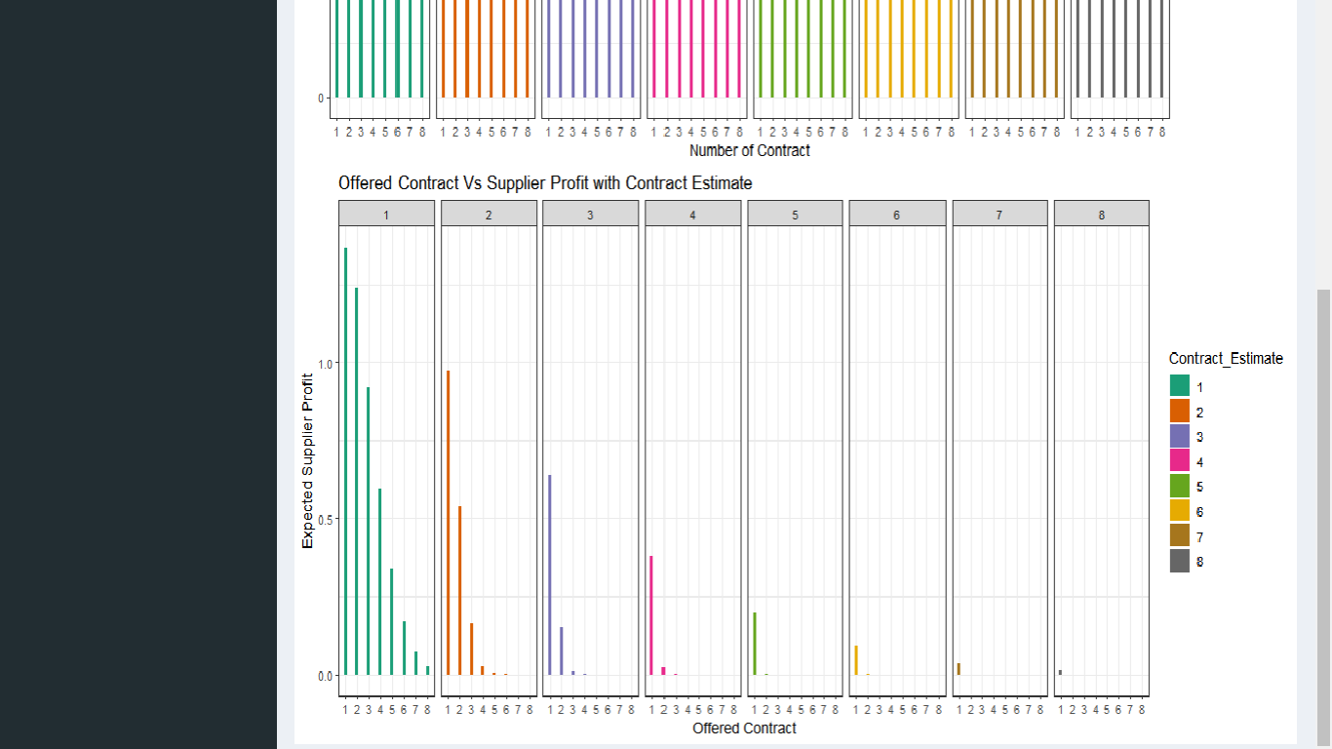

*Figure 10: New Model Effect on Supplier Profit*

# Bibliography

Abeliuk, A., Berbeglia, G., Cebrian, M. et al. (2016) Assortment optimization under a multinomial logit model with position bias and social influence. 4OR-Q J Oper Res 14, 57–75.

Amrani, A., Deschamps, J.-C., & Bourrières, J.-P. (2012). The impact of supply contracts on supply chain product-flow management. Journal of Manufacturing Systems, 31(2), 253–266.

BASOV, S. (2009). Monopolistic Screening with Boundedly Rational Consumers. Economic Record, 85, S29–S34.

Bertsimas, D., Miˇsi´c, V., (2015). Data-driven assortment optimization, working paper, Massachusetts Institute of Technology

Besedeš T, Deck C, Sarangi S, Shor M. (2015) Reducing choice overload without reducing choices. Review of Economics and Statistics,97(4):793-802.

Cachon, G. (2003). Supply chain coordination with contracts. S. C. Graves, A. G. de Kok, eds. Handbooks in Operations Research and Management Science: Supply Chain Management. North Holland, Amsterdam, the Netherlands, 229– 339.

Cachon, G. P., & Swinney, R. (2009). Purchasing, Pricing, and Quick Response in the Presence of Strategic Consumers. Management Science, 55(3), 497–511.

Centreforaviation.com. (2021). COVID-19 and European airlines: zero capacity becomes a reality. Available: https://centreforaviation.com/analysis/reports/covid-19-and-european-airlines-zero-capacity-could-become-a-reality-518812. Last accessed 10th April 2021.

Chernev A, Böckenholt U, Goodman J. (2015) Choice overload: A conceptual review and meta-analysis. Journal of Consumer Psychology,25(2):333-58.

Deb J, Zhou J (2018) Reference Dependence and Choice Overload. Munich Personal RePEc Archive.

Dragan, L. (2021). A Silicon Chip Shortage May Delay Headphones and Game Consoles, but Don't Panic. Available: https://www.nytimes.com/wirecutter/blog/silicon-chip-shortage-delays/. Last accessed 10th April 2021.

Haase, K. (2009). Discrete location planning. Technical Report WP-09-07. Institute for

Transport and Logistics Studies, University of Sydney.

Haase K, Müller S (2014) A comparison of linear reformulations for multinomial logit choice probabilities in facility location models. Eur J Oper Res 232(3):689–691

Haynes GA. (2009) Testing the boundaries of the choice overload phenomenon: The effect of number of options and time pressure on decision difficulty and satisfaction. Psychology & Marketing, 26(3):204-12.

Inbar Y, Botti S, Hanko K. (2011) Decision speed and choice regret: When haste feels like waste. Journal of Experimental Social Psychology,47(3):533-40.

Iyengar SS, Lepper MR. (2000) When choice is demotivating: Can one desire too much of a good thing? Journal of personality and social psychology,79(6):995.

Jeet. (2021). Apple to account for 53% of TSMC 5nm chips production in 2021. Available: https://www.gizmochina.com/2021/02/08/apple-tsmc-5nm-chips-2021/. Last accessed 10th April 2021.

King, I., Wu, D., & Pogkas, D.. (2021). How a Chip Shortage Snarled Everything From Phones to Cars. Available: https://www.bloomberg.com/graphics/2021-semiconductors-chips-shortage/. Last accessed 10th April 2021.

Koppelman F.S., Bhat C.R (2006) A self instructing course in mode choice modeling: multinomial and nested logit models. Prepared for U.S. Department of Transportation Federal Transit Administration.

Krohn, R., Müller, S., & Haase, K. (2020). Preventive healthcare facility location planning with quality-conscious clients. OR Spectrum.

Lee, Hau L.; Padmanabhan, V.; Whang, Seungjin (1997): Information Distortion in a Supply Chain: The Bullwhip Effect. In Management Science 43 (4), pp. 546–558.

Li, Jianbin; Luo, Xiaomeng; Wang, Qifei; Zhou, Weihua (2021): Supply chain coordination through capacity reservation contract and quantity flexibility contract. In Omega 99, p. 102195.

Lv, Fei; Ma, Shihua; Guan, Xu (2015): The implication of capacity reservation contracts in assembly system with asymmetric demand information. In International Journal of Production Research 53 (18), pp. 5564–5591.

McCracken, Marti L.; Manly, Bryan F. J.; Heyden, Madeleine Vander (1998): The Use of Discrete-Choice Models for Evaluating Resource Selection. In Journal of Agricultural, Biological, and Environmental Statistics 3 (3), pp. 268–279.

Mckellop, M. (2021). Renesas and Innolux Executives Expect Chip Shortage will Persist into 2022. Available: https://www.sourcengine.com/blog/renesas-innolux-executives-expect-chip-shortage-will-persist-into-2022. Last accessed 10th April 2021.

Oppewal H, Koelemeijer K. (2005) More choice is better: Effects of assortment size and composition on assortment evaluation. International Journal of Research in Marketing, 22(1):45-60.

Özalp Özer, Wei Wei, (2006) Strategic Commitments for an Optimal Capacity Decision Under Asymmetric Forecast Information. Management Science 52(8):1238-1257

Park, M., Park, S., Mele, F. D., & Grossmann, I. E. (2006). Modeling of Purchase and Sales Contracts in Supply Chain Optimization. Industrial & Engineering Chemistry Research, 45(14), 5013–5026

Römer, N., Voigt, G., Müller, S.(2020). A Choice-Based Optimization Approach for Contracting in Supply Chains. Working Paper.

Sahin, F., and E. P. Robinson. 2002. "Flow Coordination and Information Sharing in Supply Chains: Review, Implications, and Directions for Future Research." Decision Sciences 33 (4): 505–536.

Serel, Dogan A.; Dada, Maqbool; Moskowitz, Herbert (2001): Sourcing decisions with capacity reservation contracts. In European Journal of Operational Research 131 (3), pp. 635–648.

Shen, B., Choi, T.-M., & Minner, S. (2018). A review on supply chain contracting with information considerations: information updating and information asymmetry. International Journal of Production Research, 1–39.

Train, Kenneth E. (2012): Discrete Choice Methods with Simulation.

Yang, D., Qi, E., & Li, Y. (2015). Quick response and supply chain structure with strategic consumers. Omega, 52, 1–14.