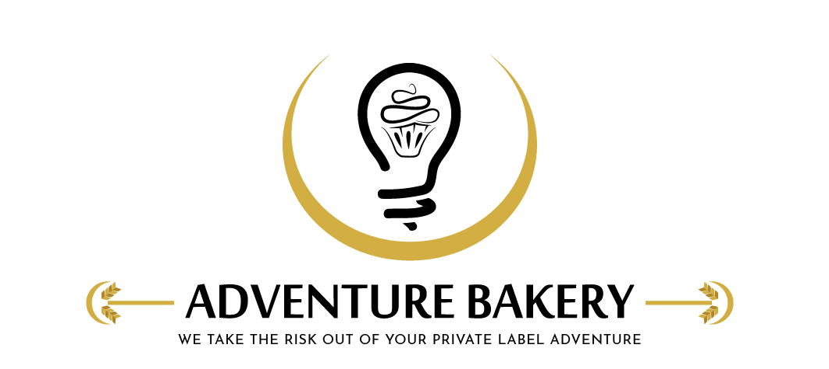
Adventure Bakery, LLC |  | Revision Num. | New
Form Title | Depositor Cleaning & Pre-Use Check Log (Beldos 275) | Filled By
Form No. | FRM-911

Date |  | Product run |  | Allergen changeover | ☐
Cleaning
Step | Done | Notes
Machine and air supply off; air line disconnected and pressure bled
Depositor fully disassembled — nozzle, hopper, rotation cylinder, hopper block, product cylinder, piston
All seals / O-rings removed from every part
Product-contact parts and seals washed in the sink — detergent, rinse, sanitizer at label strength, drying rack
Machine body and air cylinders wiped only — not submerged
Every seal inspected for wear; worn or damaged seals replaced
Reassembled — seals greased with food-approved grease, clamps tight, correct nozzle fitted
Allergen changeover: every food contact surface checked under good light (changeover only)
Sanitizer strength (test strip) | __________ ppm | Cleaned by
Signature statement: "I cleaned the depositor as described in SOP-903."
Check Before Next Run
All parts clean and dry; seals inspected and worn ones replaced (none torn or missing a piece); clamps tight; correct nozzle fitted; nothing left on the machine | Pass ☐ Fail ☐
Anything wrong, and what was done about it
Checked and released by |  | Date
Signature statement: "I checked the depositor after cleaning and release it for production." (Supervisor / admin sign-off)
Adventure Bakery, LLC · Confidential · FRM-911

