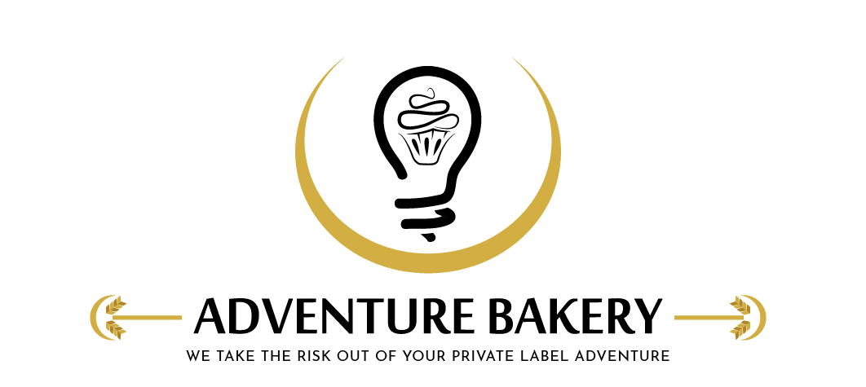
Adventure Bakery, LLC |  | Revision Num. | New
Form Title | Kettle Cleaning & Pre-Use Check Log (Groen TDB) | Filled By
Form No. | FRM-912

Date |  | Product run |  | Allergen changeover | ☐
Cleaning
Step | Done | Notes
Kettle switched off and power isolated; cooled enough to clean safely (cleaned while still warm)
Large food residues scraped and flushed out — non-abrasive brushes only, no metal tools or steel wool
Inside and outside washed with detergent at label strength; burned-on soaked, not gouged
Rim, pouring lip, cover underside and any baskets/strainers washed; controls and housing wiped (no water in controls)
Rinsed thoroughly with hot water and drained completely
Sanitized with Noble Sani-512 at 1:512 (1 oz per 4 gal); every surface wet at least 1 min and air-dried — no-rinse
Allergen changeover: every food contact surface checked under good light (changeover only)
Sanitizer strength | __________ ppm | Cleaned by
Signature statement: "I cleaned the kettle as described in SOP-904."
Check Before Next Run
Kettle clean inside and out; rim, pouring lip, cover and baskets clean; no detergent residue; sanitized just before use (Sani-512, air-dried); jacket water level at the sight-glass midpoint | Pass ☐ Fail ☐
Anything wrong, and what was done about it
Checked and released by |  | Date
Signature statement: "I checked the kettle after cleaning and release it for production." (Supervisor / admin sign-off)
Adventure Bakery, LLC · Confidential · FRM-912

