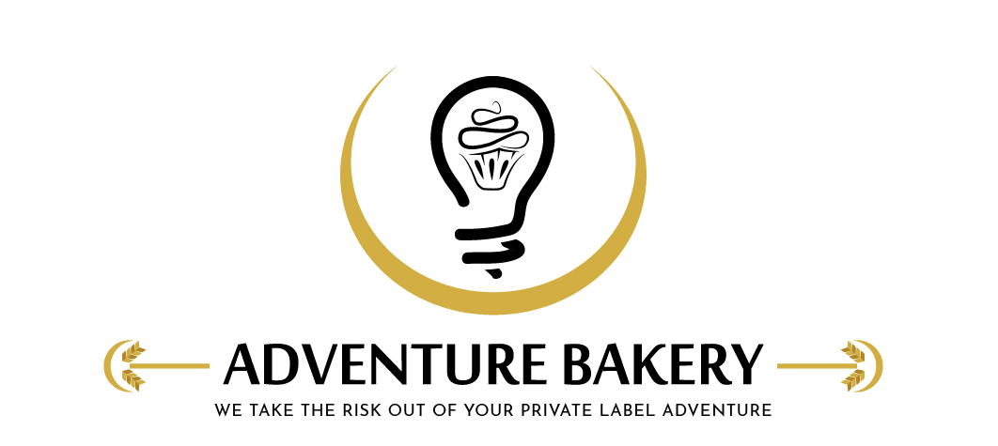
Adventure Bakery, LLC |  | Revision | A
Form Title | Daily Sanitation, Pre-Operation & Release Record | Effective Date | 2026-06-01
Form No. | FRM-903 | Approved By | GJM
SQF Reference | 11.2.5.7, 11.2.5.3, 11.2.5.9, 11.7.3.4 | Filled By

Day / Shift
Date |  | Production area / line

Shift | ☐ 1st Shift ☐ 2nd Shift ☐ 3rd Shift | Product / batch run

1. Pre-Operation Cleanliness Check
Before production starts, following cleaning and sanitation, confirm each surface/equipment is visibly clean and sanitized (SQF 11.2.5.7). Mark Pass (clean/sanitized) or Fail; note any corrective action taken before start-up. Add or remove items as the line changes.
Item / Surface | Visibly clean | Sanitized | Corrective action / comments
Tables

Mixers

Bowls

Utensils

Pans

Racks

Ovens

Scales

Depositors

Chopper

Floors

2. Production Equipment — Cleaned & Sanitized per SSOP
For each machine used in today's production, confirm it was verified clean and sanitized per its SSOP and recorded on its own cleaning log, or mark "Not used today". Add or remove equipment as the line changes.
Equipment | Status | Notes
Hobart V-1401 Mixer — SOP-901 / FRM-909

Kook-E-King Depositor — SOP-902 / FRM-910

Beldos 275 Depositor — SOP-903 / FRM-911

Smipack S560NA Shrink Wrapper — SOP-601

Groen TDB Kettle — SOP-904 / FRM-912

3. Sanitizer Verification
Confirm and record sanitizer concentration before use (SQF 11.2.5.3).
Sanitizer used |  | Concentration (PPM)

Within target? | Pass ☐ Fail ☐

Test method (e.g. test strip)

4. Glass & Brittle Plastic Check
At the start of the shift, confirm glass instrument dial covers and MIG thermometers are undamaged (SQF 11.7.3.4). Mark Pass (undamaged), Fail (damaged/broken), or N/A. Any Fail requires a Glass Breakage Incident Report (FRM-908) and follows SOP-11.7.3. Items are drawn from the Glass & Brittle Plastic Register (FRM-907).
Location | Item | Undamaged | Condition / comments | Action taken
Processing Room | Pan scrubber dials
Processing Room | Oven controls and door glass
Processing Room | MIG thermometers

5. Operational GMP Check
During production, confirm operational GMPs are being followed. Mark Pass, Fail, or N/A; note corrective action for any Fail (absorbs the former FRM-904 Daily Operation Check).
Check | Conforms | Corrective action / comments
Hair/beard nets worn; no exposed jewelry

Clean outer garments; no eating/drinking/gum in production

Handwash stations stocked (soap, towels, sanitizer)

Hands washed on entry and as required

Allergen controls / segregation followed

Waste and floor debris controlled

No condensation or drip over exposed product

Pest control devices in place and intact

Doors/screens to outside kept closed

6. Corrective Actions & Release
Production shall not begin until all non-conformances are corrected and the area is verified clean (SOP-11.2.12). A record of pre-operational hygiene inspection is maintained for a minimum of 12 months (SQF 11.2.5.9).
All corrective actions completed before start-up | Pass ☐ Fail ☐

QA Technician (qualified inspector) |  | Date
"I inspected the area and equipment before start of production, verified the sanitizer concentration, and confirm the area is clean and released for production (or corrective action was completed as noted)."

Production Supervisor |  | Date
"I confirm the pre-operation inspection was completed and the area is released for production."

Adventure Bakery, LLC · Confidential · FRM-903 · Handwritten entries are photographed and entered into the digital form

