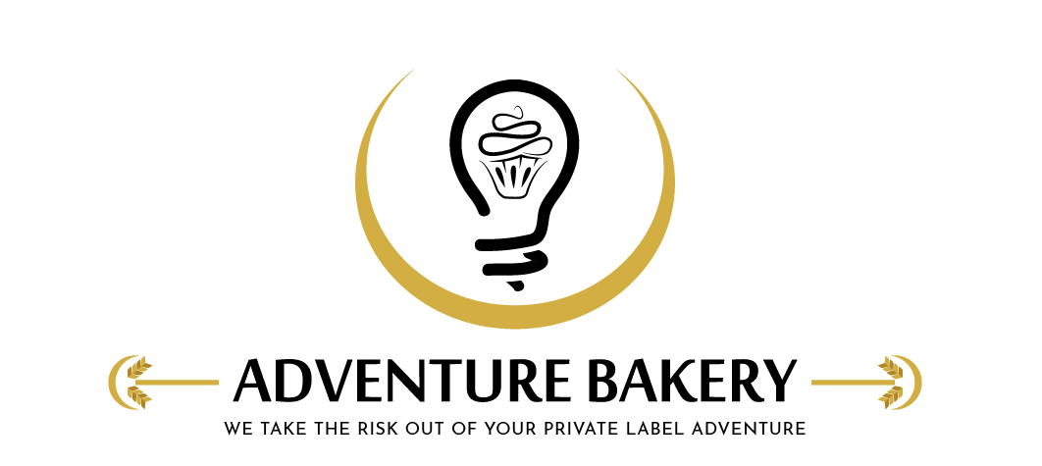
Adventure Bakery, LLC |  | Revision Num. | New
Form Title | Depositor Cleaning & Pre-Use Check Log | Filled By
Form No. | FRM-910

Date |  | Product run |  | Allergen changeover | ☐
Cleaning
Step | Done | Notes
Wire clear of the die, machine unplugged; guards opened
Hopper, feed rollers, die and scrapers removed
Cut-off wire and support fingers wiped clean in place (not removed)
Head interior, die slot, cabinet and belts dry-then-damp wiped (no water on the panel)
Hopper, feed rollers, die and scrapers washed in the sink — detergent, rinse, sanitizer at label strength, drying rack
Cut-off wire whole and accounted for — no missing pieces
Reassembled: die finger-tight in a clean slot, a finger in each die slot, guards locked
Allergen changeover: every food contact surface checked under good light (changeover only)
Sanitizer strength (test strip) | __________ ppm | Cleaned by
Signature statement: "I cleaned the depositor as described in SOP-902."
Check Before Next Run
Hopper, rollers, die and scrapers clean and dry; wire and fingers wiped clean and wire accounted for; guards locked; nothing left on the machine | Pass ☐ Fail ☐
Anything wrong, and what was done about it
Checked and released by |  | Date
Signature statement: "I checked the depositor after cleaning and release it for production." (Supervisor / admin sign-off)
Adventure Bakery, LLC · Confidential · FRM-910

