LAB Logbook

Lab 1

Lab 2

Accuracy = 0.915

Task 2

O1 = O2 = 0.819

Lab 3

Accuracy = 0.8856

Lab 4

Lab 5

Optimal Number of Epochs = 4

Lab 6

Optimal Number of of Epochs = 9

Lab 7

VGG16 Model Performance

Optimal Number of Epochs = 39

VGG19 Model Performance

Final Performance Table

Histogram of VGG16 and VGG19

Lab 8

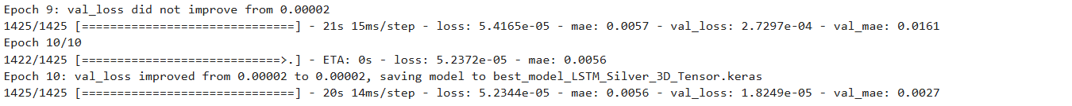

Lab 9



Error Metrics

Lab 10

**Task -1**

Encoder summary

Decoder Summary

Autoencoder Summary

**Task-2**

Autoencoder summary

Autoencoder.fit() code

Detailed Accuracy Graph

Lab 11

SID – 2372670

70/2 = 35

Epoch no. = 35

Lab 12

SID – 2372670

Epochs = 10 +50 = 60

Patience = 10 + 10 = 20

Early Stopping

