LAB Logbook

Lab 1

Lab 2

Accuracy = 0.915

Task 2

O1 = O2 = 0.819

Lab 3

Accuracy = 0.8856

Lab 4

Lab 5

Optimal Number of Epochs = 4

Lab 6

Optimal Number of of Epochs = 9

Lab 7

VGG16 Model Performance

Optimal Number of Epochs = 39

VGG19 Model Performance

Final Performance Table

Histogram of VGG16 and VGG19

Lab 8

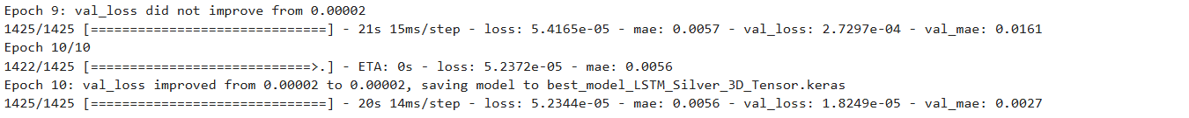

Lab 9

Lab 10

Lab 11

Lab 12