

A synopsis

On

**Quick Medical Diagnosis with Automated Symptoms Analyzer and Basic Healthcare Management App**

Under

Project Based Learning-II

Batch G3

Date: 11-03-2023

AY: 2022-2023

**Group members (Roll no and Name)**

21354 – Advait Naik

21356 – Shubham Panchal

21358 – Chinmay Patil

21362 – Soaham Pimparkar

**Title**

Quick Medical Diagnosis with Automated Symptoms Analyzer and Basic Healthcare Management App

**Motivation**

In India, medical health services are becoming expensive in urban and rural areas. The availability of medical facilities is sparse in rural areas due to which patients are devoid of proper medication. By building this project, we are bringing doctors and patients closer where patients could find the best doctor available for treating their ailment. As a surplus, prescriptions, medical history and dose reminders are also provided for the patient’s wellbeing. Epidemic tracking could also be performed by tracking the number of cases of a particular disease occurring in a locality.

**Objectives**

While emphasizing on quick medical diagnosis, the following objectives are at the core of the project:

* Providing no-cost medical diagnosis for non-severe symptoms or ailments
* Manage prescriptions and dose-reminders for users
* Providing information on the healthcare infrastructure in a user’s locality
* Validating symptoms and the corresponding automated diagnosis to ensure reliability of the diagnosis process

**S/W and H/W requirement**

Software requirements include tools and SDKs needed to develop the Flutter and Android applications:

* Android Studio – an IDE for Android App Development
* Android SDK and Build Tools (Gradle)
* Android Emulator
* Flutter SDK with configuration managed in VS Code

The project does not have any hardware requirements, and only Android/iOS mobile devices are needed to test the applications.

**Theory/ Short Description**

Our project includes two mobile applications, one for the user/patient and another for doctors who have subscribed to our service. The user and doctor need to authenticate themselves with the apps, providing essential information that would identify them uniquely. For doctors, appointment details, check-up fees, speciality etc. are also included. The users could provide their health-oriented details such as age, weight, blood group and history of other ailments if needed. The users will then get a gross automated diagnosis based on the symptoms they have entered.

Following to the diagnosis, the users will get contact details of doctors and hospitals in their locality that specialize the diagnosed ailment. Moreover, the automated diagnosis also gets verified by a doctor. Prescriptions are sent digitally to the user’s app, which creates automatic dose remainders on their device.

**Flowchart**

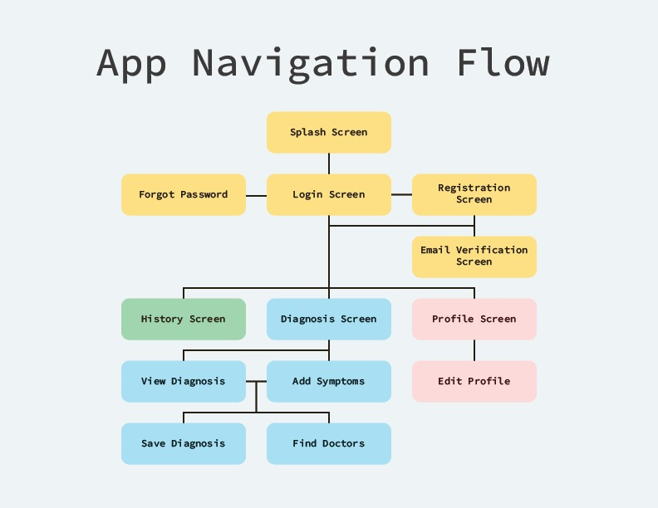

**References**

* Automated Diagnosis: <https://endlessmedical.com>
* Jetpack Compose: <https://developer.android.com/jetpack/compose>
* iOS Development: <https://developer.apple.com/tutorials/app-dev-training#swiftui-essentials>
* Flutter Development: <https://docs.flutter.dev>
* <https://www.ndtv.com/health/year-ender-2020-the-rise-of-digital-healthcare-services-a-doctors-take-2339609>
* <https://www.ndtv.com/india-news/online-health-start-ups-e-connect-patients-doctors-across-india-1457260>
* <https://www.ndtv.com/video/news/banega-swasth-india/the-rural-india-healthcare-crisis-shortage-of-doctors-630067>
* <https://www.forbesindia.com/article/take-one-big-story-of-the-day/tech-for-health-inside-the-rise-of-practo-and-its-ambitious-roadmap-for-the-future/66485/1>

**Conclusion**

With the help of Android and Flutter frameworks, we aim to provide an app that could provide quick medical diagnosis to users and give basic information on the local healthcare infrastructure and reminders for prescriptions. We wish to make the project open-source and follow all software-development practices so facilitate project-based learning.