

CSE2005 OS – LAB 01
Advait Deochakke
20BCE1143

Shell, Unix, and fork()
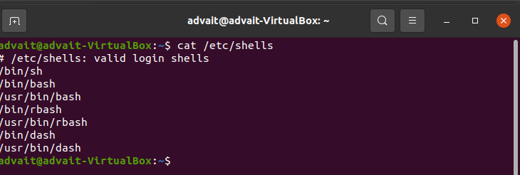
a) Shell Programming

1. Types of Shells available to the system

2. Show where the bash file is located
3. Contrasting non-shell programs with shell programs
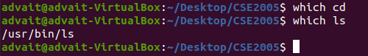

(cd is not shell, while ls is a shell program)

4. man (manual command) , gives manual for the thing (eg. Bash manual page 1)

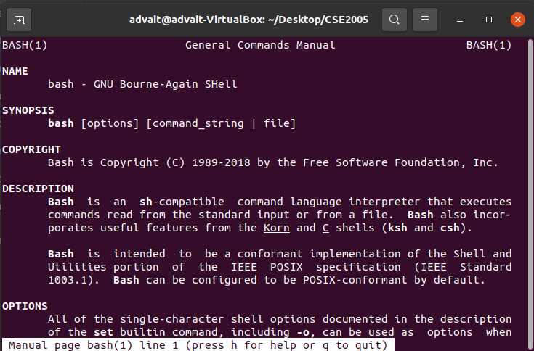
5. showcasing cd (change directory) command

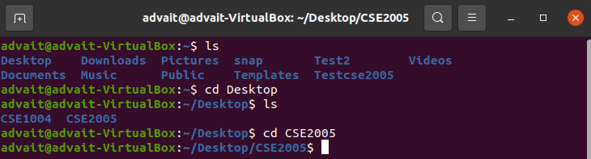
6. echo (similar to print command)

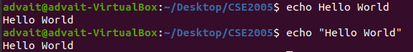

7. touch command to create shell executable

8. Selecting shell with #! shbang

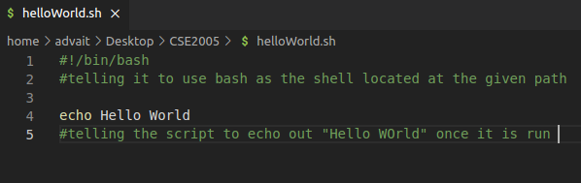

9. Running shell file
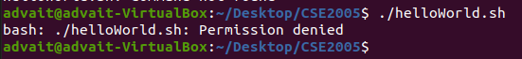

(permission denied as creating with touch)

10. chmod to change file perms

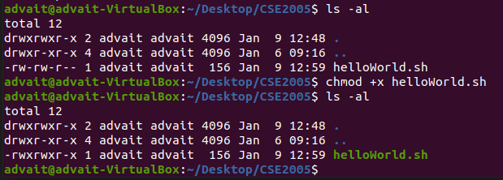
(notice the change in helloWorld.sh in first and second execution of ls -al)

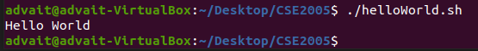

11. set $variable
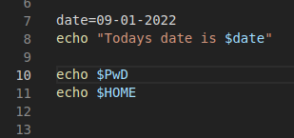

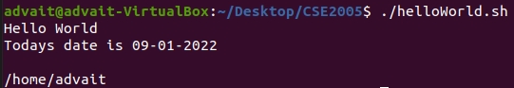

12. # (pound/hash) comments

(notice how the text preceded by only # is not taken into account)

13. read

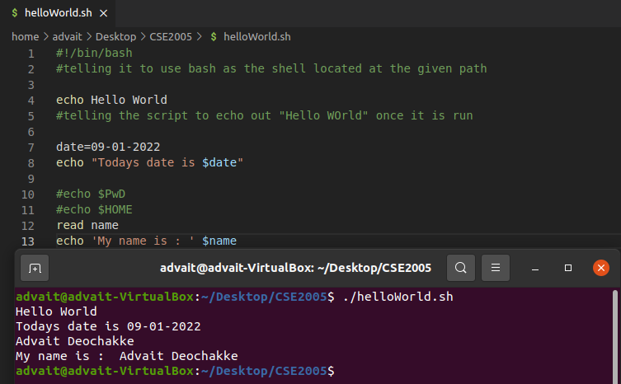

14. read -sp (read password silently)
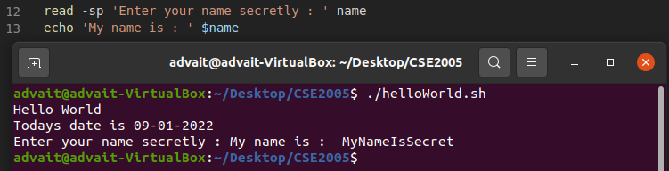

15. read -a (read list on words separated by spaces)
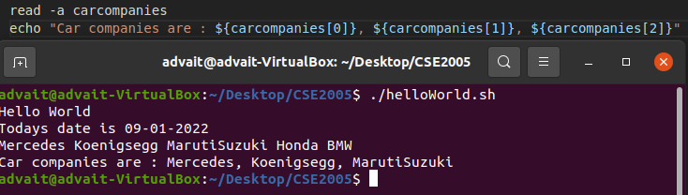
16. passing arguments

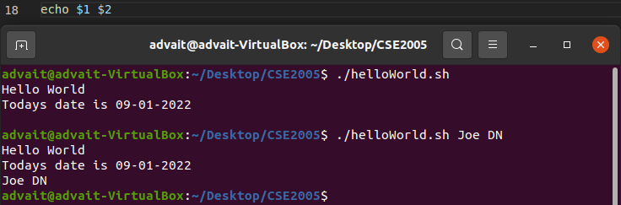
where $1 and $2 are taken as the 1st and 2nd input on the line when we execute shell
(bonus: ./helloWorld.sh would be considered as the 0th input, $0)

17. storing arguments passed as arrays with $@ (ignore the comments)

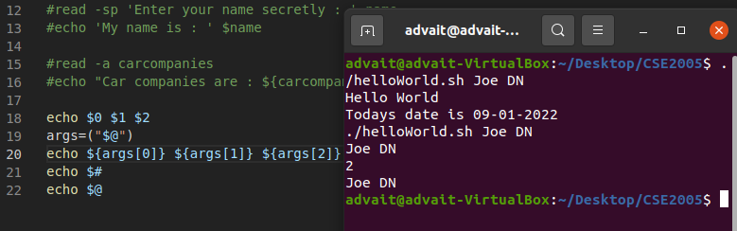

18. if then
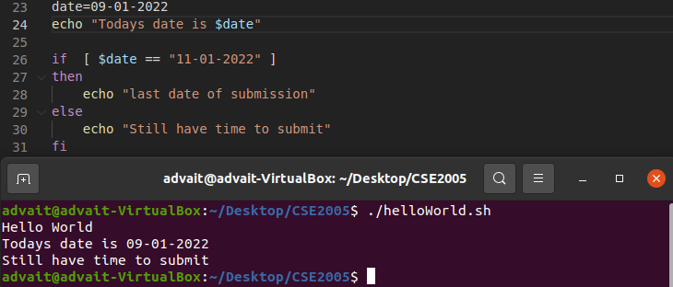
19. if then else

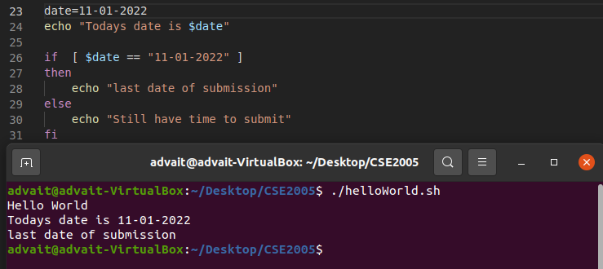
20. elif
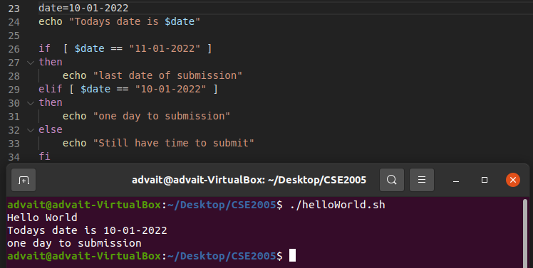
b) Unix/terminal commands

1. date
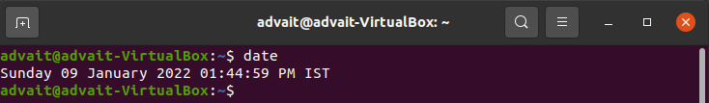
2. cal
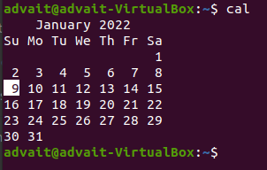

3. echo
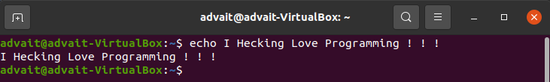
4. multiline echo
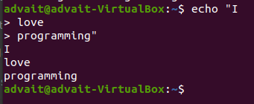

5. who
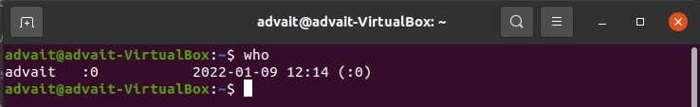
6.whoami

7. tty (TeleTYpewriter)

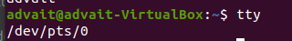

8. in-terminal calculator

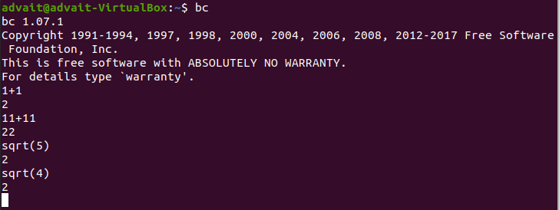
9. in-line calculator (append with ‘ | bc’ )
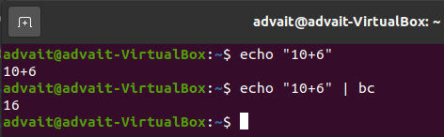

10. ls (list contents of current dir)
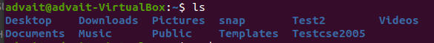

11. pwd (print working directory)
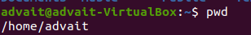

12. mkdir (make directory)

13. rmdir (remove directory)
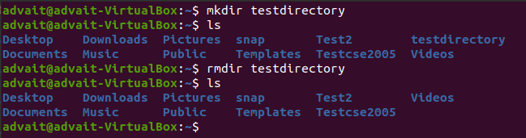
14. cat> (filename) (create file)

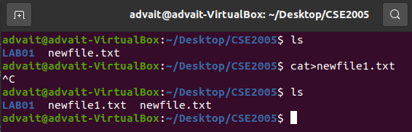

15. cat (filename) (show file contents)

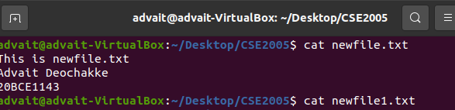

16. cat (file 1) >> (file 2) (copy file contents) (ctrl c ctrl v)

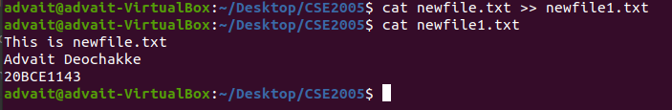
17. sort (filename) (sort file lines in alphabetical order)
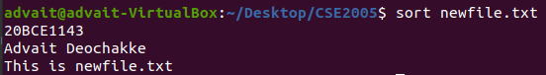

18. mv (file 1) (file 2) (ctrl x ctrl v) (move contents) (removes the original file)

19. rm (filename) (remove file)

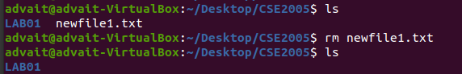

20. clear (removes contents of the screen to default)

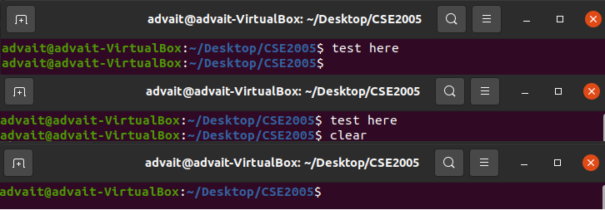
c) C program to show fork() (printing random numbers, but srand is in seconds and fork childe happens under a second, so unix time doesnt change)

